3. Assessment of the Sablefish Stock in Alaska

Daniel R. Goethel and Matthew L.H. Cheng

November 2024

**Contributors:**

Katy Echave, Kevin Siwicke, Kalei Shotwell, Bridget Ferris, Elizabeth Siddon, Ivonne Ortiz, Cindy Tribuzio, Pat Malecha, Andrew Dimond, Kelli Johnson, Maia Kapur, Kendra Holt, Rhea Ehresmann, Krista Oke, Pete Hulson, Jane Sullivan, Ben Williams, Joshua Zahner, Dana Hanselman, and Chris Lunsford

This report may be cited as:

Goethel, D.R. and Cheng, M.L.H. 2024. Assessment of the sablefish stock in Alaska. North Pacific Fishery Management Council, Anchorage, AK. Available from: Available here.

The last operational full assessment for sablefish was in 2021 and a full description of the final Model *21.12* can be found in the 2021 SAFE document:

<https://www.fisheries.noaa.gov/resource/data/2021-assessment-sablefish-stock-alaska>

Updates as implemented in the current model used for management advice (Model *23.5*) can be found in the 2023 SAFE document:

<https://apps-afsc.fisheries.noaa.gov/Plan_Team/2023/sablefish.pdf>

The following appendices can be found at the end of this document:

**Appendix 3D. Ecosystem and Socioeconomic Profile (ESP) of the Sablefish Stock**

**Appendix 3E. Sablefish in Eastern Bering Sea Trawl Fisheries**

**Appendix 3F. Fishery Dependent Data Collections of the Sablefish Stock**

Executive Summary

Summary of Changes to the Assessment

An update assessment was undertaken for sablefish (*Anoplopoma fimbria*) in 2024 and the author recommended model for the 2024 SAFE is the same as the final 2023 SAFE model, model *23.5*.

Changes to the Input Data

New data included in the author recommended assessment model *23.5* were:

1. Length data from the fixed gear fishery for 2023.
2. Length data from the trawl fisheries for 2023.
3. Age data from the longline survey and fixed gear fishery for 2023.
4. Finalized catch for 2023.
5. Preliminary catch for 2024, including non-commercial catch of sablefish in federal waters, and projected catch for the portion of the fishing year not yet completed.
6. Estimates of killer and sperm whale depredation in the fishery for 2024 were held constant at 2022 values.

Changes to the Assessment Methodology

There were no changes to the stock assessment model methodology in 2024.

Summary of Results

There were no surveys or fishery-dependent abundance indices available in 2024. Due to poor sablefish market conditions, the cost-recovery NOAA domestic longline survey did not take place in 2024. The longline survey has been running continuously since 1979 (begun as a cooperative survey with the Japanese) and 2024 was the first year that the survey did not occur. The longline survey abundance index (relative population numbers, RPNs) demonstrated no change from 2022 to 2023, which followed a 17% increase in 2022 and a 9% increase in 2021 (Figure 3.3). The NOAA Gulf of Alaska (GOA) trawl survey was in an off year in 2024 (biennial survey), but the trawl survey biomass index decreased by 50% from 2021 to 2023 following a nearly five-fold increase from 2013 through 2021. The catch-per-unit effort (CPUE) index can no longer be updated, because the International Pacific Halibut Commission (IPHC) is no longer funded by NOAA to collect and enter the data from sablefish logbooks, thus, fishery logbook data are not currently available in a database to update the CPUE. The standardized fishery CPUE index increased by 37% from 2021 to 2022.

Model *23.5* demonstrated good fit to the primary abundance indices, especially the longline survey RPNs, but the extreme decline observed in the 2023 trawl survey could not be replicated by the model (Figure 3.12). Aggregated fits to the compositional data were adequate, but year and cohort specific residual patterns were present (Figures 3.13—3.33, Appendix 3C Figures 3C.1-3C.13). For instance, recent year classes tend to be initially overestimated and subsequently underestimated in the longline survey and fixed gear fishery age compositions, while discrepancies in fitting age compared to length data within a given fleet remain common. Yet, no strong diagnostic or retrospective issues were noted (Figures 3.46—3.47), and the model demonstrated consistent estimation with the 2023 model *23.5* (Figure 3.48).

The model estimates that all year classes since 2014 have been at or well above the time series average (Figure 3.38), though the two most recent estimated year classes (2020 and 2021) are well below the recent (since 2014) mean. However, early indications from Eastern Bering Sea (EBS) trawl fishery length data suggest that the 2022 year class (not estimated in the 2024 assessment) could be large (Appendix 3E). Growth in total biomass has leveled off over the last year (1% increase), which follows a tripling of the population from a time series low of 234,000 t in 2015 to 705,000 t in 2024 (Figure 3.34). Conversely, spawning stock biomass (SSB) grew by 20% in 2024, representing a more than doubling of the spawning population from the time series low of 83,000 t in 2018 to 191,000 t in 2024 (Figure 3.34). Thus, the sablefish population continues to grow rapidly, where total biomass is at the fifth highest level on record and SSB is nearing levels observed in the mid-1980s. Currently, the SSB in 2024 is at 63% of the unfished SSB (i.e., B100%).

Additionally, the sablefish age structure continues to gradually expand as the recent large year classes (e.g., 2014) begin to enter ages that are nearing full maturity. For instance, the 2014 year class is now 10 years old and around 90% mature, while the larger 2016 year class is 8 years of age and 67% mature. The abundance of the 2014—2019 cohorts remain high as they age (Figures 3.35 – 3.36), which is a positive sign for the sablefish population. However, there remains a lack of fully mature sablefish age classes (i.e., greater than 10 years of age), and these recent year classes may need to support the population and fishery for a decade or more. The imbalance in the age structure is apparent given that the 2014 through 2021 cohorts comprise more than 81% of the projected 2025 SSB (Figure 3.54).

Fishery dynamics for sablefish are rapidly fluctuating due to changes in gear utilization (i.e., transition from predominantly hook-and-line gear to pot gear), the influx of low value small fish, and market saturation leading to reduced value. Due to biological and socioeconomic drivers, catch has been well below acceptable biological catch (ABC) with the proportion of the quota utilized averaging ~71% over the last three years and projected to be <50% in 2024. Stakeholders have been pursuing changes to the full retention requirement for sablefish through the North Pacific Fisheries Management Council (NPFMC) to allow for discarding of small, low-value fish (NPFMC, 2024; results of analyses exploring the potential impacts of small sablefish release are available from <https://shinyfin.psmfc.org/small_sablefish/>). Exploring alternate harvest control rules that can better maintain a balanced age structure and reduce market fluctuations associated with large recruitment events has been the focus of an ongoing research-based and stakeholder-informed management strategy evaluation (MSE) project (see <https://ovec8hkin.github.io/SablefishMSE/index.html>).

Although the sablefish assessment model does not demonstrate any strong diagnostic issues, a number of moderate concerns with data inputs and model performance are worth monitoring. Poor market conditions led to the 2024 NOAA domestic longline survey for sablefish being cancelled, which has led to increased uncertainty in assessment estimates of recent population growth and year class strength. Moreover, projections are hindered due to overestimation of ABC utilization in future years, but this leads to overly pessimistic projections and is not a major concern for management advice. Resolving trends in residual patterns is a priority for future assessments, primarily through improved modeling of sex-specific sablefish dynamics. Generally, the population remains in a very healthy state (Figure 3.55), though continued expansion of the age structure is needed and should be monitored. Environmental and ecosystem conditions for sablefish remain generally favorable and near average conditions, while no fishery performance metrics indicate any biological concerns for the resource (see the ‘Ecosystem and Socioeconomic Profile’, Appendix 3D; Shotwell et al., 2024). Thus, there are no elevated risk table concerns for sablefish.

Sablefish are managed under Tier 3 of the NPFMC harvest control rule, which aims to maintain the population at *B40%*. Since projected female spawning biomass (combined areas) for 2025 is equivalent to *B73%*, sablefish is in sub-tier “a” of Tier 3. Spawning biomass is projected to increase rapidly in the near-term, and the maximum permissible value of *FABC* under Tier 3a is 0.087, which translates into **a Tier 3a maximum permissible 2025 ABC (combined areas) of 50,283 t**. **After adjusting for whale depredation, the final author recommended ABCw is 50,111 t** (representing a 6% increase in the author recommended ABC from 2024)**.** The OFL fishing mortality rate is 0.102, which translates into a 2025 OFL (combined areas) of 58,731 t, and results in a whale depredation adjusted OFLw of 58,532 t. The current model projections indicate that the Alaskan sablefish stock is not subject to overfishing, not overfished, and not approaching an overfished condition.

Summary Table

|  |  |  |  |  |
| --- | --- | --- | --- | --- |
|  | As estimated or  specified *last* year for (model *23.5*): | | As estimated or  recommended *this* year for (model *23.5*): | |
| **Quantity/Status** | 2024 | 2025* | 2025 | 2026** |
| *M* (natural mortality rate, estimated) | 0.113 | 0.113 | 0.114 | 0.114 |
| Tier | 3a | 3a | 3a | 3a |
| Projected total (age 2+) biomass (t) | 700,353 | 691,260 | 704,713 | 695,681 |
| Projected female spawning biomass (t) | 185,079 | 209,500 | 219,714 | 241,217 |
| *B100%#* | 299,901 | 299,901 | 302,672 | 302,672 |
| *B40%#* | 119,960 | 119,960 | 121,069 | 121,069 |
| *B35%#* | 104,965 | 104,965 | 105,935 | 105,935 |
| *FOFL* | 0.101 | 0.101 | 0.102 | 0.102 |
| *maxFABC* | 0.086 | 0.086 | 0.087 | 0.087 |
| *FABC* | 0.086 | 0.086 | 0.087 | 0.087 |
| OFL (t) | 55,385 | 55,620 | 58,731 | 57,993 |
| **OFLw (t)^** | **55,084** | **55,317** | **58,532** | **57,797** |
| max ABC (t) | 47,367 | 47,572 | 50,283 | 49,651 |
| ABC (t) | 47,367 | 47,572 | 50,283 | 49,651 |
| **ABCw (t)^** | **47,146** | **47,350** | **50,111** | **49,482** |
| **Status** | As determined *last* year for: | | As determined *this* year for: | |
|  | 2022 | 2023 | 2023 | 2024 |
| Overfishing | No | n/a | No | n/a |
| Overfished | n/a | No | n/a | No |
| Approaching overfished | n/a | No | n/a | No |

*2023 SAFE projections for biomass and SSB were based on specified catch of 31,500 t in 2024 (based on the ratio of extrapolated catch to max ABC in 2023, which was 0.66 based on a 2023 extrapolated catch of 27,200 t and an ABC of 40,500 t) used in place of maximum permissible ABC for 2024. The realized catch in 2023 was 25,493 t and the extrapolated catch in 2024 from the 2024 SAFE is 23,152 t, both of which represent a large overestimation of catch removals for sablefish.

**The 2024 SAFE projections were based on specified catch of 24,692 t in 2025 (a yield ratio of 0.49 was assumed based on a 2024 extrapolated catch of 23,152 t and an ABC of 47,146t). Specified catch projections are utilized in response to management requests for a more accurate two-year projection. SSB and biomass are less than presented when the full ABC is removed in 2025.

^ABCw and OFLw are the final author recommended ABCs and OFLs after accounting for whale depredation.

#The average recruitment for calculation of biological reference points was 25.9 million fish for the 2024 SAFE and 25.3 million fish for the 2023 SAFE.

Spatial Catch Apportionment

Based on biological rationale, the SSC adopted a five-year average survey apportionment method in 2020. A five-year moving average of the longline survey proportions of biomass in each region are used to apportion catch to management area. The apportionment values are updated yearly as new survey data is collected. There was no longline survey in 2024, so apportionment remains unchanged from 2023.

### **Accounting for Whale Depredation**

For the final recommended ABC (ABCw) or OFL (OFLw), sperm and killer whale depredation in the fixed gear fishery is accounted for by reducing the maximum ABC by the last estimate of the three-year average of depredation estimates by area. Beginning in 2023, whale depredation estimates have been held constant at the 2022 levels, per SSC recommendations. By accounting for whale depredation in the assessment and associated catch projections, the approach does not create additional regulations or burden for in-season management.

#### **Whale Depredation ABC Table with Final Author Recommended 2025 ABC.**

|  |  |  |  |  |  |  |  |
| --- | --- | --- | --- | --- | --- | --- | --- |
| **Area** | **AI** | **BS** | **WG** | **CG** | **WY\*** | **SEO\*** | **Total** |
| 2024 ABC | 13,108 | 11,474 | 4,718 | 9,670 | 2,683 | 5,714 | 47,367 |
| 2025 ABC | 12,180 | 13,915 | 5,009 | 10,265 | 2,848 | 6,066 | 50,283 |
| 2021 - 2023 Mean Depredation | 5 | 14 | 12 | 8 | 20 | 101 | 160 |
| Ratio 2025:2024 ABC | 0.93 | 1.21 | 1.06 | 1.06 | 1.06 | 1.06 | 1.06 |
| Deduct 3-Year Adjusted Mean | -5 | -17 | -12 | -8 | -21 | -108 | -171 |
| **\*\*2025 ABCw** | 12,175 | 13,898 | 4,996 | 10,257 | 2,827 | 5,958 | 50,111 |

*Before 95:5 hook and line : trawl split between WY and SEO shown below.

**ABCw is the author recommended ABC that accounts for whale depredation.

#### **Whale Depredation ABC Table with Final Author Recommended 2026 ABC.**

|  |  |  |  |  |  |  |  |
| --- | --- | --- | --- | --- | --- | --- | --- |
| **Area** | **AI** | **BS** | **WG** | **CG** | **WY\*** | **SEO\*** | **Total** |
| 2024 ABC | 13,108 | 11,474 | 4,718 | 9,670 | 2,683 | 5,714 | 47,367 |
| 2026 ABC | 12,027 | 13,740 | 4,946 | 10,136 | 2,812 | 5,989 | 49,651 |
| 2021 - 2023 Mean Depredation | 5 | 14 | 12 | 8 | 20 | 101 | 160 |
| Ratio 2026:2024 ABC | 0.9 | 1.2 | 1.0 | 1.0 | 1.0 | 1.0 | 1.0 |
| Deduct 3-Year Adjusted Mean | -5 | -17 | -12 | -8 | -21 | -106 | -169 |
| **\*\*2026 ABCw** | 12,022 | 13,723 | 4,934 | 10,128 | 2,791 | 5,883 | 49,482 |

*Before 95:5 hook and line : trawl split between WY and SEO shown below.

**ABCw is the author recommended ABC that accounts for whale depredation.

#### **West Yakutat (WY) and Southeast Outside (SEO) ABC Gear Adjustment Table.**

|  |  |  |
| --- | --- | --- |
| **Year** | **West Yakutat** | **Southeast Outside** |
| 2025 | 3,125 | 5,660 |
| 2026 | 3,086 | 5,589 |

*ABCs represent total regional ABCw across gears (after whale depredation adjustments), but with the 5% trawl allocation in SEO reallocated to WY.

**Whale Depredation OFL Table with Final Author Recommended 2025 and 2026 OFLs.**

|  |  |  |
| --- | --- | --- |
| **Year** | **2025** | **2026** |
| OFL | 58,731 | 57,993 |
| 3-Year Mean Depredation | 160 | 160 |
| Depredation Inflation Factor | 1.24 | 1.22 |
| Deduct 3-Year Mean | -199 | -196 |
| **\*OFLw** | **58,532** | **57,797** |

*OFLw is the author recommended OFL that accounts for whale depredation.

Groundfish Plan Team Summary Table by Region

|  |  |  |  |  |  |  |
| --- | --- | --- | --- | --- | --- | --- |
| **Area** | **Year** | **Biomass(4+)\*** | **OFL\*\*** | **ABC#** | **TAC** | **Catch^** |
| GOA | 2023 | 317,000 | -- | 23,201 | 23,201 | 13,581 |
| 2024 | 303,000 | -- | 22,596 | 22,596 | 13,406 |
| 2025 | 305,000 | -- | 24,038 | -- | -- |
| 2026 | 299,000 | -- | 23,737 | -- | -- |
| BS | 2023 | 151,000 | -- | 8,417 | 7,996 | 4,851 |
| 2024 | 174,100 | -- | 11,450 | 7,996 | 3,940 |
| 2025 | 175,000 | -- | 13,898 | -- | -- |
| 2026 | 172,000 | -- | 13,723 | -- | -- |
| AI | 2023 | 153,000 | -- | 8,884 | 8,440 | 1,924 |
| 2024 | 152,000 | -- | 13,100 | 8,440 | 1,266 |
| 2025 | 153,000 | -- | 12,175 | -- | -- |
| 2026 | 151,000 | -- | 12,022 | -- | -- |

*Biomass represents the value projected by the model used to determine the ABC in that year assuming specified catch (not the full ABC), while regional biomass is determined by multiplying the total age-4 biomass by the longline survey proportions by region in the terminal year of the associated model.

**The OFL is set for the entire Alaska management region, so no area specific OFLs are provided.

#The ABC for 2023 is based on model *21.12* and a 75% stair step from fixed apportionment to the 5-year average survey apportionment. For 2024 — 2026, model *23.5* was used and no stair step was applied for ABCs. Also, these values are after the whale depredation adjustments described above.

^As of October 10, 2024 Alaska Fisheries Information Network, ([www.akfin.org](http://www.akfin.org)) and not including extrapolated catch for 2024.

Whale Adjusted Catch Tables by Region

|  |  |  |  |  |  |  |  |  |
| --- | --- | --- | --- | --- | --- | --- | --- | --- |
| **Year** | **2024** | | | | **2025** | | **2026** | |
| Region | OFLw | ABCw | TAC | Catch* | OFLw | ABCw** | OFLw | ABCw** |
| BS | -- | 11,450 | 7,996 | 3,940 | -- | 13,898 | -- | 13,723 |
| AI | -- | 13,100 | 8,440 | 1,266 | -- | 12,175 | -- | 12,022 |
| GOA | -- | 22,596 | 22,596 | 13,406 | -- | 24,038 | -- | 23,737 |
| WGOA | -- | 4,699 | 4,699 | 2,101 | -- | 4,996 | -- | 4,934 |
| CGOA | -- | 9,651 | 9,651 | 5,655 | -- | 10,257 | -- | 10,128 |
| **WY | -- | 2,926 | 2,926 | 2,172 | -- | 3,125 | -- | 3,086 |
| ** SEO | -- | 5,320 | 5,320 | 3,478 | -- | 5,660 | -- | 5,589 |
| Total | 55,084 | 47,146 | 39,032 | 18,612 | 58,532 | 50,111 | 57,797 | 49,482 |

*As of October 10, 2024 Alaska Fisheries Information Network, ([www.akfin.org](http://www.akfin.org)).

**After 95:5 trawl split shown above and after whale depredation methods described above.

Graphical Summary



Responses to SSC and Plan Team Comments

SSC Concerns on Assessments in General

This section lists new or outstanding SSC comments pertaining generally to AFSC assessments. SSC comments are provided in italics with responses to each comment directly following.

*There remains considerable confusion over the application of the fishery performance category of the risk table. The SSC reiterates that only fishery performance indicators that provide some inference regarding biological status of the stock should be used. (Dec. 2023)*

The sablefish risk table scoring for the fishery performance category was revised to account for only biological inference. Aspects of fishery performance (e.g., proportion of the ABC utilized) are still reported in the SAFE, as these provide indications of how accurate ABC projections may be, but they are not utilized in the fishery performance category of the risk table.

*The SSC requests that when Bayesian model output is reported, basic convergence diagnostics are also presented. The appropriate statistics will depend on the algorithm used (e.g., MCMC or ADNUTS), but should include a summary of convergence for all estimated model parameters and quantities of management interest. If tail probabilities (e.g., probabilities <5-10%), are reported, Monte-Carlo estimates of estimation error would also be helpful to illustrate the uncertainty associated with the values reported. (Dec. 2023)*

The sablefish assessment utilized the adnuts algorithm for the first time in 2024 and associated convergence diagnostics are provided (e.g., minimum effective sample size and maximum rhat).

SSC Concerns Specific to the Sablefish Assessment

This section lists new or outstanding SSC comments specific to the previous Alaskan sablefish assessment and any model updates presented during the fall meetings. SSC comments are provided in italics with responses to each comment directly following.

*The SSC discussed risk table considerations and agreed with the elevated concern (level 2) in the Fishery Performance category. In particular, the authors and JGPT noted the declining utilization with catch well below ABC, the substantial reductions in market value, and rapid changes in the fishery such as the rapid switch to pot gear. Under-utilization has resulted in uncertain estimates of current year catches that affect the projected biomass and resulting OFL and maxABC. The rapid transition from longline to pot gear has changed selectivity patterns in the fishery that may result in increased uncertainty, but this should likely be an assessment-related concern. The SSC also notes that market-related concerns do not pertain to ABC considerations so should not be in the risk table. (Dec. 2023)*

As noted in response to the general SSC comments, the sablefish fishery performance section of the risk table has been revised to account for inference only related to biology.

*The SSC appreciates the inclusion of residual bubble plots (Pearson and OSA) and agrees with the authors that the disconnect between fitting sex-aggregated age compositions, but disaggregated length compositions may contribute to the lack of fit. The SSC supports disaggregating age data by sex as a high priority for the next full assessment to help address residual patterns. See also SSC comments on OSA residuals in the General Stock Assessment Comments. (Dec. 2023)*

Although disaggregating age compositional data by sex remains a high priority, this was not undertaken for the 2024 SAFE update model, but will be a part of the next full assessment.

*The SSC suggests that retrospective analysis can be extended to 10 years in line with other stocks, despite the selectivity time block starting in 2017, but that Mohn’s rho values should be computed for both the full ten years of peels and for the period after the time block. (Dec. 2023)*

The authors reiterate that this recommendation does not provide useful inference about model performance, because a 10-year peel will force the model to estimate selectivity in the recent time block with only 1 year of data (in 2016). The resulting model would be extremely unstable and provide poor inference. The sablefish assessment provides multiple forms of retrospective analyses, including an all model retrospective (i.e., displaying values from the model used for management advice in the given year) that has peels back to 2016. Between the 8-years of peels in the main retrospective analysis and the longer all model retrospective, the authors believe that the appropriate inference can be made. By 2026, the sablefish assessment will have a full 10-year peel without having to deal with the uncertainty associated with the recent selectivity time blocks.

*Describe the method used for developing input/initial (pre-Francis weighting) sample sizes used for compositional data. Consider using a bootstrapping approach, based on the work by Hulson et al., that is applied in other groundfish stock assessments. (Dec. 2023)*

The input sample sizes are set to 20 for each source of compositional data and in each year (Table 3.7). Through the Francis reweighting procedure, the weights (lambdas) for each compositional data source are then updated. The choice for input sample sizes was originally recommended and implemented during the 2016 CIE when SDNRs were utilized to tune the lambdas for each data source. For 2024, sensitivity runs were conducted to ensure the choice of input sample size was not impacting estimates and results indicate that the model was insensitive to different starting values (Figure 3.53a). As recommended, future sablefish assessment updates will look into using the Hulson and Williams (2024) bootstrapping approach for ISS.

*Provide further investigation and potential alternative model parameterizations to address the poor fit to the new domestic fishery index that combines longline and pot gear (Figure 3.12). (Dec. 2023)*

Because sablefish have a dedicated fishery-independent survey, emphasis is placed on survey fits over CPUE fits. Overall, fit to the CPUE index is deemed to be sufficient and poor fits often only occur when the trend in the CPUE differs strongly from the trends in the longline survey, which is to be expected given the relatively higher information content in the survey index for informing scale and trends in the sablefish resource. Moreover, using CPUE data for species with dedicated surveys is usually not advised, given potential issues with inferring biomass trends from fishery-dependent data. Given that the fishery CPUE index will no longer be updated, future assessment updates will look into removing the CPUE index from the model.

*The SSC encourages the use of an appropriate sigma constraining recruitment but notes that the maximum likelihood estimate of a random effects variance is negatively biased. This can be avoided by iteratively tuning in a maximum likelihood framework (per the approach of Methot and Taylor) or by using a full Bayesian analysis such that the recruitment deviations are integrated out. As suggested by the JGPT, please clarify how the bias correction is treated, as it will have to be used differently during maximum likelihood estimation and for Bayesian analyses (where the full range of each recruitment deviation is integrated regardless of the information content of the data). (Dec. 2023)*

The treatment of the recruitment variance will be explored again in the next full assessment, but, since the 2024 assessment was an update, no changes were made. However, per JPT and SSC advice, the bias correction term was not utilized during MCMC.

Plan Team Concerns Specific to the Sablefish Assessment

This section lists new or outstanding PT comments specific to the previous Alaskan sablefish assessment and any model updates presented during the fall meetings. PT comments are provided in italics with responses to each comment directly following.

*The Teams asked about the improvements and fixes to the stock-recruit bias correction algorithm and appreciated the author’s response and improvements to the code. Some unknowns about the method remain including how the bias-correction is applied across years with more or less information, how the bias-correction is applied during MCMC, and if estimating sigmaR is reasonable for this assessment especially during MLE. It was noted that the bias correction is unnecessary from posterior samples (MCMC evaluations) and that the NPFMC Tier 3 estimates use proxy values for spawning biomass reference points instead of the stock-recruitment relationship and estimates of theoretical unfished biomass. (Nov. 2023)*

As described in Methot and Taylor (2011), the recruitment bias correction approach scales the correction term linearly from 0 in data poor years (when there is little information to inform recruitment) to 1.0 in recent data rich years (when there is information to inform recruitment), but then declines near the terminal year to account for lack of information on the most recent recruitment events. For sablefish, the break points for the bias correction term included a start year of 1980 when compositional data starts to become available (from the NOAA cooperative longline survey), a max of 1.0 starting in 1990 when length composition data become available for most fleets, and a subsequent decline starting in 2019 to account for limited information in the compositional data on recruitment events within the last five years of the model terminal year. As noted in the response to the SSC comments, the bias correction was not implemented during MCMC. Future model updates will explore how the recruitment variance term should be treated (i.e., fixed or estimated), but no changes were made in 2024 as this was an update assessment.

Introduction

For a full description of the sablefish resource and fishery dynamics, see Goethel et al. (2021; available at <https://www.fisheries.noaa.gov/resource/data/2021-assessment-sablefish-stock-alaska>).

Sablefish are found from northern Mexico to the Gulf of Alaska (GOA), westward to the Aleutian Islands (AI), northward in the Bering Sea (BS), and into the northwestern Pacific Ocean off the Siberian coast of Russia and the Kuril Islands in Japan (Wolotira et al. 1993). Genetic analysis has found no population sub-structure throughout their range along the US West Coast to Alaska, and suggested that observed differences in growth and maturation rates may be due to phenotypic plasticity or are environmentally driven (Jasonowicz et al., 2017; Timm et al., 2024). Sablefish are assessed as a single, homogeneous population in Federal waters off Alaska, because of their high movement rates and panmictic stock structure. However, management is by discrete regions to distribute exploitation throughout their wide geographical range, including the Bering Sea, Aleutian Islands, Western GOA, Central GOA, West Yakutat (WY), and Southeast Outside (SEO).

Adult sablefish live at depths greater than 200 m and are highly mobile, though, exact movement patterns and drivers are not well understood. Spawning occurs in winter at depths of 300 - 500 m near the edges of the continental slope (Mason et al. 1983). Juvenile sablefish spend their first two to three years on the continental shelf of the GOA and the southeast BS. After their second summer, they begin moving offshore to deeper water, typically reaching their adult habitat, the upper continental slope, at 4 to 5 years of age. This corresponds to the age range when sablefish start becoming reproductively viable (Mason et al. 1983, Rodgveller et al. 2016).

Fishery

Sablefish have been exploited since the end of the 19th century with rapid fishery expansion in the 1960s when Japanese longliners began operations in the eastern BS (Table 3.1, Figures 3.1 and 3.2). Heavy fishing by foreign vessels expanded into the GOA during the 1970s and total catch peaked at 53,000 t in 1972, which led to a substantial population decline and implementation of fishery regulations in Alaska. By 1988 the U.S. harvested all sablefish taken in Alaska, primarily by hook-and-line gear in the eastern and central GOA. In 1995, individual fishery quotas (IFQs) were implemented for hook-and-line vessels. Since 2021, the majority of removals by the fixed gear fleet was taken by pot gear (Table 3.1, Figure 3.1), primarily driven by the increasing popularity of collapsible ‘slinky’ pots. Further details on the Alaskan sablefish fisheries can be found in Appendices 3D – 3F (links provided on title page). Appendix 3D contains the sablefish Ecosystem and Socioeconomic Profile (ESP), which includes summaries of various fishery socioeconomic metrics. Appendix 3E describes the catch of small sablefish in the eastern Bering Sea in the various trawl fisheries. Appendix 3F summarizes sampling and observer coverage rates in the sablefish fisheries, including analysis of coverage rates by electronic monitoring (EM).

**Management Measures and Bycatch**

A summary of historical catch and management measures pertinent to sablefish in Alaska are provided in Table 3.2. Under current regulations, release of any sablefish by the sablefish IFQ fishery is prohibited, as long as there is remaining IFQ for persons onboard the fishing vessel. The NPFMC is currently exploring options to loosen full retention requirements based on requests from stakeholders to be able to release small, low value fish (NPFMC, 2024; <https://shinyfin.psmfc.org/small_sablefish/>). Sablefish discards in groundfish target fisheries are dominated by trawl fisheries in recent years, primarily in the BSAI due to an influx of recent large year classes in the BS, but discards have declined substantially starting in 2023 (Table 3B.1). Bycatch of federally managed groundfish species in the sablefish target fishery has primarily been composed of shortspine thornyhead, arrowtooth flounder, halibut, skates, and shortraker and rougheye rockfish, with amounts of incidental catch increasing drastically (by upwards of three-fold) in 2024 for many flounder and rockfish species likely in response to the transition to pot gear from hook-and-line gear (Table 3B.2). In terms of non-target bycatch, grenadiers are consistently the primary species encountered in the target sablefish fishery (Table 3B.3). The predominant prohibited species catch (PSC) in both the BSAI and GOA sablefish target fisheries is golden king crab and tanner crab (Table 3B.4).

Data

A variety of data sources are included in the assessment and were updated for 2024 (as available; Table 3.3), including fishery catch (Table 3.1), fishery and survey compositional data (Table 3.4), and various indices of abundance and biomass (Figure 3.3; Table 3.5). The final input data used for the assessment can be found on the sablefish SAFE Github site at <https://github.com/dgoethel-noaa/2024-Sablefish-SAFE/blob/main/Data/tem_2024_na_wh.dat>).

Japan and the U.S. conducted a cooperative longline survey for sablefish in the GOA annually from 1978 to 1994, adding the AI region in 1980 and the eastern BS in 1982 (Sasaki 1985). Since 1987, the NOAA domestic longline survey for sablefish has been conducted in the GOA with the aim of continuing the cooperative longline survey time series, with biennial sampling of the AI beginning in 1996 and biennial sampling of the eastern BS in 1997. Relative population abundance in numbers (RPNs) are computed annually using survey catch rates scaled to management area size. Sablefish length data were randomly collected for all survey years. Since 1996, a random sample of otoliths has been collected and aged (~1,200 per year; Table 3.4). The age and length compositions are weighted by RPNs in each FMP area to obtain a representative estimate of survey catch-at-age or length. The lowest RPN values in the domestic survey time series occurred in 2015, but have increased steadily with 2019 through 2023 survey RPNs representing some of the highest in the time series (Figure 3.3). Although RPNs had been trending upwards in most regions in recent years, RPNs were down slightly in the western GOA and BS in 2023 (Figures 3.4 – 3.5). Due to market conditions and the cost-recovery nature of the longline survey, there was no survey conducted in 2024. The NOAA longline survey RPN indices are adjusted to account for whale depredation, but the impact on the final index is minimal (Figure 3.6; Hanselman et al., 2018). Interactions between the fishery and survey are described in Appendix 3A.

Since 1984, NOAA has conducted triennial or biennial trawl surveys in the GOA on the upper continental slope to 500 m depth. Since the full range of adult sablefish habitat is not always sampled and adult sablefish may also outswim the net, trawl survey indices are developed primarily as an index of juvenile sablefish biomass. The GOA trawl survey index was at its lowest level of the time series in 2013, more than quadrupled until 2021, then declined precipitously by ~50% in 2023 (Figure 3.3; Table 3.5). Lengths are sampled during each survey year (Table 3.4). There was no trawl survey in 2024, as this was a scheduled off year.

Records of catch weight and effort for vessels that target sablefish are collected by observers and by vessel captains in voluntary and required logbooks. Based on Japanese longline fishery catch rate data, a nominal index of historical CPUE is included from 1964 – 1981 (Table 3.5). For the domestic fishery, a combined gear (i.e., including data from both hook-and-line and pot gear) standardized CPUE index is used (Cheng et al., 2023). Since 2020, CPUE has been increasing rapidly, similar to, but slightly less than, rates of increase in the NOAA domestic longline survey RPNs over the same period (Figure 3.3). The last year of CPUE data is 2022, as the data needed to produce the index is no longer available to NOAA.

The catch used in this assessment (Table 3.1) represents total catch (landings plus bycatch or discards assuming 100% mortality), and includes catch from minor state-managed fisheries (i.e., these are reported by federal statistical areas and directly incorporated into the NOAA catch accounting system) in the northern GOA and in the AI region (constituting about 1% of the average total catch). Additionally, all non-commercial sablefish removals (see Table 3.1) are integrated into the fixed gear fishery catch, including research catches and Alaska state sport fishery removals not associated with the NSEI or SSEI fisheries. Whale depredation on hook-and-line gear has been pervasive in the fishery, and methods for estimating fixed gear fishery whale depredation are also integrated into the assessment and associated catch projections (Peterson and Hanselman, 2017). Estimated depredation is generally below 1,000 t per annum, often composing less than 1% of the total catch. Despite low overall impact relative to total catch, depredation varies by area and species with orca depredation higher in western regions (primarily the WGOA) and sperm whale depredation more significant in the CGOA and EGOA (Figure 3.7). Since 2023, fishery whale depredation has been held constant at 2022 levels, per SSC recommendations.

Length compositions from the U.S. fixed gear (longline and pot) and U.S. trawl fisheries are both measured by sex (Table 3.4), and gear- and sex-specific proportions-at-length are fit in the assessment. Only years that have sample sizes of at least 300 per sex are included. The length compositions are weighted by catch (in numbers) in each Fisheries Management Plan (FMP) area to obtain a representative estimate of catch-at-length.

Age compositions from the U.S. fixed gear fishery are available since 1999 with adequate coverage and sample sizes (~1,200 otoliths aged yearly) to be fit in the assessment as sex-aggregated proportion-at-age (Table 3.4). The age compositions are weighted by the catch (in numbers) in each FMP area to obtain a representative estimate of catch-at-age. The number of fishery ages read in 2024 (from the 2023 fishery samples) decreased slightly (~1,000 fish were aged; Table 3.4) due to high demand for aging requests across species in 2024 for the NOAA AFSC Age and Growth Program.

Data Input Changes for 2024

Aside from updating the time series of each data set (if available; Table 3.3), there were no changes to the data for the 2024 SAFE. Note that there were no updates to survey or fishery CPUE indices in 2024 as there was no NOAA longline survey conducted, but age composition data from the NOAA longline survey were provided for the 2023 survey (there is a one year lag in otolith readings).

Population Trends in Nearby Regions Not Incorporated in the Assessment Model

Alaska Northern Southeast and Southern Southeast Inside Waters

Sablefish in the Northern Southeast Inside (NSEI) Subdistrict waters and Southern Southeast Inside (SSEI) Subdistrict waters of Alaska are treated as separate stocks from the federal population, but some migration into and out of Alaska federal and state waters has been confirmed with tagging studies (Hanselman et al. 2015). NSEI sablefish continue to demonstrate similar population trends as the federal stock with strong recent recruitment observed, particularly the 2016-year class, which is now over 50% mature and comprises approximately 32% of the biomass (Figure 3.8a). The longline survey CPUE has remained substantially above the long term mean since 2020 with minimal variation over the last three years. However, estimates from the 2023 stock assessment suggest sablefish spawning stock biomass remains at lower levels than estimated during the 1980s and 1990s. In SSEI waters, the longline survey CPUE showed a 40% increase from 2022 to 2023 (Figure 3.8a). The SSEI pot fishery CPUE increased 10% from 2022 to 2023 while the SSEI longline fishery CPUE decreased in recent years, most likely due to a substantial shift from longline gear to pot gear. Alaska state fisheries are seeing a similar rapid transition from hook-and-line gear to pot gear as the federal fishery.

Canada

The estimated biomass trend for the British Columbia (BC) stock of sablefish is similar to that in Alaska federal waters, with strong increases in the mid-2010s due to above average recruitment in 2016 – 2017. Spawning stock biomass has shown consistent increases in recent years (Figure 3.8b). The survey index value in 2023 was 10% less than the 2022 value, but still in line with the above-average levels seen since 2018. Total allowable catches (TACs) for the BC Sablefish stock are determined using a surplus production model implemented as part of a management procedure approach chosen through management strategy evaluation (Kendra Holt, pers. comm.).

United States West Coast (Washington, Oregon, and California)

For the United States west coast stock of sablefish (assessed by NOAA’s Northwest Fisheries Science Center), the estimated trajectory of relative spawning biomass across the times series is highly variable. The population increased rapidly in the 1970s to near unfished levels, declined for the next two decades to near *B40%* target biomass levels around 2000, and has increased again in recent years (Figure 3.8c). The above-average cohorts from 2008, 2013, 2015, 2016, 2020, and 2021 are driving the recent increase in spawning biomass. In particular, the recruitment events from 2020 and 2021 are two of the three largest in the time series. Based on the last (2023) assessment, the maximum ABCs are projected to be three-fold larger (36,000 t starting in 2025) than the adopted ACL for 2024.

Pacific Sablefish Transboundary Assessment Team (PSTAT)

Concurrent sablefish trends seen in Alaska, Canada, and the West Coast highlights the need to better understand the contribution to Alaska sablefish productivity from other areas and vice versa. A Pacific Sablefish Transboundary Assessment Team (PSTAT) consisting of scientists from the U.S. (west coast and Alaska regions, including both federal and state scientists) and Canada has been working to better understand the dynamics, population trends, and biology of sablefish across the eastern Pacific Ocean (<https://www.pacificsablefishscience.org/>). The PSTAT has engaged in a multi-year research endeavor that produced two key products: 1) a spatially structured, data-conditioned operating model (OM), and 2) the development of an MSE for the transboundary sablefish stock, with seven management strategies explored (Kapur et al., 2024). All management strategies were evaluated using criteria developed by fishery stakeholders during a 2021 workshop (Kapur et al., 2021) concerning the viability, sustainability, and economic value of the sablefish population through the projection period (2020—2040). Future research will examine spatial recruitment patterns and potential climactic drivers at more biologically sensible spatial scales. However, no future meetings are scheduled due to lack of future funding for PSTAT work.

Analytic approach

Model Structure

The update model *23.5* has no changes in structure compared to the 2023 model used for sablefish management advice (Goethel et al., 2023), and it utilizes the same general structure as a previously accepted sablefish model *21.12* with minor updates to recruitment bias correction and selectivity estimation (Goethel et al., 2021). The complete model structure is described in the 2021 SAFE (full documentation is available at: <https://www.fisheries.noaa.gov/resource/data/2021-assessment-sablefish-stock-alaska>). The model was coded in the AD Model Builder software, a C++ based software for development and fitting of general nonlinear statistical models (Fournier et al. 2012). The final model can be downloaded from: <https://github.com/dgoethel-noaa/2024-Sablefish-SAFE>.

An age structured statistical catch-at-age (SCAA) framework was utilized, which tracks population numbers-at-age by sex. The model assumed a single Alaska-wide stock. Recruitment occurred at age-2, and age-based dynamics were then tracked from age-2 to age-31+, where the terminal age was a plus group. Recruitment at age-2 was calculated as a yearly deviation from an average recruitment parameter. As described in Methot and Taylor (2011), a bias correction term was implemented in the stock-recruit relationship and recruitment penalty term in the objective function to ensure that recruitment estimates were mean unbiased. The correction term was scaled linearly from 0 in data poor years (when there was little information to inform recruitment) to 1.0 in recent data rich years (when there was extensive information to inform recruitment), but then declined near the terminal year to account for lack of information on the most recent year classes. For sablefish, the break points for the bias correction term included a start year of 1980 when compositional data becomes available (e.g., from the NOAA cooperative longline survey), a max of 1.0 starting in 1990 when length composition data become available for most fleets, and a subsequent decline starting in 2019 to account for limited information in the compositional data on recruitment events within the last five years of the model terminal year.

Primary demographic parameters were estimated outside the model and treated as fixed inputs, including maturity- (single time block), length- (two time blocks, pre- and post-1996), and weight-at-age (single time block; see Table 3C.1 for age-based values for all inputs). To allow fitting length data directly, predicted age compositions were converted to length compositions using input size-at-age transition matrices. Because sablefish can be difficult to age, an ageing error matrix was directly integrated into the assessment based on known-age otoliths (Hanselman et al., 2012).

The model assumes two primary fishing fleets (i.e., the directed fixed gear fishery, including both pot and hook-and-line gear, and the combined trawl gear fishery) with independent dynamics, including unique fishing mortality and fishery selectivity parameters. Selectivity was modeled by sex and fishery, except for the Japanese longline fishery (1964 – 1981) for which a single sex-aggregated selectivity curve was estimated. Selectivity for the fixed-gear fishery was estimated separately for the “derby” fishery prior to 1995, the IFQ fishery from 1995 to 2015, and the recent IFQ fishery (2016 – present). Two fishery-independent survey fleets were modeled, including the NOAA longline survey and the NOAA trawl survey. A single selectivity and catchability time block was assumed for the trawl survey, while the domestic longline survey was modeled with two selectivity time blocks (i.e., with a break in 2016) and a single catchability time block.

Selectivity for the longline surveys and fixed-gear fisheries was modeled with a logistic function where sex-specific age at 50% selectivity (*a50%*) and the difference in age at 50% selectivity and 95% selectivity, *δ* (i.e., controlling the slope of the curve), were estimated. However, due to limited data and sex-aggregated age composition data, instability in certain selectivity parameters existed. Therefore, some selectivity parameters were shared among similar gears and across sexes. The derby (i.e., first time block) fixed gear fishery and Japanese longline fishery have limited compositional data, so these fleets share *a50%* parameters within a sex, and a single *δ* parameter is estimated and shared across fleets and sexes. The other two (i.e., IFQ and recent) fixed gear fishery time blocks have independently estimated, sex-specific parameters. For the longline surveys, sex-specific *a50%* was estimated for each survey and time block, whereas sex-specific *δ* parameters were estimated then shared across all surveys and time blocks (i.e., for the cooperative longline survey, the domestic longline survey, and the recent selectivity time block for the domestic longline survey). Selectivity for the trawl fishery and trawl survey were allowed to be dome-shaped (right descending limb) and estimated with a two-parameter gamma-function and a one-parameter power function, respectively. The right-descending limb was incorporated because the trawl survey and fishery infrequently catch older fish (i.e., due to fishing at shallower depths). There were 3 total estimated parameters for the trawl fishery gamma functions (i.e., sex-specific *a50%* and a single *δ* parameter shared among sexes) and 2 estimated sex-specific parameters for the trawl survey power functions. A total of 14 fishery and 8 survey selectivity parameters were estimated in the model (Table 3.6).

Each of the data sources described in the previous section (see Table 3.3) are fit directly in the model, and a statistical maximum likelihood estimation (MLE) framework enabled estimation of key parameters (i.e., a total of 252 parameters were estimated; Table 3.6). For the compositional data, a multinomial error distribution was assumed (with fixed input sample size of 20) whereas indices utilized a lognormal error structure (with yearly variance terms). A penalized likelihood approach was integrated, including penalties on recruitment deviations, fishing mortality deviations, and a prior on natural mortality. Projections of future catch limits (e.g., ABC and OFL) are computed externally.

Definitions

Recruitment was the estimated number of age-2 sablefish (in millions of fish). Total biomass (in kilotons) was the abundance of all sablefish age-2 and older multiplied by sex-specific input weight-at-age. Spawning stock biomass (SSB) was the mass of mature (based on input age-based maturity) females (in kilotons). Summary fishing mortality was fully selected *F*, which is the instantaneous mortality at the age of maximum fishery selectivity, summed across fleets.

Model Alternatives and Justification

No changes to the assessment methodology were made from the accepted 2023 model (*23.5*), so no model alternatives were developed in 2024.

Model Bridging and Final Model Development

The first step in model development after adding the new data for 2024 was to perform Francis data reweighting (i.e., accounting for correlations among ages or length bins in the compositional data; Francis, 2017) to adjust data weights to account for the addition of the 2024 data. The data weights (lambdas) used for each data source before and after Francis reweighting along with the input sample sizes for the compositional data are available in Table 3.7. A jitter analysis was then implemented to identify if altering the starting parameters led to an improved fit to the observed data. For the jitter analysis, the model was rerun 250 times with parameter values altered from the initial conditions by adding a small random deviation selected from a uniform distribution ~Unif(0.01, 0.1). If a given jitter run resulted in a lower total negative log-likelihood value, then that model was chosen as the final author recommended model.

Model Evaluation

Model convergence was identified through successful inversion of the Hessian matrix, a maximum gradient component of less than 1e-4, and all parameters being estimated within their pre-specified bounds. Model performance and goodness of fit were determined through exploration of the size of objective function data components, visual fits to the data (including indices of abundance and age and length composition data), and residual analysis of both Pearson and one step ahead (OSA) residuals (to identify potential age or time trends in residuals; for OSA residuals the first age or length bin was dropped). Evaluating compositional model fits using Pearson residuals has the potential to result in spurious conclusions regarding lack of fit and/or independence, because correlated observations are retained. OSA residuals, which decorrelate observations arising from multinomial distributions, are increasingly being recommended as best practice for interpreting stock assessment model fits (Trijoulet et al., 2023). The overall interpretation of OSA and Pearson residuals is similar: large magnitude (e.g., greater than three) or systematic trends in residuals could indicate model misspecification. Finally, time series estimates of population trends were explored to ensure these were consistent with observations from the resource and general expert judgement regarding temporal dynamics.

Uncertainty

Two forms of uncertainty were evaluated, including the Hessian approximations from the MLEs and the posterior distributions from Markov Chain Monte Carlo (MCMC) simulations. For MCMCs, the recruitment bias adjustment was turned off and priors were implemented on most parameters. The adnuts package was utilized for MCMC with 3,000 iterations, 1,000 warmups, and 5 chains. Key diagnostics were reported including maximum Rhat and the minimum effective sample size.

Model Diagnostic Analyses

Retrospective Analysis

Retrospective analysis is the examination of the consistency among successive estimates of the same parameters obtained as new data are sequentially removed from a model. An eight-year retrospective analysis (i.e., terminal years 2017 through 2024) was undertaken to examine whether any significant time trends in spawning biomass or recruitment were present. Because the recent fishery and survey selectivity time blocks begin in 2016, peels before 2017 preclude informative retrospective analysis due to model instability when attempting to estimate selectivity parameters with only one year of data. ‘Mohn’s rho’ (*ρ*), a measure of overall retrospective bias, was calculated as the mean of the relative ‘bias’ across all retrospective peels.

Historical Assessment Retrospective Analysis

An historical assessment retrospective analysis addresses consistency across successive stock assessment applications with the actual data available in the terminal model year. Two versions of an historical retrospective analysis were conducted: 1) the ‘all model’ historical retrospective compared the actual assessment outputs from the model used as the basis of management advice for a given SAFE year (i.e., going back to the 2016 SAFE; this included successive applications of models *16.5*, *21.12*, and *23.5*); 2) the ‘current model’ historical retrospective utilized the current assessment model *23.5* applied to the actual data available at the time of the given SAFE (i.e., terminal years 2018 through 2024 were included). Mohn’s rho was calculated based on the difference between the projected SSB from a two-year projection to the corresponding realized SSB in the 2024 model.

Profile Likelihoods

Likelihood profiles allow exploration of how the likelihood response surface varies for different values of a given parameter and highlights potential tension between data sources for estimation of key parameters. A likelihood profile was developed for the primary scaling parameter, mean recruitment.

Incremental Influence of New Data

A data building analysis was conducted to demonstrate how new data affected parameter estimates (e.g., the magnitude of the most recent estimated year class). For this exercise, the 2024 catch data was added along with one additional new data source and the model was run. In the case of fishery independent surveys, the associated index was always added in combination with associated compositional data.

Index Sensitivity Analysis

An index sensitivity analysis was implemented to demonstrate the influence of each index by removing a given index and comparing model outputs. When a given fishery-independent index was removed, all associated age and length composition data were also removed from the model.

Model Sensitivity Runs

A handful of sensitivity runs were implemented to test how sensitive the model was to certain model assumptions. The primary sensitivity runs included testing alternate values of compositional data input sample size (i.e., using either 50, *ISS_50*, or 100, *ISS_100*, instead of 20 as assumed in model *23.5*) and fixing the recruitment variance term at the value estimated in 2023 (*Sig_R_Fixed_1.04*).

Results

Model Bridging and Final Model

Data Reweighting

The updated ‘lambdas’ (overall data weight) for each data source only varied slightly from the 2023 model (Table 3.7). The Francis approach continues to emphasize fishery length compositions over associated age compositions, but age compositions were given slightly more emphasis after reweighting with the 2024 data. In the future, the age data should be disaggregated by sex (as is done for length data) to provide more information on sex-specific dynamics (and which may lead to increased weights given to the age data). The data reweighting had no appreciable impact on model dynamics (Figure 3.9).

Jitter Analysis

The jitter analysis identified a handful of model runs with slightly lower total negative log-likelihoods, which provided minimally improved fits to the observed data (based on comparison of the total negative log-likelihood values; Figure 3.10). However, the lack of variation in objective function values and time series trends from the comprehensive (250 run) jitter analysis provides support that a robust model solution was attained (Figure 3.10). The final model *23.5* for 2024 used the jitter analysis run with the lowest negative log-likelihood and the Francis weights as calculated in 2024. The combined impact of data reweighting and the jitter analysis was minimal, with very slight changes to recruitment estimates compared to the 2023 continuity model *23.5* (i.e., which did not include updated Francis weights; Figure 3.9).

Model Evaluation

The final model 23.5 had a positive-definite Hessian, a maximum gradient component of 6.43e-5, and no parameters were estimated on or near the parameter bounds, which indicates (when also accounting for the jitter analysis results) that the model converged to a robust solution. However, a number of parameters are highly uncertain, including historical recruitment deviations defining the initial age structure (given lack of compositional data at the start of the model), recent recruitment deviations (due to elevated uncertainty associated with limited data on incoming year classes), and a handful of selectivity parameters (caused by the number of model partitions resulting from sex-specific dynamics, limited compositional data for historical fleets, and lack of sex-specific age composition data to inform estimates; Table 3C.2). The objective function values by data source indicated that the compositional data, particularly the NOAA longline survey ages and the fixed gear fishery lengths, had the largest contributions (Figure 3.11).

Goodness of fit

Model *23.5* demonstrated good fit to the indices with predicted values generally within the confidence intervals of the observations, especially for the sablefish NOAA domestic longline survey RPNs (Figure 3.12). Notable exceptions include poor fits for a few years of the trawl survey biomass index (i.e., early values and the large decline in 2023), the Japanese CPUE index, and a few recent data points from the domestic fishery CPUE index (Figure 3.12). The lack of fit to the 2023 trawl survey decline is not surprising, given that this trend is not reflected in any of the other data sources and is likely driven by a reduction in incoming recruitment that has yet to be observed in other data sources. Lack of fit to recent CPUE data points is driven by discrepancies in the rate of population increase between the NOAA domestic longline survey and the domestic fishery CPUE, where the latter does not show as drastic an increase in the late 2010s as is observed in the survey. Overall, the lack of a 2024 NOAA domestic longline survey data point is a moderate source of uncertainty, as this survey is the primary source of information on population trend and would have helped verify whether the 2023 trawl survey decline is indicative of a decline in recent recruitment or a broader population decline.

Mean fits to the compositional data were adequate, but some strong year and age- or length-specific residual patterns were present (Figures 3.13 – 3.33). For instance, recent year classes tend to be initially overestimated and subsequently underestimated (i.e., at ages when these year classes reach their peak abundance) in the longline survey and fixed gear fishery age compositions (Figures 3.15 – 3.18). Thus, primary estimation uncertainty pertains to the magnitude of recent year classes. The aggregated fits to the length composition data demonstrated a general tendency to overestimate fish in the 55cm to 65cm range, then underestimate the proportion of fish in the 65cm to 75cm range (Figures 3.19 – 3.33). However, in recent years, the trend is reversed with an underestimation of small fish and overestimation of the proportion of larger fish (e.g., in the NOAA longline survey, Figures 3.23 – 3.24, and the fixed gear fishery, Figures 3.29 – 3.30). Length compositions from the trawl gear tend to be more variable and are not well fit, while potentially indicating that recent selectivity may have changed resulting in the model overestimating selectivity of larger fish (Figures 3.25 – 3.27 for the survey and Figures 3.31 – 3.33 for the fishery).

Many of the same patterns observed from visual analysis of compositional data fits were observed in analysis of residuals (both Pearson and OSA residuals are provided for each compositional data source; Figures 3C.1—3C.13). For fits to the age compositions from the NOAA longline survey, OSA residuals indicate underestimation of recent large cohorts as they enter the population (e.g., since 2016; Figure 3C.2), which is generally replicated in the fishery age compositions (Figure 3C.3). Similar patterns emerge in OSA residuals for the length compositions (females and males) in the domestic longline survey (Figures 3C.6—3C.7) and fixed gear fishery (Figure 3C.10—3C.11), but with increased underestimation at intermediate length, particularly for females. Pearson residuals indicate stronger systematic patterns in residuals over time for length composition data, revealing runs of positive and negative residuals across a wide range of sizes (Figure 3C.4—3C.13). Although the observed residual patterns are not ideal, the bubble plots may tend to exaggerate lack of model fit to compositional data, given that the aggregate fit to these data appears adequate (Figures 3.15, 3.17, 3.22, and 3.28).

The recent patterns in fits to compositional data may be indicative of changing dynamics in the population that is not well accounted for in the model (e.g., reduced growth within recent extreme year classes or reduced availability of large fish to the gears; Cheng et al., 2024a,b). Conversely, it may simply be due to the model currently fitting sex-aggregated age data and sex-disaggregated length data, which may limit information on sex-specific selectivity. Moreover, it may represent discrepancies in the age and length data (e.g., due to measurement error) that the model is not able to rectify. For instance, given the extreme magnitude of the 2016 and 2017 cohorts in the age composition data in 2022 and 2023, the model is likely expecting there to be a preponderance of fish in the 60 – 70cm size bins in the 2022 and 2023 NOAA longline survey and fixed gear fishery length data. However, the survey data shows few fish greater than 60 – 64 cm especially for males (Figures 3.23 –3.24) with a similar, though less pronounced, pattern in the fishery data (Figures 3.29 – 3.30). A number of model assumptions need to be more thoroughly explored in the future to address whether increasingly poor fit in recent years is due to model misspecification, data issues, or both. However, the lack of fit has not been a major source of retrospective patterns or resulted in other concerning model diagnostics.

Time Series Results

Sablefish abundance and biomass dropped throughout much of the 1960s and 1970s (Table 3.8, Figure 3.34), as the population began to be heavily exploited, with catches peaking at 53,000 t in 1972 (Table 3.1, Figure 3.2). The population recovered in the mid-1980s due to a series of strong year classes in the late 1970s (Figures 3.35 – 3.36). The population subsequently declined as these strong year classes were removed, with a slight rebound in the early 2000s due to a handful of above average year classes in the late 1990s, then declined to a time series low in 2015 (Figure 3.34). Associated with a series of above average recruitment events since 2014, age-2+ biomass has more than tripled since 2015 to 705,000 t in 2024, which represents sablefish population levels on par with those at the time the fishery expanded in the 1960s (Figure 3.34). The population age structure is slowly expanding as recent year classes begin to enter more fully mature age classes, but the number of fish greater than age-10 still remains low compared to historical levels (Figures 3.35 – 3.37; see Table 3C.3—3C.4 for numbers-at-age by sex). SSB typically lags behind biomass with less pronounced extremes and, aside from a ten-year upswing in the 1980s, had been on a downward trajectory for the entire time series (Table 3.8; Figure 3.34). However, SSB has more than doubled from the time series low of 83,000 t in 2017 to 191,000 t in 2024, yet remains well below time series high levels observed in the 1960s (Figure 3.34).

Sablefish are characterized by highly spasmodic recruitment events with periodic year classes that are well above average, then prolonged periods of depressed recruitment (Figure 3.38). Moreover, no apparent relationship between SSB and subsequent recruitment exists, with many of the larger cohorts being spawned from relatively low SSB (Figure 3.39). However, the large recruitment events in the late 1970s and early 1980s were associated with a more balanced age structure (Figures 3.35 – 3.36), which may indicate a potential age diversity and spawning portfolio effect on recruitment success (e.g., Griffiths et al., 2023). The largest historical recruitment event was the 1977 year class followed by the 1980 year class, but below average recruitment events then occurred throughout much of the 1980s and early 1990s (Table 3.8, Figure 3.38). Since 2014, recruitment has been at or above the time series mean (Figure 3.38). The 2016 and 2017 year classes are the two largest cohorts in the time series, while the 2019 year class is on par with the 1977 year class (Table 3.8). The most recent year class estimates (2020 and 2021) appear to have declined back towards the time series mean level (Figure 3.38). However, the size of recent strong recruitment events is uncertain, given that they are informed by limited age and length composition data. Thus, it is common for variability to exist in estimates of recent year class strength in subsequent SAFE models. Downward shifts in estimates of the strength of the 2020 year class following the addition of 2023 fishery age and length data along with 2023 NOAA domestic longline survey age data lend further support that this year class is much smaller than other recent year classes (Figure 3.40).

Generally, selectivity has shifted towards younger fish for the longline survey and fixed gear fishery over time (Figure 3.41). Males tend to be selected at an older age than females in all fleets, likely because they are smaller at a given age. Compared to the fixed gear, younger fish are more vulnerable and older fish are less vulnerable to trawl gear, because trawling often occurs on the continental shelf in shallower waters (< 300 m) where young sablefish reside (i.e., this is reflected in the dome-shaped trawl gear selectivity patterns).

Fishing mortality was estimated to be high in the 1970s, relatively low in the early 1980s, then increased in the 1990s before undergoing a gradual decline throughout the 2000s (Figure 3.42; Table 3.9). Over the last five years, fishing mortality has steadily declined and is on par with the low levels of the early 1980s. Recent management has generally constrained fishing mortality to below limit reference point values, while biomass is above limit reference point values indicating that the resource is not overfished and overfishing is not occurring (Figure 3.43). However, recent low fishing mortality is associated with poor sablefish market conditions leading to low ABC utilization in recent years (~70% on average over the last three years and ~50% in 2024).

Uncertainty

Final MCMC diagnostics indicated adequate diagnostics (maximum Rhat of 1.008 and minimum effective sample size of 401) to allow for model inference. The MLE and MCMC estimates of parameters were generally similar, with some minor discrepancies among mean estimates for recent recruitment (Table 3.9). For primary scaling parameters (mean recruitment and catchability), the marginal posterior histograms from MCMC and asymptotic normal distributions generally align (Figure 3.44) and no major pairwise correlations were noted aside from expected moderate correlation among primary scaling parameters (Figure 3C.14). Moreover, the MLE estimates of projected spawning biomass for 2025 (220,000 t) and 2026 (241,000 t; based on the maximum permissible ABC and specified catch projections) fall near the center of the posterior distribution of spawning biomass from MCMC, and indicate an extremely high probability of being above *B40%* in both years (Figure 3.45).

Comparison to Last Year’s Model

The 2023 and 2024 implementations of model *23.5* provide generally identical trends, with a subtle increase in scale in 2024 (Table 3.10). The only major differences occur with the 2022 recruitment estimate (2020 year class), which was reduced by 70% in the 2024 model (Figure 3.40), primarily due to the addition of the NOAA domestic longline survey age compositions for 2023. However, recent estimates of SSB and biomass are consistent among models, with the 2023 SAFE projected SSB for 2024 being within 6,000 t of the realized 2024 SSB as estimated by the 2024 model *23.5*. Discrepancies in projected SSB are primarily due to continued overestimation of specified catch in the projection period, given that only 50% of the ABC is projected to be utilized in 2024 (the 2023 projections assumed 66% utilization). However, depletion estimates in 2023 and 2024 are nearly identical for both models (*B52%* and *B62%* for the 2023 model, respectively, and *B53%* and *B63%* for the 2024 model).

Model Diagnostic Analyses

Retrospective Analysis

The retrospective analysis indicated that the model is quite consistent, demonstrating a slight tendency to underestimate population scale and terminal SSB (Mohn’s *ρ* = -0.035; Figure 3.46). Although variability exists in the estimates of recent year class strength, there is no consistent directional trend (Figure 3.47). However, there is a tendency to initially overestimate year class strength, which may reflect the over influence of trawl survey data as it provides the first observations of new cohorts. Given that the trawl survey often conflicts with subsequent data from fishery and longline survey age and length compositions, the initial year class estimates tend to undergo a downward scaling in subsequent years. One exception appears to be the 2017 year class, which was downgraded in the second year of estimation, but estimates have subsequently increased over the last three years. Likely there is some interplay between recruitment estimates and aging error leading to uncertainty in the estimates of the adjacent 2016 and 2017 year classes, both of which are estimated near time series highs. However, uncertainty in recruitment estimates and associated recruitment retrospective patterns do not lead to retrospective patterns in SSB, because by the time a year class begins to significantly contribute to the SSB (e.g., by around age-5) the estimate of year class strength has already stabilized (Figure 3.47).

**Historical Assessment Retrospective Analysis**

Aside from former model *16.5* (i.e., used as the basis of management advice prior to 2021), which tended to severely overestimate recruitment and SSB growth, recent models have been highly consistent from one year to the next (i.e., based on the ‘all model’ historical retrospective; Figure 3.48). As noted, projections from recent model implementations appear to be consistent, but tend to underestimate population growth due to overestimation of ABC utilization in recent years.

Furthermore, applying model *23.5* to the data available at the time of previous assessments (i.e., the ‘current model’ retrospective) demonstrated that the two-year projections were again consistent (Figure 3.49). There was a slight pattern of increased population scaling as new data is added with concomitant underestimation of SSB in previous years, as was seen in the normal retrospective analysis. The observed patterns are primarily driven by the uncertainty in recent recruitment events, the assumption of average recruitment in the model terminal year, and overestimation of ABC utilization in projection years.

Profile Likelihoods

A profile likelihood analysis for the log of the mean recruitment parameter demonstrated model tension among data sources, where the indices and length composition data support higher estimates than the age composition data (Figure 3.50). Conflict among the length and age data is discussed in the goodness of fit section, and likely stems from fitting aggregated age compositions across sexes but disaggregated length compositions by sex (note that Figure 3.50 shows the sex-aggregated length composition objective function contribution, but these patterns differ by sex). Additionally, it is expected that recent temporal dynamics in growth (i.e., reductions in growth due to density-dependent impacts of recent large year classes), which are not accounted for in the model, may contribute to discrepancies between length and age data.

Incremental Influence of New Data

As new data were added to the model, there were no strong changes in model dynamics or population trajectories (Figure 3.51). As was expected based on similar analyses in previous years, the biggest differences across model runs as new data points were added was the magnitude of recent recruitment events. The fixed gear fishery length composition data tended to support increases in the size of the 2019—2021 year classes, but the associated age compositions from the fixed gear fishery tended to support more moderate recruitment estimates. Conversely, the addition of the NOAA domestic longline survey age composition data for 2023 led to strong reductions in the magnitude of those same year classes. The final model *23.5* balances each of the data sources, but more closely reflects the longline survey trends in recruitment (Figure 3.51). The fluid nature of recent recruitment estimates highlights the uncertainty in these estimates and the importance of the longline survey for informing them (as well as the potential detriments of not having a longline survey in 2024).

Index Sensitivity Analysis

As was observed with the incremental data analysis, the primary differences when various indices were removed is in the interpretation of recent recruitment (Figure 3.52). Removal of the trawl survey index led to a large decrease in the 2019 year class estimate and a similar increase in the 2020 year class. Thus, apparent tension exists among the trawl survey index and length compositions compared to the NOAA longline survey index and compositional data, which is likely a primary driver of fluctuations in year class estimates from one model year to the next as well as recruitment retrospective patterns (Figure 3.47). However, when viewed in tandem with the incremental data addition analysis (Figure 3.51), it demonstrates that the longline survey age compositions may support the trawl survey indications of lower recent recruitment. Also, there is likely tension among age and length composition data in deciphering which of the recent recruitment events are large, which is likely interacting with changes in growth and aging error. Future explorations into the removal of the trawl survey data or filtering the data to use it as an index of age-two recruitment may be warranted, given that the trawl survey does not consistently sample the entire sablefish population distribution, encounters primarily juvenile sablefish, and appears to provide conflicting signals as to the magnitude of sablefish recruitment events. Conversely, removal of the CPUE index had little impact on model results. As expected, removing the NOAA domestic longline survey index greatly reduced both recruitment and SSB estimates, given that this is the primary data source informing model scale and productivity.

Sensitivity Runs

Sensitivity runs indicated that the model was generally insensitive to initial sample size for compositional data and that fixing the recruitment variance term slightly reduced model scale and average recruitment estimates (Figure 3.53).

Harvest Recommendations

Population Projections

A standard set of seven projections is required for each stock managed under Tiers 1, 2, or 3 by the NPFMC. Five of the seven standard scenarios support the alternative harvest strategies analyzed in the Alaska Groundfish Harvest Specifications Final Environmental Impact Statement. The seven projection scenarios are (“*max* *FABC*” refers to the maximum permissible value of *FABC*):

* + *Scenario 1*: In all future years, *F* is set equal to *max* *FABC*.
  + *Scenario 2*: In 2025 and 2026, *F* is set equal to the *F* associated with the specified catch, which is the whale corrected ABC multiplied by the fraction of the 2024 ABC that was harvested (i.e., a harvest ratio of 50% was calculated in 2024). For the remainder of the future years, maximum permissible ABC is used.
  + *Scenario 3*: In all future years, *F* is set equal to 50% of max *FABC*.
  + *Scenario 4*: In all future years, *F* is set equal to the 2019 – 2023 average *F*.
  + *Scenario 5*: In all future years, *F* is set equal to zero.
  + *Scenario 6*: In all future years, *F* is set equal to *FOFL*. This scenario determines whether a stock is overfished. If the stock is expected to be 1) above its *BMSY* level in 2024, or 2) above ½ of its *BMSY* level in 2024 and above its *BMSY* level in 2033 under this scenario, then the stock is not overfished.
  + *Scenario 7*: In 2025 and 2026, *F* is set equal to *max* *FABC*, and in all subsequent years, *F* is set equal to *FOFL*. This scenario determines whether a stock is approaching an overfished condition. If the stock is 1) above its *BMSY* level in 2026, or 2) above 1/2 of its *BMSY* level in 2026 and expected to be above its *BMSY* level in 2036 under this scenario, then the stock is not approaching an overfished condition.

Spawning biomass, fishing mortality, and yield are tabulated for the seven standard projection scenarios (Table 3.11). In Scenario 2 (Specified Catch), the specified catches are used to increase the accuracy of the short-term projections. For current year catch, an expansion factor is applied to the observed catch (at the time the data is downloaded for the assessment in early October), which is calculated as a 3-year average of catch removals between October 1 and December 31 in the last three complete catch years (i.e., 2021 – 2023 for the 2024 catch). For catch projections in the two years following the assessment terminal year, the ratio of the terminal year catch to terminal year ABC is used to determine the fraction of the ABC to be removed in each projection year. This method results in slightly higher future ABCs due to the lower initial removals in the initial projection years.

Status Determination

For the purpose of ABC and OFL reporting, the specified catch projections (Scenario 2) are used and reported in the executive summary. Under the Magnuson-Stevens Fishery Conservation and Management Reauthorization Act, the Secretary of Commerce is required to report on the status of each U.S. fishery with respect to overfishing. This report involves the answers to three questions: 1) Is the stock being subjected to overfishing? 2) Is the stock currently overfished? 3) Is the stock approaching an overfished condition?

The official catch estimate for the most recent complete year (2023) is 25,000 t, which is less than the 2023 OFL of 47,400 t. Therefore, the stock is not being subjected to overfishing. Because 2024 SSB is at *B63%* (i.e., above *B35%*), sablefish are not overfished. Similarly, given that the 2026 SSB is projected to be at *B80%* (i.e., above *B35%*), sablefish are not approaching an overfished condition (Table 3.11).

Thus, **overfishing is not occurring** on Alaskan sablefish and the stock **is not overfished nor is it approaching an overfished condition.**

Acceptable Biological Catches (ABCs) and Overfishing Limits (OFLs)

Sablefish are managed under Tier 3 of the NPFMC harvest control rule, which aims to maintain the population at *B40%*. The updated point estimate of *B40%* is 121,100 t. Since projected female spawning biomass (combined areas) for 2025 is 219,700 t (equivalent to *B73%*), sablefish is in sub-tier “a” of Tier 3. The updated point estimates of *F40%,* and *F35%* from this assessment are 0.087 and 0.102, respectively. Thus, the maximum permissible value of *FABC* under Tier 3a is 0.087, which translates into a 2025 ABC (combined areas, before whale adjustments) of 50,283 t. The OFL fishing mortality rate is 0.102, which translates into a 2025 OFL (combined areas) of 58,731 t. **After adjusting for whale depredation, the final author recommended ABCw is 50,111 t in 2025 and 49,482 t in 2026. The whale adjusted OFLw is 58,532** **t in 2025 and 57,797 t in 2026.**

Fishing Mortality to Achieve Previous Year’s OFL

The NOAA Species Information System (SIS) requires reporting the fishing mortality rate from the current model that would have produced a catch for the previous year equivalent to the previous year’s OFL. The OFL for last year (2023) was 47,400 t. The fishing mortality rate required to harvest the OFL would have been 0.083 based on the 2024 model.

Risk Table ABC Considerations

The risk table approach is used to highlight externalities to the assessment across four categories (i.e., assessment, population dynamics, environmental and ecosystem, and fishery performance) that may indicate potential issues that should be considered when managers are determining future ABC recommendations. In particular, high risk table scores can be used to justify setting an ABC below the maximum permissible ABC.

Assessment Related Considerations

The sablefish assessment is data-rich and the quality of the data that goes into the model is generally considered to be high. All sablefish indices have indicated rapid population growth in recent years, aside from the 2023 decline in the trawl survey. Similarly, the age and length composition data continue to indicate strong recent recruitment. Although recruitment in recent years (i.e., the 2020 and 2021 year classes) appears to have declined, these estimates remain at the time series mean. Despite some data conflicts (primarily between the trawl survey and longline survey along with between age and length composition data), the suite of diagnostic analyses implemented demonstrate that the author recommended sablefish assessment is robust and consistent. No strong retrospective patterns exist, though SSB tends to be slightly underestimated as new data are added to the model. The primary assessment uncertainty is the magnitude of recent recruitment events, but catch projections are generally robust to this uncertainty.

Moreover, the rapid transition to pot gear, which is implicitly handled through a selectivity time block in the fixed gear fishery fleet and the integration of a combined gear CPUE index, remains another potential source of uncertainty. However, rapid transitions in gear usage can be adequately modeled through selectivity time blocks (Cheng et al., 2024c), and the lack of explicit modeling of the pot gear fleet does not appear to be detrimentally impacting assessment performance at this time. Another concern, particularly for the accuracy of ABC projections, is that the proportion of the quota utilized has declined rapidly in recent years (i.e., averaging around 70% over the last three years, but only 50% in 2024). The reductions in ABC utilization is linked to declining market conditions for sablefish, especially for small size categories (see ESP, Appendix 3D), and unlikely an indication of an inability to catch the full ABC (i.e., the latter of which might indicate overestimation of biomass). In recent years, the sablefish ABC projections have been overestimating ABC utilization. However, catch levels well below the maximum permissible ABC provide additional biological protection and lead to higher population estimates in future assessments (since less fish are removed than was projected). More importantly, the lack of a 2024 NOAA domestic longline survey is a potential source of increased uncertainty for the assessment, particularly for estimation of recent year class strength. Given that sablefish are long-lived and dynamics tend to fluctuate in a long-term cyclic fashion (Figure 3.55), missing a single survey data point is unlikely to be too detrimental. **Therefore, the assessment related concern is ‘level 1 – no concern’.**

Population Dynamics Considerations

Overall, sablefish productivity remains high and the population continues to grow rapidly. However, the lack of sablefish greater than 10 years of age (i.e., the age when sablefish are greater than 90% mature), especially compared to historic levels of older and larger fish, remains moderately concerning for such an extremely long-lived species (Figures 3.35 – 3.36). The resulting evenness of the age distribution of sablefish has dropped rapidly as has the diversity in the ages contributing to the overall SSB (Figure 3.54). The model projects that the 2014 – 2021 year classes will comprise over 81% of total SSB in 2025, despite none of these cohorts being fully mature. Unfortunately, the NPFMC harvest control rule does not recognize the potential importance of a well-distributed age composition in the population. Similarly, if the recent increase in productivity is associated with transient environmental or ecosystem conditions, then it is likely that the sablefish resource and fishery will be reliant on these handful of year classes for a decade or more. For instance, the sudden appearance of numerous large year classes starting in 2014 occurred at historically low SSB levels (Figure 3.39), which suggests that these recruitment events may be environmentally driven. Because the exact drivers are not known, a transition to more depressed recruitment levels (as has typically happened following periods of high recruitment) may occur at any time (Figure 3.55). However, large year classes (e.g., 2014, 2016, 2017, and 2019) are helping to expand the age structure and will likely reach fully mature ages at relatively high abundance. Although the most recent year classes estimated in the assessment (2020 and 2021) appear to align with time series mean recruitment and are well below the size of the 2016 and 2017 year classes, early indications from EBS trawl fishery length data suggest that the 2022 year class (not estimated in the 2024 assessment) could be large (Appendix 3E). Thus, population trends are generally positive and indicate continued growth of the population. **Hence, the population dynamics related concern is a ‘level 1 – no concern’.**

Environmental and Ecosystem Considerations

In 2024, environmental conditions (temperature and cross shelf transport) were potentially favorable for survival and growth of sablefish larvae in the eastern GOA, average to above average for young-of-the-year (YOY) and juvenile sablefish, and average/unknown for adult slope habitat in the GOA and EBS. YOY and pre-recruit spring and summer foraging conditions (planktivorous and piscivorous) were average to above average in the GOA, declining (planktivorous) from east to west in the AI, and mixed (planktivorous) in the EBS. Adult foraging conditions (on the continental slope) in the GOA are less known as there was no longline survey in 2024, but condition metrics were above average based on large female adult condition in the fishery. Competition for zooplankton prey (primarily utilized by larval/juvenile sablefish) was lower in the GOA due to low pink salmon returns, but potentially increased for all prey in the AI (given generally low groundfish body conditions) and remained approximately average in the EBS (given average apex groundfish predator biomass). Predation (of most importance to juvenile/pre-recruits) generally decreased (AI) or remained approximately average (EBS, GOA) due to continued reductions (AI) or average biomass of apex groundfish predators in 2024, although arrowtooth flounder biomass increased in the EBS. Upcoming 2025 winter and spring surface temperatures are predicted to be cooler than average, in alignment with weak La Niña conditions, and less favorable for larval sablefish in the eastern GOA. Based on the ecosystem information related to Alaska sablefish provided in the 2024 EBS, AI, and GOA Ecosystem Status Reports (ESRs; Siddon, 2024; Ferriss, 2024; Ortiz, 2024) along with the sablefish Ecosystem and Socioeconomic Profile (ESP; Shotwell et al., 2024), the **environmental and ecosystem related concern is a ‘level 1 – no concern’**.

Fishery Performance Considerations

Although no longer updated, the fishery CPUE had been rapidly increasing in recent years, similar to the NOAA domestic longline survey RPN trends, indicating that biomass in the population has been increasing rapidly. **Thus, the fishery performance concern is a ‘level 1 – no concern’.**

Risk Table Summary

For the 2024 sablefish risk table, all scores were a ‘level 1 – no concern’. Given the lack of major concerns for sablefish, no additional reductions in ABC are being recommended (though deductions for whale depredation are still incorporated). However, it is important to note that the projected maximum permissible ABC would represent the second largest catch on record (i.e., 53,000 t were harvested in 1972). Sustained harvest of this magnitude was likely responsible for the strong population declines observed throughout the 1970s (Figure 3.55). Currently, the ABC has not been fully harvested in recent years, which is acting as a population buffer, but could disappear if sablefish markets recover and the quota becomes more fully utilized. Moreover, moderate concerns still exist due to the moderately contracted population age structure, especially considering that over 81% of SSB is from the 2014 to 2021 year classes.

|  |  |  |  |
| --- | --- | --- | --- |
| *Assessment-related considerations* | *Population dynamics considerations* | *Ecosystem considerations* | *Fishery Performance considerations related to health of the stock* |
| Level 1: Normal | Level 1: Normal | Level 1: Normal | Level 1: Normal |

In the future, alternative harvest control rules (e.g., stability constraints on quota increases) or SSB metrics (e.g., based on changes in age structure over time; Griffiths et al., 2023) might be warranted for sablefish to increase the long-term harvest value, while helping to stabilize long-term sablefish dynamics (i.e., to prevent cyclical declines as the resource transitions between high and low recruitment levels; e.g., Licandeo et al., 2020). The sablefish research team is currently undertaking the development of a research-based management strategy evaluation (MSE) tool with input from stakeholders (<https://ovec8hkin.github.io/SablefishMSE/index.html>). The goal of this research is to identify whether current harvest control rules are robust for sablefish, given spasmodic and cyclic recruitment. Additionally, by integrating crude economic metrics and engaging stakeholders throughout the development and analytical process, the objective is to identify whether various HCRs can be expected to achieve desired levels of fishery and conservation performance metrics.

Area Apportionment of Harvests

An apportionment method that tracks regional biomass, or a proxy thereof, is likely the best defense against localized depletion or other conservation concerns (e.g., disproportionately targeting spawners in only a handful of regions or population strongholds). Based on a biological perspective, the five-year average survey apportionment method was recommended by the SSC in 2020, because it tracks biomass across management regions to the best of our current ability (i.e., by using estimates of regional biomass from the yearly longline survey that targets sablefish in primary adult habitat). Because a moving five-year average is used, the apportionment values change each year as new survey data is added into the calculation. However, no survey occurred in 2024, so the area apportionment values remain the same as 2023. Given that sablefish are assumed to be a single population across the GOA and BSAI, area-specific OFLs are not implemented. The final area-apportioned ABCs can be found in the summary tables in the ‘Executive Summary’.

Data Gaps and Research Priorities

In terms of the assessment model and general knowledge of sablefish dynamics, the following research is being considered:

1. Use sex-disaggregated age composition data to help better estimate sex-specific selectivity and implement best practices for sex-specific models (e.g., estimation of sex-specific natural mortality and sex ratios; ongoing work led by M. Cheng, UAF).
2. Allow for time-varying growth (estimated internally or externally) to address the potential for declines in growth due to recent extreme year classes (Cheng et al., 2024b).
3. Determine whether both age and length data should be fit in years when both are available (given the potential discrepancies in these data that can lead to model misspecification if not handled adequately).
4. Update the aging error matrix.
5. Explore use of bootstrapping methods to determine appropriate input sample sizes for compositional data using the methods of Hulson and Williams (2024).
6. Explore appropriate selectivity parametrization and time blocking for trawl fishery and survey fleets.
7. Explore the impact of the removal of various data sources that may no longer be updated or may not be reflective of population trends across the entire population (e.g., the NOAA trawl survey and the domestic fishery CPUE index).
8. Pending NPFMC action on small sablefish release motions, explore methods for handling discards in the assessment model.
9. Transition the assessment model from AD Model Builder (ADMB) to Template Model Builder (TMB) or R-TMB (work has been completed, model testing is ongoing).
10. Develop quantitative methods to inform recent recruitment based on analysis of environmental data and alternate data sets available in the ESP (ongoing work led by K. Oke, UAP).
11. Implement a spatially explicit, tag-integrated assessment model for sablefish (<https://craig44.github.io/SableFishResearch/>) that can be used as a companion to the single region operational assessment to better identify regional and spatial dynamics of the resource and fishery (work is wrapping up; led by Craig Marsh and Matt Cheng).
12. Expand the spatial model to get a better understanding of juvenile distribution, spawning locations, and habitat utilization (e.g., using electronic and satellite tagging) through integration of a high resolution tagging and movement model (<https://github.com/chengmatt/SpatialSabieModel>; work beginning; led by Matt Cheng, UAF).
13. Expand the spatial model into a full life cycle model that incorporates larval individual-based modeling outputs to inform connectivity during early life history stages and ecosystem drivers of settlement success (work starting in 2025; led by Samara Nehemiah, UAF).
14. Continue work on the sablefish MSE tool (<https://ovec8hkin.github.io/SablefishMSE/index.html>) to identify robust harvest control rules that account for age structure and fishery performance metrics (work ongoing; led by Joshua Zahner, UAF).
15. Continue analyses using the coast wide sablefish operating model through the Pacific Sablefish Transboundary Assessment Team (PSTAT; led by M. Kapur, AFSC).

Acknowledgments

The authors wish to acknowledge the many additional contributors that help make this sablefish assessment possible each year. The feedback we receive from industry participants is vital in aiding our understanding of patterns in the fishery and the stock. The careful data collection by fishery observers and survey biologists is greatly appreciated and form the backbone of all of our assessments. Finally, we thank our excellent AFSC Age and Growth program.

Literature Cited

Cheng, M.L.H., Rodgveller, C.J., Langan, J.A., and Cunningham, C.J. 2023. Standardizing fishery-dependent catch-rate information across gears and data collection programs for Alaska sablefish (*Anoplopoma fimbria*). ICES Journal of Marine Science. 80 (4): 1028–1042. Doi: <https://doi.org/10.1093/icesjms/fsad037>

Cheng, M.L.H., Goethel, D.R., and Cunningham, C.J. 2024a. Addressing complex fleet structure in fishery stock assessment models: Accounting for a rapidly developing pot fishery for Alaska sablefish (*Anoplopoma fimbria*). Fish. Res. 271: 106917. Doi: <https://doi.org/10.1016/j.fishres.2023.106917>

Cheng, M.L.H., Goethel, D.R., Hulson, P.-J., Echave, K.B., and Cunningham, C.J. 2024b. ‘Slim Pickings?’: Extreme large recruitment events may induce density-dependent reductions in growth for Alaska sablefish (*Anoplopoma fimbria*) with implications for stock assessment. Can. J. Fish. Aquat. Sci. <https://doi.org/10.1139/cjfas-2024-0228>

Cheng, M.L.H., Goethel, D.R., Hulson, P.-J., and Cunningham, C.J. 2024c. Confronting transitions in fishery fleet structure and selectivity: Practical recommendations for integrated age-structured stock assessments based on simulation analysis. Can. J. Fish. Aquat. Sci. <https://doi.org/10.1139/cjfas-2024-0129>

Ferriss, B., 2024. Ecosystem Status Report 2024: Gulf of Alaska. *In* Stock assessment and fishery evaluation report for the groundfish resources of the Gulf of Alaska. North Pacific Fishery Management Council, 1007 West Third, Suite 400, Anchorage, Alaska 99501.

[Fournier, D.A., H.J. Skaug, J. Ancheta, et al. 2012. AD Model Builder: using automatic differentiation for statistical inference of highly parameterized complex nonlinear models. Optim. Methods Softw. 27, 233-249.](http://tandfonline.com/doi/abs/10.1080/10556788.2011.597854) Doi: <https://doi.org/10.1080/10556788.2011.597854>

Francis, R.I.C. 2017. Revisiting data weighting in fisheries stock assessment models. Fish. Res. 192: 5-15. Doi: <https://doi.org/10.1016/j.fishres.2016.06.006>

Goethel, D.R., Hanselman, D.H., Rodgveller, C., Echave, K.B., Williams, B.C., Shotwell, S.K., Sullivan, J.Y., Hulson, P.F., Malecha, P.W., Siwicke, K.A., and Lunsford, C.R. 2021. Assessment of the sablefish stock in Alaska. *In* Stock assessment and fishery evaluation report for the groundfish resources of the GOA and BS/AI as projected for 2021. North Pacific Fishery Management Council, 605 W 4th Ave, Suite 306 Anchorage, AK 99501. <https://www.fisheries.noaa.gov/resource/data/2021-assessment-sablefish-stock-alaska>

Goethel, D.R., Cheng, M., Echave, K.B., Marsh, C., Rodgveller, C., Shotwell, K., and Siwicke, K. 2023. Assessment of the sablefish stock in Alaska. *In* Stock assessment and fishery evaluation report for the groundfish resources of the GOA and BS/AI as projected for 2023. North Pacific Fishery Management Council, 605 W 4th Ave, Suite 306 Anchorage, AK 99501. <https://apps-afsc.fisheries.noaa.gov/Plan_Team/2023/sablefish.pdf>

Griffiths, C. A., Winker, H., Bartolino, V., Wennhage, H., Orio, A., & Cardinale, M. 2023. Including older fish in fisheries management: A new age-based indicator and reference point for exploited fish stocks. Fish Fish. 25: 18-37. Doi: <https://doi.org/10.1111/faf.12789>

Hanselman, D.H., W. Clark, J. Heifetz, and D. Anderl. 2012. Statistical distribution of age readings of known-age sablefish (*Anoplopoma fimbria*). Fish. Res. 131: 1-8. Doi: <https://doi.org/10.1016/j.fishres.2012.07.004>

Hanselman, D.H., J. Heifetz, K.B. Echave, and S.C. Dressel. 2015. Move it or lose it: Movement and mortality of sablefish tagged in Alaska. Can. J. Fish Aquat. Sci. 72(5): 238-251. Doi: <https://doi.org/10.1139/cjfas-2014-0251>

Hanselman, D.H., B.J. Pyper, and M.J. Peterson. 2018. Sperm whale depredation on longline surveys and implications for the assessment of Alaska sablefish. Fish. Res. 200: 75-83. Doi: <https://doi.org/10.1016/j.fishres.2017.12.017>

Hulson, P.-J. F., and Williams, B.C. 2024. Inclusion of ageing error and growth variability using a bootstrap estimation of age composition and conditional age-at-length input sample size for fisheries stock assessment models. Fish. Res. 270: 106894. Doi: <https://doi.org/10.1016/j.fishres.2023.106894>

Jasonowicz, A. J., F. W. Goetz, G. W. Goetz, and K. M. Nichols. 2017. Love the one you’re with: genomic evidence of panmixia in the sablefish (Anoplopoma fimbria). Can. J. Fish. Aquat. Sci. 74:377-387. Doi: <https://doi.org/10.1139/cjfas-2016-0012>

Johnson, K. F., Wetzel, C. R., and Tolimieri, N. 2023. Status of sablefish (*Anoplopoma fimbria*) along the U.S. West Coast in 2023. Pacific Fisheries Management Council, Portland, Oregon. 173 p. <https://www.pcouncil.org/documents/2024/02/status-of-sablefish-anoplopoma-fimbria-along-the-u-s-west-coast-in-2023.pdf/>

Kapur, M., Connors, B., Devore, J.D., Fenske, K.H., Haltuch, M., Key, M., 2021.Transboundary sablefish management strategy evaluation (MSE) workshop report. Available at: <https://static1.squarespace.com/static/603eb96a62adf77c01edc2ac/t/60c8f38a98b60b4b649c27eb/1623782283651/April_2021_StakeholderWorkshop_FinalReport.pdf>

Kapur, M.S., Haltuch, M.A., Connors, B.M., Berger, A.M., Holt, K., Marshall, K.N., Punt, A.E., 2024. Range-wide contrast in management outcomes for transboundary Northeast Pacific sablefish. Can. J. Fish. Aquat. Sci. 81: 810-827. <https://doi.org/10.1139/cjfas-2024-0008>

Licandeo, R., Duplisea, D.E., Senay, C., Marentette, J.R., and McAllister, M.K. 2020. Management strategies for spasmodic stocks: a Canadian Atlantic redfish fishery case study. Can. J. Fish. Aquat. Sci. 77(4): 684-702. Doi: <https://doi.org/10.1139/cjfas-2019-0210>

Mason, J. C. R. J. Beamish, and G. A. McFarlane. 1983. Sexual maturity, fecundity, spawning, and early life history of sablefish (*Anoplopoma fimbria*) off the Pacific coast of Canada. Can. J. Fish. Aquat. Sci. 40: 2126-2134. Doi: <https://doi.org/10.1139/f83-247>

Methot, R.D., and Taylor, I.G. 2011. Adjusting for bias due to variability of estimated recruitment in fishery assessment models. Can. J. Fish Aquat. Sci. 68: 1744-1760. doi: <https://doi.org/10.1139/f2011-092>

NPFMC (North Pacific Fishery Management Council). 2024. Initial Review Draft Environmental Assessment/Regulatory Impact Review for Proposed Amendments to the Fishery Management Plans for Groundfish of the Bering Sea/Aleutian Islands Management Area and Groundfish of the Gulf of Alaska: Small Sablefish Release. North Pacific Fisheries Management Council. Anchorage, AK. <https://meetings.npfmc.org/CommentReview/DownloadFile?p=03fd2da2-8a1e-495b-97ff-2ca6c50e66e8.pdf&fileName=C4%20Small%20Sablefish%20Release%20Analysis.pdf>

Ortiz, I., and Zador, S. 2024. Ecosystem Status Report 2024: Aleutian Islands. *In* Stock assessment and fishery evaluation report for the groundfish resources of the Bering Sea and Aleutian Islands. North Pacific Fishery Management Council, 1007 West Third, Suite 400, Anchorage, Alaska 99501.

Peterson, M.J. and D.H. Hanselman. 2017. Sablefish mortality associated with whale depredation in Alaska. ICES J. Mar. Sci. 74(5): 1382-1394. doi: <https://doi.org/10.1093/icesjms/fsw239>

Rodgveller, C. J., J. W. Stark, K. B. Echave, and P.-J. Hulson. 2016. Age at maturity, skipped spawning, and fecundity of female sablefish (Anoplopoma fimbria) during the spawning season. Fish. Bull. 114:89-102. <https://spo.nmfs.noaa.gov/sites/default/files/rodgveller.pdf>

Sasaki, T. 1985. Studies on the sablefish resources in the North Pacific Ocean. Far Seas Fishery Laboratory. Shimizu, Japan. <https://fsf.fra.affrc.go.jp/bulletin/documents/kenpou22-1.pdf>

Shotwell, S.K., and R. Dame. 2024. Ecosystem and socioeconomic profile of the sablefish stock in Alaska – Report Card. Appendix 3D *In* Goethel, D.R., and Cheng, M.L.H.. 2024. Assessment of the Sablefish stock in the Gulf of Alaska. *In* Stock assessment and fishery evaluation report for the groundfish resources of the Gulf of Alaska. North Pacific Fishery Management Council, Anchorage, AK 99501.

Siddon, E. 2024. Ecosystem Status Report 2024: Eastern Bering Sea. *In* Stock assessment and fishery evaluation report for the groundfish resources of the Bering Sea and Aleutian Islands. North Pacific Fishery Management Council, 1007 West Third, Suite 400, Anchorage, Alaska 99501

Timm, L.E., Larson, W.A., Jasonowicz, A.J., and Nichols, K.M. 2024. Whole genome resequencing of sablefish at the northern end of their range reveals genetic panmixia and large putative inversions. ICES J. Mar. Sci. 81: 1096-1110. Doi: <https://doi.org/10.1093/icesjms/fsae070>

Trijoulet, V., Albertsen, C.M., Kristensen, K., Legault, C.M., Miller, T.J., and Nielsen, A. 2023. Model validation for compositional data in stock assessment models: calculating residuals with correct properties. Fish. Res. 257: 106487. Doi: <https://doi.org/10.1016/j.fishres.2022.106487>

Wolotira, R. J. J., T. M. Sample, S. F. Noel, and C. R. Iten. 1993. Geographic and bathymetric distributions for many commercially important fishes and shellfishes off the west coast of North America, based on research survey and commercial catch data, 1912-1984. NOAA Tech. Memo. NMFS-AFSC-6. 184 pp. <https://repository.library.noaa.gov/view/noaa/6101>

Tables

**Table 3.1.** Alaska sablefish total catch (t). Eastern GOA includes West Yakutat (WY) and Southeast Outside (SEO). 2024 catches are as of October 10, 2024 (from www.akfin.org). The 2024 catch value is incomplete and does not include specified catch. The values in this table are not adjusted for whale depredation. Abbreviations are: Bering Sea (BS), Aleutian Islands (AI), Western Gulf of Alaska (WGOA), Central Gulf of Alaska (CGOA), Eastern Gulf of Alaska (EGOA), West Yakutat (WY), Southeast Outside (SEO), non-commercial (Non-Comm.), Hook and Line (HAL).

|  |  |  |  |  |  |  |  |  |  |  |  |  |  |
| --- | --- | --- | --- | --- | --- | --- | --- | --- | --- | --- | --- | --- | --- |
|  | **By Area** | | | | | | | | | **By Gear** | | | |
| **Year** | **Total** | **AI** | **BS** | **WGOA** | **CGOA** | **EGOA** | **WY** | **SEO** | **Non-Comm.** | **HAL** | **Trawl** | **Pot** | **% Trawl** |
| 1960 | 3,100 | - | 1,861 | - | - | 1,193 | - | - | - | 3,100 | - | - | - |
| 1961 | 16,100 | - | 15,627 | - | - | 451 | - | - | - | 16,100 | - | - | - |
| 1962 | 26,400 | - | 25,989 | - | - | 390 | - | - | - | 26,400 | - | - | - |
| 1963 | 16,900 | 664 | 13,706 | 266 | 1,324 | 941 | - | - | - | 10,600 | 6,300 | - | 37 |
| 1964 | 7,300 | 1,541 | 3,545 | 92 | 955 | 1,140 | - | - | - | 3,300 | 4,000 | - | 55 |
| 1965 | 8,700 | 1,249 | 4,838 | 764 | 1,449 | 433 | - | - | - | 900 | 7,800 | - | 90 |
| 1966 | 15,600 | 1,341 | 9,505 | 1,093 | 2,632 | 1,012 | - | - | - | 3,800 | 11,800 | - | 76 |
| 1967 | 19,200 | 1,652 | 11,698 | 523 | 1,955 | 3,368 | - | - | - | 3,900 | 15,300 | - | 80 |
| 1968 | 31,000 | 1,673 | 14,374 | 297 | 1,658 | 12,938 | - | - | - | 11,200 | 19,800 | - | 64 |
| 1969 | 36,800 | 1,673 | 16,009 | 836 | 4,214 | 14,099 | - | - | - | 15,400 | 21,400 | - | 58 |
| 1970 | 37,800 | 1,248 | 11,737 | 1,566 | 6,703 | 16,604 | - | - | - | 22,700 | 15,100 | - | 40 |
| 1971 | 43,500 | 2,936 | 15,106 | 2,047 | 6,996 | 16,382 | - | - | - | 22,900 | 20,600 | - | 47 |
| 1972 | 53,000 | 3,531 | 12,758 | 3,857 | 11,599 | 21,320 | - | - | - | 28,500 | 24,500 | - | 46 |
| 1973 | 36,900 | 2,902 | 5,957 | 3,962 | 9,629 | 14,439 | - | - | - | 23,200 | 13,700 | - | 37 |
| 1974 | 34,600 | 2,477 | 4,258 | 4,207 | 7,590 | 16,006 | - | - | - | 25,500 | 9,100 | - | 26 |
| 1975 | 29,900 | 1,747 | 2,766 | 4,240 | 6,566 | 14,659 | - | - | - | 23,300 | 6,600 | - | 22 |
| 1976 | 31,700 | 1,659 | 2,923 | 4,837 | 6,479 | 15,782 | - | - | - | 25,400 | 6,300 | - | 20 |
| 1977 | 21,403 | 1,897 | 2,718 | 2,968 | 4,270 | 9,543 | - | - | 3 | 18,900 | 2,500 | - | 12 |
| 1978 | 10,414 | 821 | 1,193 | 1,419 | 3,090 | 3,870 | - | - | 14 | 9,200 | 1,200 | - | 12 |
| 1979 | 12,031 | 782 | 1,376 | 999 | 3,189 | 5,391 | - | - | 131 | 10,400 | 1,500 | - | 12 |
| 1980 | 10,584 | 275 | 2,205 | 1,450 | 3,027 | 3,461 | - | - | 184 | 8,400 | 2,000 | - | 19 |
| 1981 | 12,838 | 533 | 2,605 | 1,595 | 3,425 | 4,425 | - | - | 238 | 11,000 | 1,600 | - | 12 |
| 1982 | 12,348 | 964 | 3,238 | 1,489 | 2,885 | 3,457 | - | - | 348 | 10,200 | 1,800 | - | 15 |
| 1983 | 12,082 | 684 | 2,712 | 1,496 | 2,970 | 3,818 | - | - | 282 | 10,200 | 1,600 | - | 13 |
| 1984 | 14,511 | 1,061 | 3,336 | 1,326 | 3,463 | 4,618 | - | - | 411 | 10,300 | 3,800 | - | 26 |
| 1985 | 15,076 | 1,551 | 2,454 | 2,152 | 4,209 | 4,098 | - | - | 576 | 13,000 | 1,500 | - | 10 |
| 1986 | 29,419 | 3,285 | 4,184 | 4,067 | 9,105 | 8,175 | - | - | 519 | 21,600 | 7,300 | - | 25 |
| 1987 | 35,666 | 4,112 | 4,904 | 4,141 | 11,505 | 10,500 | - | - | 466 | 27,600 | 7,600 | - | 21 |
| 1988 | 39,107 | 3,616 | 4,006 | 3,789 | 14,505 | 12,473 | - | - | 707 | 29,300 | 9,100 | - | 23 |
| 1989 | 35,564 | 3,704 | 1,516 | 4,533 | 13,224 | 11,852 | - | - | 764 | 27,500 | 7,300 | - | 21 |
| 1990 | 30,880 | 2,120 | 2,330 | 1,993 | 12,066 | 11,707 | - | - | 664 | 25,532 | 4,684 | - | 15 |
| 1991 | 27,092 | 2,190 | 1,209 | 1,931 | 11,178 | 9,938 | 4,069 | 5,869 | 645 | 23,349 | 3,097 | - | 11 |
| 1992 | 24,574 | 1,553 | 613 | 2,221 | 10,355 | 9,158 | 4,408 | 4,750 | 674 | 20,977 | 2,910 | 13 | 12 |
| 1993 | 26,099 | 2,078 | 669 | 740 | 11,955 | 9,976 | 4,620 | 5,356 | 682 | 22,912 | 2,506 | - | 10 |
| 1994 | 24,174 | 1,727 | 694 | 539 | 9,377 | 11,243 | 4,493 | 6,750 | 594 | 20,614 | 2,938 | 29 | 12 |
| 1995 | 21,080 | 1,119 | 930 | 1,747 | 7,673 | 9,223 | 3,872 | 5,352 | 388 | 18,062 | 2,613 | 18 | 12 |
| 1996 | 17,834 | 764 | 648 | 1,649 | 6,773 | 7,558 | 2,899 | 4,659 | 441 | 15,147 | 2,187 | 59 | 12 |
| 1997 | 14,951 | 781 | 552 | 1,374 | 6,234 | 5,666 | 1,930 | 3,735 | 344 | 12,975 | 1,632 | 1 | 11 |
| 1998 | 14,242 | 535 | 563 | 1,432 | 5,922 | 5,422 | 1,956 | 3,467 | 368 | 12,386 | 1,487 | 1 | 10 |
| 1999 | 13,977 | 683 | 675 | 1,488 | 5,874 | 4,867 | 1,709 | 3,159 | 390 | 11,566 | 1,985 | 37 | 14 |
| 2000 | 15,894 | 1,049 | 742 | 1,587 | 6,173 | 6,020 | 2,066 | 3,953 | 324 | 13,402 | 2,019 | 149 | 13 |
| 2001 | 14,435 | 1,074 | 864 | 1,588 | 5,518 | 5,021 | 1,737 | 3,284 | 370 | 12,057 | 1,783 | 225 | 12 |
| 2002 | 15,205 | 1,118 | 1,144 | 1,865 | 6,180 | 4,441 | 1,550 | 2,891 | 457 | 11,993 | 2,243 | 512 | 15 |
| 2003 | 16,797 | 1,118 | 1,012 | 2,118 | 6,994 | 5,170 | 1,822 | 3,347 | 386 | 13,671 | 2,060 | 680 | 12 |
| 2004 | 17,896 | 955 | 1,041 | 2,173 | 7,310 | 6,041 | 2,241 | 3,801 | 376 | 15,042 | 1,656 | 822 | 9 |
| 2005 | 16,951 | 1,481 | 1,070 | 1,930 | 6,706 | 5,399 | 1,824 | 3,575 | 366 | 13,741 | 1,556 | 1,288 | 9 |
| 2006 | 15,904 | 1,151 | 1,078 | 2,151 | 5,921 | 5,251 | 1,889 | 3,362 | 353 | 13,218 | 1,246 | 1,087 | 8 |
| 2007 | 16,284 | 1,169 | 1,182 | 2,101 | 6,004 | 5,502 | 2,074 | 3,429 | 326 | 13,087 | 1,235 | 1,636 | 8 |
| 2008 | 14,857 | 899 | 1,141 | 1,679 | 5,495 | 5,337 | 2,016 | 3,321 | 305 | 12,490 | 1,122 | 940 | 8 |
| 2009 | 13,364 | 1,100 | 916 | 1,423 | 4,967 | 4,656 | 1,831 | 2,825 | 302 | 11,370 | 1,057 | 635 | 8 |
| 2010 | 12,275 | 1,048 | 752 | 1,354 | 4,512 | 4,270 | 1,579 | 2,692 | 339 | 10,422 | 1,005 | 510 | 8 |
| 2011 | 13,328 | 1,027 | 707 | 1,395 | 4,922 | 4,936 | 1,902 | 3,034 | 341 | 11,251 | 1,180 | 556 | 9 |
| 2012 | 14,144 | 1,205 | 744 | 1,352 | 5,328 | 5,243 | 2,033 | 3,210 | 272 | 12,259 | 1,102 | 511 | 8 |
| 2013 | 13,851 | 1,082 | 635 | 1,358 | 5,187 | 5,349 | 2,102 | 3,246 | 240 | 12,134 | 1,037 | 439 | 7 |
| 2014 | 11,806 | 813 | 314 | 1,194 | 4,736 | 4,489 | 1,671 | 2,817 | 259 | 10,195 | 1,025 | 326 | 9 |
| 2015 | 11,179 | 422 | 210 | 998 | 4,626 | 4,677 | 1,866 | 2,811 | 246 | 9,721 | 1,090 | 122 | 10 |
| 2016 | 10,472 | 340 | 531 | 1,052 | 4,195 | 4,106 | 1,651 | 2,455 | 248 | 8,701 | 1,336 | 187 | 13 |
| 2017 | 12,552 | 588 | 1,150 | 1,181 | 4,838 | 4,510 | 1,694 | 2,816 | 285 | 8,464 | 2,272 | 1,531 | 18 |
| 2018 | 14,494 | 664 | 1,536 | 1,389 | 5,778 | 4,881 | 1,861 | 3,019 | 246 | 8,690 | 3,780 | 1,778 | 26 |
| 2019 | 16,912 | 663 | 3,162 | 1,533 | 6,280 | 4,915 | 1,802 | 3,113 | 360 | 8,268 | 5,154 | 3,130 | 30 |
| 2020 | 19,416 | 1,232 | 5,329 | 1,462 | 6,041 | 4,971 | 1,835 | 3,137 | 381 | 5,813 | 7,493 | 5,730 | 39 |
| 2021 | 21,748 | 1,578 | 4,169 | 1,994 | 7,325 | 6,201 | 2,329 | 3,872 | 481 | 4,644 | 4,853 | 11,771 | 22 |
| 2022 | 27,420 | 2,230 | 5,514 | 3,028 | 8,165 | 7,971 | 2,750 | 5,221 | 512 | 4,056 | 5,366 | 17,485 | 20 |
| 2023 | 25,493 | 2,488 | 6,132 | 2,789 | 6,457 | 7,151 | 2,453 | 4,698 | 476 | 3,313 | 5,596 | 16,107 | 22 |
| 2024 | 18,682 | 1,266 | 3,939 | 2,101 | 5,655 | 5,650 | 2,172 | 3,478 | 71 | 2,323 | 5,134 | 11,155 | 27 |

**Table 3.2.** Summary of management measures with time series of catch, ABC, OFL, and TAC. All values are in tons. 2024 catches are as of October 10, 2024 (from www.akfin.org). The 2024 catch value is incomplete and does not include specified catch as incorporated in the assessment model. Catch does not include non-commercial catch (i.e., as opposed to Table 3.1).

|  |  |  |  |  |  |  |  |  |  |  |
| --- | --- | --- | --- | --- | --- | --- | --- | --- | --- | --- |
| **Year** | **Catch** | **OFL** | **ABC** | **TAC** | **Management measure** | | | | | |
| 1980 | 10,400 |  |  | 18,000 | Amendment 8 to the Gulf of Alaska Fishery Management Plan established the West and East Yakutat (now SEO) management areas for sablefish. | | | | | |
| 1981 | 12,600 |  |  | 19,300 |  |  |  |  |  |  |
| 1982 | 12,000 |  |  | 17,300 |  |  |  |  |  |  |
| 1983 | 11,800 |  |  | 14,500 |  |  |  |  |  |  |
| 1984 | 14,100 |  |  | 14,800 |  |  |  |  |  |  |
| 1985 | 14,500 |  |  | 13,500 | Amendment 14 of the GOA FMP allocated sablefish quota by gear type: 80% to fixed gear and 20% to trawl gear in WGOA and CGOA and 95% fixed to 5% trawl in the EGOA. | | | | | |
| 1986 | 28,900 |  |  | 21,400 | Pot fishing banned in Eastern GOA. | | | | | |
| 1987 | 35,200 |  |  | 27,700 | Pot fishing banned in Central GOA. | | | | | |
| 1988 | 38,400 |  | 44,200 | 36,400 |  |  |  |  |  |  |
| 1989 | 34,800 |  | 37,100 | 32,200 | Pot fishing banned in Western GOA. | | | | | |
| 1990 | 30,200 |  | 33,400 | 33,200 | Amendment 15 of the BSAI FMP allocated sablefish quota by gear type: 50% to fixed gear in and 50% to trawl in the EBS, and 75% fixed to 25% trawl in the Aleutian Islands. | | | | | |
| 1991 | 26,400 |  | 28,800 | 28,800 |  |  |  |  |  |  |
| 1992 | 23,900 | 34,100 | 25,200 | 25,200 | Pot fishing banned in Bering Sea (57 FR 37906). | | | | | |
| 1993 | 25,400 | 33,200 | 25,000 | 25,000 |  |  |  |  |  |  |
| 1994 | 23,600 | 35,900 | 28,800 | 28,800 |  |  |  |  |  |  |
| 1995 | 20,700 | 25,700 | 25,300 | 25,300 | Amendment 20 to the Gulf of Alaska Fishery Management Plan and 15 to the Bering Sea/Aleutian Islands Fishery Management Plan established IFQ management for sablefish beginning in 1995. These amendments also allocated 20% of the fixed gear allocation of sablefish to a CDQ reserve for the Bering Sea and Aleutian Islands. | | | | | |
| 1996 | 17,400 | 22,800 | 19,600 | 19,400 | Pot fishing ban repealed in Bering Sea except from June 1-30. | | | | | |
| 1997 | 14,600 | 45,600 | 17,200 | 16,800 | Maximum retainable allowances for sablefish were revised in the Gulf of Alaska. The percentage depends on the basis species. | | | | | |
| 1998 | 13,900 | 27,800 | 16,800 | 16,800 |  |  |  |  |  |  |
| 1999 | 13,600 | 24,700 | 15,900 | 15,400 |  |  |  |  |  |  |
| 2000 | 15,600 | 21,500 | 17,200 | 17,200 |  |  |  |  |  |  |
| 2001 | 14,100 | 20,700 | 16,900 | 16,900 |  |  |  |  |  |  |
| 2002 | 14,700 | 26,100 | 17,300 | 17,300 |  |  |  |  |  |  |
| 2003 | 16,400 | 28,900 | 20,900 | 20,900 |  |  |  |  |  |  |
| 2004 | 17,500 | 30,800 | 23,000 | 22,600 |  |  |  |  |  |  |
| 2005 | 16,600 | 25,400 | 21,000 | 21,000 |  |  |  |  |  |  |
| 2006 | 15,600 | 25,300 | 21,000 | 20,700 |  |  |  |  |  |  |
| 2007 | 16,000 | 23,700 | 20,100 | 20,100 |  |  |  |  |  |  |
| 2008 | 14,600 | 21,300 | 18,000 | 18,000 | Pot fishing ban repealed in Bering Sea for June 1-30 (74 FR 28733). | | | | | |
| 2009 | 13,100 | 19,000 | 16,100 | 16,100 |  | | | | | |
| 2010 | 11,900 | 18,000 | 15,200 | 15,200 |  | | | | | |
| 2011 | 13,000 | 19,000 | 16,000 | 16,000 |  | | | | | |
| 2012 | 13,900 | 20,400 | 17,200 | 17,200 |  | | | | | |
| 2013 | 13,600 | 19,200 | 16,200 | 16,200 |  | | | | | |
| 2014 | 11,500 | 16,200 | 13,700 | 13,700 |  | | | | | |
| 2015 | 10,900 | 16,100 | 13,700 | 13,700 | NPFMC passes Amendment 101 to allow pot fishing in the GOA. | | | | | |
| 2016 | 10,200 | 13,400 | 11,800 | 11,800 | Whale depredation accounted for in survey and fishery. | | | | | |
| 2017 | 12,300 | 15,400 | 13,100 | 13,100 | Pot fishing begins in the GOA. | | | | | |
| 2018 | 14,200 | 29,500 | 15,000 | 15,000 |  | | | | | |
| 2019 | 16,600 | 32,800 | 15,100 | 15,100 |  | | | | | |
| 2020 | 19,000 | 50,500 | 22,000 | 18,300 | OFL changed to Alaska-wide. TAC set below ABC based on AP recommendation. | | | | | |
| 2021 | 21,300 | 60,400 | 29,600 | 26,100 |  | | | | | |
| 2022 | 26,900 | 40,400 | 34,500 | 34,500 |  | | | | | |
| 2023 | 25,000 | 47,400 | 40,500 | 39,600 |  | | | | | |
| 2024 | 18,600 | 55,100 | 47,100 | 39,000 |  | | | | | |

**Table 3.3**. Data used in the 2024 assessment model (model *23.5*). Years in **bold** are data new to this assessment.

|  |  |  |
| --- | --- | --- |
| **Source** | **Data** | **Years** |
| Fixed Gear Fisheries | Catch | 1960 – **2024** |
| Trawl Fisheries | Catch | 1960 – **2024** |
| Non-Commercial Catch | Catch | 1977 – **2024** |
| Japanese Longline Fishery | Catch-per-Unit-Effort (CPUE) | 1964 – 1981 |
| U.S. Fixed Gear Fisheries | CPUE | 1990 – 2022 |
| Length | 1999 – **2023** |
| Age | 1999 – **2023** |
| U.S. Trawl Fisheries | Length | 1990,1991,1999, 2005 – **2023** |
| Japan-U.S. Cooperative Longline Survey | RPNs, Length | 1979 - 1994 |
| Age | 1981, 1983, 1985, 1987, 1989, 1991, 1993 |
| NOAA Domestic Longline Survey | RPNs, Length | 1990 – 2023 |
| Age | 1996 – **2023** |
| NOAA GOA Trawl Survey | Biomass index | 1990, 1993, 1996, 1999, 2003, 2005, 2007, 2009, 2011, 2013, 2015, 2017, 2019, 2021, 2023 |
| Lengths | 1990, 1993, 1996, 1999, 2003, 2005, 2007, 2009, 2011, 2013, 2015,2017, 2019, 2021, 2023 |

**Table 3.4.** Sample sizes for age and length data. Japanese fishery data are from Sasaki (1985), U.S. fishery data are from the observer databases, and longline survey data are from longline survey databases. Trawl survey data are from AKFIN. All fish were sexed before measurement, except for the Japanese fishery data.

|  |  |  |  |  |  |  |  |  |
| --- | --- | --- | --- | --- | --- | --- | --- | --- |
|  | **Age Samples** | | | **Length Samples** | | | | |
| **Year** | **Japanese Coop LL Survey** | **NOAA LL Survey** | **US Fixed Gear Fishery** | **Japanese Coop LL Survey** | **NOAA LL Survey** | **NOAA GOA Trawl Survey** | **US Fixed Gear Fishery** | **US Trawl Gear Fishery** |
| 1979 |  |  |  | 19,349 |  |  |  |  |
| 1980 |  |  |  | 40,949 |  |  |  |  |
| 1981 | 1,146 |  |  | 34,699 |  |  |  |  |
| 1982 |  |  |  | 65,092 |  |  |  |  |
| 1983 | 889 |  |  | 66,517 |  |  |  |  |
| 1984 |  |  |  | 100,029 |  |  |  |  |
| 1985 | 1,294 |  |  | 125,129 |  |  |  |  |
| 1986 |  |  |  | 128,718 |  |  |  |  |
| 1987 | 1,057 |  |  | 102,639 |  |  |  |  |
| 1988 |  |  |  | 114,239 |  |  |  |  |
| 1989 | 655 |  |  | 115,067 |  |  |  |  |
| 1990 |  |  |  | 78,794 | 101,530 | 5,115 | 32,936 | 1,204 |
| 1991 | 902 |  |  | 69,653 | 95,364 |  | 28,182 | 655 |
| 1992 |  |  |  | 79,210 | 104,786 |  | 20,929 |  |
| 1993 | 1,178 |  |  | 80,596 | 94,699 | 7,552 | 21,943 |  |
| 1994 |  |  |  | 74,153 | 70,431 |  | 11,914 |  |
| 1995 |  |  |  |  | 93,413 |  | 17,735 |  |
| 1996 |  | 1,176 |  |  | 84,038 | 4,296 | 14,416 |  |
| 1997 |  | 1,214 |  |  | 86,690 |  | 20,330 |  |
| 1998 |  | 1,191 |  |  | 57,773 |  | 8,932 |  |
| 1999 |  | 1,186 | 1,141 |  | 79,451 | 4,020 | 28,070 | 447 |
| 2000 |  | 1,236 | 1,148 |  | 62,513 |  | 32,208 | 471 |
| 2001 |  | 1,214 | 1,003 |  | 83,726 | 3,501 | 30,315 | 422 |
| 2002 |  | 1,136 | 1,059 |  | 75,937 |  | 33,719 | 527 |
| 2003 |  | 1,128 | 1,185 |  | 77,668 | 4,949 | 36,077 | 463 |
| 2004 |  | 1,185 | 1,145 |  | 82,767 |  | 31,199 | 717 |
| 2005 |  | 1,187 | 1,114 |  | 74,433 | 4,607 | 36,213 | 2,541 |
| 2006 |  | 1,178 | 1,154 |  | 77,758 |  | 32,497 | 898 |
| 2007 |  | 1,174 | 1,115 |  | 73,480 | 3,665 | 29,854 | 2,142 |
| 2008 |  | 1,184 | 1,164 |  | 71,661 |  | 23,414 | 2,268 |
| 2009 |  | 1,197 | 1,126 |  | 67,978 | 3,455 | 24,674 | 1,897 |
| 2010 |  | 1,176 | 1,159 |  | 75,010 |  | 24,530 | 1,634 |
| 2011 |  | 1,199 | 1,190 |  | 87,498 | 2,061 | 22,659 | 1,877 |
| 2012 |  | 1,186 | 1,165 |  | 63,116 |  | 22,203 | 2,533 |
| 2013 |  | 1,190 | 1,157 |  | 51,586 | 1,178 | 16,093 | 2,674 |
| 2014 |  | 1,183 | 1,126 |  | 52,290 |  | 19,524 | 2,210 |
| 2015 |  | 1,190 | 1,176 |  | 52,110 | 2,027 | 20,056 | 2,320 |
| 2016 |  | 1,197 | 1,169 |  | 66,232 |  | 12,857 | 1,630 |
| 2017 |  | 1,190 | 1,190 |  | 71,202 | 2,830 | 12,345 | 2,625 |
| 2018 |  | 1,188 | 1,174 |  | 71,912 |  | 13,269 | 3,306 |
| 2019 |  | 1,193 | 1,140 |  | 102,725 | 7,541 | 13,537 | 2,620 |
| 2020 |  | 1,186 | 1,188 |  | 104,723 |  | 9,122 | 9,421 |
| 2021 |  | 1,189 | 1,183 |  | 91,599 | 8,166 | 15,762 | 7,681 |
| 2022 |  | 1,193 | 1,174 |  | 76,836 |  | 16,152 | 6,485 |
| 2023 |  | 1,074 | 991 |  | 67,824 | 2,790 | 17,975 | 6,732 |

**Table 3.5.** Sablefish abundance or biomass index values used in the assessment model along with associated coefficients of variation (CVs). Relative population number (RPN; in 1000s of fish) equals CPUE in numbers weighted by respective strata areas. Relative population weight (RPW; in kilotons) equals CPUE in weight multiplied by strata areas. NMFS trawl survey biomass estimates (kilotons) are from the Gulf of Alaska only at depths < 500 m.

|  |  |  |  |  |  |  |  |  |  |  |  |  |  |  |
| --- | --- | --- | --- | --- | --- | --- | --- | --- | --- | --- | --- | --- | --- | --- |
|  | **Relative Population Numbers (RPNS)** | | | | **Relative Population Weights (RPWs) or Biomass** | | | | | | | | | |
| **Year** | **NOAA Domestic LL Survey\*** | | **Japanese COOP LL Survey** | | **NOAA Domestic LL Survey\*** | | **Japanese COOP LL Survey** | | **NOAA GOA Trawl Survey** | | **Japanese Fishery CPUE** | | **Fixed Gear Fishery CPUE** | |
| **RPN** | **CV** | **RPN** | **CV** | **RPW** | **CV** | **RPW** | **CV** | **RPW** | **CV** | **RPW** | **CV** | **RPW** | **CV** |
| 1964 |  |  |  |  |  |  |  |  |  |  | 1,452 | 0.08 |  |  |
| 1965 |  |  |  |  |  |  |  |  |  |  | 1,806 | 0.09 |  |  |
| 1966 |  |  |  |  |  |  |  |  |  |  | 2,462 | 0.13 |  |  |
| 1967 |  |  |  |  |  |  |  |  |  |  | 2,855 | 0.15 |  |  |
| 1968 |  |  |  |  |  |  |  |  |  |  | 2,336 | 0.12 |  |  |
| 1969 |  |  |  |  |  |  |  |  |  |  | 2,443 | 0.13 |  |  |
| 1970 |  |  |  |  |  |  |  |  |  |  | 2,912 | 0.15 |  |  |
| 1971 |  |  |  |  |  |  |  |  |  |  | 2,401 | 0.12 |  |  |
| 1972 |  |  |  |  |  |  |  |  |  |  | 2,247 | 0.12 |  |  |
| 1973 |  |  |  |  |  |  |  |  |  |  | 2,318 | 0.12 |  |  |
| 1974 |  |  |  |  |  |  |  |  |  |  | 2,295 | 0.12 |  |  |
| 1975 |  |  |  |  |  |  |  |  |  |  | 1,953 | 0.10 |  |  |
| 1976 |  |  |  |  |  |  |  |  |  |  | 1,780 | 0.09 |  |  |
| 1977 |  |  |  |  |  |  |  |  |  |  | 1,511 | 0.08 |  |  |
| 1978 |  |  |  |  |  |  |  |  |  |  | 942 | 0.05 |  |  |
| 1979 |  |  | 413 | 0.04 |  |  | 1,075 | 0.07 |  |  | 809 | 0.04 |  |  |
| 1980 |  |  | 387 | 0.04 |  |  | 968 | 0.06 |  |  | 1,040 | 0.05 |  |  |
| 1981 |  |  | 458 | 0.04 |  |  | 1,146 | 0.07 |  |  | 1,343 | 0.07 |  |  |
| 1982 |  |  | 613 | 0.06 |  |  | 1,572 | 0.10 |  |  |  |  |  |  |
| 1983 |  |  | 621 | 0.06 |  |  | 1,632 | 0.10 |  |  |  |  |  |  |
| 1984 |  |  | 685 | 0.06 |  |  | 1,804 | 0.11 |  |  |  |  |  |  |
| 1985 |  |  | 903 | 0.08 |  |  | 2,569 | 0.16 |  |  |  |  |  |  |
| 1986 |  |  | 838 | 0.08 |  |  | 2,456 | 0.15 |  |  |  |  |  |  |
| 1987 |  |  | 667 | 0.06 |  |  | 2,068 | 0.13 |  |  |  |  |  |  |
| 1988 |  |  | 707 | 0.06 |  |  | 2,088 | 0.13 |  |  |  |  |  |  |
| 1989 |  |  | 661 | 0.06 |  |  | 2,177 | 0.13 |  |  |  |  |  |  |
| 1990 | 642 | 0.03 | 449 | 0.04 | 2,103 | 0.12 | 1,454 | 0.09 | 214 | 0.25 |  |  |  |  |
| 1991 | 580 | 0.03 | 386 | 0.03 | 2,031 | 0.11 | 1,321 | 0.08 |  |  |  |  |  |  |
| 1992 | 499 | 0.03 | 402 | 0.04 | 1,718 | 0.09 | 1,390 | 0.08 |  |  |  |  |  |  |
| 1993 | 550 | 0.04 | 395 | 0.04 | 1,842 | 0.10 | 1,318 | 0.08 | 250 | 0.26 |  |  |  |  |
| 1994 | 477 | 0.03 | 366 | 0.03 | 1,846 | 0.10 | 1,288 | 0.08 |  |  |  |  |  |  |
| 1995 | 489 | 0.03 |  |  | 1,759 | 0.10 |  |  |  |  |  |  | 0.35 | 0.12 |
| 1996 | 507 | 0.03 |  |  | 1,941 | 0.11 |  |  | 145 | 0.16 |  |  | 0.34 | 0.12 |
| 1997 | 478 | 0.03 |  |  | 1,850 | 0.10 |  |  |  |  |  |  | 0.37 | 0.13 |
| 1998 | 475 | 0.03 |  |  | 1,678 | 0.09 |  |  |  |  |  |  | 0.33 | 0.12 |
| 1999 | 527 | 0.04 |  |  | 1,788 | 0.10 |  |  | 104 | 0.07 |  |  | 0.33 | 0.12 |
| 2000 | 456 | 0.04 |  |  | 1,576 | 0.09 |  |  |  |  |  |  | 0.33 | 0.12 |
| 2001 | 535 | 0.04 |  |  | 1,780 | 0.10 |  |  |  |  |  |  | 0.31 | 0.11 |
| 2002 | 551 | 0.05 |  |  | 1,895 | 0.10 |  |  |  |  |  |  | 0.32 | 0.12 |
| 2003 | 517 | 0.04 |  |  | 1,710 | 0.09 |  |  | 189 | 0.17 |  |  | 0.35 | 0.12 |
| 2004 | 540 | 0.04 |  |  | 1,663 | 0.09 |  |  |  |  |  |  | 0.33 | 0.12 |
| 2005 | 542 | 0.05 |  |  | 1,654 | 0.09 |  |  | 179 | 0.15 |  |  | 0.36 | 0.13 |
| 2006 | 571 | 0.05 |  |  | 1,844 | 0.10 |  |  |  |  |  |  | 0.30 | 0.11 |
| 2007 | 509 | 0.04 |  |  | 1,627 | 0.09 |  |  | 111 | 0.09 |  |  | 0.31 | 0.11 |
| 2008 | 461 | 0.03 |  |  | 1,530 | 0.08 |  |  |  |  |  |  | 0.32 | 0.12 |
| 2009 | 415 | 0.04 |  |  | 1,399 | 0.08 |  |  | 107 | 0.09 |  |  | 0.28 | 0.10 |
| 2010 | 459 | 0.04 |  |  | 1,528 | 0.08 |  |  |  |  |  |  | 0.26 | 0.09 |
| 2011 | 556 | 0.05 |  |  | 1,680 | 0.09 |  |  | 84 | 0.10 |  |  | 0.25 | 0.09 |
| 2012 | 445 | 0.04 |  |  | 1,294 | 0.07 |  |  |  |  |  |  | 0.27 | 0.10 |
| 2013 | 421 | 0.03 |  |  | 1,292 | 0.07 |  |  | 60 | 0.07 |  |  | 0.22 | 0.08 |
| 2014 | 484 | 0.04 |  |  | 1,467 | 0.08 |  |  |  |  |  |  | 0.21 | 0.08 |
| 2015 | 386 | 0.03 |  |  | 1,201 | 0.07 |  |  | 67 | 0.04 |  |  | 0.19 | 0.07 |
| 2016 | 495 | 0.04 |  |  | 1,373 | 0.08 |  |  |  |  |  |  | 0.17 | 0.06 |
| 2017 | 562 | 0.05 |  |  | 1,399 | 0.08 |  |  | 119 | 0.14 |  |  | 0.19 | 0.07 |
| 2018 | 611 | 0.04 |  |  | 1,260 | 0.07 |  |  |  |  |  |  | 0.17 | 0.06 |
| 2019 | 900 | 0.08 |  |  | 1,798 | 0.10 |  |  | 211 | 0.13 |  |  | 0.19 | 0.07 |
| 2020 | 1,187 | 0.08 |  |  | 2,614 | 0.14 |  |  |  |  |  |  | 0.20 | 0.07 |
| 2021 | 1,298 | 0.08 |  |  | 2,888 | 0.16 |  |  | 291 | 0.20 |  |  | 0.27 | 0.10 |
| 2022 | 1,517 | 0.10 |  |  | 3,580 | 0.20 |  |  |  |  |  |  | 0.37 | 0.13 |
| 2023 | 1,524 | 0.12 |  |  | 3,346 | 0.18 |  |  | 142 | 0.11 |  |  |  |  |

*Indices were extrapolated for survey areas not sampled every year, including Aleutian Islands (1979, 1995, and subsequent odd numbered years) or Bering Sea (1979-1981, 1995, 1996, and subsequent even numbered years). There was no longline survey in 2024.

**Table 3.6.** Summary of the parameters estimated within the assessment model.

|  |  |  |
| --- | --- | --- |
| **Parameter Name** | **Symbol** | **Number of Parameters** |
| Catchability | *q* | 7 |
| Mean recruitment | *μr* | 1 |
| Recruitment Variance | *σR* | 1 |
| Natural mortality | *M* | 1 |
| Recruitment deviations | *τy* | 92 |
| Average fishing mortality | *μf* | 2 |
| Fishing mortality deviations | *φy* | 127 |
| Fishery selectivity | *fsa* | 14 |
| Survey selectivity | *ssa* | 8 |
| Total |  | 252 |

**Table 3.7.** Input sample size (ISS; for composition data) and adjusted data weights (i.e., ‘lambdas’) for each data source after Francis data reweighting was applied. The effective sample size (ESS) for composition data is the ISS multiplied by the associated weighting factor. Note that the Francis reweighting method assumes fixed weights for the indices. The yearly coefficients of variation used to weight the yearly index values are provided in Table 3.5.

|  |  |  |  |  |
| --- | --- | --- | --- | --- |
| **Data Source** | Input Sample Size | 2022  (Model *21.12*) | 2023  (Model *23.5*) | 2024  (Model *23.5*) |
| Fixed Gear Catch | -- | 50.000 | 50.000 | 50.000 |
| Trawl Catch | -- | 50.000 | 50.000 | 50.000 |
| Longline Survey RPN | -- | 0.448 | 0.448 | 0.448 |
| Coop Survey RPN | -- | 0.448 | 0.448 | 0.448 |
| Fixed Gear Fishery CPUE | -- | 0.448 | 0.448 | 0.448 |
| Japan Longline Fishery CPUE | -- | 0.448 | 0.448 | 0.448 |
| Trawl Survey RPW | -- | 0.448 | 0.448 | 0.448 |
| Fixed Gear Age Composition | 20 | 0.799 | 0.798 | 0.826 |
| Longline Survey Age Composition | 20 | 3.961 | 3.724 | 3.792 |
| Coop Longline Survey Age Composition | 20 | 1.142 | 1.272 | 1.317 |
| Fixed Gear Fishery Length Composition Males | 20 | 5.592 | 5.216 | 4.27 |
| Fixed Gear Fishery Length Composition Females | 20 | 5.099 | 4.945 | 4.184 |
| Trawl Fishery Size Composition Males | 20 | 0.272 | 0.255 | 0.229 |
| Trawl Fishery Size Composition Females | 20 | 0.372 | 0.350 | 0.316 |
| Longline Survey Size Composition Males | 20 | 1.389 | 1.115 | 1.071 |
| Longline Survey Size Composition Females | 20 | 1.658 | 1.500 | 1.438 |
| Coop Survey Size Composition Males | 20 | 1.086 | 0.902 | 0.858 |
| Coop Survey Size Composition Females | 20 | 1.622 | 1.268 | 1.278 |
| Trawl Survey Size Composition Males | 20 | 0.599 | 0.450 | 0.465 |
| Trawl Survey Size Composition Females | 20 | 0.773 | 0.673 | 0.671 |

**Table 3.8.** Estimates (MLE mean) of sablefish recruitment (millions of age-2 fish), total biomass (kt), and spawning biomass (kt) with lower and upper lower 95% credible intervals (2.5%, 97.5%) from MCMC.

|  |  |  |  |  |  |  |  |  |  |
| --- | --- | --- | --- | --- | --- | --- | --- | --- | --- |
| **Year** | **Recruits** | **2.5% CI** | **97.5% CI** | **SSB** | **2.5% CI** | **97.5% CI** | **Biomass** | **2.5% CI** | **97.5% CI** |
| 1960 | 28 | 16 | 46 | 283 | 261 | 345 | 699 | 636 | 855 |
| 1961 | 30 | 17 | 48 | 282 | 260 | 345 | 704 | 639 | 858 |
| 1962 | 32 | 17 | 50 | 275 | 254 | 337 | 700 | 632 | 850 |
| 1963 | 34 | 18 | 52 | 264 | 242 | 325 | 690 | 615 | 834 |
| 1964 | 36 | 18 | 53 | 259 | 237 | 320 | 693 | 611 | 831 |
| 1965 | 36 | 18 | 53 | 261 | 238 | 319 | 708 | 620 | 837 |
| 1966 | 34 | 18 | 52 | 263 | 239 | 320 | 720 | 625 | 841 |
| 1967 | 32 | 18 | 48 | 264 | 238 | 318 | 722 | 624 | 836 |
| 1968 | 29 | 17 | 46 | 264 | 236 | 315 | 716 | 617 | 825 |
| 1969 | 26 | 16 | 42 | 259 | 228 | 307 | 694 | 599 | 800 |
| 1970 | 24 | 15 | 39 | 251 | 218 | 296 | 663 | 572 | 765 |
| 1971 | 22 | 15 | 37 | 241 | 207 | 282 | 629 | 542 | 729 |
| 1972 | 20 | 14 | 35 | 227 | 192 | 266 | 587 | 509 | 686 |
| 1973 | 19 | 14 | 33 | 207 | 174 | 245 | 535 | 464 | 633 |
| 1974 | 19 | 13 | 34 | 194 | 162 | 230 | 501 | 437 | 600 |
| 1975 | 9 | 1 | 18 | 180 | 150 | 215 | 459 | 398 | 551 |
| 1976 | 10 | 1 | 20 | 167 | 140 | 202 | 422 | 365 | 506 |
| 1977 | 11 | 2 | 23 | 153 | 128 | 187 | 384 | 329 | 459 |
| 1978 | 14 | 2 | 32 | 144 | 121 | 177 | 361 | 306 | 430 |
| 1979 | 83 | 46 | 135 | 141 | 119 | 173 | 428 | 367 | 518 |
| 1980 | 46 | 5 | 90 | 137 | 117 | 167 | 470 | 401 | 553 |
| 1981 | 23 | 2 | 63 | 136 | 116 | 164 | 492 | 416 | 575 |
| 1982 | 69 | 23 | 133 | 138 | 119 | 165 | 559 | 479 | 665 |
| 1983 | 40 | 3 | 82 | 147 | 127 | 173 | 600 | 516 | 699 |
| 1984 | 14 | 2 | 39 | 161 | 140 | 188 | 611 | 528 | 707 |
| 1985 | 16 | 2 | 44 | 179 | 156 | 208 | 611 | 531 | 706 |
| 1986 | 26 | 4 | 49 | 196 | 171 | 226 | 614 | 537 | 704 |
| 1987 | 10 | 2 | 26 | 205 | 178 | 237 | 582 | 510 | 667 |
| 1988 | 7 | 1 | 17 | 205 | 178 | 237 | 536 | 470 | 615 |
| 1989 | 8 | 2 | 18 | 197 | 170 | 228 | 484 | 423 | 558 |
| 1990 | 12 | 3 | 24 | 184 | 159 | 215 | 440 | 383 | 506 |
| 1991 | 24 | 10 | 36 | 170 | 146 | 199 | 414 | 359 | 478 |
| 1992 | 8 | 1 | 19 | 157 | 134 | 183 | 381 | 330 | 440 |
| 1993 | 26 | 16 | 36 | 144 | 123 | 168 | 370 | 321 | 428 |
| 1994 | 7 | 2 | 14 | 130 | 111 | 153 | 343 | 297 | 397 |
| 1995 | 8 | 2 | 15 | 119 | 102 | 140 | 318 | 275 | 368 |
| 1996 | 13 | 5 | 22 | 112 | 95 | 131 | 301 | 260 | 348 |
| 1997 | 21 | 10 | 31 | 107 | 91 | 125 | 296 | 256 | 343 |
| 1998 | 10 | 2 | 20 | 103 | 88 | 120 | 285 | 246 | 330 |
| 1999 | 37 | 25 | 51 | 99 | 85 | 116 | 305 | 263 | 354 |
| 2000 | 16 | 4 | 31 | 96 | 82 | 112 | 308 | 265 | 357 |
| 2001 | 16 | 3 | 32 | 93 | 80 | 108 | 308 | 264 | 357 |
| 2002 | 44 | 27 | 61 | 93 | 79 | 108 | 339 | 292 | 394 |
| 2003 | 13 | 3 | 26 | 94 | 80 | 110 | 341 | 295 | 395 |
| 2004 | 10 | 2 | 20 | 96 | 82 | 112 | 335 | 289 | 389 |
| 2005 | 12 | 5 | 21 | 98 | 84 | 116 | 326 | 282 | 379 |
| 2006 | 8 | 2 | 15 | 102 | 87 | 119 | 312 | 269 | 362 |
| 2007 | 11 | 5 | 18 | 104 | 89 | 122 | 299 | 258 | 348 |
| 2008 | 10 | 3 | 18 | 105 | 90 | 123 | 285 | 245 | 331 |
| 2009 | 16 | 7 | 27 | 103 | 88 | 122 | 278 | 239 | 323 |
| 2010 | 22 | 11 | 33 | 101 | 86 | 118 | 281 | 241 | 327 |
| 2011 | 10 | 3 | 20 | 97 | 83 | 114 | 275 | 236 | 319 |
| 2012 | 12 | 5 | 19 | 93 | 79 | 109 | 268 | 230 | 312 |
| 2013 | 5 | 1 | 10 | 89 | 76 | 105 | 253 | 217 | 295 |
| 2014 | 8 | 2 | 14 | 86 | 73 | 102 | 239 | 204 | 279 |
| 2015 | 14 | 7 | 23 | 85 | 72 | 100 | 234 | 200 | 274 |
| 2016 | 50 | 36 | 65 | 84 | 70 | 99 | 271 | 231 | 317 |
| 2017 | 22 | 8 | 37 | 83 | 70 | 98 | 288 | 244 | 336 |
| 2018 | 96 | 68 | 124 | 83 | 70 | 98 | 383 | 323 | 450 |
| 2019 | 94 | 65 | 132 | 86 | 73 | 102 | 492 | 421 | 580 |
| 2020 | 43 | 7 | 76 | 95 | 80 | 112 | 554 | 469 | 647 |
| 2021 | 82 | 53 | 122 | 110 | 94 | 130 | 649 | 555 | 759 |
| 2022 | 25 | 3 | 54 | 133 | 113 | 156 | 682 | 580 | 794 |
| 2023 | 28 | 5 | 53 | 161 | 137 | 188 | 698 | 589 | 808 |
| 2024 | NA | NA | NA | 191 | 163 | 223 | 705 | 594 | 818 |

**Table 3.9.** Key parameter estimates along with their uncertainty, including 95% credible intervals from MCMC analysis. Recruitment year classes are in millions of fish, while SSB and ABC is in kilotons (kt).

|  |  |  |  |  |  |  |  |
| --- | --- | --- | --- | --- | --- | --- | --- |
| **Parameter**  **or Quantity** | **** (MLE)** | ***  (MLE)*** | **** (MCMC)** | **Median (MCMC)** | *** (MCMC)*** | **97.5% CI** | **2.5% CI** |
| q (LL Survey) | 6.38 | 0.95 | 6.40 | 6.39 | 0.47 | 7.35 | 5.52 |
| q (Coop LL Survey) | 4.58 | 0.66 | 4.59 | 4.58 | 0.33 | 5.26 | 3.97 |
| q (Trawl Survey) | 0.84 | 0.18 | 0.84 | 0.84 | 0.06 | 0.97 | 0.72 |
| Natural Mortality | 0.11 | 0.01 | 0.11 | 0.11 | 0.01 | 0.12 | 0.10 |
| ln Mean Recruit | 3.30 | 0.20 | 3.35 | 3.35 | 0.10 | 3.55 | 3.15 |
| ABC (Terminal+1) | 50.44 | 7.72 | 49.55 | 49.36 | 4.09 | 58.14 | 42.14 |
| Terminal SSB | 191.10 | 29.65 | 190.88 | 190.26 | 15.39 | 223.25 | 162.61 |
| 2014 Year Class | 49.92 | 10.24 | 49.75 | 49.44 | 7.39 | 65.34 | 36.06 |
| 2016 Year Class | 95.91 | 20.09 | 94.47 | 94.03 | 14.41 | 124.17 | 67.46 |
| 2017 Year Class | 94.31 | 21.94 | 97.03 | 96.40 | 16.77 | 131.82 | 65.43 |
| 2018 Year Class | 42.74 | 18.99 | 38.47 | 37.43 | 17.78 | 75.55 | 7.25 |
| 2019 Year Class | 82.41 | 21.55 | 85.80 | 85.64 | 17.29 | 121.55 | 52.84 |
| Last Estimated Year Class | 27.92 | 14.44 | 23.76 | 21.85 | 12.71 | 53.20 | 5.07 |

**Table 3.10.** Comparison of the 2023 SAFE model (*23.5*) estimates and the 2024 SAFE model (*23.5*) estimates.

|  |  |  |  |  |  |  |  |  |  |  |  |  |
| --- | --- | --- | --- | --- | --- | --- | --- | --- | --- | --- | --- | --- |
|  | **Recruits (millions)** | | | **SSB (kt)** | | | **Biomass (kt)** | | | **Fishing Mortality** | | |
| **Year** | **2023 SAFE** | **2024 SAFE** | **Diff (%)** | **2023 SAFE** | **2024 SAFE** | **Diff (%)** | **2023 SAFE** | **2024 SAFE** | **Diff (%)** | **2023 SAFE** | **2024 SAFE** | **Diff (%)** |
| 1960 | 28.0 | 28.4 | 1 | 281.0 | 283.0 | 1 | 694.0 | 699.0 | 1 | 0.01 | 0.01 | -2 |
| 1961 | 29.7 | 30.2 | 2 | 281.0 | 282.0 | 0 | 699.0 | 704.0 | 1 | 0.03 | 0.03 | -2 |
| 1962 | 31.7 | 32.3 | 2 | 274.0 | 275.0 | 0 | 695.0 | 700.0 | 1 | 0.06 | 0.06 | -2 |
| 1963 | 33.6 | 34.3 | 2 | 262.0 | 264.0 | 0 | 685.0 | 690.0 | 1 | 0.04 | 0.04 | -1 |
| 1964 | 34.7 | 35.5 | 2 | 258.0 | 259.0 | 1 | 687.0 | 693.0 | 1 | 0.02 | 0.02 | -1 |
| 1965 | 35.1 | 36.0 | 3 | 259.0 | 261.0 | 0 | 702.0 | 708.0 | 1 | 0.02 | 0.02 | -1 |
| 1966 | 33.4 | 34.3 | 3 | 262.0 | 263.0 | 0 | 713.0 | 720.0 | 1 | 0.03 | 0.03 | -1 |
| 1967 | 30.7 | 31.5 | 3 | 263.0 | 264.0 | 1 | 715.0 | 722.0 | 1 | 0.04 | 0.04 | -1 |
| 1968 | 27.8 | 28.6 | 3 | 263.0 | 264.0 | 1 | 708.0 | 716.0 | 1 | 0.07 | 0.06 | -1 |
| 1969 | 25.4 | 26.0 | 2 | 257.0 | 259.0 | 1 | 686.0 | 694.0 | 1 | 0.08 | 0.08 | -1 |
| 1970 | 23.2 | 23.8 | 2 | 249.0 | 251.0 | 1 | 655.0 | 663.0 | 1 | 0.09 | 0.09 | -2 |
| 1971 | 21.3 | 21.8 | 2 | 238.0 | 241.0 | 1 | 621.0 | 629.0 | 1 | 0.11 | 0.10 | -2 |
| 1972 | 19.8 | 20.2 | 2 | 224.0 | 227.0 | 1 | 580.0 | 587.0 | 1 | 0.14 | 0.14 | -2 |
| 1973 | 18.8 | 19.1 | 2 | 205.0 | 207.0 | 1 | 528.0 | 535.0 | 1 | 0.11 | 0.10 | -2 |
| 1974 | 18.6 | 18.9 | 2 | 191.0 | 194.0 | 1 | 494.0 | 501.0 | 1 | 0.11 | 0.11 | -3 |
| 1975 | 9.1 | 8.8 | -3 | 177.0 | 180.0 | 2 | 453.0 | 459.0 | 1 | 0.10 | 0.10 | -3 |
| 1976 | 10.3 | 10.2 | -1 | 164.0 | 167.0 | 2 | 417.0 | 422.0 | 1 | 0.12 | 0.11 | -3 |
| 1977 | 10.9 | 10.8 | -1 | 151.0 | 153.0 | 2 | 380.0 | 384.0 | 1 | 0.09 | 0.08 | -3 |
| 1978 | 13.7 | 13.9 | 2 | 141.0 | 144.0 | 2 | 358.0 | 361.0 | 1 | 0.04 | 0.04 | -3 |
| 1979 | 84.0 | 83.0 | -1 | 138.0 | 141.0 | 2 | 426.0 | 428.0 | 0 | 0.05 | 0.05 | -2 |
| 1980 | 41.8 | 46.0 | 9 | 135.0 | 137.0 | 1 | 464.0 | 470.0 | 1 | 0.04 | 0.04 | -2 |
| 1981 | 19.3 | 23.0 | 16 | 134.0 | 136.0 | 1 | 482.0 | 492.0 | 2 | 0.05 | 0.05 | -2 |
| 1982 | 74.3 | 69.3 | -7 | 137.0 | 138.0 | 1 | 553.0 | 558.0 | 1 | 0.04 | 0.04 | -2 |
| 1983 | 36.2 | 39.7 | 9 | 145.0 | 147.0 | 1 | 592.0 | 600.0 | 1 | 0.04 | 0.04 | -3 |
| 1984 | 14.3 | 14.1 | -2 | 160.0 | 161.0 | 1 | 604.0 | 611.0 | 1 | 0.04 | 0.04 | -3 |
| 1985 | 16.0 | 15.5 | -3 | 177.0 | 179.0 | 1 | 605.0 | 611.0 | 1 | 0.04 | 0.04 | -3 |
| 1986 | 23.9 | 25.5 | 6 | 194.0 | 196.0 | 1 | 607.0 | 614.0 | 1 | 0.08 | 0.08 | -3 |
| 1987 | 10.1 | 9.8 | -3 | 202.0 | 205.0 | 1 | 576.0 | 582.0 | 1 | 0.10 | 0.09 | -3 |
| 1988 | 7.2 | 6.8 | -6 | 202.0 | 205.0 | 1 | 531.0 | 536.0 | 1 | 0.11 | 0.11 | -3 |
| 1989 | 8.4 | 7.7 | -9 | 194.0 | 197.0 | 1 | 481.0 | 484.0 | 1 | 0.11 | 0.11 | -3 |
| 1990 | 11.7 | 12.3 | 5 | 182.0 | 184.0 | 1 | 436.0 | 440.0 | 1 | 0.10 | 0.10 | -3 |
| 1991 | 22.8 | 23.7 | 4 | 168.0 | 170.0 | 1 | 411.0 | 414.0 | 1 | 0.09 | 0.09 | -3 |
| 1992 | 7.9 | 7.5 | -5 | 155.0 | 157.0 | 1 | 378.0 | 381.0 | 1 | 0.09 | 0.09 | -2 |
| 1993 | 24.3 | 25.5 | 5 | 142.0 | 144.0 | 1 | 367.0 | 370.0 | 1 | 0.10 | 0.10 | -2 |
| 1994 | 6.8 | 6.9 | 1 | 129.0 | 130.0 | 1 | 340.0 | 343.0 | 1 | 0.10 | 0.10 | -2 |
| 1995 | 7.3 | 7.5 | 3 | 118.0 | 119.0 | 1 | 315.0 | 318.0 | 1 | 0.08 | 0.08 | 0 |
| 1996 | 12.2 | 12.6 | 3 | 111.0 | 112.0 | 1 | 297.0 | 301.0 | 1 | 0.07 | 0.07 | -1 |
| 1997 | 20.3 | 20.7 | 2 | 105.0 | 107.0 | 1 | 293.0 | 296.0 | 1 | 0.07 | 0.07 | -1 |
| 1998 | 10.1 | 9.5 | -6 | 101.0 | 103.0 | 1 | 282.0 | 285.0 | 1 | 0.07 | 0.07 | -1 |
| 1999 | 36.4 | 37.2 | 2 | 98.0 | 99.0 | 1 | 301.0 | 305.0 | 1 | 0.07 | 0.07 | -1 |
| 2000 | 16.0 | 16.3 | 2 | 95.0 | 96.0 | 1 | 304.0 | 308.0 | 1 | 0.08 | 0.08 | -1 |
| 2001 | 16.2 | 15.8 | -2 | 92.0 | 93.0 | 1 | 305.0 | 308.0 | 1 | 0.08 | 0.07 | -1 |
| 2002 | 42.6 | 43.7 | 2 | 91.0 | 93.0 | 1 | 335.0 | 338.0 | 1 | 0.08 | 0.08 | -2 |
| 2003 | 13.3 | 13.3 | 0 | 93.0 | 94.0 | 1 | 338.0 | 341.0 | 1 | 0.08 | 0.08 | -1 |
| 2004 | 9.9 | 10.0 | 1 | 95.0 | 96.0 | 1 | 332.0 | 335.0 | 1 | 0.09 | 0.09 | -1 |
| 2005 | 11.8 | 12.1 | 3 | 97.0 | 98.0 | 1 | 323.0 | 326.0 | 1 | 0.08 | 0.08 | -1 |
| 2006 | 7.6 | 7.6 | 0 | 101.0 | 102.0 | 1 | 309.0 | 312.0 | 1 | 0.07 | 0.07 | -1 |
| 2007 | 10.2 | 10.6 | 3 | 103.0 | 104.0 | 1 | 296.0 | 299.0 | 1 | 0.08 | 0.08 | -1 |
| 2008 | 9.7 | 9.9 | 2 | 104.0 | 105.0 | 1 | 282.0 | 284.0 | 1 | 0.07 | 0.07 | -1 |
| 2009 | 15.7 | 16.0 | 2 | 102.0 | 103.0 | 1 | 275.0 | 278.0 | 1 | 0.07 | 0.07 | -1 |
| 2010 | 21.3 | 21.6 | 1 | 100.0 | 101.0 | 1 | 278.0 | 281.0 | 1 | 0.07 | 0.07 | -1 |
| 2011 | 10.3 | 10.2 | -1 | 96.0 | 97.0 | 1 | 272.0 | 275.0 | 1 | 0.08 | 0.07 | -1 |
| 2012 | 11.2 | 11.6 | 3 | 92.0 | 93.0 | 1 | 265.0 | 268.0 | 1 | 0.08 | 0.08 | -1 |
| 2013 | 4.7 | 4.5 | -4 | 88.0 | 89.0 | 1 | 250.0 | 252.0 | 1 | 0.08 | 0.08 | -1 |
| 2014 | 7.5 | 7.6 | 1 | 85.0 | 86.0 | 1 | 237.0 | 239.0 | 1 | 0.07 | 0.07 | -1 |
| 2015 | 14.4 | 14.3 | -1 | 84.0 | 85.0 | 1 | 233.0 | 234.0 | 1 | 0.07 | 0.07 | -1 |
| 2016 | 49.5 | 49.9 | 1 | 83.0 | 84.0 | 1 | 269.0 | 271.0 | 1 | 0.06 | 0.06 | -3 |
| 2017 | 21.7 | 21.5 | -1 | 82.0 | 83.0 | 1 | 286.0 | 288.0 | 0 | 0.07 | 0.07 | -3 |
| 2018 | 95.4 | 95.9 | 1 | 82.0 | 83.0 | 1 | 382.0 | 383.0 | 0 | 0.07 | 0.06 | -3 |
| 2019 | 86.5 | 94.3 | 8 | 85.0 | 86.0 | 1 | 483.0 | 492.0 | 2 | 0.06 | 0.06 | -5 |
| 2020 | 40.6 | 42.7 | 5 | 94.0 | 95.0 | 1 | 540.0 | 554.0 | 2 | 0.06 | 0.05 | -6 |
| 2021 | 75.1 | 82.4 | 9 | 109.0 | 110.0 | 2 | 627.0 | 649.0 | 3 | 0.05 | 0.05 | -9 |
| 2022 | 42.7 | 25.1 | -70 | 131.0 | 133.0 | 2 | 677.0 | 682.0 | 1 | 0.06 | 0.05 | -9 |
| 2023 | 26.7 | 27.9 | 4 | 157.0 | 161.0 | 3 | 695.0 | 698.0 | 0 | 0.05 | 0.04 | -13 |
| 2024 | NA | NA | NA | NA | 191.0 | NA | NA | 705.0 | NA | NA | 0.04 | NA |

**Table 3.11.** Sablefish spawning biomass (tons), fishing mortality, and yield (tons) for the seven projection harvest scenarios (columns) outlined in the ‘Population Projections’ section. The ‘Specified Catch’ scenario uses the proportion of the ABC utilized in 2023 (~49%, based on projected catch through the end of the year and the 2024 ABC) to set the realized yield for 2025 and 2026.

|  |  |  |  |  |  |  |  |
| --- | --- | --- | --- | --- | --- | --- | --- |
| **Year** | **Maximum Permissible F** | **Author's F (Specified Catches)** | **Half maximum F** | **5-year Average F** | **No Fishing** | **Overfished** | **Approaching Overfished** |
| **Spawning biomass (t)** | | | | | | | |
| 2024 | 191,102 | 191,102 | 191,102 | 191,102 | 191,102 | 191,102 | 191,102 |
| 2025 | 219,714 | 219,714 | 219,714 | 219,714 | 219,714 | 219,714 | 219,714 |
| 2026 | 231,006 | 241,217 | 240,837 | 239,993 | 251,091 | 227,639 | 231,006 |
| 2027 | 233,422 | 254,819 | 253,613 | 251,846 | 275,570 | 226,701 | 233,422 |
| 2028 | 228,617 | 249,312 | 258,622 | 255,946 | 292,622 | 218,907 | 225,313 |
| 2029 | 219,347 | 238,704 | 257,952 | 254,447 | 303,495 | 207,193 | 213,098 |
| 2030 | 208,190 | 225,803 | 253,958 | 249,730 | 310,089 | 194,160 | 199,457 |
| 2031 | 196,823 | 212,484 | 248,350 | 243,513 | 313,932 | 181,426 | 186,069 |
| 2032 | 186,117 | 199,782 | 242,141 | 236,801 | 315,996 | 169,774 | 173,769 |
| 2033 | 176,449 | 188,205 | 235,896 | 230,148 | 316,891 | 159,492 | 162,882 |
| 2034 | 167,922 | 177,937 | 229,905 | 223,834 | 317,001 | 150,606 | 153,454 |
| 2035 | 160,552 | 169,028 | 224,363 | 218,037 | 316,632 | 143,069 | 145,444 |
| 2036 | 154,280 | 161,424 | 219,371 | 212,848 | 316,018 | 136,816 | 138,767 |
| 2037 | 149,004 | 154,999 | 214,954 | 208,277 | 315,303 | 131,746 | 133,327 |
| **Fishing mortality** | | | | | | | |
| 2024 | 0.04 | 0.04 | 0.04 | 0.04 | 0.04 | 0.04 | 0.04 |
| 2025 | 0.09 | 0.04 | 0.04 | 0.05 | - | 0.10 | 0.10 |
| 2026 | 0.09 | 0.04 | 0.04 | 0.05 | - | 0.10 | 0.10 |
| 2027 | 0.09 | 0.09 | 0.04 | 0.05 | - | 0.10 | 0.10 |
| 2028 | 0.09 | 0.09 | 0.04 | 0.05 | - | 0.10 | 0.10 |
| 2029 | 0.09 | 0.09 | 0.04 | 0.05 | - | 0.10 | 0.10 |
| 2030 | 0.09 | 0.09 | 0.04 | 0.05 | - | 0.10 | 0.10 |
| 2031 | 0.09 | 0.09 | 0.04 | 0.05 | - | 0.10 | 0.10 |
| 2032 | 0.09 | 0.09 | 0.04 | 0.05 | - | 0.10 | 0.10 |
| 2033 | 0.09 | 0.09 | 0.04 | 0.05 | - | 0.10 | 0.10 |
| 2034 | 0.09 | 0.09 | 0.04 | 0.05 | - | 0.10 | 0.10 |
| 2035 | 0.09 | 0.09 | 0.04 | 0.05 | - | 0.10 | 0.10 |
| 2036 | 0.09 | 0.09 | 0.04 | 0.05 | - | 0.10 | 0.10 |
| 2037 | 0.09 | 0.09 | 0.04 | 0.05 | - | 0.10 | 0.10 |
| **Yield (t)** | | | | | | | |
| 2024 | 23,152 | 23,152 | 23,152 | 23,152 | 23,152 | 23,152 | 23,152 |
| 2025 | 50,283 | 24,692 | 25,646 | 27,761 | - | 58,731 | 50,283 |
| 2026 | 47,665 | 23,407 | 25,286 | 27,280 | - | 54,909 | 47,665 |
| 2027 | 44,891 | 48,663 | 24,708 | 26,574 | - | 51,051 | 52,435 |
| 2028 | 42,198 | 45,487 | 24,022 | 25,761 | - | 47,431 | 48,621 |
| 2029 | 39,716 | 42,536 | 23,301 | 24,923 | - | 44,184 | 45,190 |
| 2030 | 37,480 | 39,869 | 22,581 | 24,098 | - | 41,329 | 42,168 |
| 2031 | 35,502 | 37,508 | 21,887 | 23,310 | - | 38,855 | 39,550 |
| 2032 | 33,835 | 35,509 | 21,265 | 22,607 | - | 36,809 | 37,381 |
| 2033 | 32,476 | 33,867 | 20,732 | 22,009 | - | 35,168 | 35,637 |
| 2034 | 31,345 | 32,496 | 20,265 | 21,488 | - | 33,810 | 34,202 |
| 2035 | 30,367 | 31,321 | 19,841 | 21,016 | - | 32,528 | 32,898 |
| 2036 | 29,497 | 30,306 | 19,455 | 20,589 | - | 31,277 | 31,613 |
| 2037 | 28,713 | 29,438 | 19,121 | 20,221 | - | 30,186 | 30,481 |

Figures

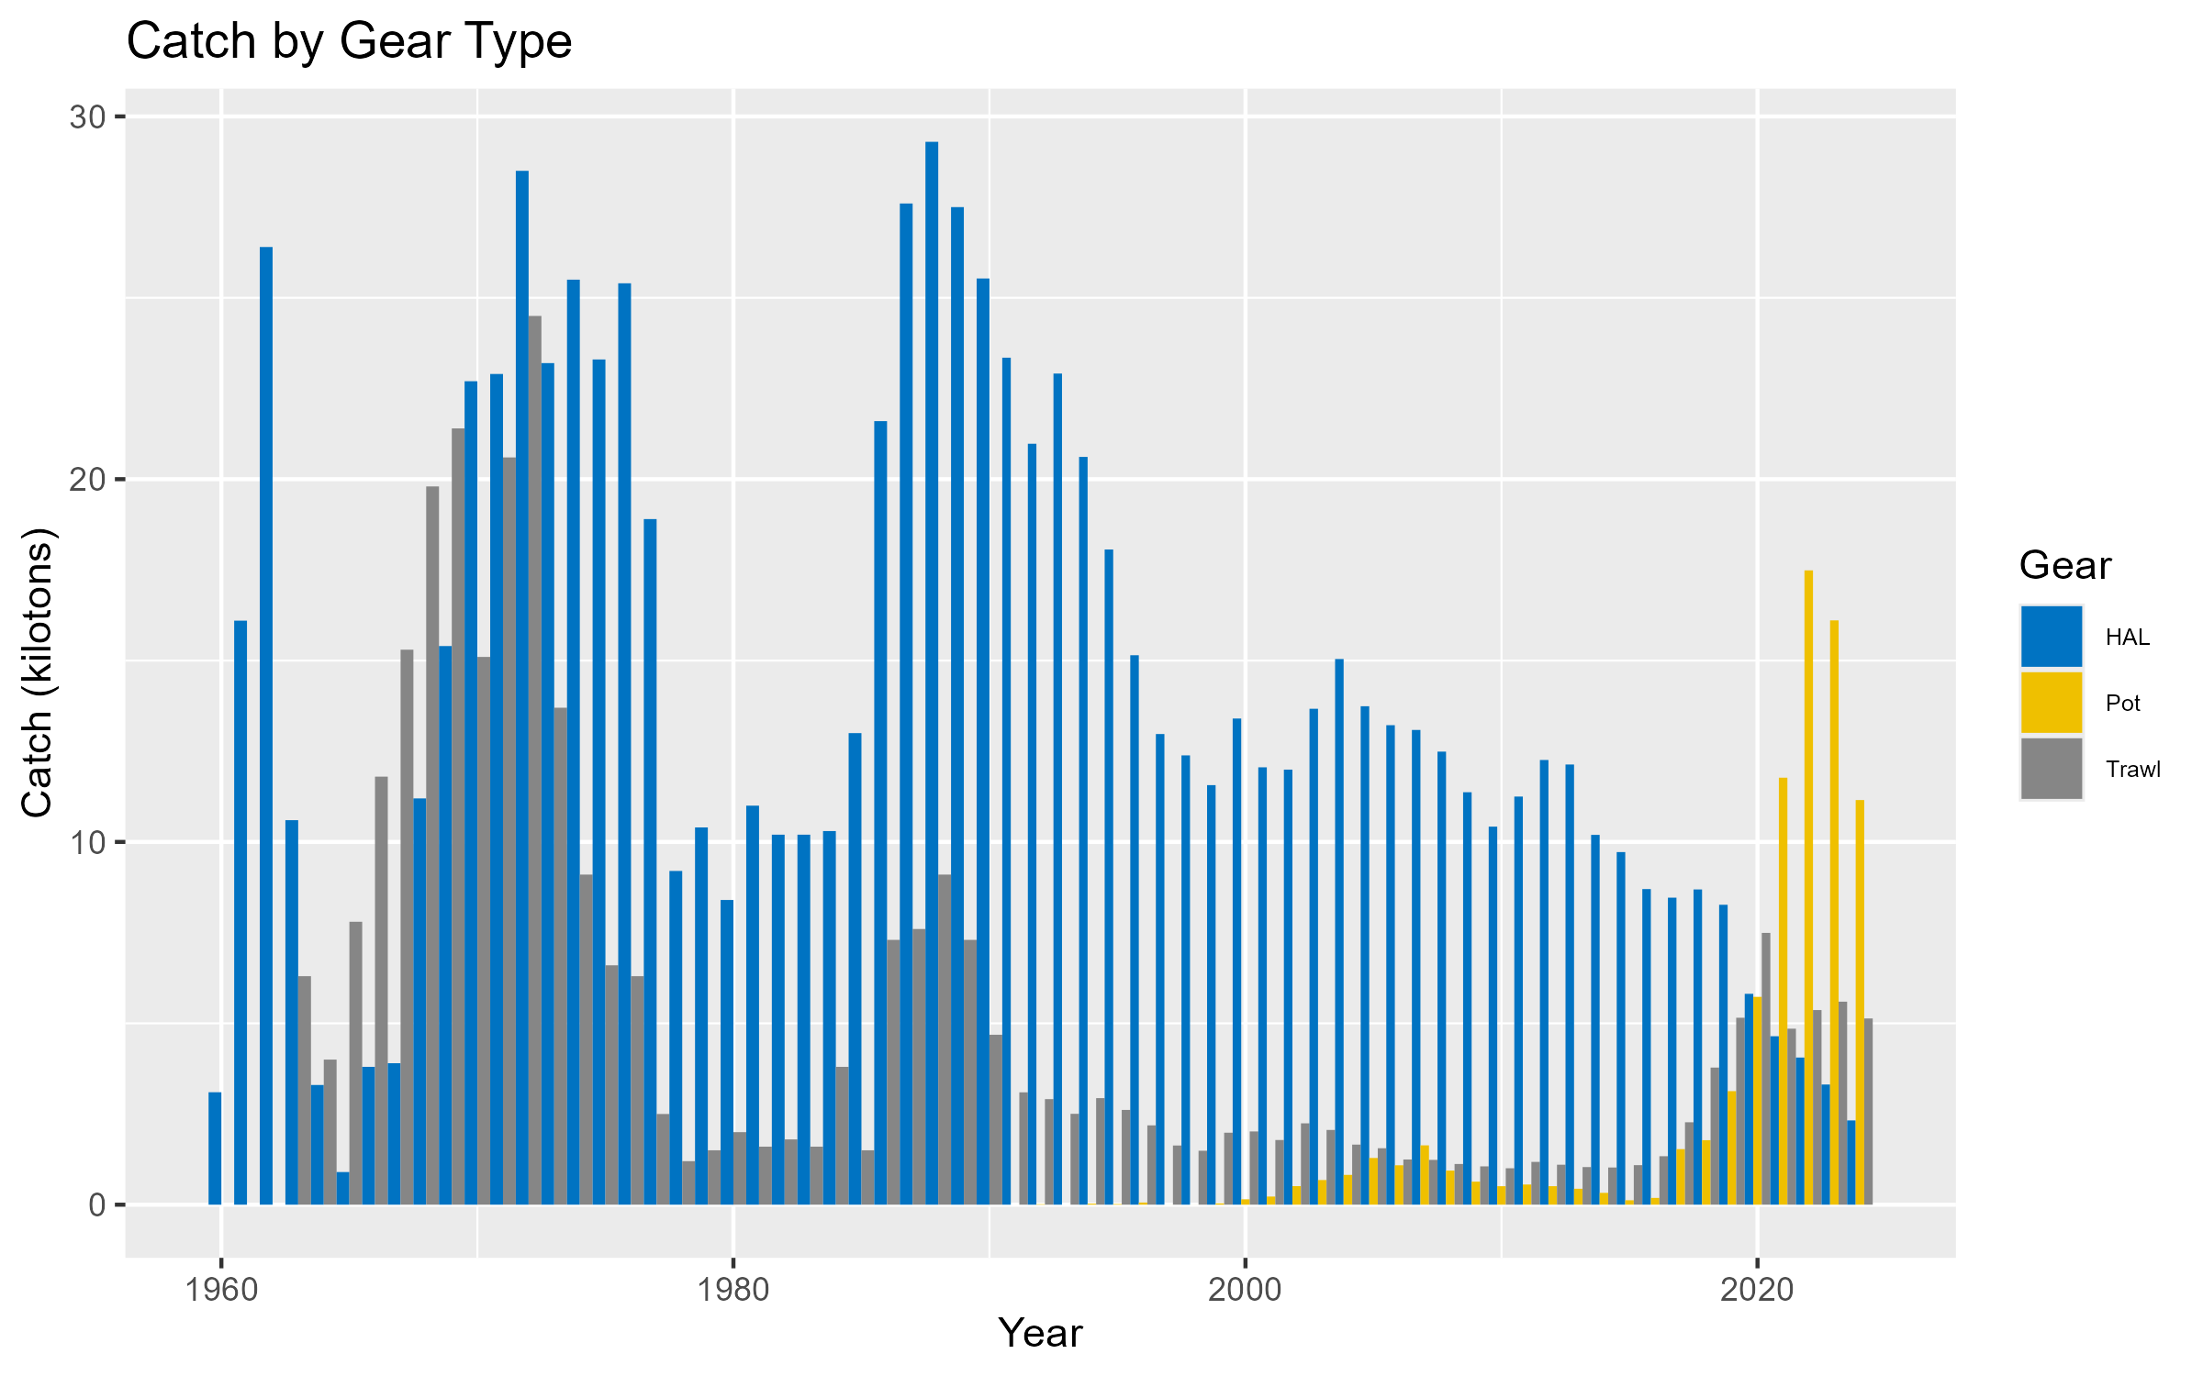

**Figure 3.1**. Sablefish catch (kt) by gear type. Note that hook and line (HAL) and pot gear catch are combined into a single ‘fixed gear’ fleet in the model.

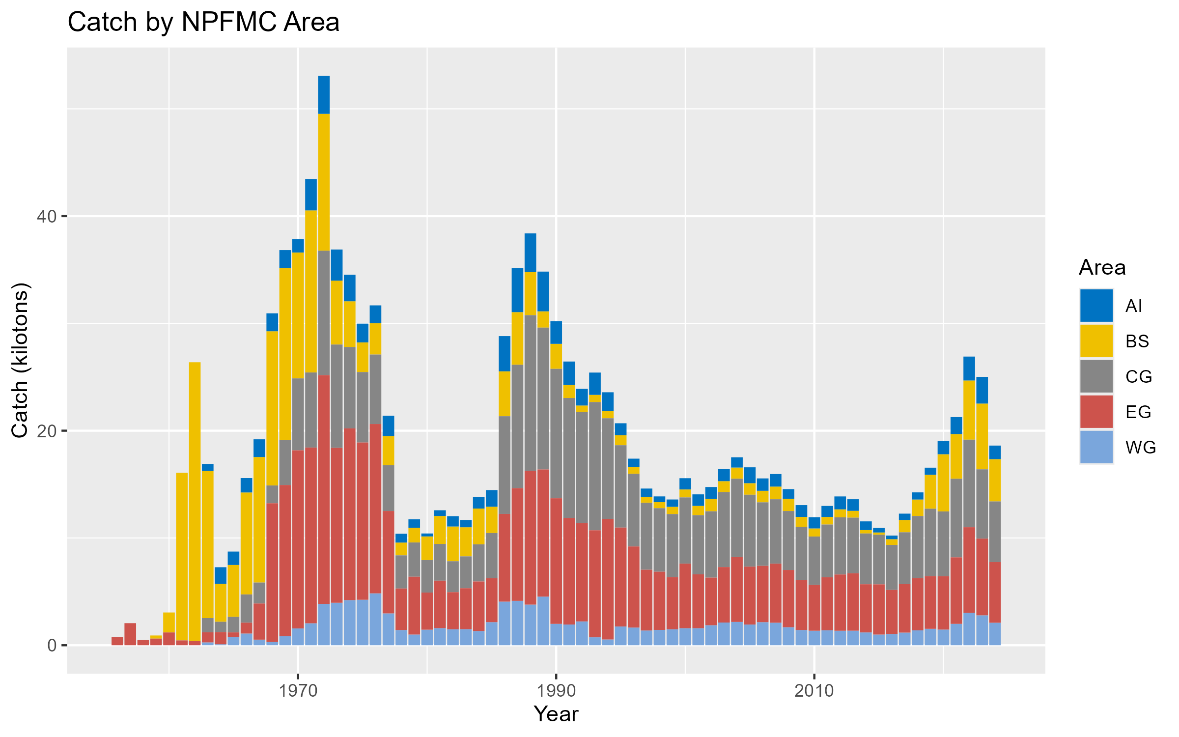

**Figure 3.2.** Sablefish total catch (kt) summed across all fleets by North Pacific Fishery Management Council area.

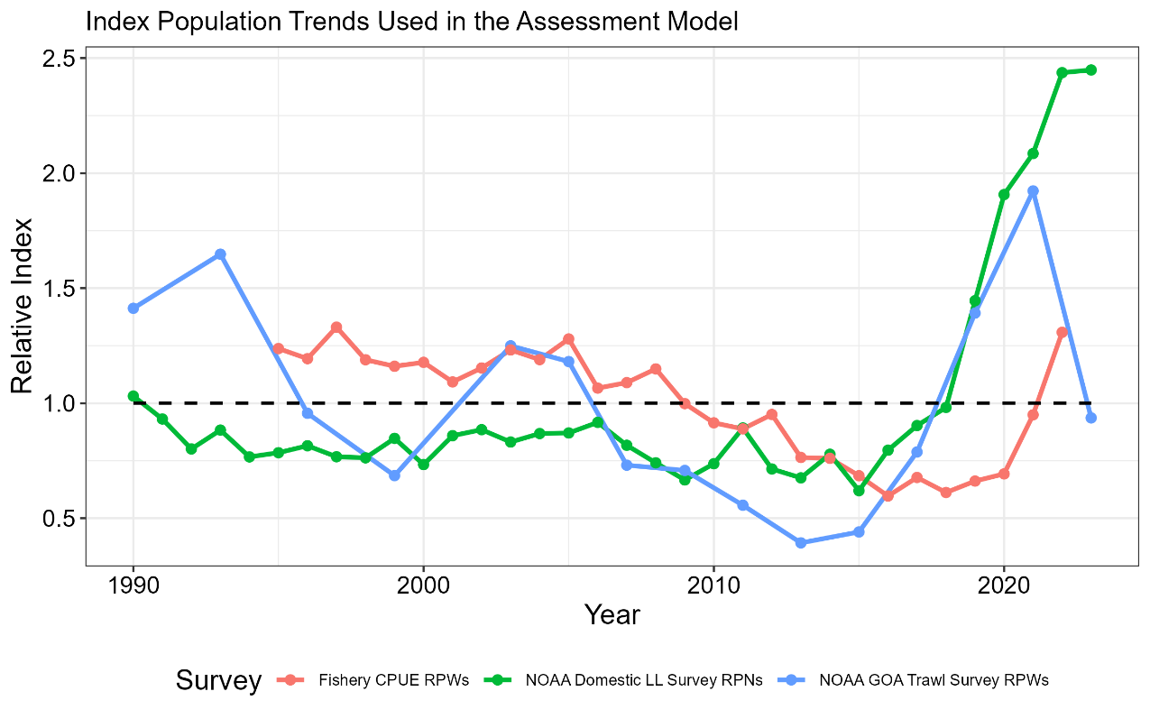

**Figure 3.3.** Comparison of the three indices used in the stock assessment model, including the NOAA domestic longline survey relative population numbers (RPNs), the fixed gear fishery standardized CPUE (in weight), and the NOAA Gulf of Alaska (stations < 500m depth) trawl survey relative population weights (RPWs). Each index is relativized to the associated mean value for the time series.

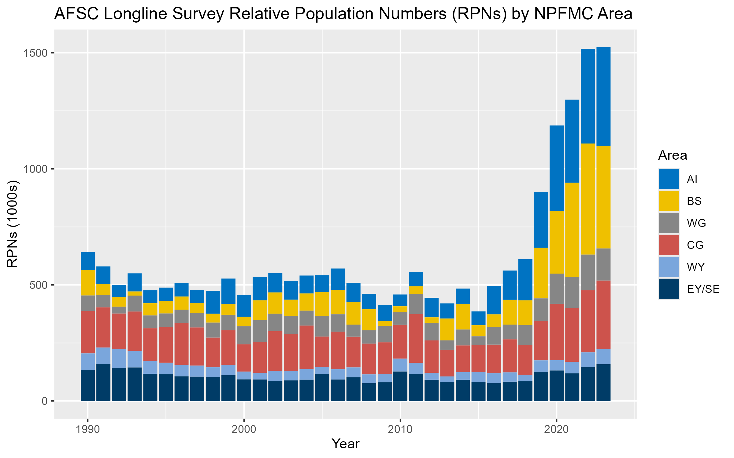

**Figure 3.4.** Relative abundance (relative population number in thousands) by region from the NOAA domestic longline survey. Note that the Bering Sea is surveyed in odd years and the Aleutian Islands are surveyed in even years (i.e., sampling occurs every other year in these regions), and that regional trends for these regions are extrapolated based on the overall trend from the Gulf of Alaska in off years.

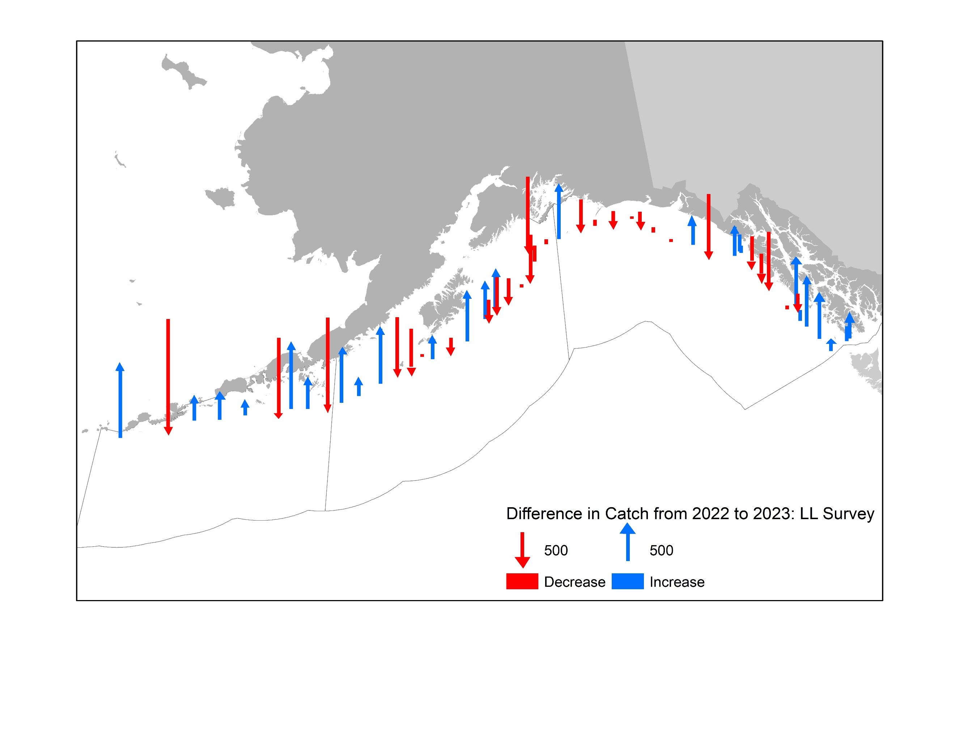

**Figure 3.5.** Comparison of the 2022 and 2023 longline survey in the Gulf of Alaska in terms of the difference in numbers of fish caught per station from 2022 in the 2023 survey. Numbers are not corrected for sperm whale depredation.

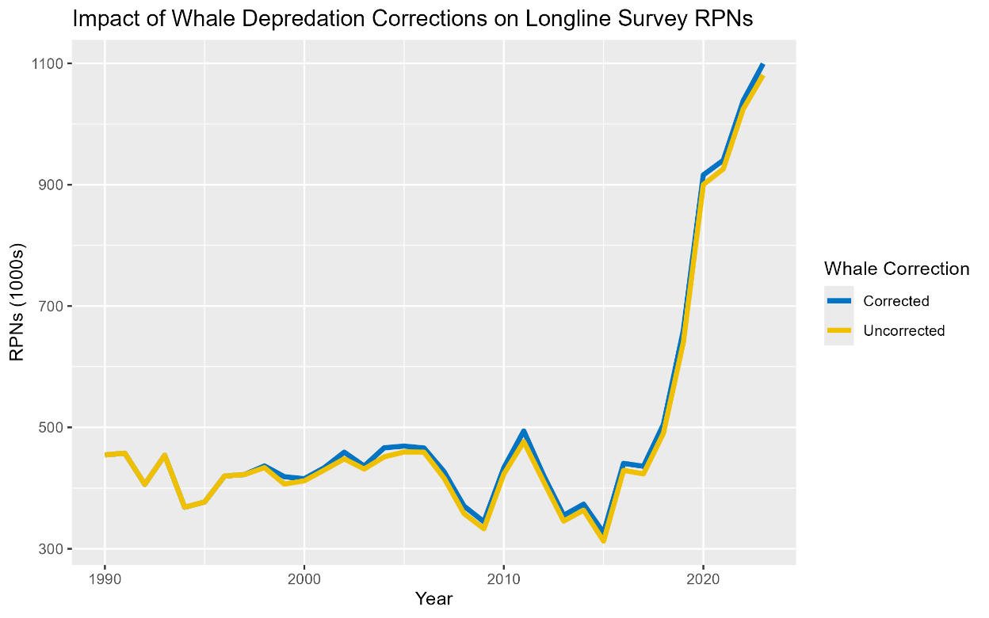

**Figure 3.6.** Longline survey relative population numbers (1000s of fish) with (blue line) and without (yellow line) corrections for sperm whale depredation. Note that these values do not include interpolations for areas not surveyed in the given year (i.e., RPNs are less than the final index by the associated RPN in either the BS or AI, depending on which area was not surveyed).

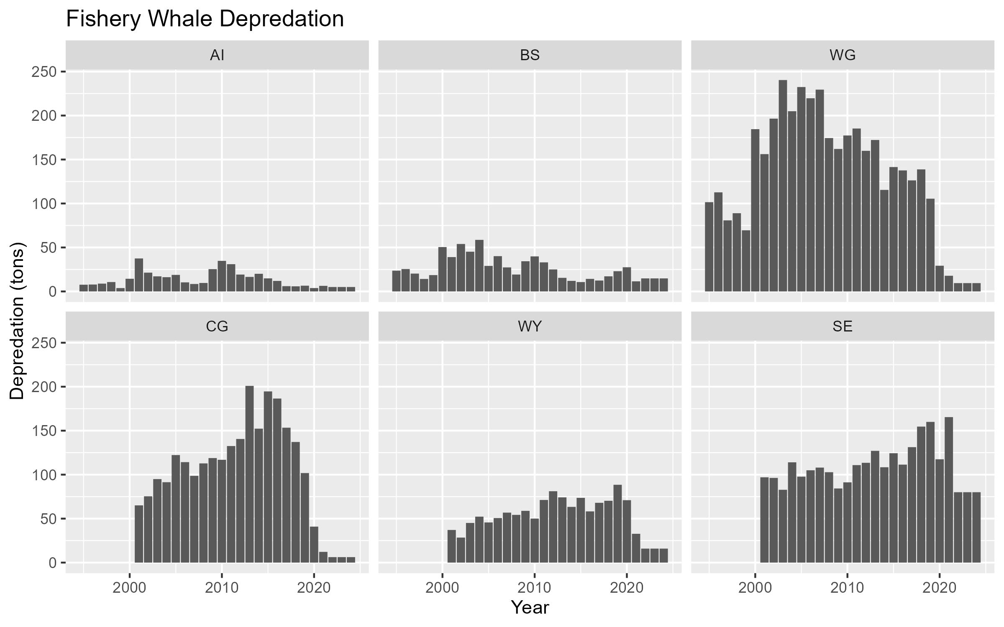

**Figure 3.7.** Estimated whale depredation in the sablefish fixed gear fishery. Depredation estimates reflect catch removals (tons) by region (panel) due to orcas (top row) and sperm whales (bottom row). Starting in 2023 estimates were held constant at 2022 values.

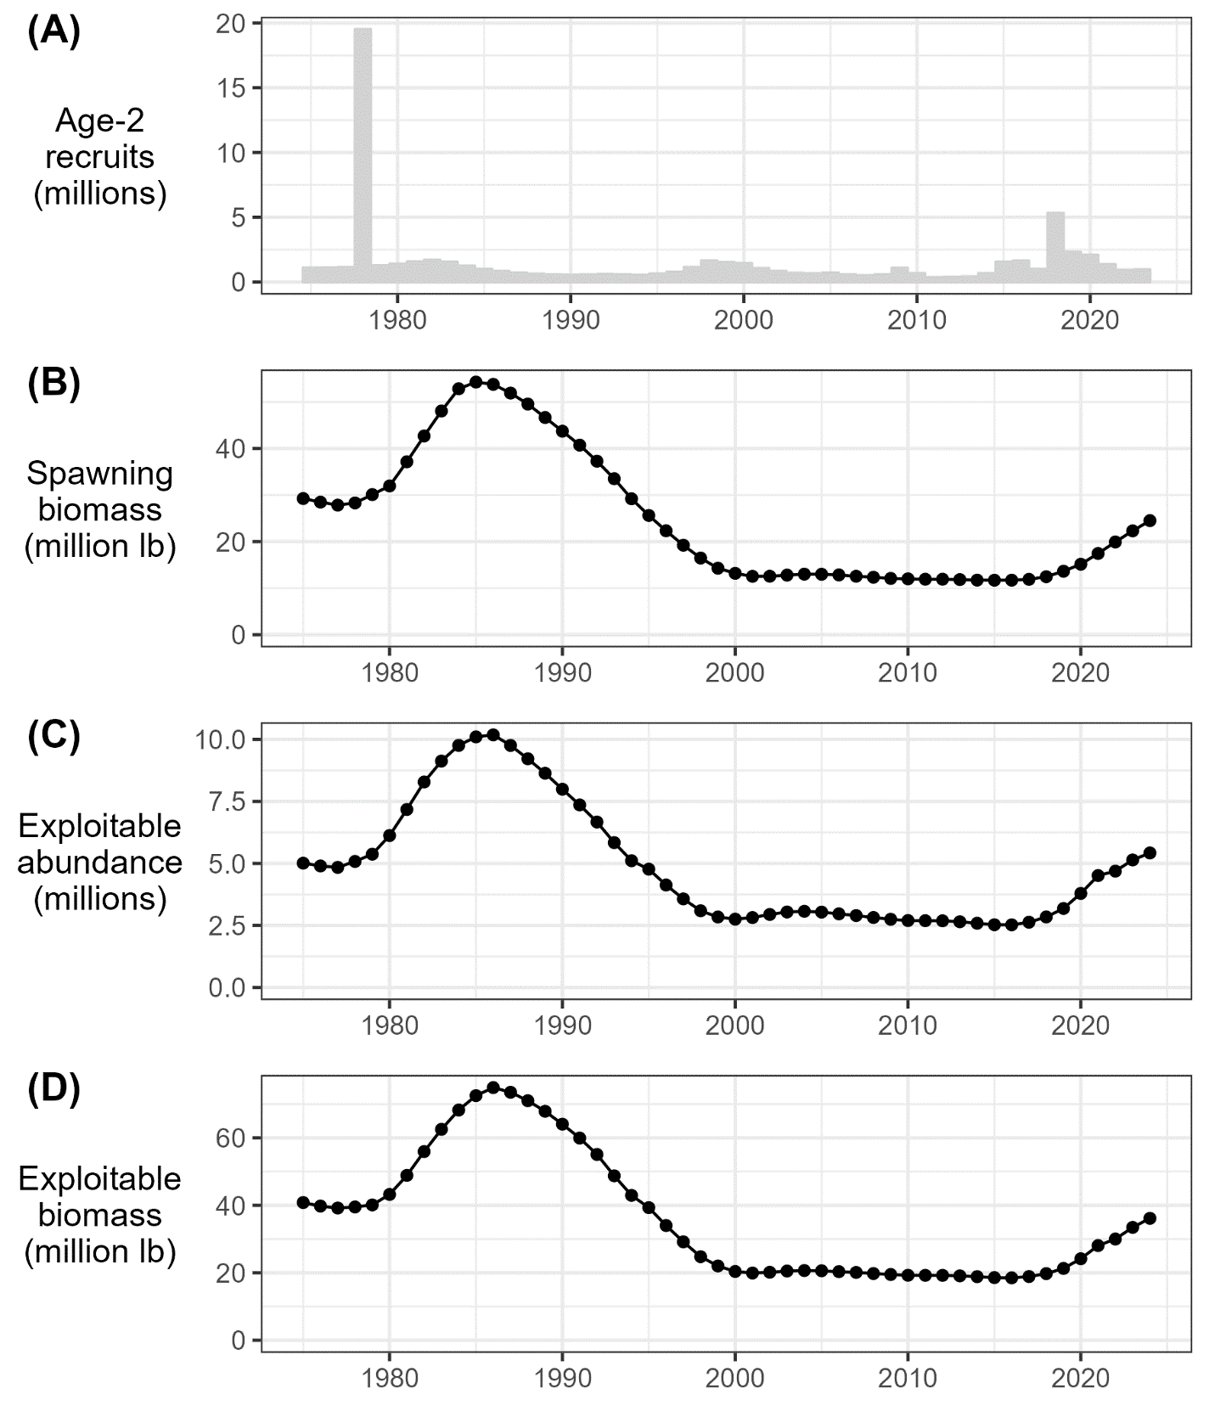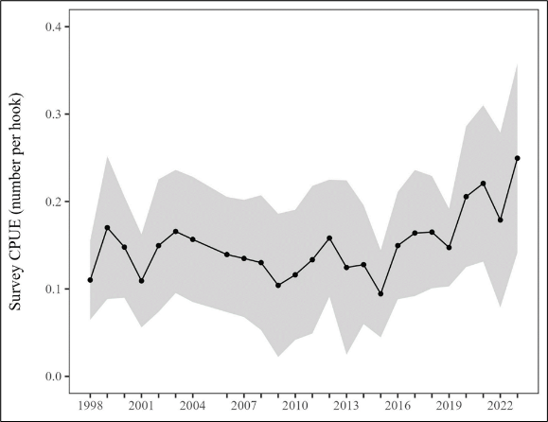

**Figure 3.8a.** Model predictions for the ADFG Northern Southeast Inside (NSEI) sablefish stock assessment (left panels; reproduced here with permission from Rhea Ehresmann, pers. comm., https://github.com/commfish/seak_sablefish) of age-2 recruitment (millions; top) and female spawning stock biomass (million pounds; bottom). Southern Southeast Inside (SSEI) sablefish longline survey catch-per-unit-effort (CPUE) in individuals per hook (right panel) from 1998 to 2023 (except 2005; reproduced here with permission from Rhea Ehresmann, pers. Comm.).

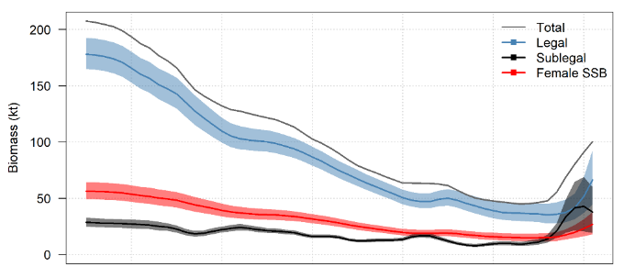

**Figure 3.8b.** Time series of total biomass, legal-sized biomass, sub-legal-sized biomass, and female spawning biomass (SSB) estimates for the British Columbia stock of sablefish based on weighted averages over the five OM scenarios used in 2022. Note that total, legal, and sub-legal biomass estimates include both female and male fish, while SSB is shown for only female Sablefish (reproduced here with permission from Kendra Holt, DFO Canada, pers. comm.).

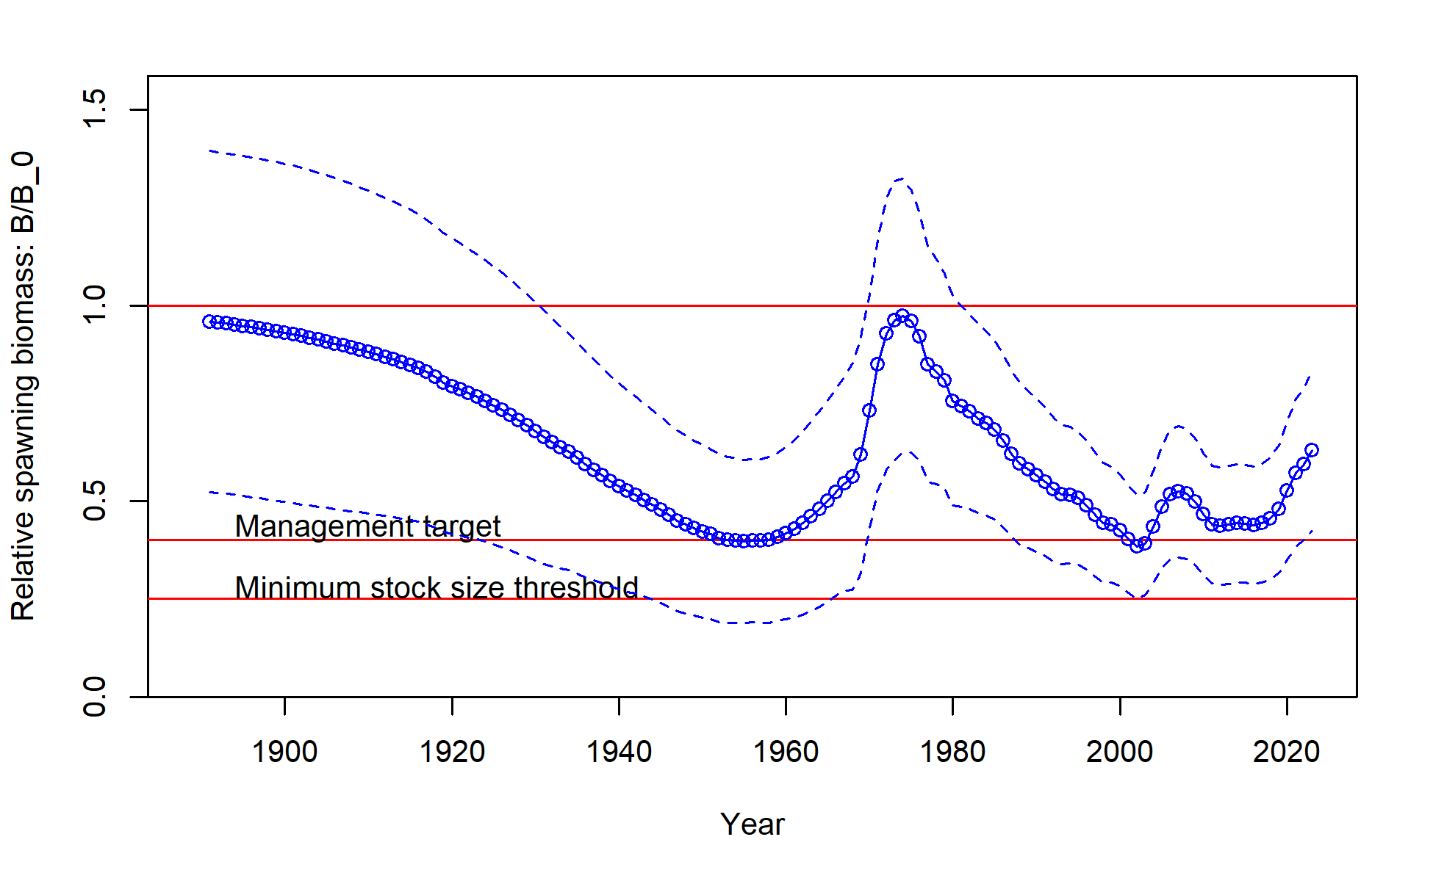

**Figure 3.8c.** Time series of total biomass relative to the unfished biomass for west coast USA sablefish (reproduced here with permission from Johnson et al. 2023).

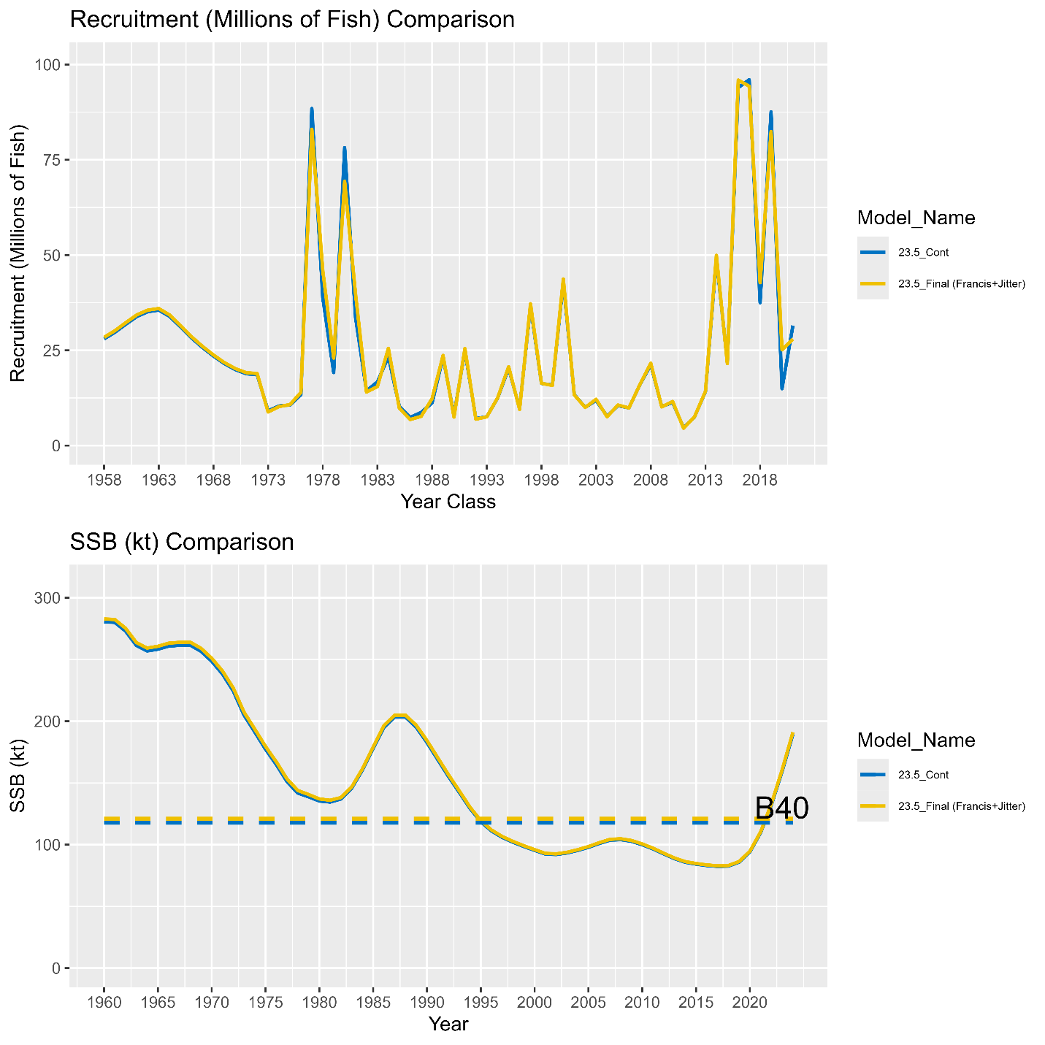

**Figure 3.9.** Results of the model bridging exercise in terms of recruitment (top panel; millions of fish) and spawning stock biomass (bottom panel; kt). See the main text for a description of each model run.

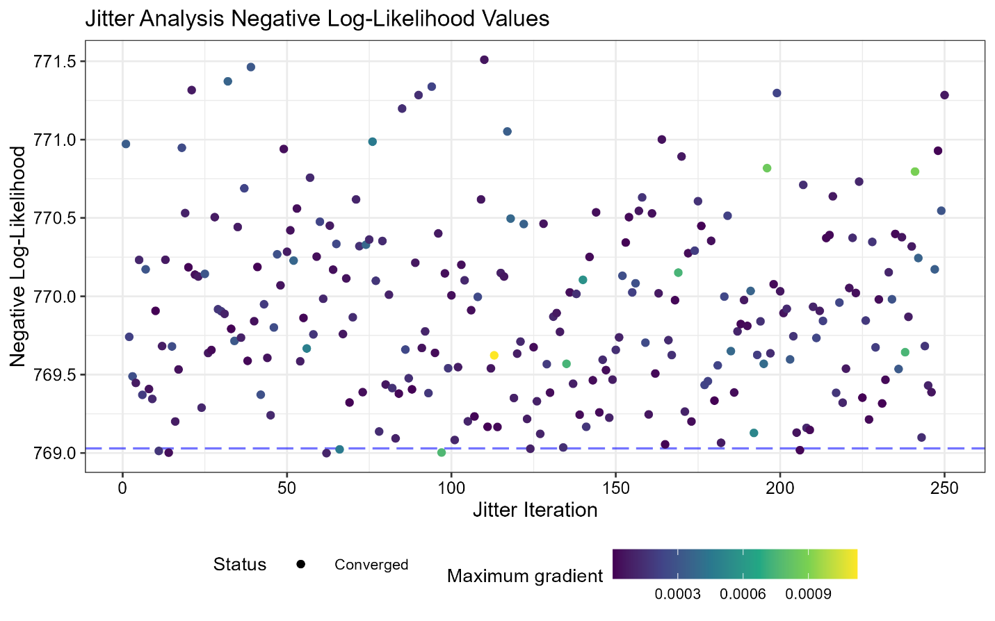

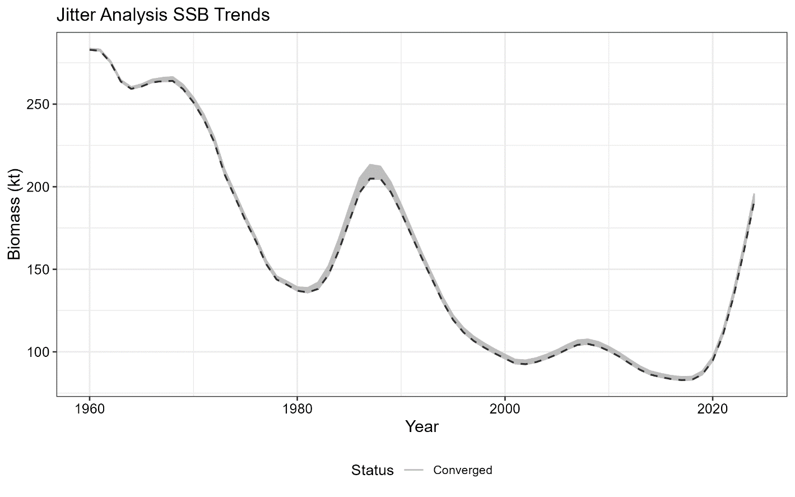

**Figure 3.10.** Results of the jitter analysis in terms of total negative log-likelihood (nll) values (top panel) and SSB estimates (kt; bottom panel). All 250 model runs are shown and the model with the smallest nll was used as the base model.

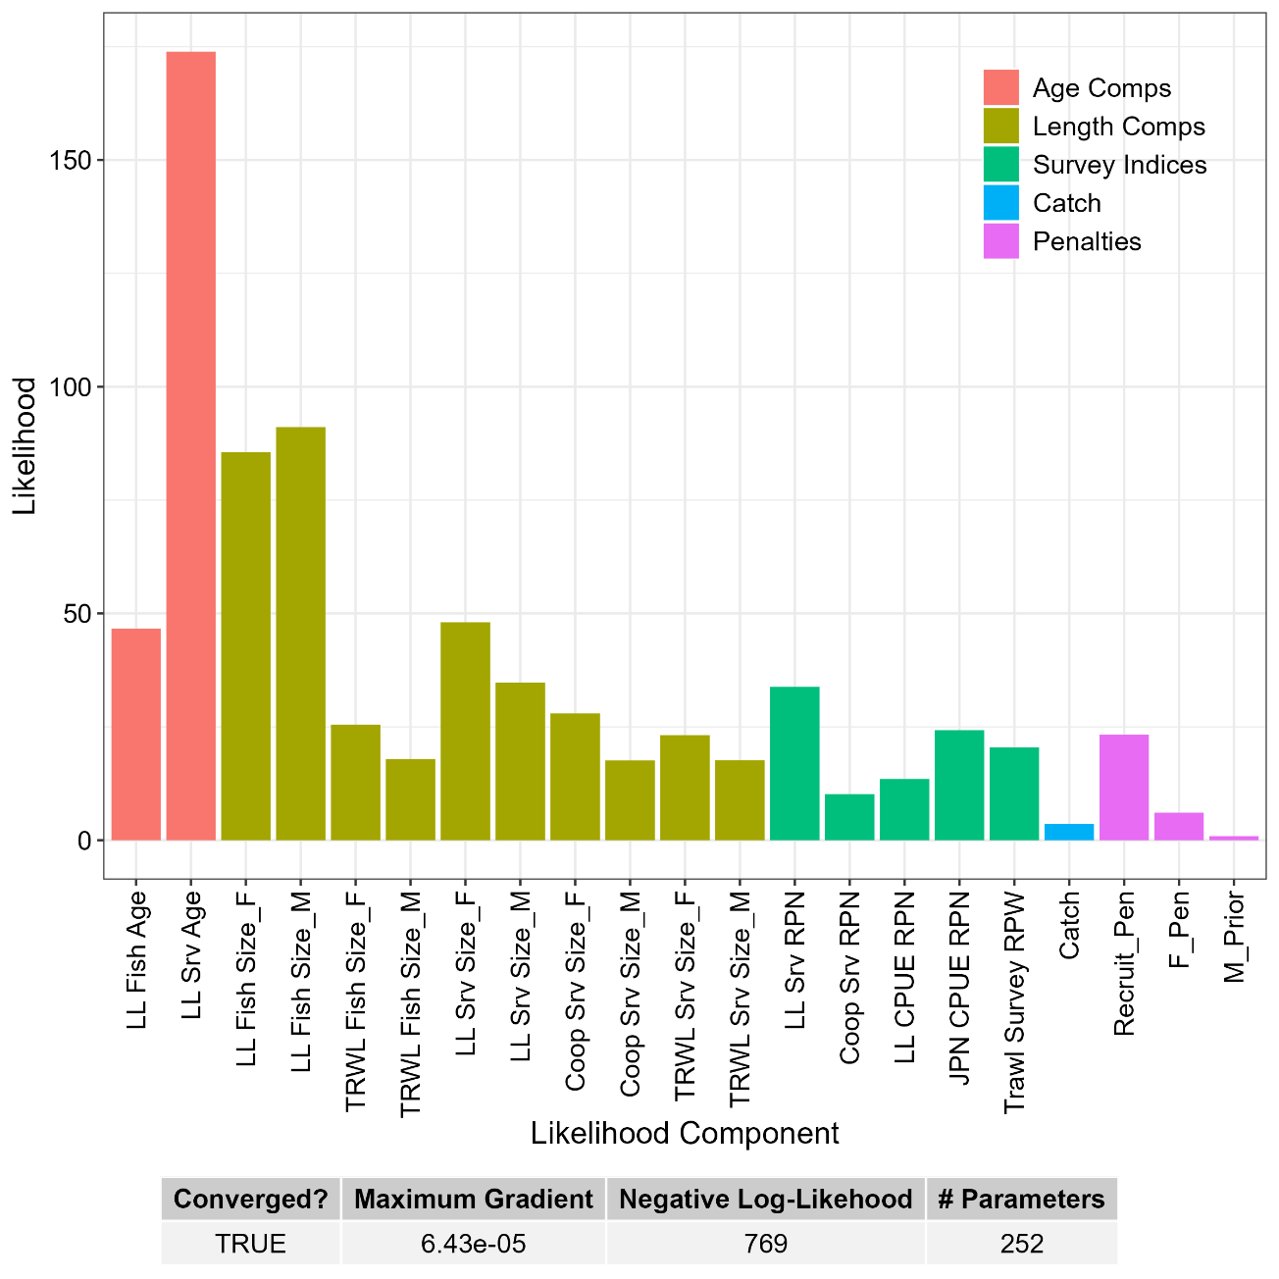

**Figure 3.11.** Contributions to the total negative log-likelihood by data component.

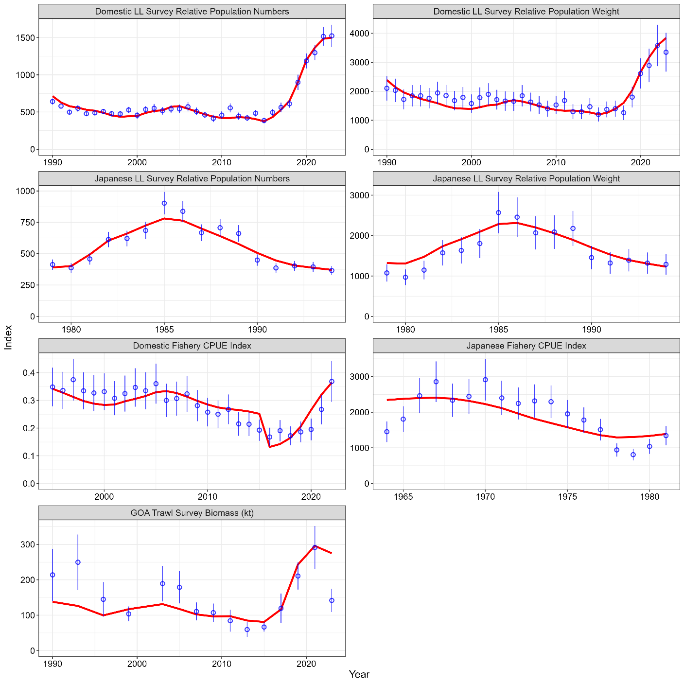

**Figure 3.12.** Observed (blue dots with approximate 95% confidence intervals) and predicted (red lines) sablefish indices of abundance and biomass. By row, these indices are: the NOAA domestic longline survey (top panels) relative population numbers (1,000s of fish; left) and weight (kt; right); the Japanese cooperative survey (second row) relative population numbers (1,000s of fish; left) and weight (kt; right); fishery CPUE indices (in weight; third row) for the domestic fishery (standardized; left) and historic Japanese fishery (kt; right); and the NOAA Gulf of Alaska (stations < 500m depth) trawl survey (kt; bottom panel) relative population weight. For the NOAA and Japanese longline surveys, only the relative population numbers are fit in the model, but the associated weights are presented for comparison.

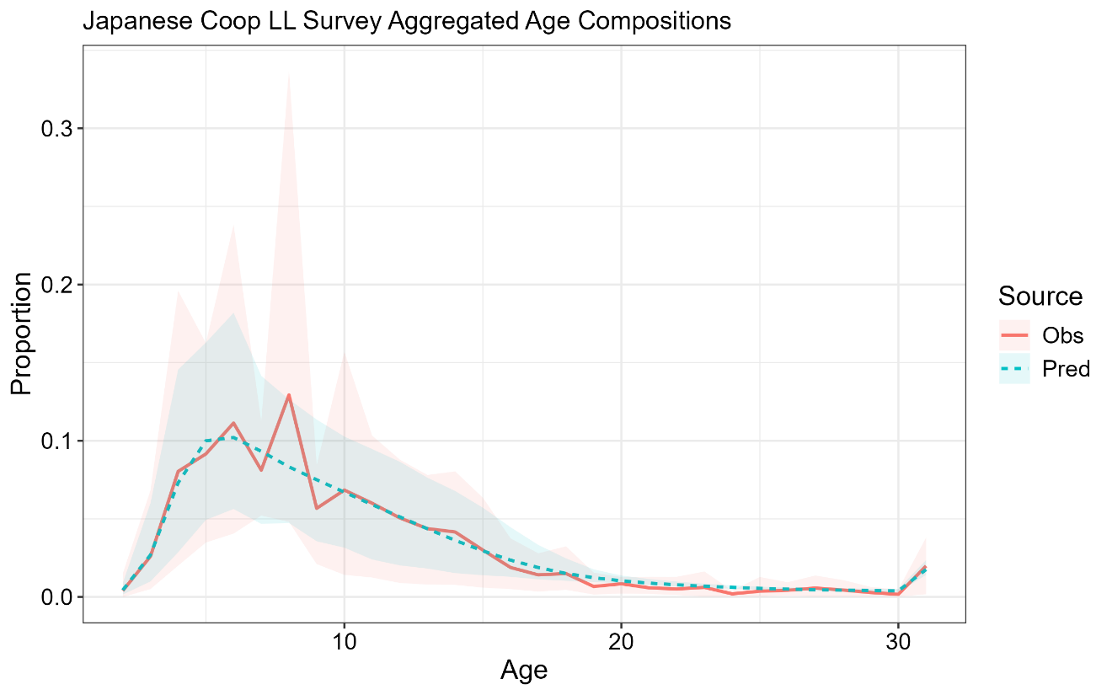

**Figure 3.13.** Mean observed (red line) Japanese cooperative longline survey age compositions aggregated across years and sexes along with the average fit of the model (blue line). The red fill is the 90% empirical confidence intervals, while the blue fill is the model estimated 90% confidence intervals.

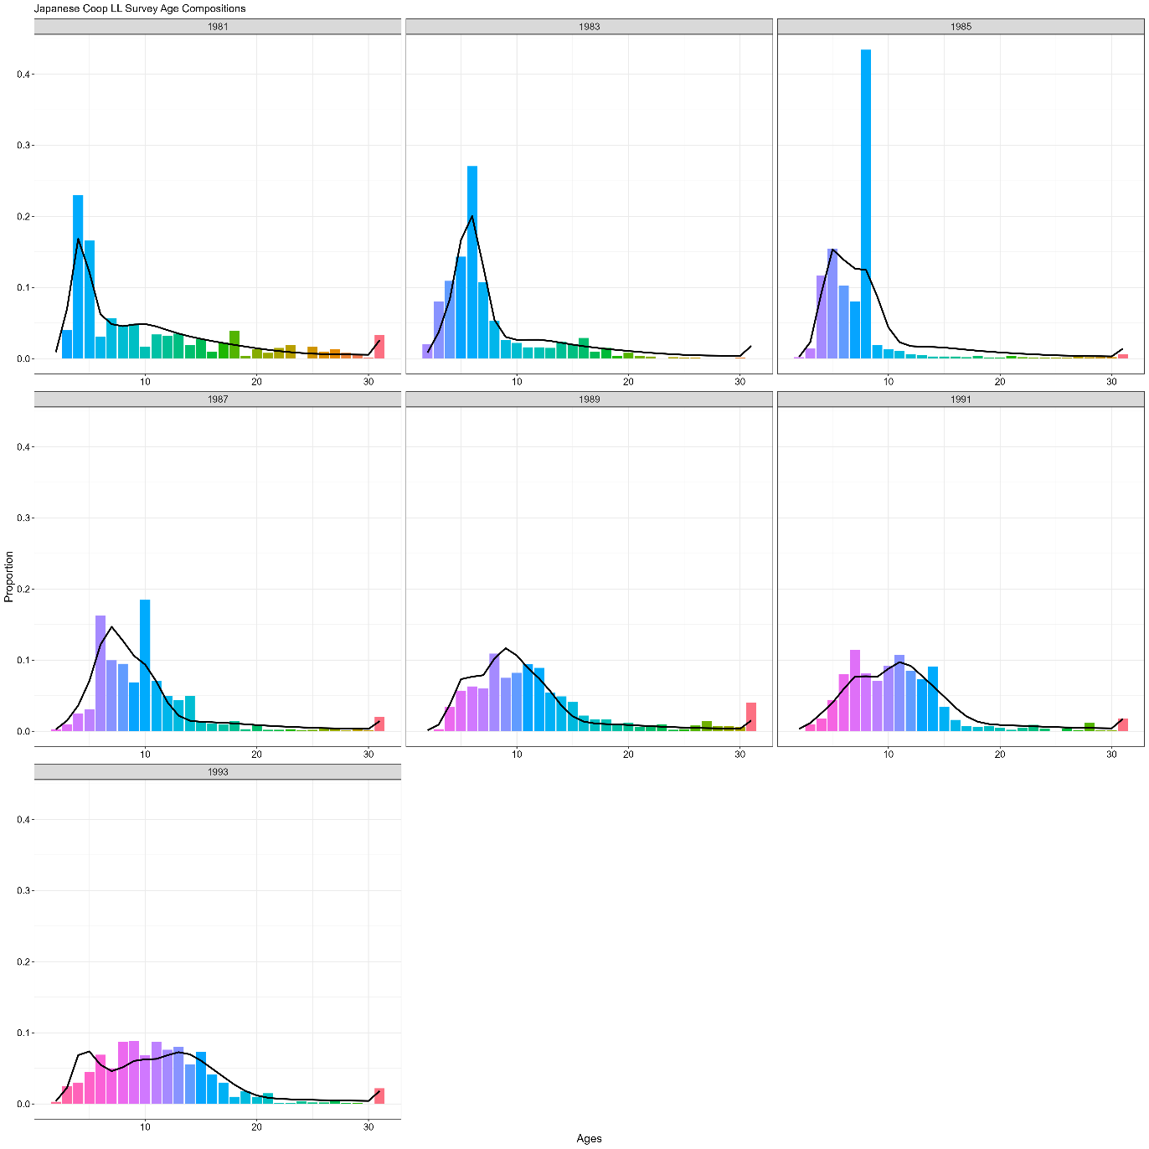

**Figure 3.14.** Japanese cooperative longline survey age compositions. Bars are observed frequencies and the line is predicted frequencies.

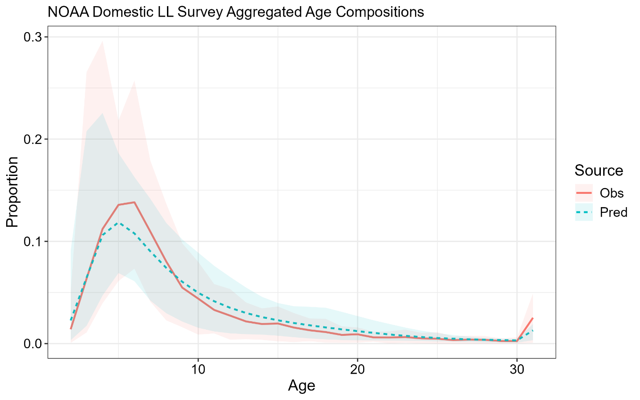

**Figure 3.15.** Mean observed (red line) NOAA domestic longline survey age compositions aggregated across years and sexes along with the average fit of the model (blue line). The red fill is the 90% empirical confidence intervals, while the blue fill is the model estimated 90% confidence intervals.

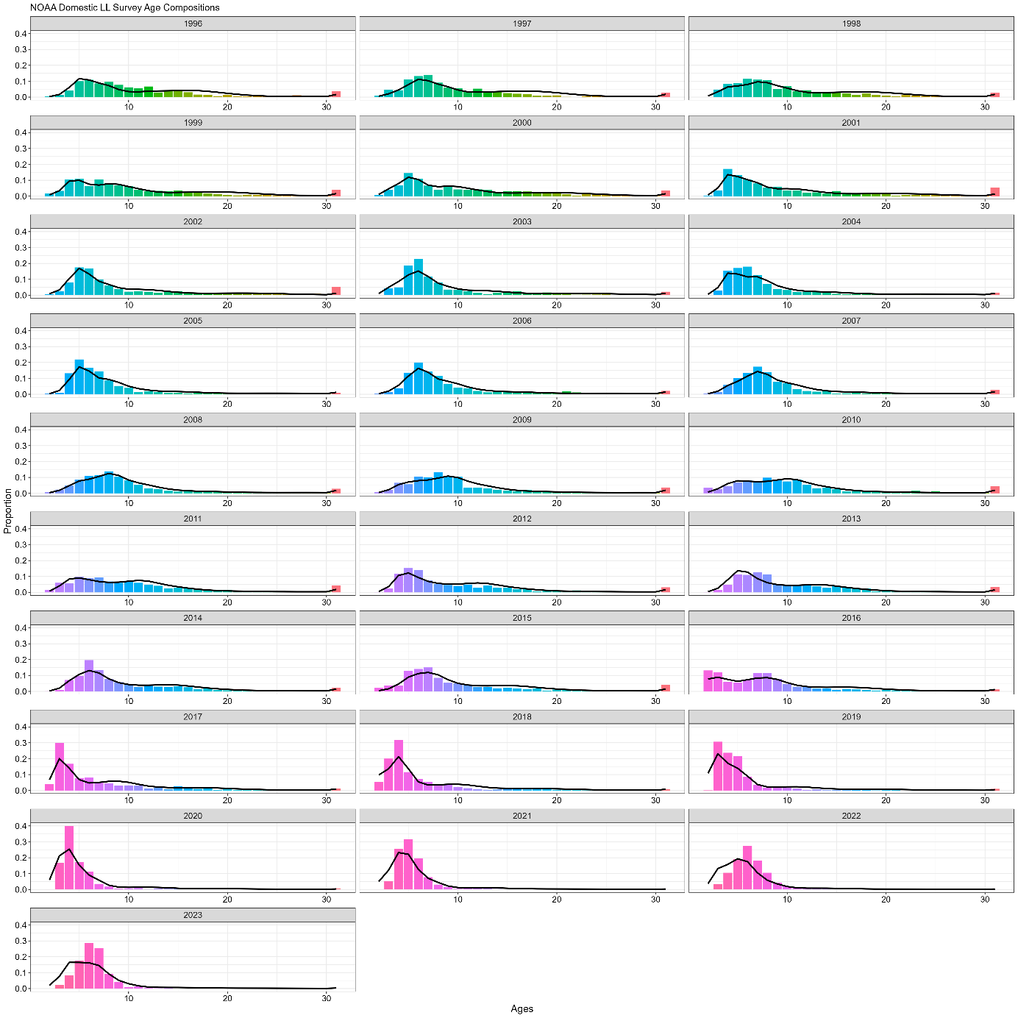

**Figure 3.16.** NOAA domestic longline survey age compositions. Bars are observed frequencies and lines are predicted frequencies.

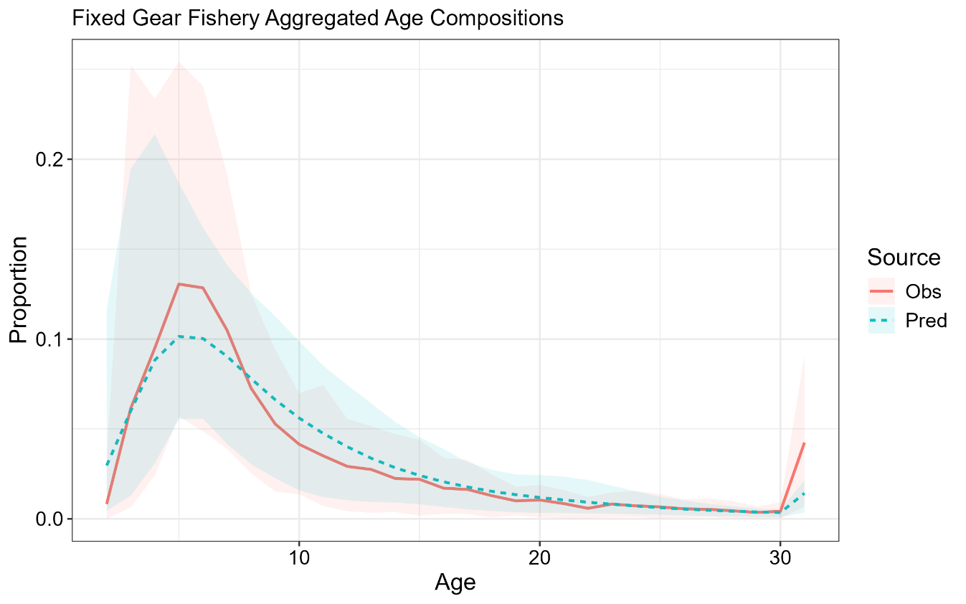

**Figure 3.17.** Mean observed (red line) fixed gear fishery age compositions aggregated across years and sexes along with the average fit of the model (blue line). The red fill is the 90% empirical confidence intervals, while the blue fill is the model estimated 90% confidence intervals.

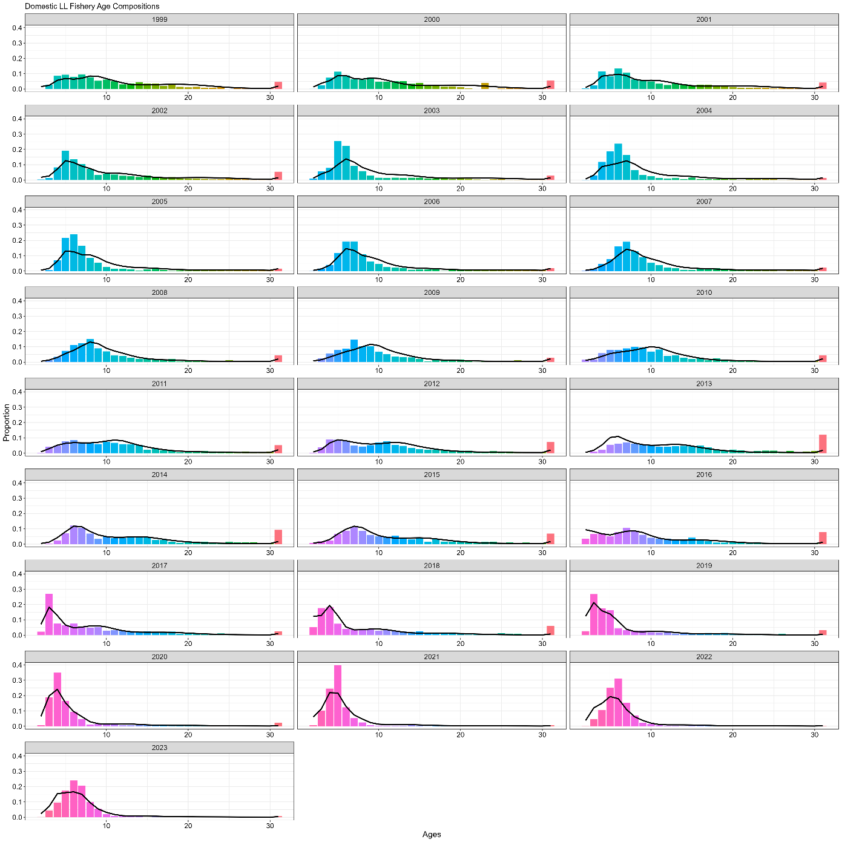

**Figure 3.18.** Domestic fixed gear fishery age compositions. Bars are observed frequencies and lines are predicted frequencies.

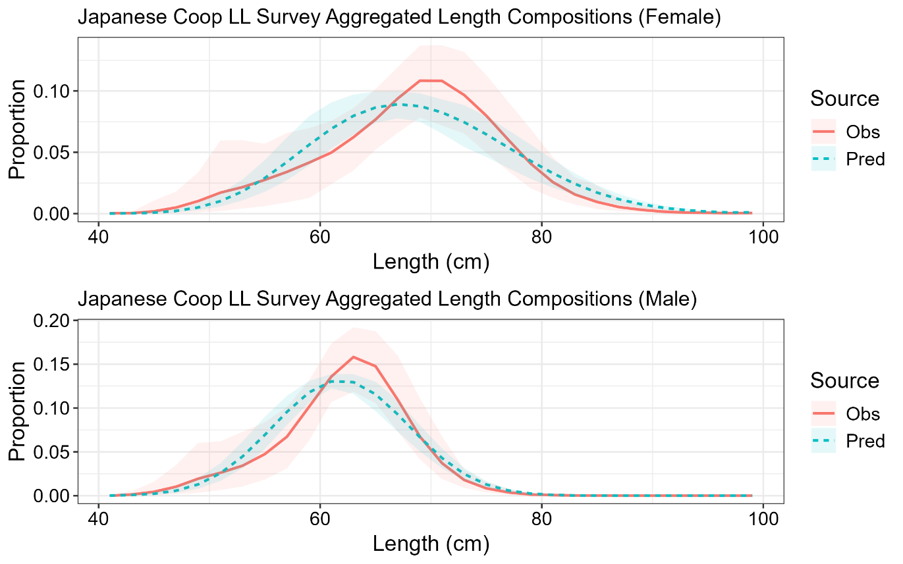

**Figure 3.19.** Mean observed (red line) Japanese cooperative longline survey length compositions aggregated across years along with the average fit of the model (blue line). The red fill is the 90% empirical confidence intervals, while the blue fill is the model estimated 90% confidence intervals. Fit to female length compositions are in the top panel and fit to male length compositions are in the bottom panel.

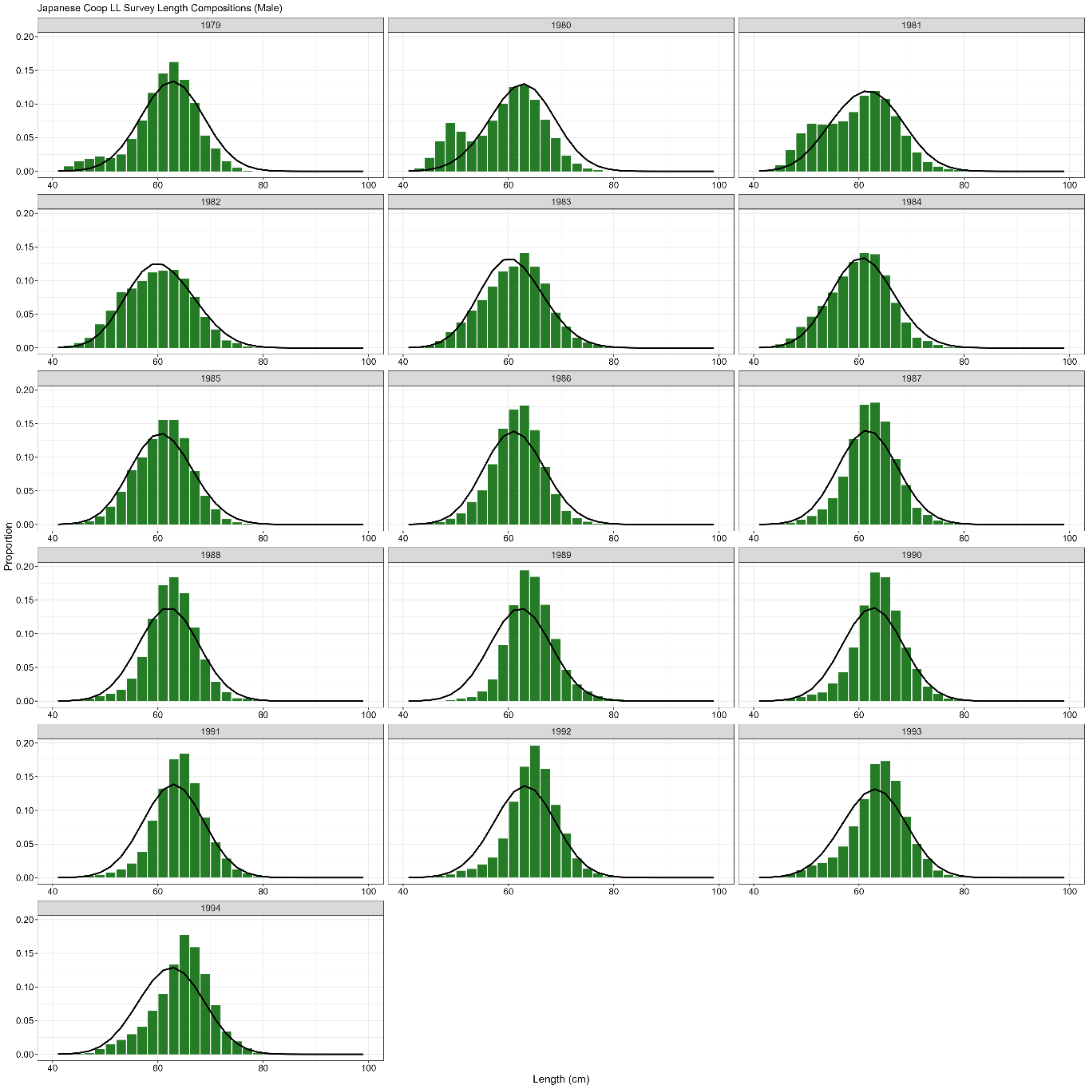

**Figure 3.20.** Japanese cooperative longline survey male length compositions. Bars are observed frequencies and lines are predicted frequencies.

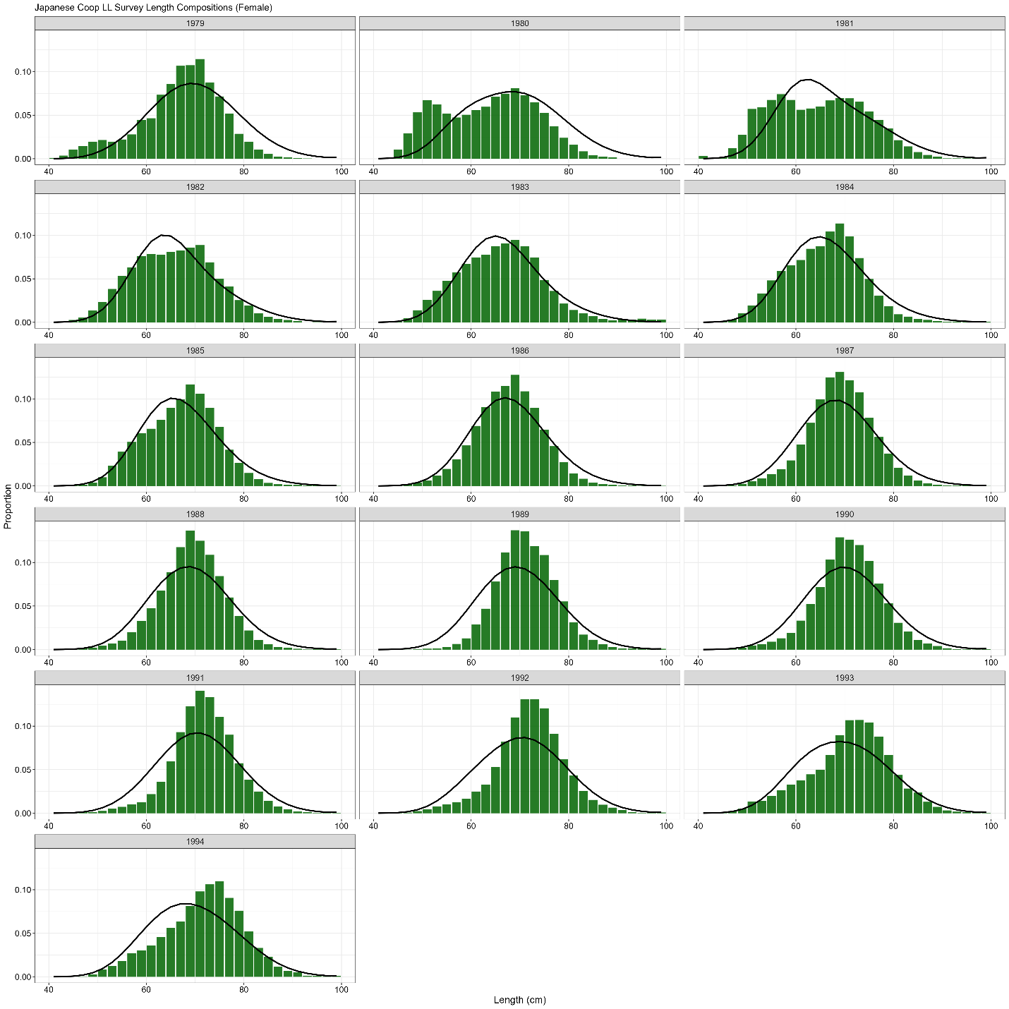

**Figure 3.21.** Japanese cooperative longline survey female length compositions. Bars are observed frequencies and lines are predicted frequencies.

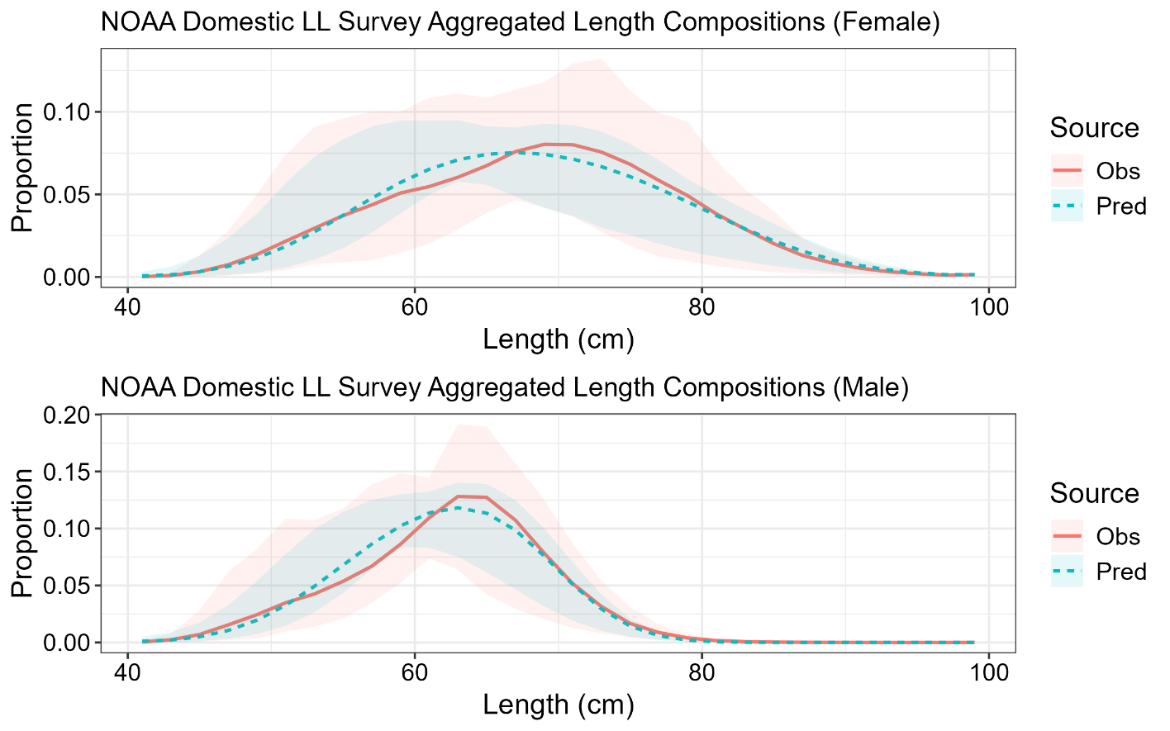

**Figure 3.22.** Mean observed (red line) NOAA domestic longline survey length compositions aggregated across years along with the average fit of the model (blue line). The red fill is the 90% empirical confidence intervals, while the blue fill is the model estimated 90% confidence intervals. Fit to female length compositions are in the top panel and fit to male length compositions are in the bottom panel.

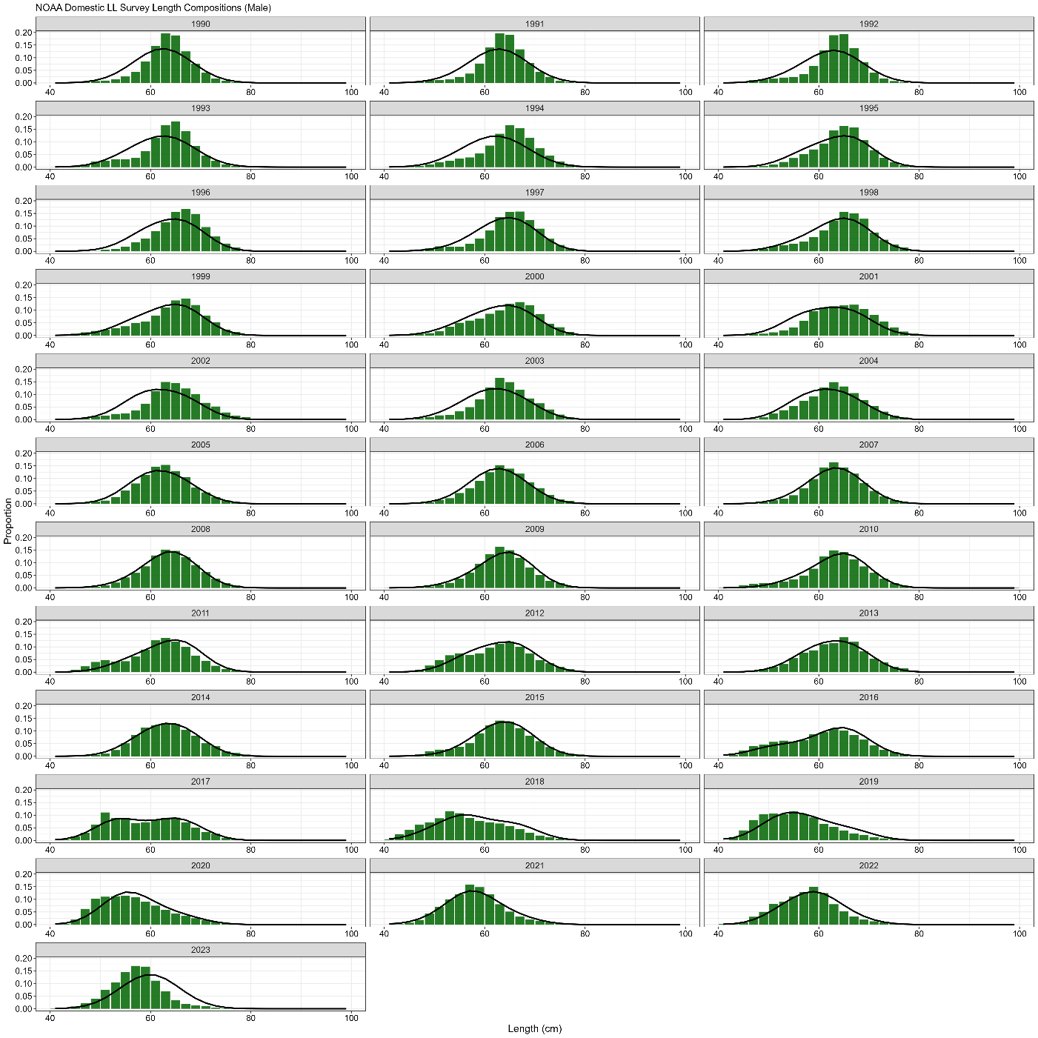

**Figure 3.23.** NOAA domestic longline survey length (cm) compositions for males. Bars are observed frequencies and lines are predicted frequencies.

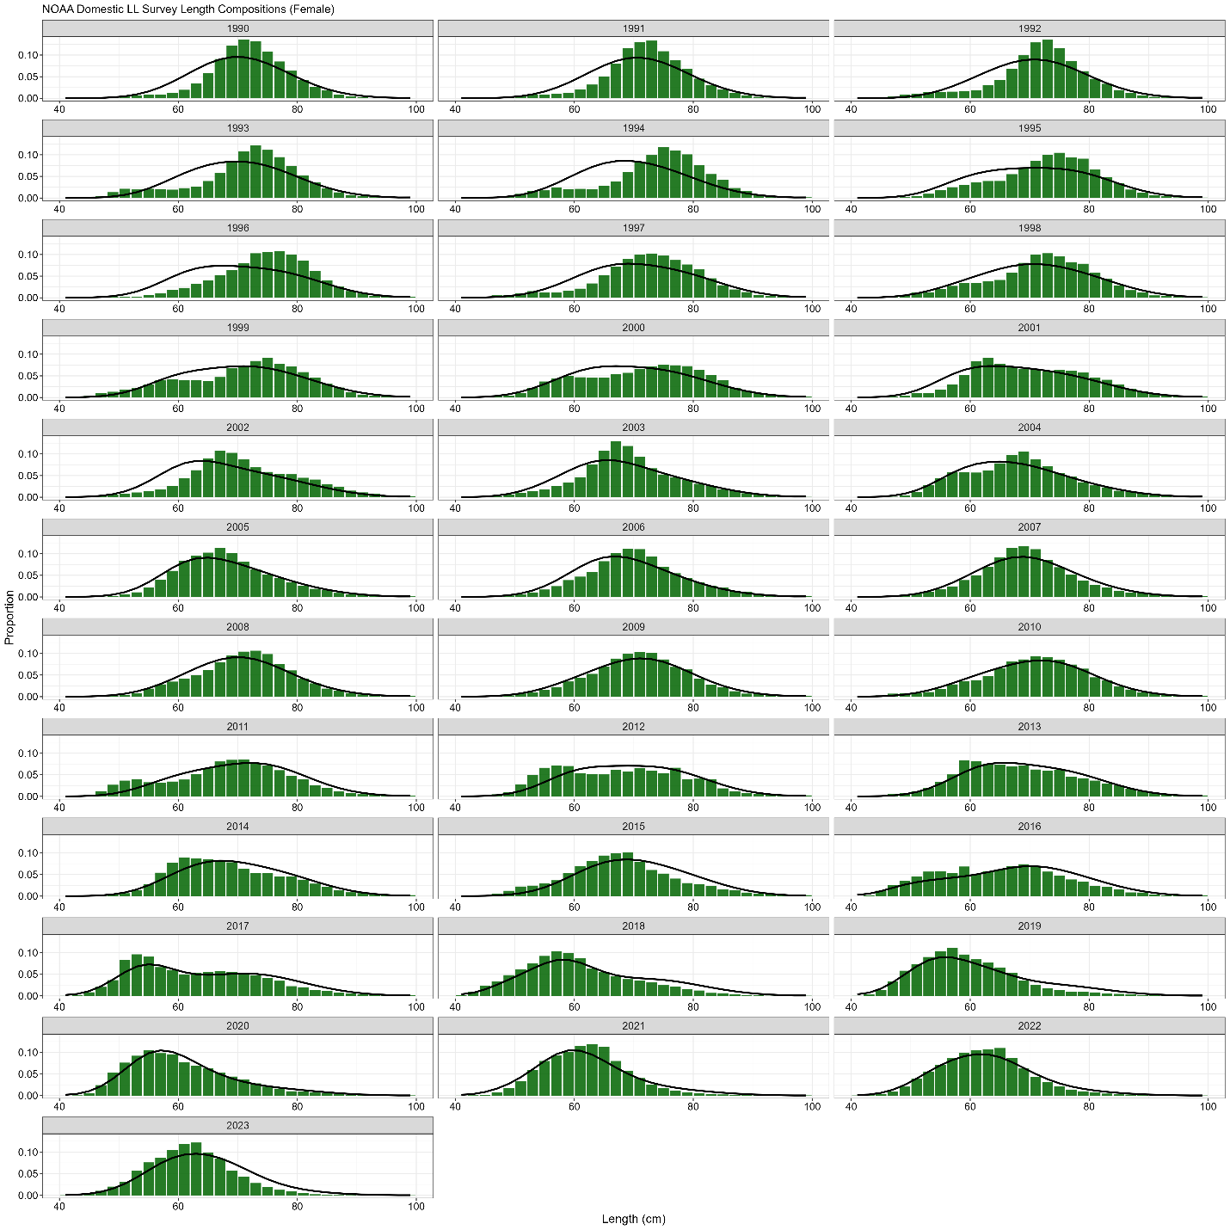

**Figure 3.24.** NOAA domestic longline survey length (cm) compositions for females. Bars are observed frequencies and lines are predicted frequencies.

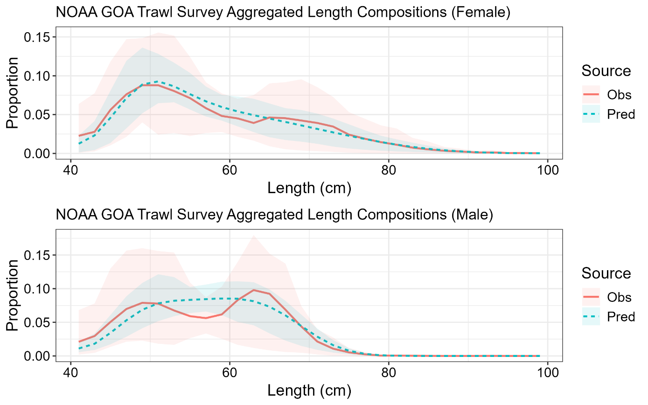

**Figure 3.25.** Mean observed (red line) NOAA Gulf of Alaska trawl survey (stations < 500m depth) length compositions aggregated across years along with the average fit of the model (blue line). The red fill is the 90% empirical confidence intervals, while the blue fill is the model estimated 90% confidence intervals. Fit to female length compositions are in the top panel and fit to male length are in the bottom panel.

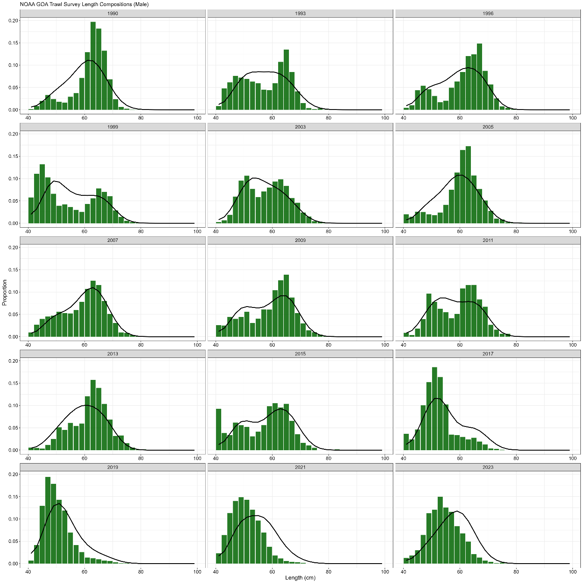

**Figure 3.26.** NOAA Gulf of Alaska (stations < 500m depth) trawl survey length (cm) compositions for males. Bars are observed frequencies and lines are predicted frequencies.

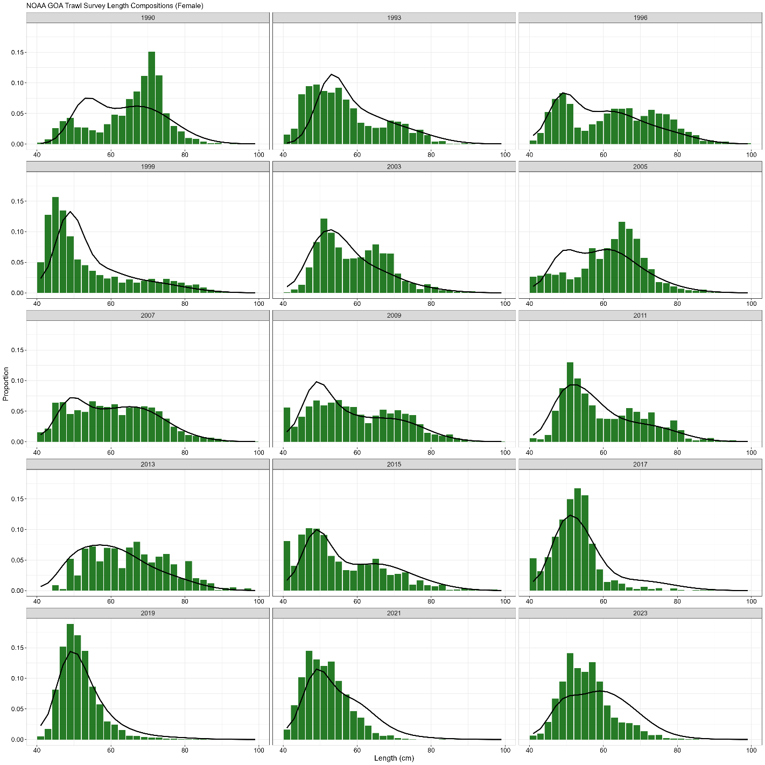

**Figure 3.27.** NOAA Gulf of Alaska (stations < 500m depth) trawl survey length (cm) compositions for females. Bars are observed frequencies and lines are predicted frequencies.

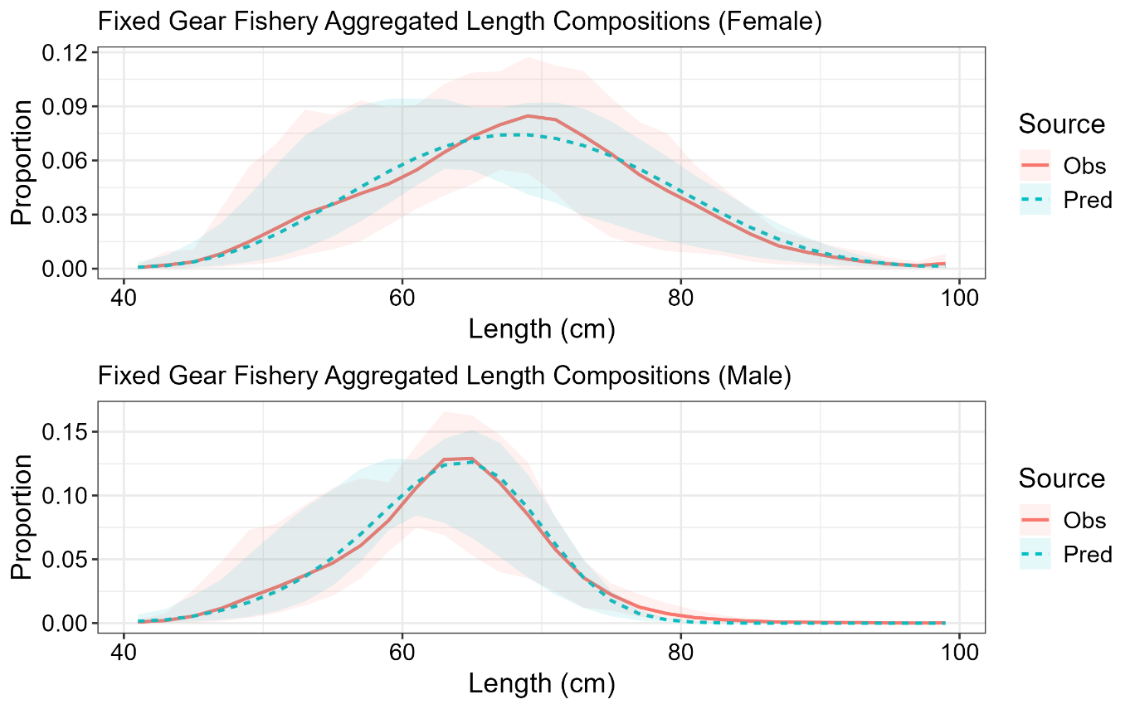

**Figure 3.28.** Mean observed (red line) domestic fixed gear fishery length compositions aggregated across years along with the average fit of the model (blue line). The red fill is the 90% empirical confidence intervals, while the blue fill is the model estimated 90% confidence intervals. Fit to female length compositions are in the top panel and fit to male length compositions are in the bottom panel.

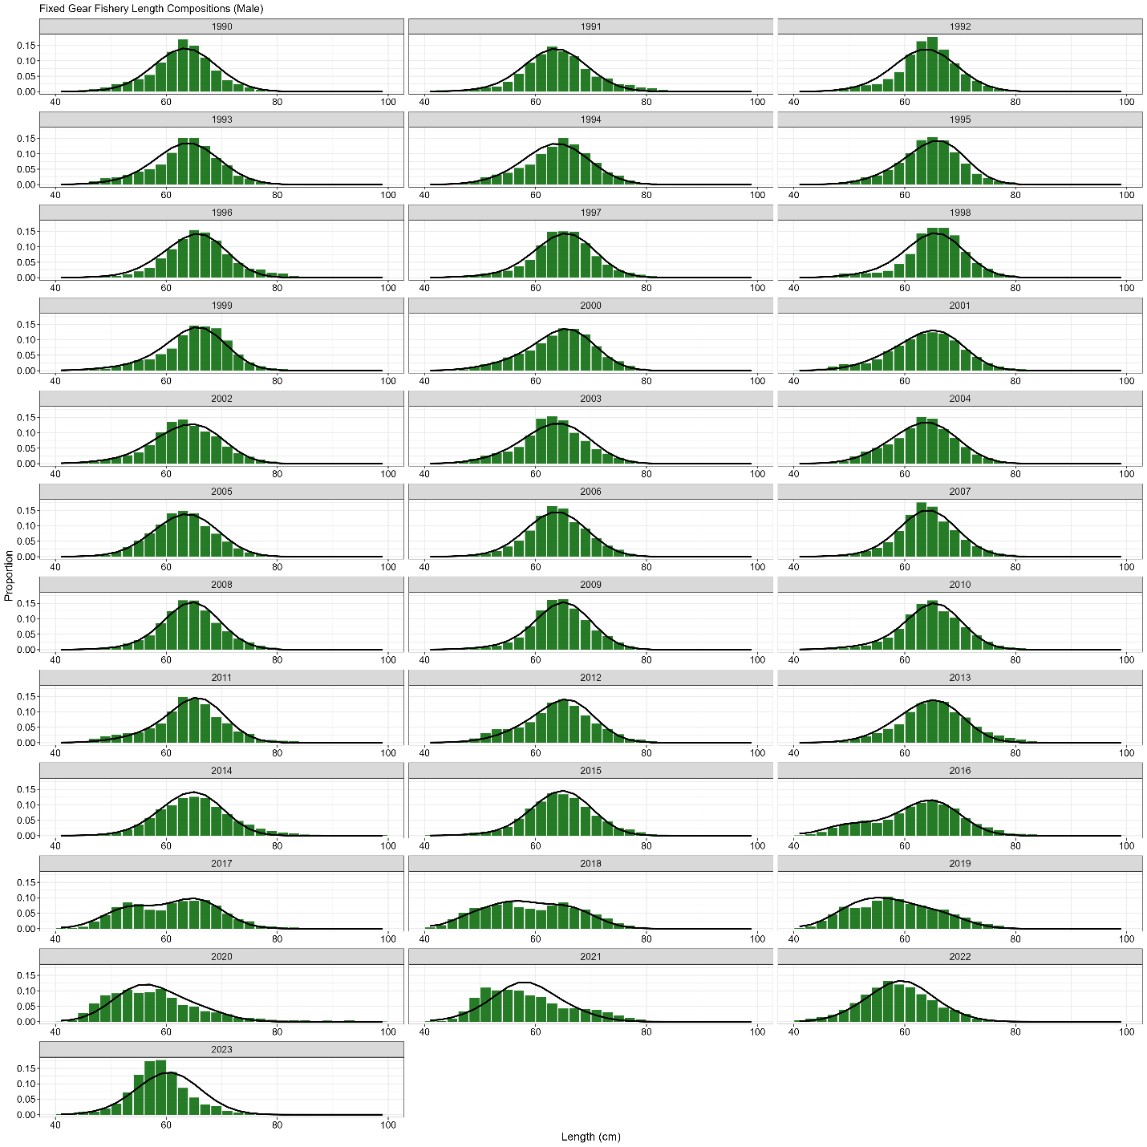

**Figure 3.29.** Domestic fixed gear fishery length (cm) compositions for males. Bars are observed frequencies and lines are predicted frequencies.

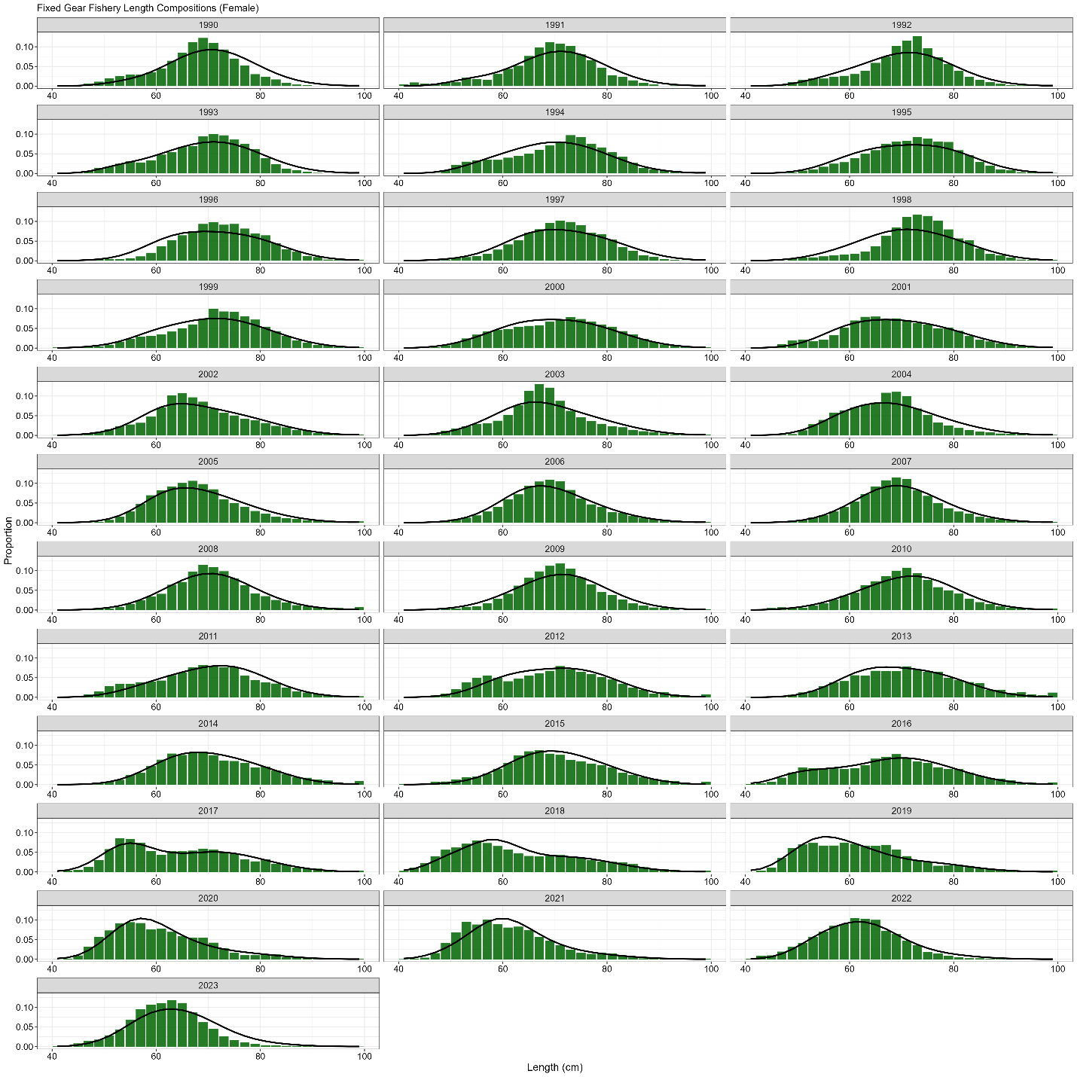

**Figure 3.30.** Domestic fixed gear fishery length (cm) compositions for females. Bars are observed frequencies and lines are predicted frequencies.

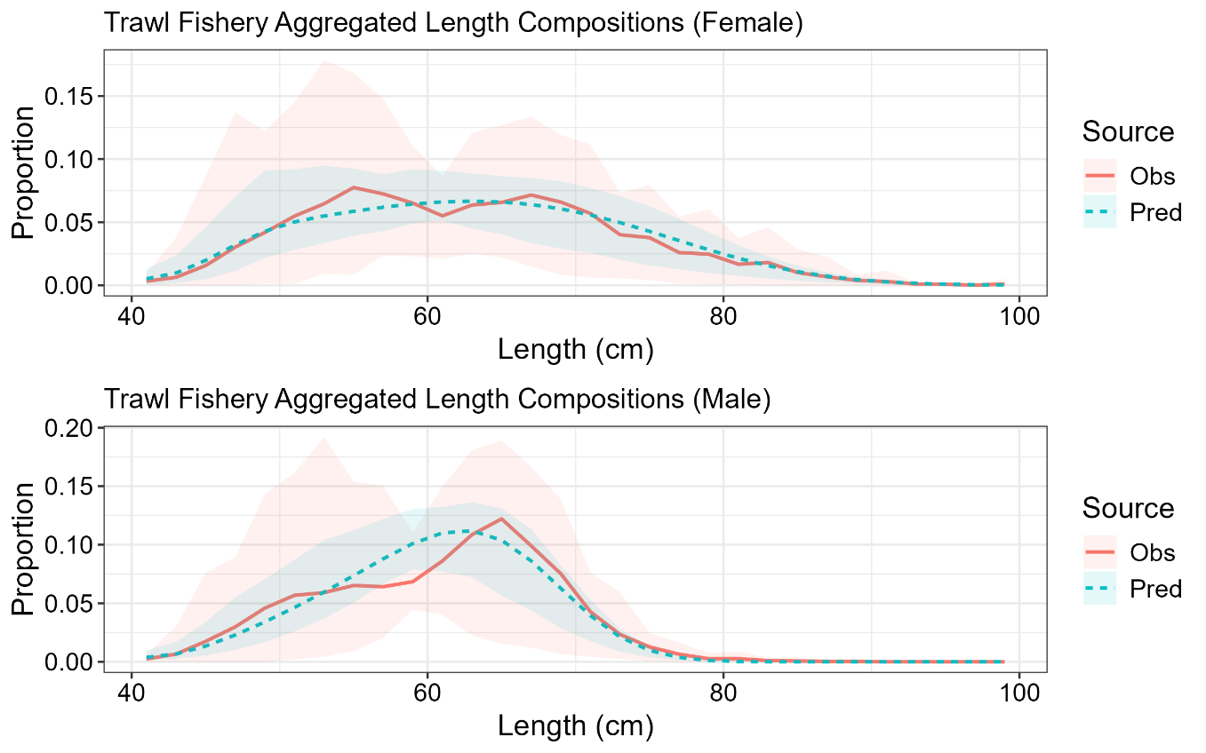

**Figure 3.31.** Mean observed (red line) domestic trawl gear fishery length compositions aggregated across years along with the average fit of the model (blue line). The red fill is the 90% empirical confidence intervals, while the blue fill is the model estimated 90% confidence intervals. Fit to female length compositions are in the top panel and fit to male length compositions are in the bottom panel.

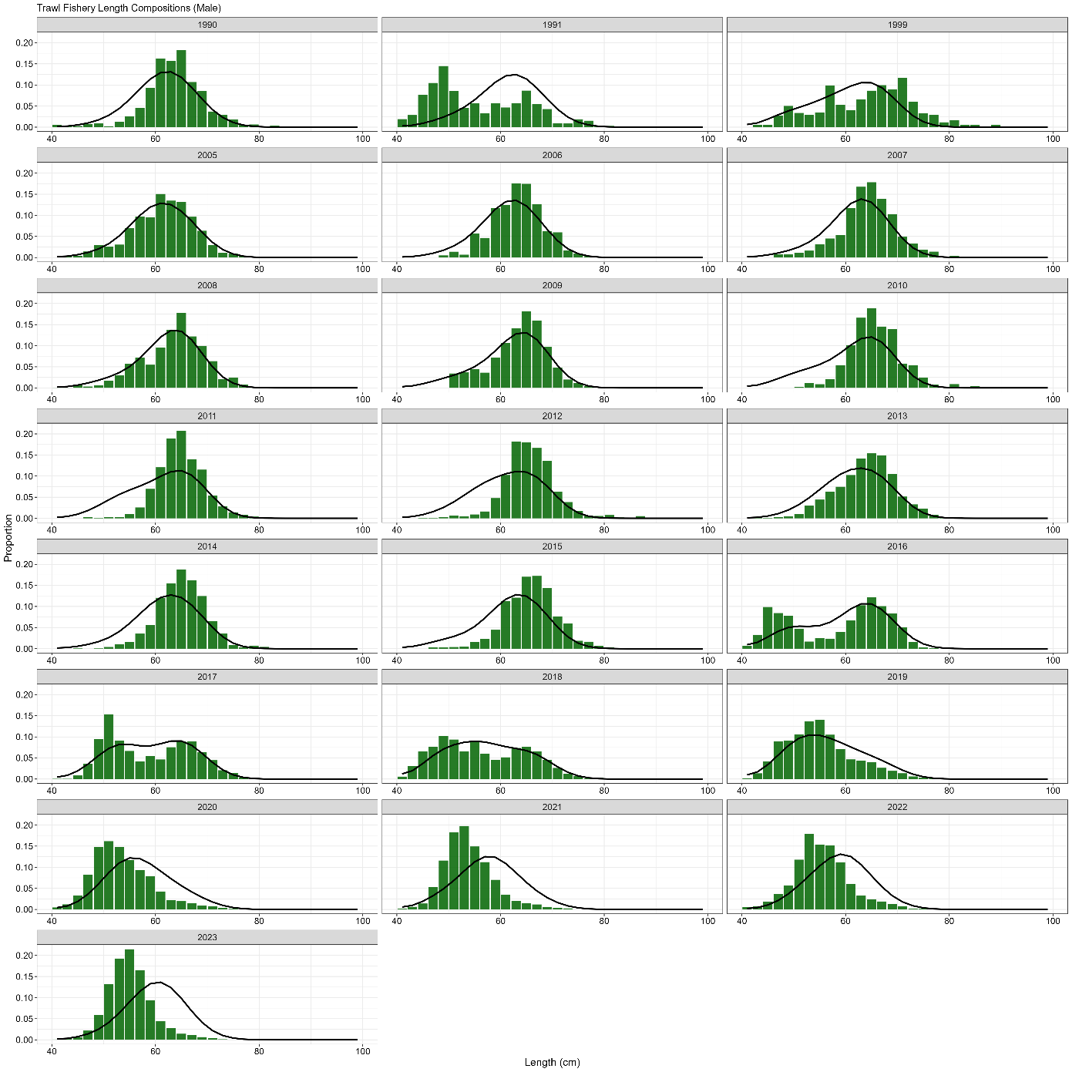

**Figure 3.32.** Domestic trawl gear fishery length (cm) compositions for males. Bars are observed frequencies and lines are predicted frequencies.

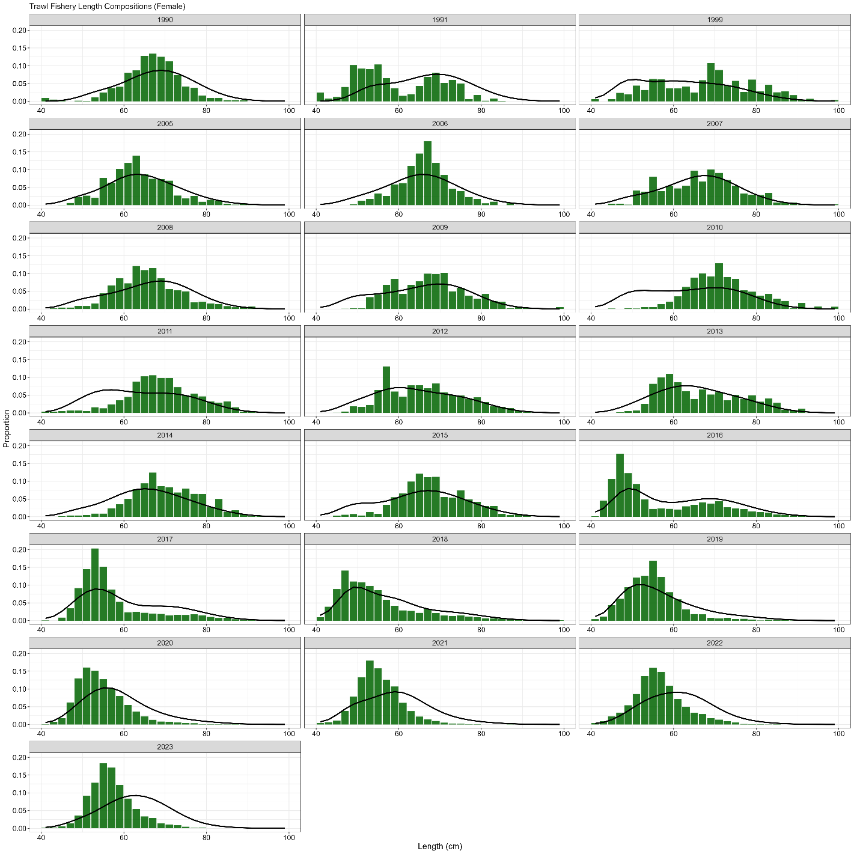

**Figure 3.33.** Domestic trawl gear fishery length (cm) compositions for females. Bars are observed frequencies and lines are predicted frequencies.

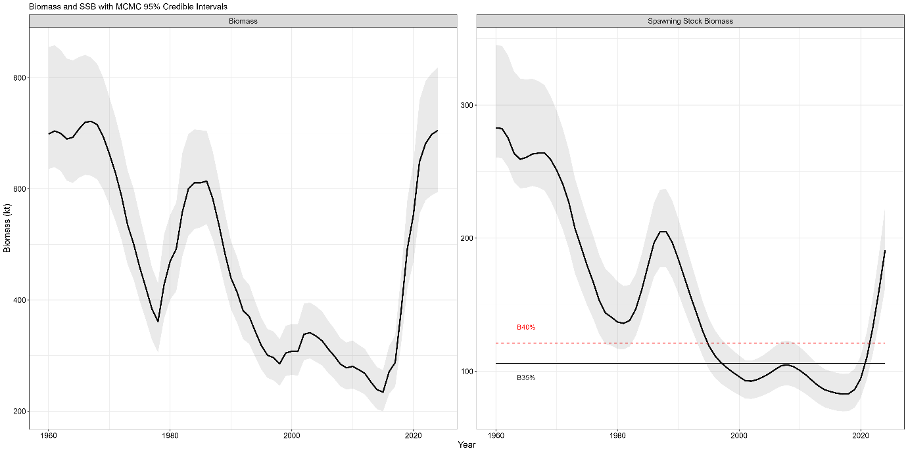

**Figure 3.34.** Estimated sablefish total biomass (top panel) and spawning biomass (bottom panel) with 95% MCMC credible intervals (grey fill). Values are in kilotons. The B35% (black solid line) and B40% (red dashed line) reference points are shown on the SSB panel.

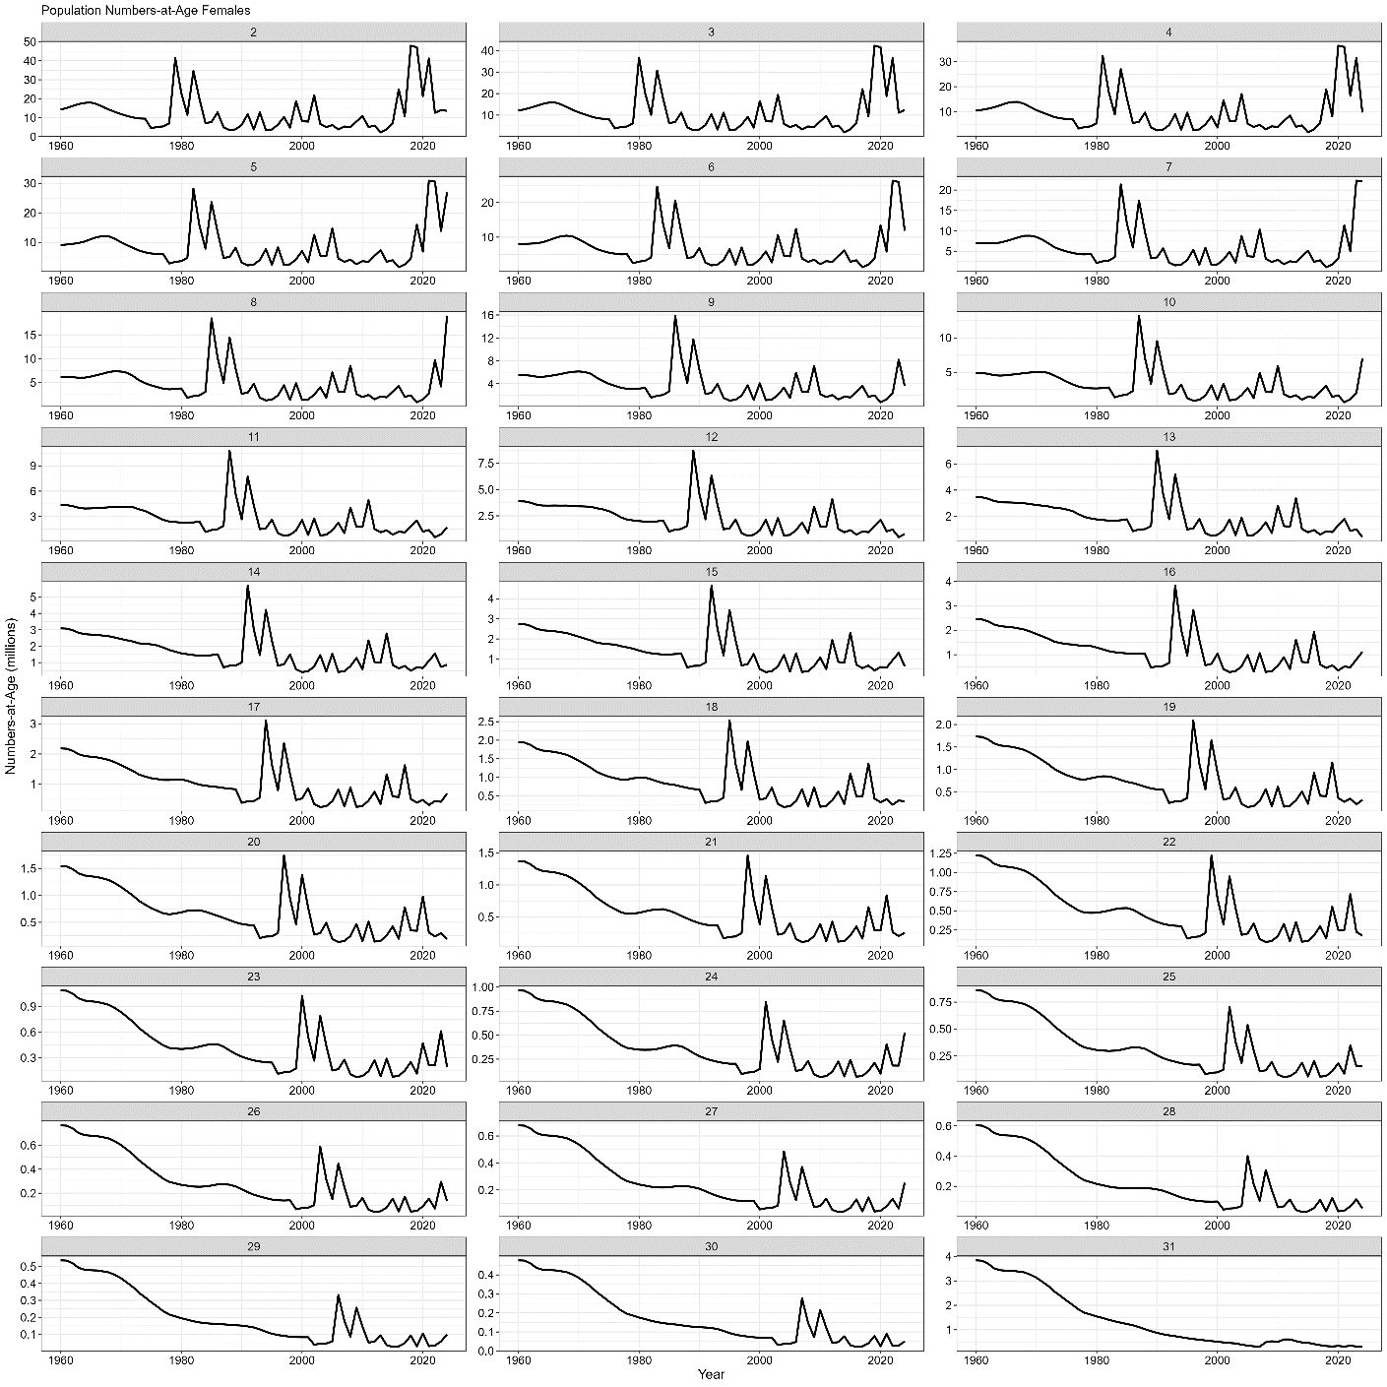

**Figure 3.35.** Model estimated female population numbers by age and year. Abundance is in millions of fish.

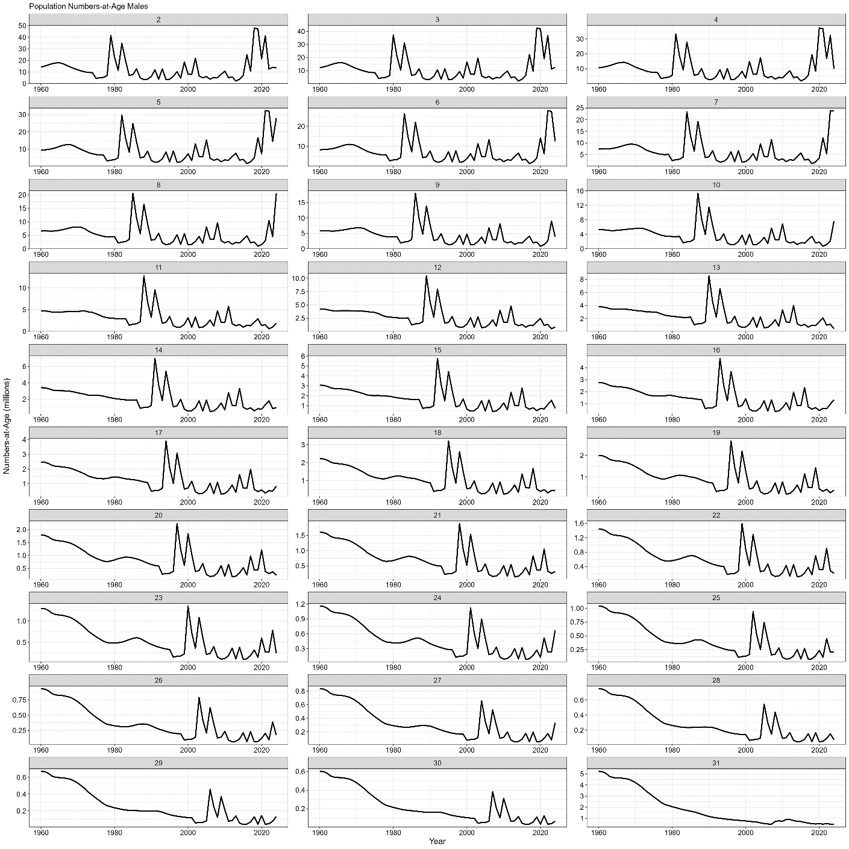

**Figure 3.36.** Model estimated male population numbers by age and year. Abundance is in millions of fish.

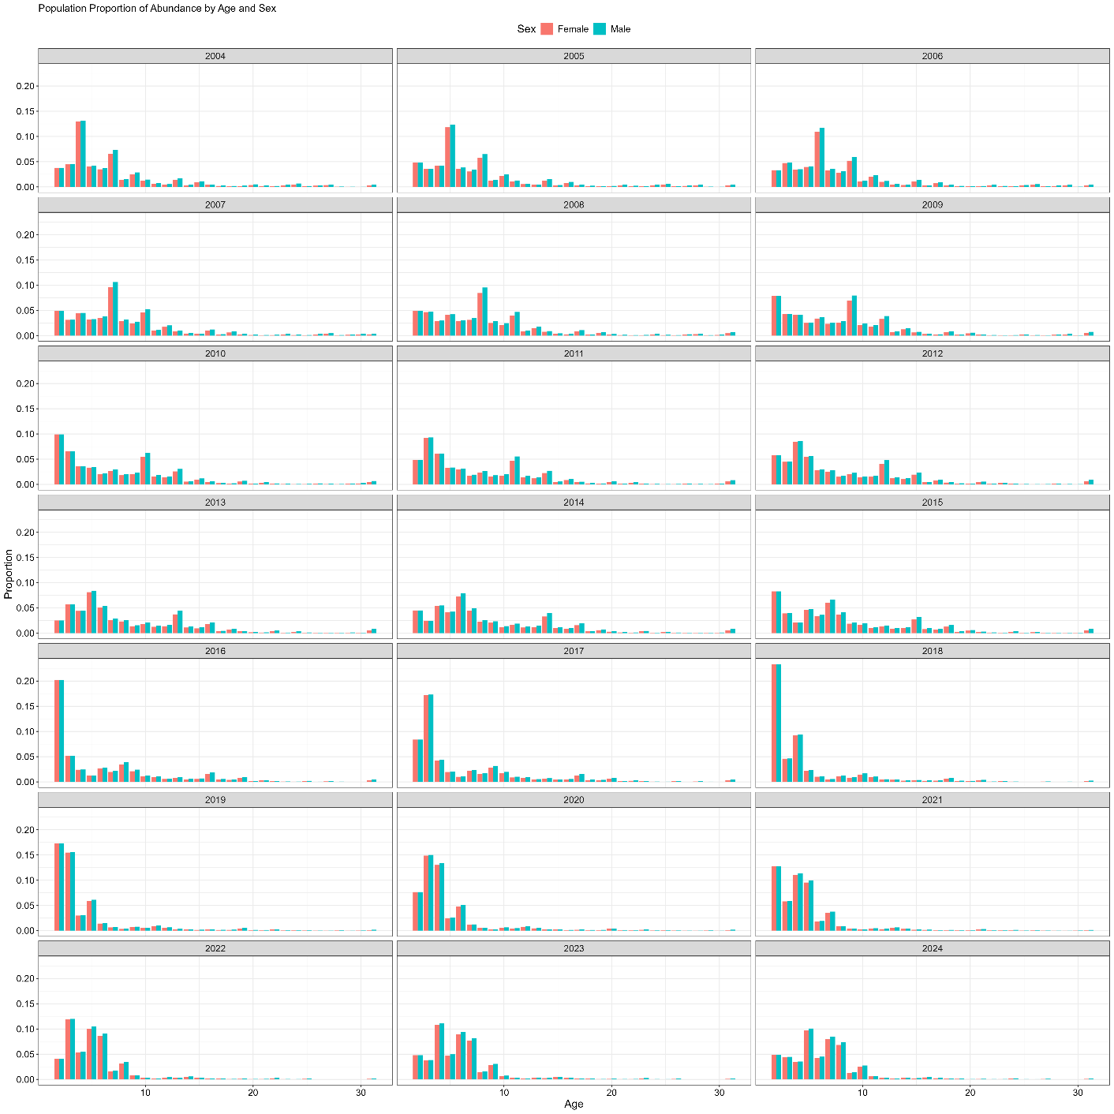

**Figure 3.37.** Model estimated proportions-at-age and sex by year. Female proportions are red bars and male proportions are blue bars.

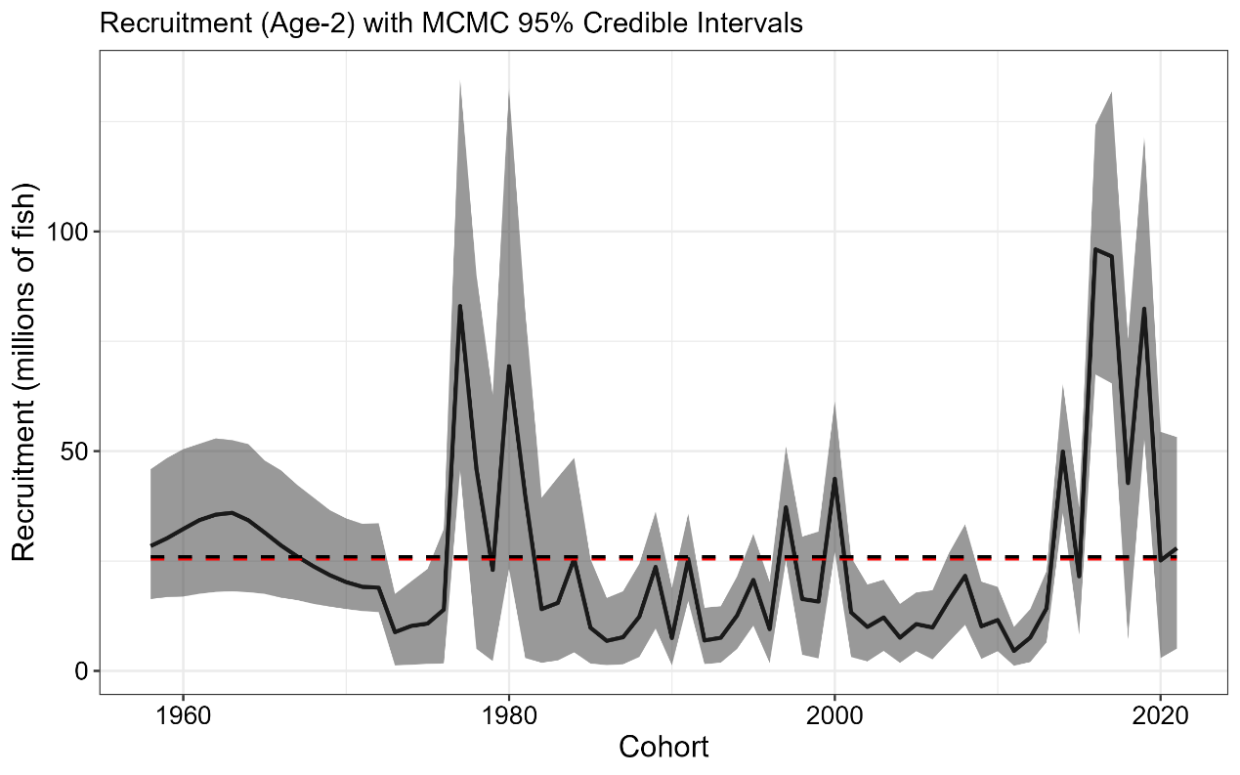

**Figure 3.38.** Estimated recruitment of age-2 sablefish (millions of fish; black line) with 95% credible intervals (grey fill) from MCMC by cohort (recruitment year minus two). Red line is time series mean, while black line is mean from year classes between 1977 and 2021. The estimate for the 2022 year class (terminal year 2024 recruitment event) is omitted, because it is fixed to the estimated mean recruitment value (*μr*) with no deviation parameter estimated.

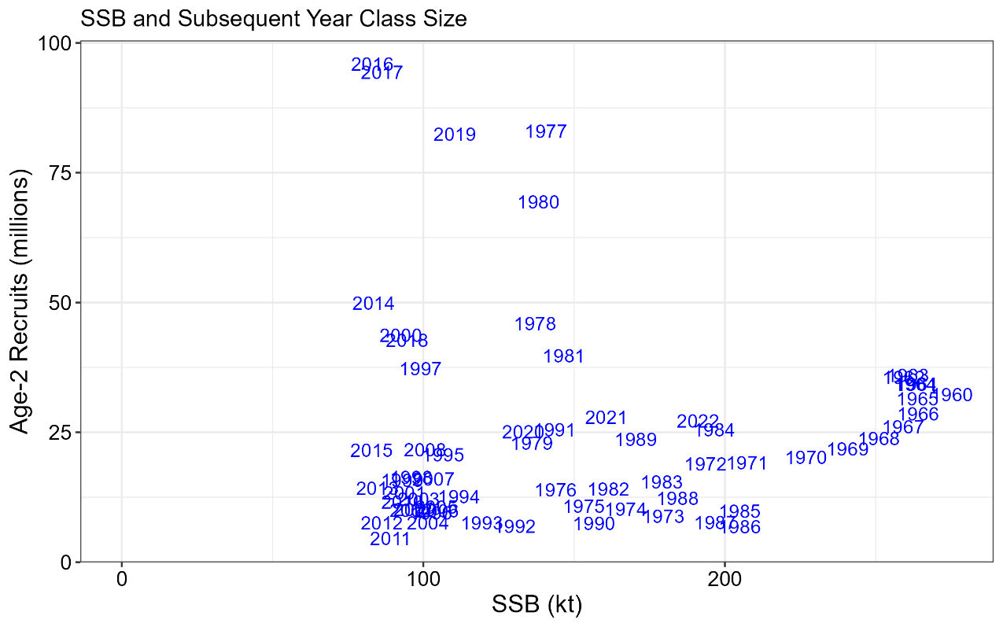

**Figure 3.39.** Age-2 recruits (millions of fish) and corresponding spawning stock biomass (kilotons) for each year class (identified by plotted year text).

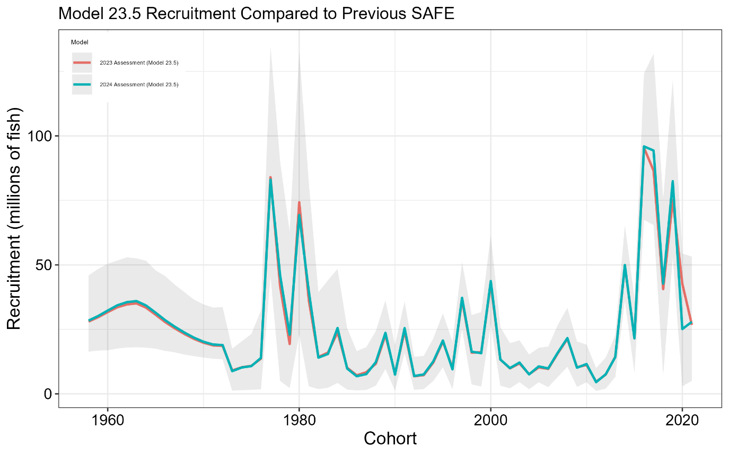

**Figure 3.40.** Estimated recruitment by cohort (recruitment year minus two) in number of age-2 fish (millions of fish) for the 2023 (red line) and 2024 (blue line) final SAFE models with 95% credible intervals (grey fill) from MCMC for the 2023 model. Note that the 2021 yearclass for the 2023 model is equivalent to the estimated mean recruitment value (*μr*).

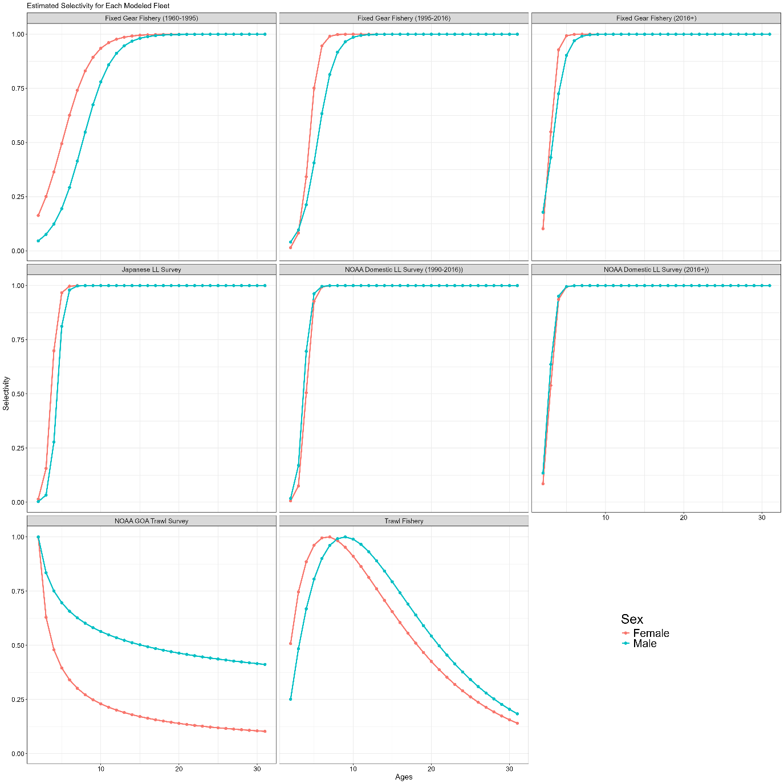

**Figure 3.41.** Estimated fishery and survey selectivity. Fixed gear fishery selectivity is in the top row for the three time blocks (i.e., pre-IFQ, IFQ, and recent), the longline survey selectivities are in the middle row (Japanese cooperative, left, NOAA domestic, center and right), and trawl survey (left) and fishery (right) in the bottom row. Female selectivity is given by the red line and male selectivity by the blue line.

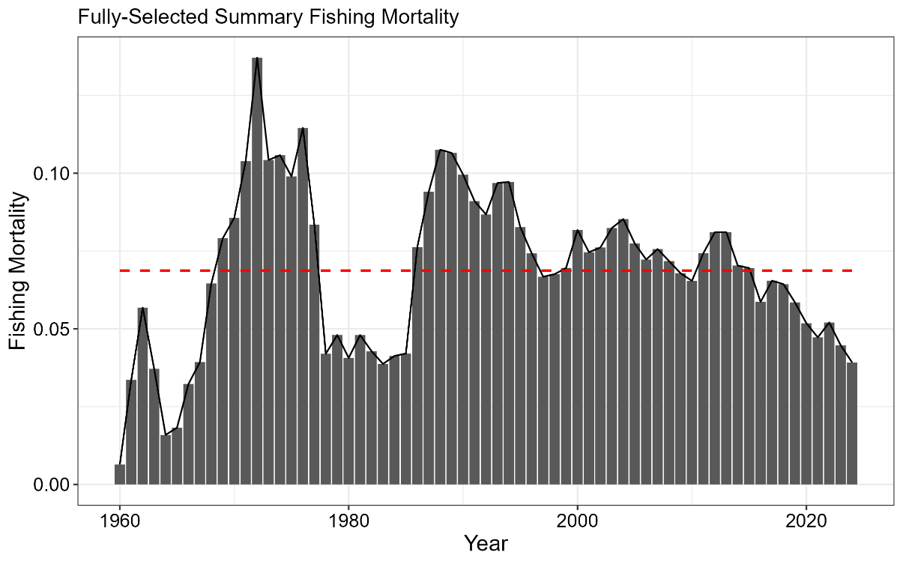

**Figure 3.42.** Time series of fully selected fishing mortality aggregated across the fixed gear and trawl fisheries. Red line is the mean fishing mortality for the entire time series.

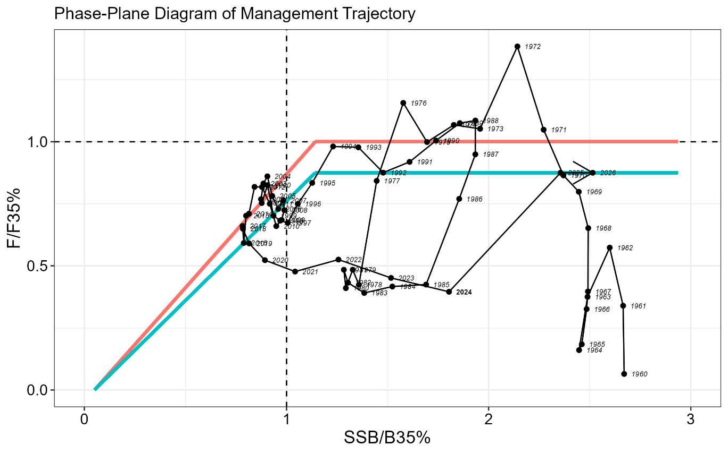

**Figure 3.43.** Phase-plane diagram illustrating the time series of sablefish estimated spawning biomass relative to the level at B35% and fishing mortality relative to F35% (equal to *FOFL*). *FABC* for the max ABC is equivalent to F40%, which is demonstrated by the blue lines. The red line represents fishing at *FOFL*, but with a target of B40% (i.e., the inflection point occurs at a biomass ratio greater than one).

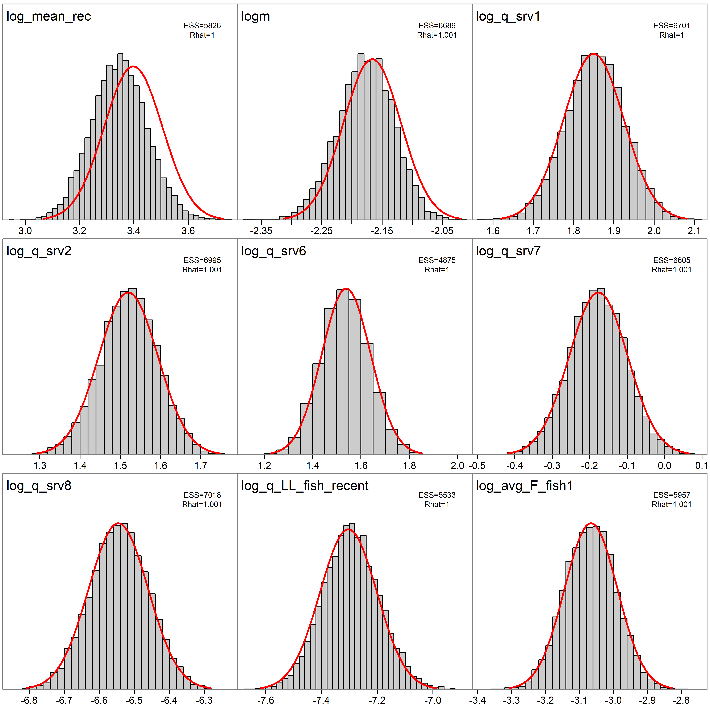

**Figure 3.44.** Key parameter marginal posterior histograms from MCMC and asymptotic normal distributions (red line) from the inverse Hessian (MLE). MCMC effective sample size (ESS) and R-hat estimates are printed in the top right corner.

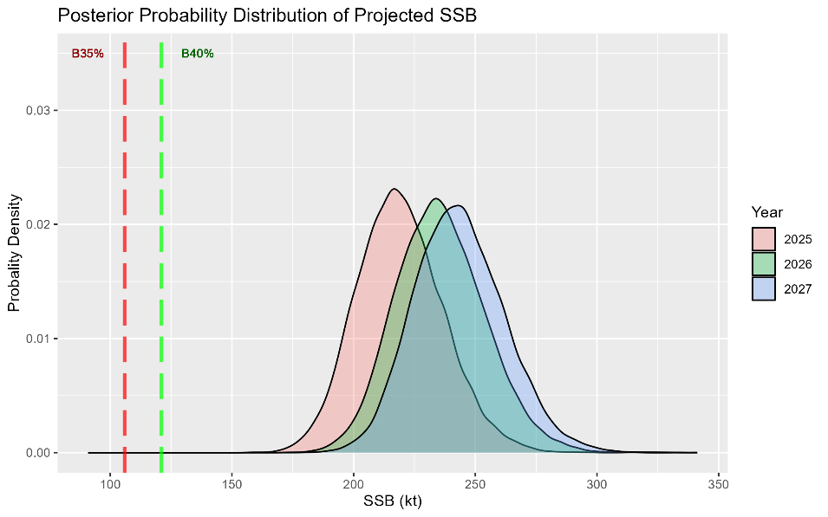

**Figure 3.45.** Posterior probability distribution from MCMC for projected spawning biomass (kilotons) in years 2025 – 2027. The dashed lines are B35% and B40%.

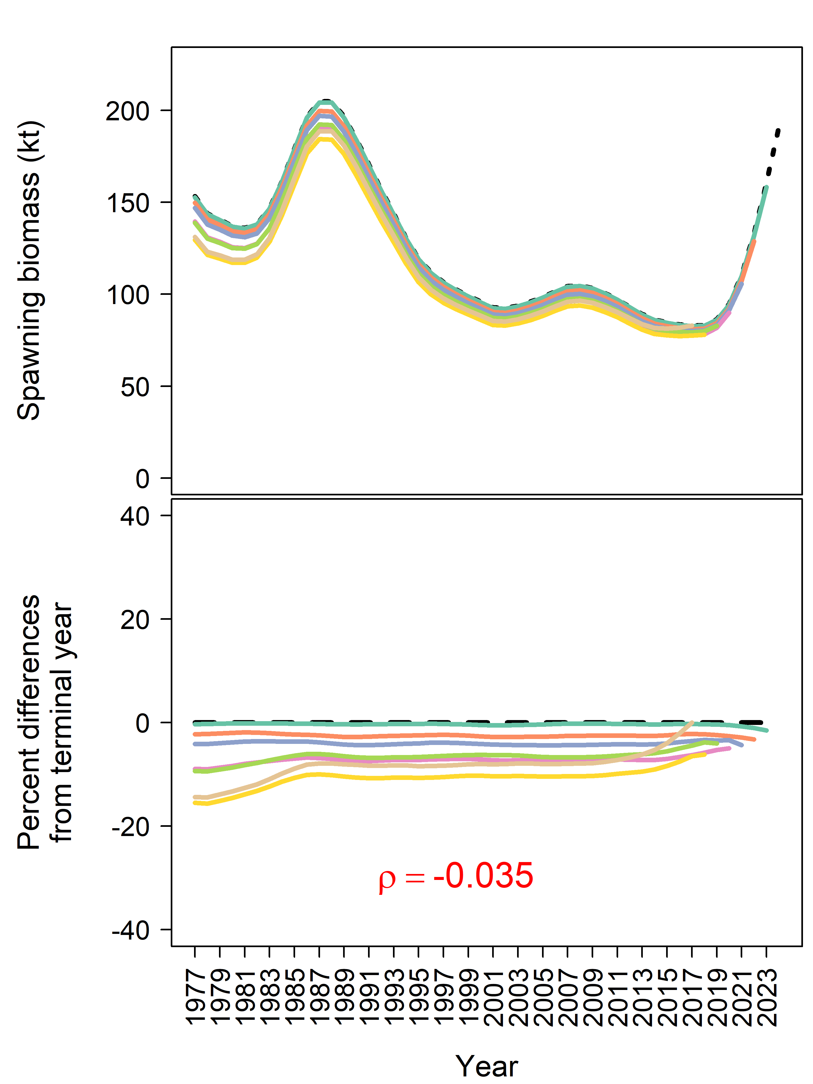

**Figure 3.46.** Retrospective trends for spawning biomass (top) and percent difference from terminal year (bottom). Mohn’s rho (*ρ*) is provided in red (bottom panel).

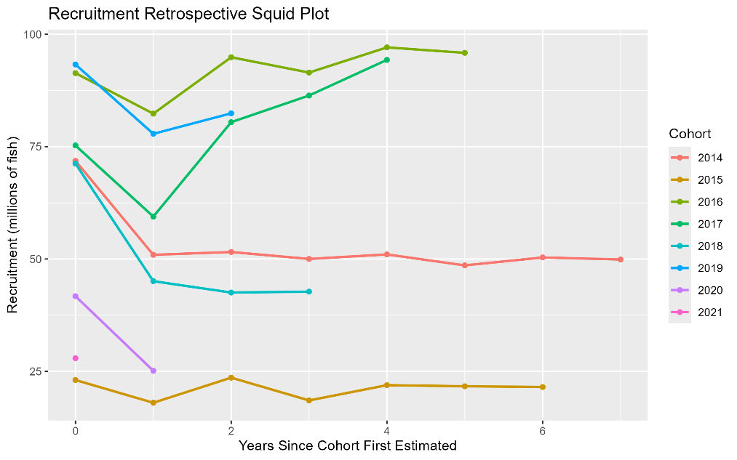

**Figure 3.47.** Squid plot of subsequent estimates of age-2 recruitment for 2014 to 2020 year classes from retrospective analysis.

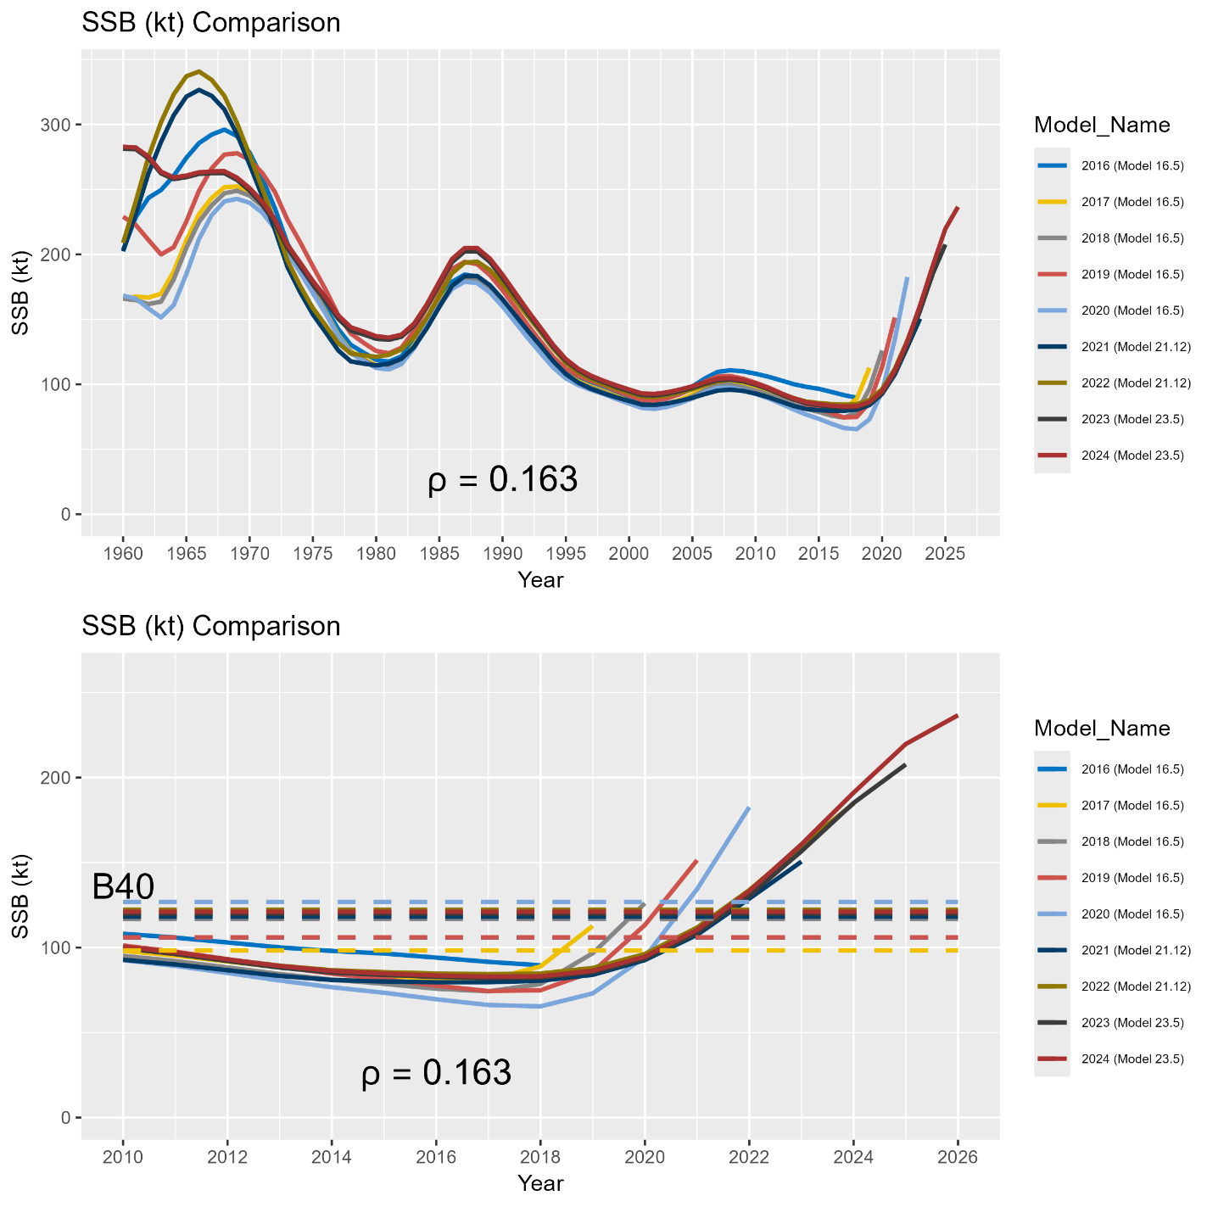

**Figure 3.48.** Results of the ‘all model’ historical retrospective illustrating estimated and projected (terminal year + 2 years) spawning stock biomass (in kilotons). Results are based on the accepted model in each terminal model year, including application of the *23.5* model for 2023 and 2024, the *21.12* model for the 2021 and 2022 model years, and the *16.5* model for earlier model years. The top panel shows the entire time series of SSB from each assessment model, while the bottom panel shows the same results since 2010 overlaid with corresponding estimates of *B40%*. Mohn’s rho for two year SSB projections is provided below the lines in each plot.

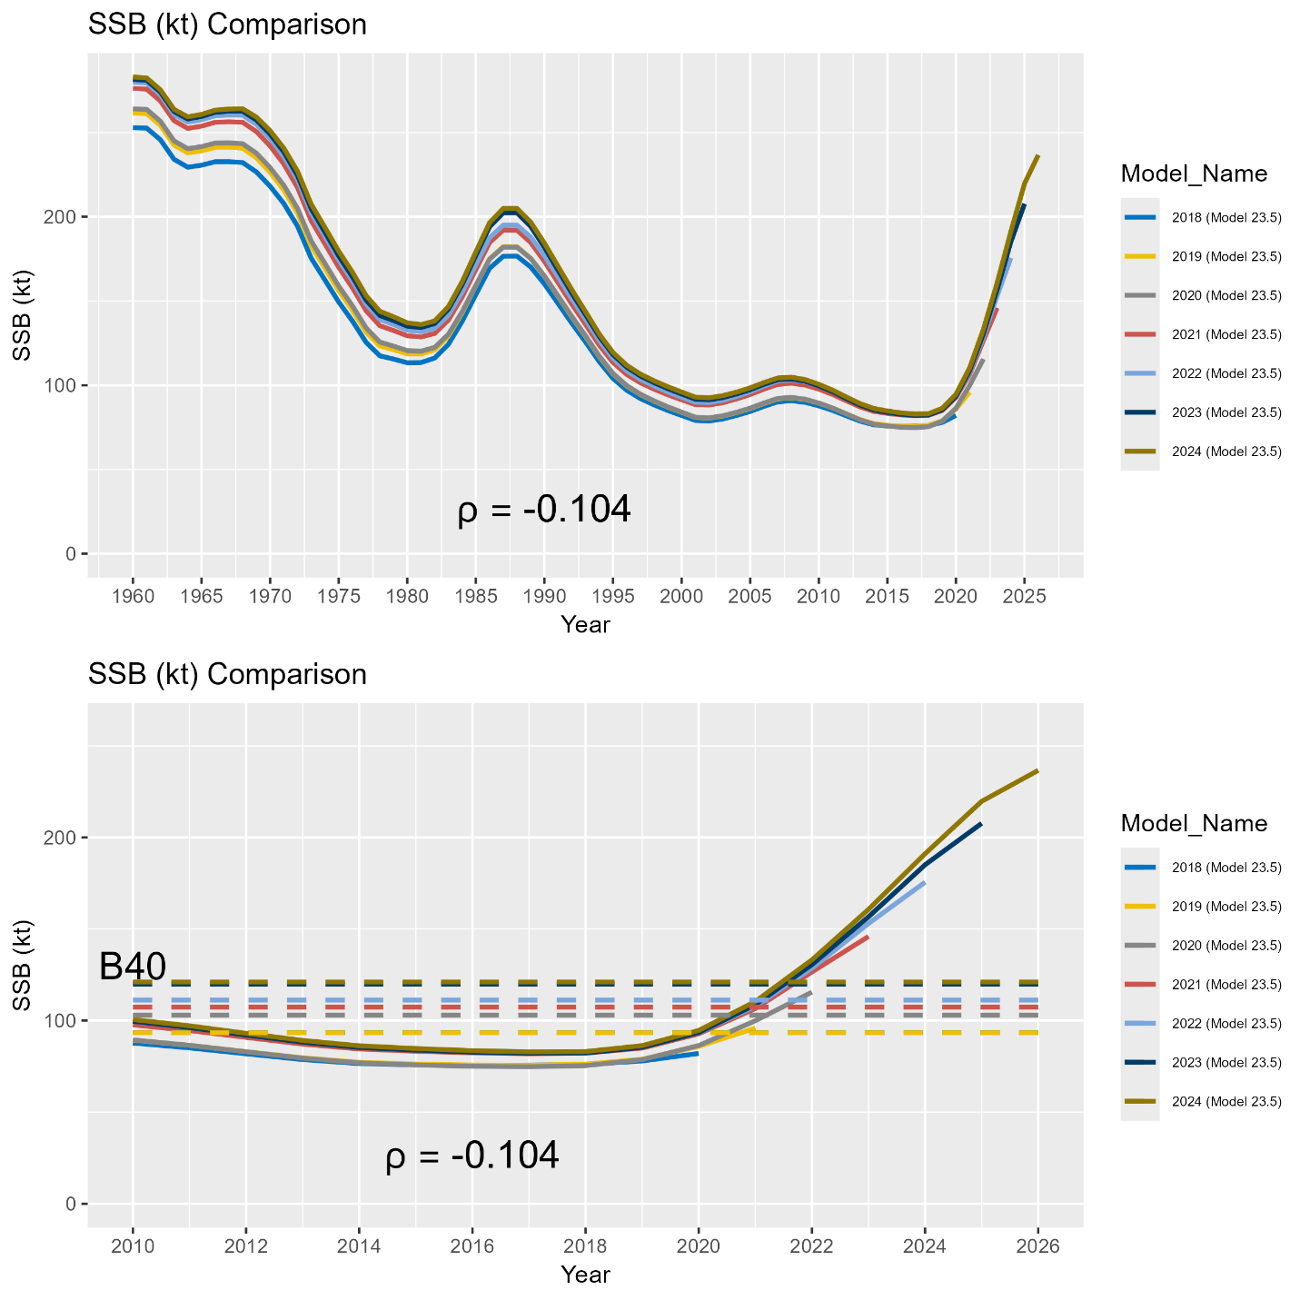

**Figure 3.49.** Results of the ‘current model’ historical retrospective illustrating estimated and projected (terminal year + 2 years) spawning stock biomass (in kilotons). Results are based on application of the *23.5* model to the available data at the time of previous sablefish assessments. The top panel shows the entire time series of SSB from each assessment model, while the bottom panel shows the same results since 2010 overlaid with corresponding estimates of *B40%*. Mohn’s rho for two year SSB projections is provided below the lines in each plot.

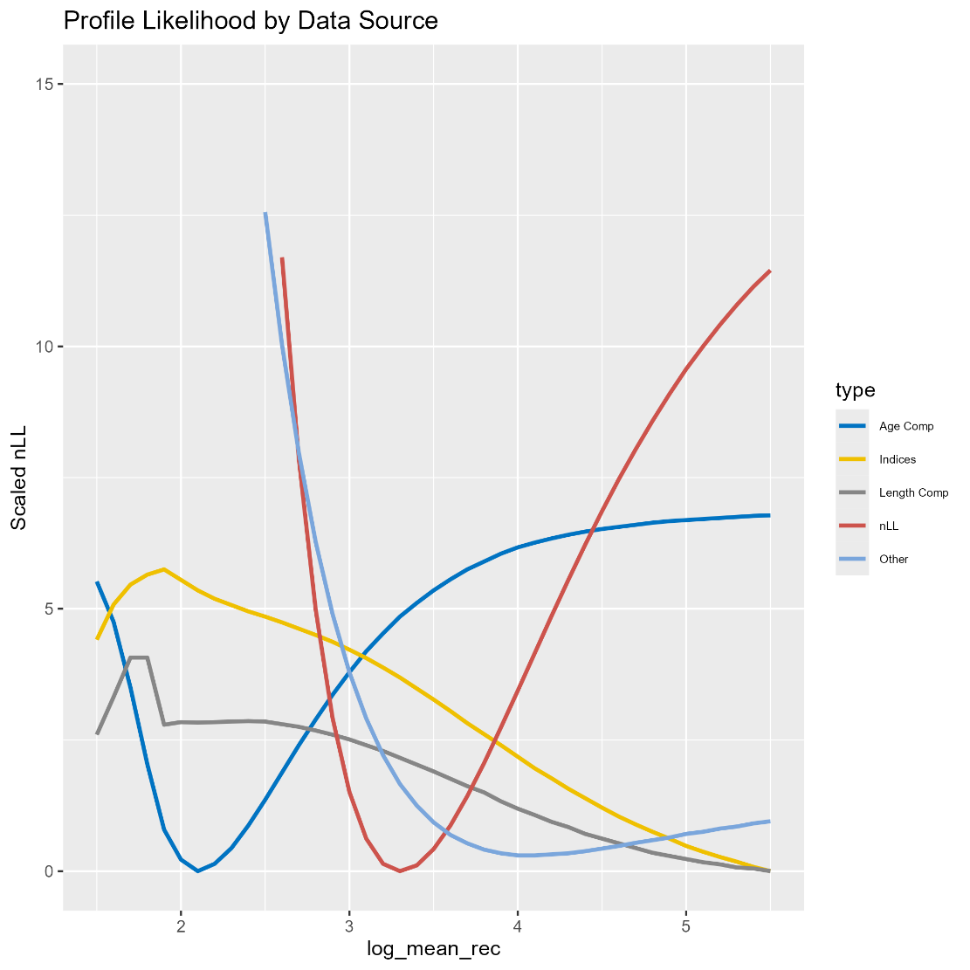

**Figure 3.50.** Likelihood profiles by data type (line color) for the mean recruitment parameter in logarithmic space.

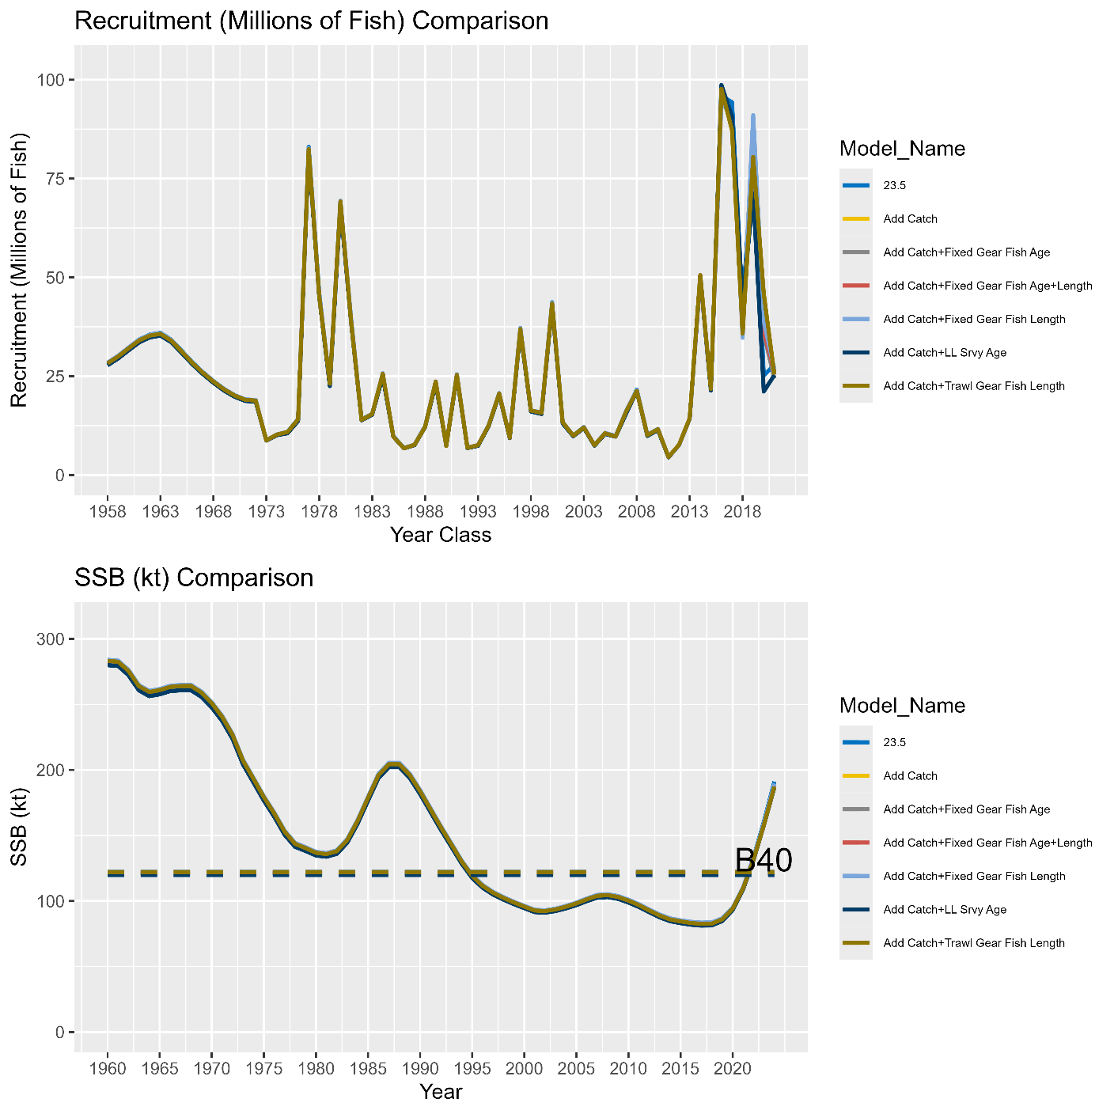

**Figure 3.51.** Results of an incremental data addition exercise where each new year of data for the 2024 model is added in a step-wise fashion. All model runs include the 2024 fishery catch data. For compositional data associated with fishery independent indices, each run also includes the associated survey index. The top panel illustrates the model estimated recruitment (millions of fish). The bottom panel depicts the time series of SSB (kt).

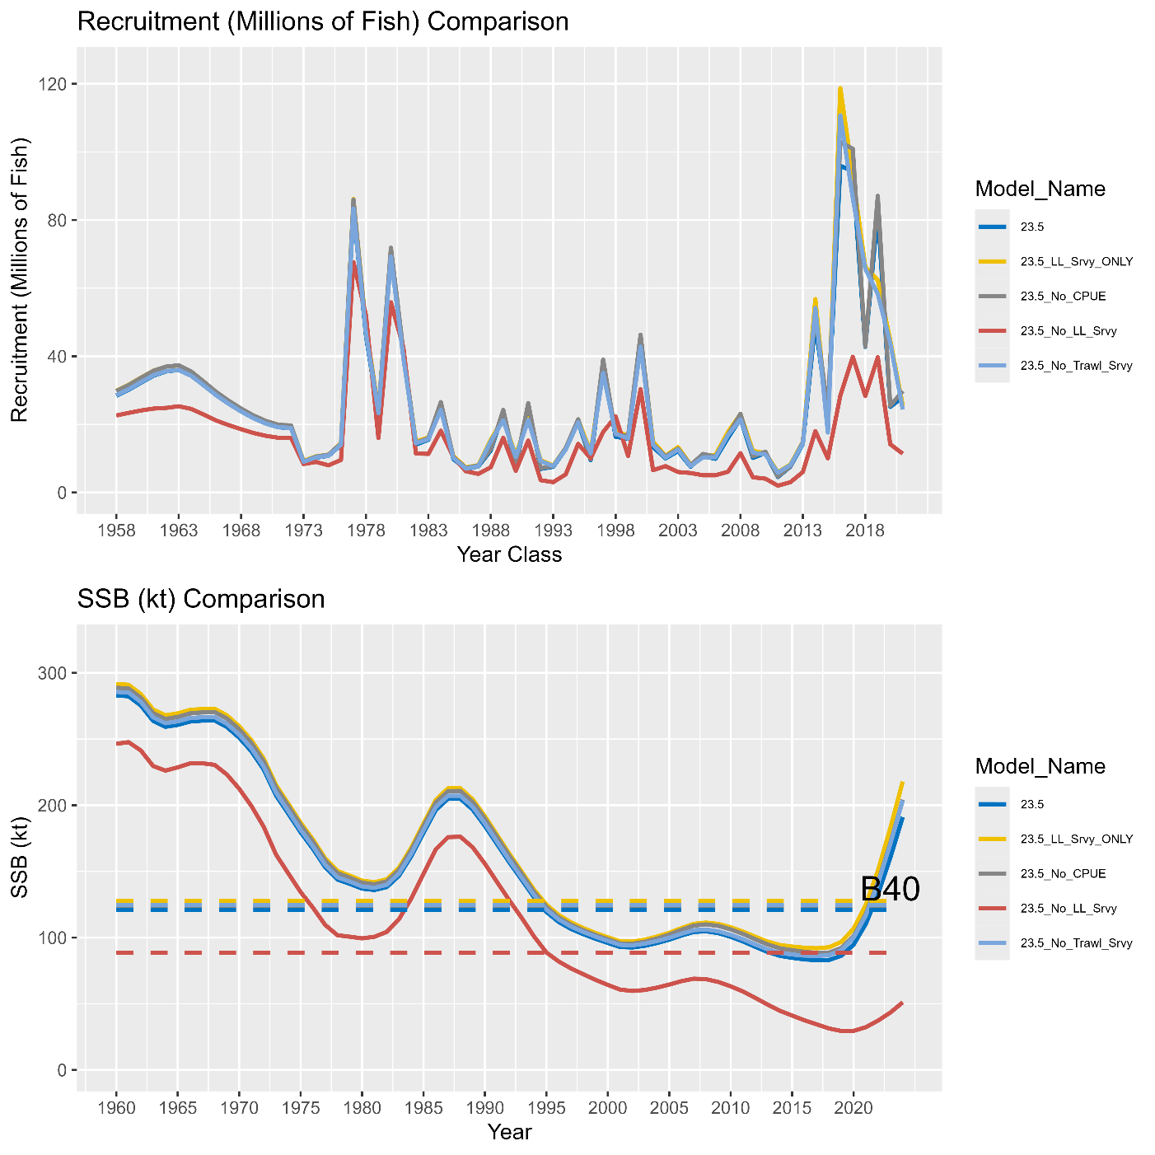

**Figure 3.52.** Results of an index sensitivity analysis where the model is rerun after removing each index (and any associated compositional data in the case of fishery independent surveys) one at a time. The top panel illustrates the model estimated recruitment (millions of fish). The bottom panel depicts the time series of SSB (kt).

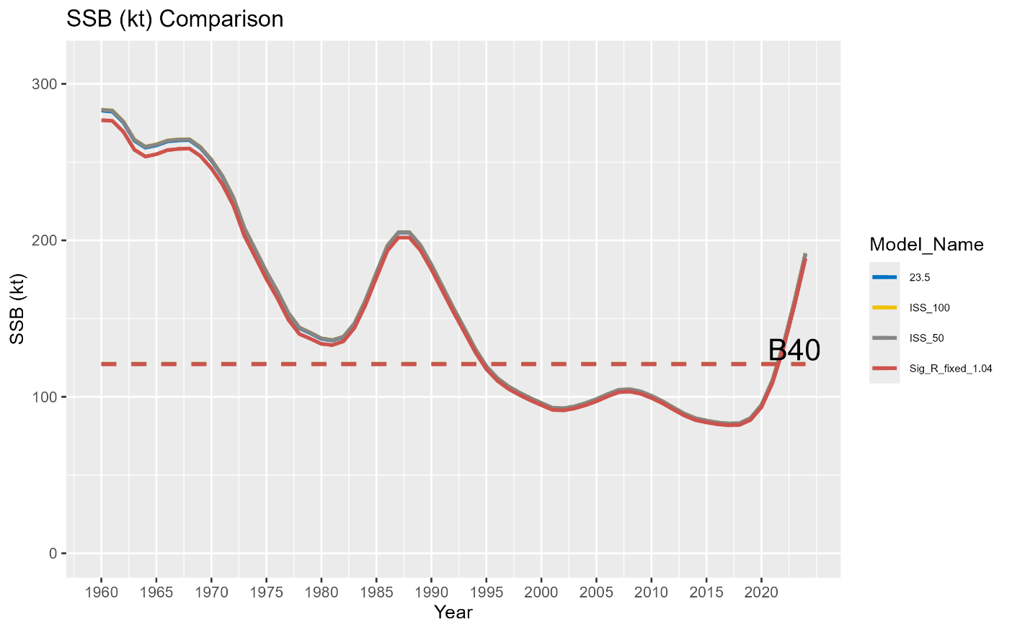

**Figure 3.53.** Results of the sensitivity runs for SSB in kt, where model naming conventions can be found in the main text.

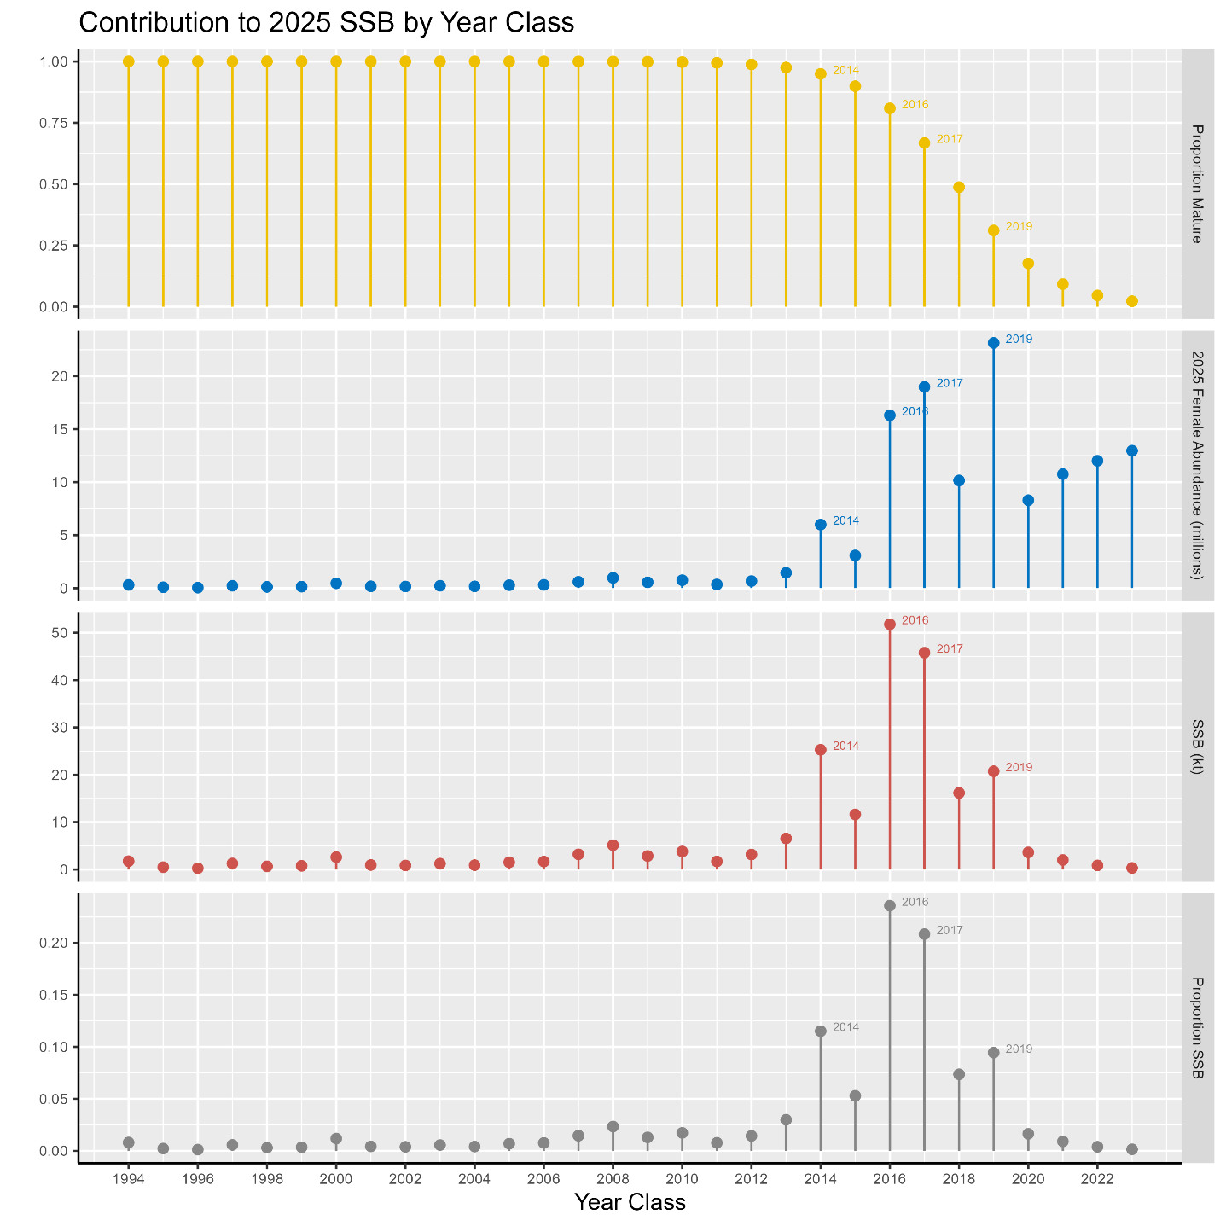

**Figure 3.54.** Proportion mature (top panel), projected 2025 female (assuming a 50:50 sex ratio) abundance (millions of fish; second panel from top), projected 2025 spawning stock biomass (kilotons; third panel from top), and proportional contribution to 2025 SSB (bottom panel) for each of the last 30 year classes. Note that the 1994 year class represents all contributions from all earlier year classes (i.e., fish in the plus group age). Abundance of the 2022 and 2023 year classes are based on mean recruitment, because these year classes have not yet been estimated in the 2024 assessment model.

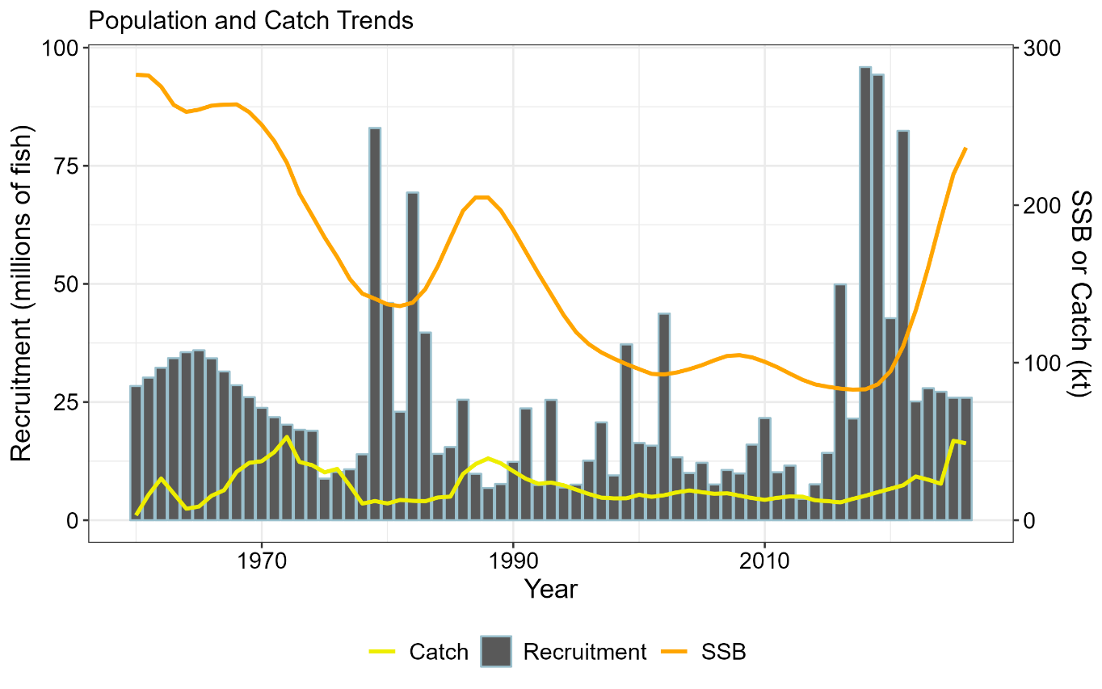

**Figure 3.55**. Time series of sablefish SSB (orange line), catch (yellow line), and recruitment (grey bars). Projected dynamics for 2025 and 2026 are included based on the maximum permissible ABC and average recruitment. Note the cyclical dynamics associated with spasmodic recruitment. Transitory increases in SSB subsequent to periods of strong recruitment are often followed by a persistent downward time series trend. Catches often rapidly increase following high recruitment periods, while recruitment reverts back towards average levels.

Appendix 3A. Sablefish Longline Survey: Fishery and Whale Interactions

NMFS has requested the assistance of the fishing fleet to avoid the annual longline survey stations since the inception of sablefish IFQ management in 1995. We request that fishermen stay at least five nm away from each survey station for 7 days before and 3 days after the planned sampling date (3 days allows for survey delays). Since 2021, survey calendars have been made available online (https://www.fisheries.noaa.gov/resource/document/alaska-sablefish-longline-survey-station-schedule). While the survey is being conducted, the skipper of the vessel makes announcements on the radio detailing the planned set locations for the upcoming days. Vessels encountered near survey stations are contacted by the survey vessel captain and interviewed to determine potential effects on survey catches. Typically, vessels have been aware of the survey and have not been fishing close to survey locations. Even with communication, there are some instances where survey gear was fished nearby commercial fishing gear or where commercial fishing had recently occurred. There are generally few interactions during the 90-day survey (Table 3A.1). In 2023 there were eight instances of vessel interactions that may have impacted survey catch or required the survey vessel to move the day’s sets from their originally intended locations. In the GOA, there were 5 interactions with pot boats (3 in Southeast Outside, 1 in West Yakutat, and 1 in the Central GOA) and 3 interactions with longline vessels (1 in the western GOA and 2 in the central GOA). There were no vessel interactions in the Bering Sea. The number of sets impacted by whales is also tallied (Table 3A.2) and those sets are dropped (for orca interaction; 16 stations, mostly in the BS) or catch rates inflated using the survey whale inflation factor (for sperm whales; 12 stations, mostly in the eastern GOA; see ‘Whale Depredation Estimation’ section). No longline survey was conducted in 2024.

Tables

**Table 3A.1.** Count of longline survey and fishery vessel interactions by area, fishery gear type, and year.

|  |  |  |  |  |  |  |  |  |  |  |
| --- | --- | --- | --- | --- | --- | --- | --- | --- | --- | --- |
|  | **Longline** | | **Trawl** | | **Pot** | | | **Total** | | |
| **Year** | **Stations** | **Vessels** | **Stations** | **Vessels** | | **Stations** | **Vessels** | | **Stations** | **Vessels** | |
| 1995 | 8 | 7 | 9 | 15 | | 0 | 0 | | 17 | 22 | |
| 1996 | 11 | 18 | 15 | 17 | | 0 | 0 | | 26 | 35 | |
| 1997 | 8 | 8 | 8 | 7 | | 0 | 0 | | 16 | 15 | |
| 1998 | 10 | 9 | 0 | 0 | | 0 | 0 | | 10 | 9 | |
| 1999 | 4 | 4 | 2 | 6 | | 0 | 0 | | 6 | 10 | |
| 2000 | 10 | 10 | 0 | 0 | | 0 | 0 | | 10 | 10 | |
| 2001 | 1 | 1 | 1 | 1 | | 0 | 0 | | 2 | 2 | |
| 2002 | 3 | 3 | 0 | 0 | | 0 | 0 | | 3 | 3 | |
| 2003 | 4 | 4 | 2 | 2 | | 0 | 0 | | 6 | 6 | |
| 2004 | 5 | 5 | 0 | 0 | | 1 | 1 | | 6 | 6 | |
| 2005 | 1 | 1 | 1 | 1 | | 0 | 0 | | 2 | 2 | |
| 2006 | 6 | 6 | 1 | 2 | | 0 | 0 | | 7 | 8 | |
| 2007 | 8 | 6 | 2 | 2 | | 0 | 0 | | 10 | 8 | |
| 2008 | 2 | 2 | 2 | 2 | | 0 | 0 | | 4 | 4 | |
| 2009 | 3 | 3 | 0 | 0 | | 0 | 0 | | 3 | 3 | |
| 2010 | 2 | 2 | 1 | 1 | | 0 | 0 | | 3 | 3 | |
| 2011 | 3 | 3 | 0 | 0 | | 0 | 0 | | 3 | 3 | |
| 2012 | 5 | 5 | 0 | 0 | | 0 | 0 | | 5 | 5 | |
| 2013 | 5 | 5 | 0 | 0 | | 0 | 0 | | 5 | 5 | |
| 2014 | 2 | 2 | 0 | 0 | | 0 | 0 | | 2 | 2 | |
| 2015 | 3 | 3 | 1 | 1 | | 0 | 0 | | 6 | 6 | |
| 2016 | 5 | 5 | 1 | 1 | | 0 | 0 | | 6 | 6 | |
| 2017 | 8 | 10 | 3 | 3 | | 3 | 3 | | 13 | 16 | |
| 2018 | 9 | 9 | 3 | 3 | | 0 | 0 | | 12 | 12 | |
| 2019 | 4 | 4 | 1 | 1 | | 4 | 4 | | 9 | 9 | |
| 2020 | 1 | 1 | 1 | 1 | | 3 | 3 | | 5 | 5 | |
| 2021 | 0 | 0 | 0 | 0 | | 4 | 4 | | 4 | 4 | |
| 2022 | 1 | 1 | 0 | 0 | | 7 | 7 | | 8 | 8 | |
| 2023 | 2 | 3 | 0 | 0 | | 4 | 5 | | 6 | 8 | |

**Table 3.A2.** Count of stations where sperm (S) or killer whale (K) depredation occurred and the number of stations sampled (in parentheses) by management area. Only stations used for RPN calculations are included. Areas not surveyed in a given year are left blank. If there were no whale depredation data taken, it is denoted with an “n/a”. Killer whale depredation did not always occur on all skates of gear, and only those skates with depredation were removed from calculations of RPNs and RPWs.

|  |  |  |  |  |  |  |  |  |  |  |  |  |
| --- | --- | --- | --- | --- | --- | --- | --- | --- | --- | --- | --- | --- |
|  | **BS (16)** | | **AI (14)** | | **WG (10)** | | **CG (16)** | | **WY (8)** | | **SEO (17)** | |
| **Year** | **S** | **K** | **S** | **K** | **S** | **K** | **S** | **K** | **S** | **K** | **S** | **K** |
| 1996 |  |  | n/a | 1 | n/a | 0 | n/a | 0 | n/a | 0 | n/a | 0 |
| 1997 | n/a | 2 |  |  | n/a | 0 | n/a | 0 | n/a | 0 | n/a | 0 |
| 1998 |  |  | 0 | 1 | 0 | 0 | 0 | 0 | 4 | 0 | 0 | 0 |
| 1999 | 0 | 7 |  |  | 0 | 0 | 3 | 0 | 6 | 0 | 4 | 0 |
| 2000 |  |  | 0 | 1 | 0 | 1 | 0 | 0 | 4 | 0 | 2 | 0 |
| 2001 | 0 | 5 |  |  | 0 | 0 | 3 | 0 | 0 | 0 | 2 | 0 |
| 2002 |  |  | 0 | 1 | 0 | 4 | 3 | 0 | 4 | 0 | 2 | 0 |
| 2003 | 0 | 7 |  |  | 0 | 3 | 2 | 0 | 1 | 0 | 2 | 0 |
| 2004 |  |  | 0 | 0 | 0 | 4 | 3 | 0 | 4 | 0 | 6 | 0 |
| 2005 | 0 | 2 |  |  | 0 | 4 | 0 | 0 | 2 | 0 | 8 | 0 |
| 2006 |  |  | 0 | 1 | 0 | 3 | 2 | 1 | 4 | 0 | 2 | 0 |
| 2007 | 0 | 7 |  |  | 0 | 5 | 1 | 1 | 5 | 0 | 6 | 0 |
| 2008 |  |  | 0 | 3 | 0 | 2 | 2 | 0 | 8 | 0 | 9 | 0 |
| 2009 | 0 | 10 |  |  | 0 | 2 | 5 | 1 | 3 | 0 | 2 | 0 |
| 2010 |  |  | 0 | 3 | 0 | 1 | 2 | 1 | 2 | 0 | 6 | 0 |
| 2011 | 0 | 7 |  |  | 0 | 5 | 1 | 1 | 4 | 0 | 9 | 0 |
| 2012 |  |  | 1 | 5 | 1 | 5 | 2 | 0 | 4 | 0 | 3 | 0 |
| 2013 | 0 | 11 |  |  | 0 | 2 | 2 | 2 | 3 | 0 | 7 | 0 |
| 2014 |  |  | 1 | 3 | 0 | 4 | 4 | 0 | 6 | 0 | 4 | 0 |
| 2015 | 0 | 9 |  |  | 0 | 5 | 4 | 0 | 6 | 0 | 7 | 0 |
| 2016 |  |  | 1 | 0 | 0 | 3 | 3 | 2 | 5 | 0 | 6 | 0 |
| 2017 | 0 | 11 |  |  | 1 | 2 | 4 | 0 | 3 | 0 | 9 | 0 |
| 2018 |  |  | 0 | 2 | 0 | 3 | 3 | 0 | 7 | 0 | 9 | 0 |
| 2019 | 0 | 10 |  |  | 1 | 4 | 6 | 3 | 6 | 0 | 4 | 0 |
| 2020 |  |  | 0 | 7 | 1 | 5 | 3 | 1 | 4 | 0 | 6 | 0 |
| 2021 | 0 | 10 |  |  | 0 | 1 | 5 | 0 | 1 | 0 | 2 | 0 |
| 2022 |  |  | 0 | 1 | 0 | 4 | 2 | 0 | 1 | 0 | 5 | 0 |
| 2023 | 0 | 12 |  |  | 0 | 3 | 2 | 1 | 2 | 0 | 8 | 0 |

Appendix 3B. Supplemental Catch Data

In order to address NS1 total accounting requirements, discards (Table 3B.1), FMP bycatch (Table 3B.2), nontarget bycatch (Table 3B.3), and prohibited species catch (PSC; Table 3B.4) are reported in this appendix. Note that all non-commercial catch is now accounted for in the assessment model catch, so no additional table is provided for these sources of removal.

Tables

**Table 3.B1.** Retained and discarded catch of sablefish (t) by year, fleet, and management (FMP) region. Abbreviations are: HAL = hook-and-line; POT = pot; TRW = trawl; and JIG = jig fishery. Source: NMFS Alaskan Regional Office Catch Accounting System via AKFIN (www.akfin.org), accessed on October 10, 2024. Discards are included in the assessment model catch assuming 100% mortality.

|  |  |  |  |  |  |
| --- | --- | --- | --- | --- | --- |
|  |  | **Gulf of Alaska** | | **Bering Sea/Aleutian Islands** | |
| **Year** | **Gear Type** | **Retained** | **Discarded** | **Retained** | **Discarded** |
| 2020 | HAL | 4,954 | 440 | 188 | 231 |
| POT | 4,614 | 136 | 948 | 32 |
| TRW | 1,088 | 1,243 | 2,239 | 2,924 |
| 2021 | HAL | 3,723 | 354 | 252 | 315 |
| POT | 9,647 | 193 | 1,881 | 50 |
| TRW | 1,142 | 460 | 1,374 | 1,875 |
| 2022 | HAL | 3,234 | 401 | 200 | 222 |
| POT | 13,493 | 156 | 3,781 | 56 |
| TRW | 1,354 | 527 | 2,209 | 1,276 |
| 2023 | HAL | 2,655 | 335 | 188 | 135 |
| POT | 11,850 | 94 | 4,155 | 9 |
| TRW | 1,173 | 291 | 3,648 | 485 |
| 2024 | HAL | 1,916 | 162 | 85 | 161 |
| JIG | 0.01 | NA | NA | NA |
| POT | 10,052 | 55 | 1,043 | 5 |
| TRW | 993 | 229 | 3,864 | 48 |

**Table 3.B2.** Bycatch (t) of FMP groundfish species by year in the targeted sablefish fishery. Source: NMFS Alaskan Regional Office Catch Accounting System via AKFIN (www.akfin.org), accessed on October 10, 2024.

|  |  |  |  |  |  |  |  |  |  |  |
| --- | --- | --- | --- | --- | --- | --- | --- | --- | --- | --- |
|  | **2020** | | **2021** | | **2022** | | **2023** | | **2024** | |
| **Species** | **R** | **D** | **R** | **D** | **R** | **D** | **R** | **D** | **R** | **D** |
| Arrowtooth Flounder | 24.1 | 410.6 | 34.4 | 504.1 | 38.5 | 435.0 | 170.5 | 237.8 | 456.5 | 80.0 |
| BSAI Kamchatka Flounder | 9.0 | 7.4 | 9.7 | 3.9 | 60.3 | 18.9 | 235.6 | 26.6 | 497.3 | 12.9 |
| BSAI Other Flatfish | 0.7 | 0.2 | 5.0 | 0.7 | 22.4 | 14.6 | 133.8 | 6.3 | 374.8 | 19.9 |
| BSAI Shortraker Rockfish | 1.1 | 0.3 | 1.6 | 0.1 | 6.4 | 2.3 | 16.9 | 2.3 | 14.0 | 2.6 |
| BSAI and GOA Skate | 0.5 | 174.3 | 3.9 | 68.3 | 0.6 | 71.9 | 4.4 | 214.2 | 21.3 | 98.8 |
| Flathead Sole | 6.5 | 5.3 | 3.0 | 1.4 | 31.4 | 5.3 | 79.8 | 3.1 | 269.2 | 7.6 |
| GOA Deep Water Flatfish | 0.2 | 14.3 | 0.6 | 13.6 | 2.0 | 19.9 | 0.1 | 14.3 | 0.2 | 14.0 |
| GOA Demersal Shelf Rockfish | 9.8 | 1.0 | 17.5 | 2.1 | 20.7 | 2.2 | 17.9 | 0.5 | 20.9 | 0.3 |
| GOA Rex Sole | 1.5 | 6.8 | 0.3 | 2.2 | 0.7 | 3.3 | 2.1 | 0.9 | 3.8 | 1.4 |
| GOA Skate, Big | 0.7 | 28.0 | 2.4 | 31.0 | 1.5 | 27.7 | 1.6 | 22.2 | 0.4 | 2.4 |
| GOA Skate, Longnose | 7.9 | 54.1 | 4.8 | 122.3 | 4.7 | 212.8 | 4.6 | 91.7 | 3.4 | 29.6 |
| GOA Thornyhead Rockfish | 227.1 | 18.6 | 108.9 | 12.2 | 76.3 | 11.5 | 60.3 | 6.4 | 51.8 | 4.6 |
| Greenland Turbot | 10.4 | 1.0 | 1.9 | 1.7 | 91.3 | 7.2 | 117.9 | 23.3 | 237.7 | 5.3 |
| Halibut | 589.1 | 217.1 | 604.3 | 222.7 | 663.5 | 299.0 | 548.9 | 284.3 | 424.9 | 94.0 |
| Octopus | 0.0 | 2.6 | 0.0 | 1.3 | 0.2 | 2.1 | 0.2 | 25.3 | 0.0 | 3.1 |
| Other Rockfish | 17.6 | 12.8 | 22.6 | 27.8 | 119.6 | 26.1 | 106.6 | 52.9 | 395.5 | 82.8 |
| Pacific Cod | 39.7 | 19.9 | 64.6 | 16.4 | 23.6 | 13.2 | 44.3 | 4.4 | 135.7 | 11.2 |
| Pacific Ocean Perch | 58.5 | 1.7 | 23.7 | 0.4 | 40.7 | 12.4 | 104.7 | 18.0 | 124.2 | 8.3 |
| Pollock | 6.7 | 13.8 | 5.2 | 55.8 | 26.3 | 13.0 | 139.0 | 15.4 | 322.0 | 10.7 |
| Rougheye Rockfish | 125.2 | 49.2 | 96.6 | 62.5 | 98.7 | 35.2 | 105.2 | 19.0 | 66.4 | 12.0 |
| Shortraker Rockfish | 100.4 | 135.6 | 71.1 | 116.4 | 56.9 | 35.6 | 58.6 | 18.9 | 37.1 | 18.8 |

**Table 3.B3.** Bycatch of nontarget species and HAPC biota in the targeted sablefish fishery. Source: NMFS AKRO Blend/Catch Accounting System via AKFIN, October 10, 2024.

|  |  |  |  |  |  |
| --- | --- | --- | --- | --- | --- |
| **Species Group** | **2020** | **2021** | **2022** | **2023** | **2024** |
| Benthic urochordata | 0.01 | 0.07 | 0.04 | 0.18 | 0.11 |
| Brittle star | 0.29 | 0.33 | 2.56 | 0.60 | 1.93 |
| Corals Bryozoans | 1.08 | 1.48 | 2.91 | 0.43 | 0.27 |
| Eelpouts | 0.14 | 0.55 | 9.52 | 19.75 | 92.54 |
| Giant Grenadier | 1,408.95 | 795.91 | 589.45 | 955.23 | 700.49 |
| Grenadier | 482.61 | 167.89 | 143.37 | 148.39 | 15.12 |
| Hermit crab | 0.01 | 0.01 | 0.07 | 0.07 | 0.36 |
| Invertebrate | 0.06 | 0.13 | 0.24 | 0.04 | 0.12 |
| Misc crabs | 4.25 | 3.86 | 5.35 | 8.71 | 8.38 |
| Misc fish | 39.16 | 29.05 | 71.71 | 38.42 | 10.69 |
| Pandalid shrimp | 0.04 | -- | 0.04 | 0.29 | 0.43 |
| Sculpin | -- | 4.26 | 6.91 | 171.66 | 11.78 |
| Scypho jellies | 0.34 | 0.26 | 0.58 | 1.06 | 0.76 |
| Sea anemone | 1.01 | 2.58 | 3.90 | 8.57 | 14.17 |
| Sea pens whips | 0.54 | 0.22 | 0.04 | 0.27 | 0.65 |
| Sea star | 7.47 | 3.83 | 16.68 | 32.64 | 49.15 |
| Snails | 2.91 | 3.71 | 7.08 | 20.07 | 2.16 |
| Sponge | 0.33 | 0.30 | 0.68 | 1.31 | 1.47 |
| Squid | 0.73 | 0.47 | 10.26 | 24.08 | 55.49 |
| Urchins, dollars, cucumbers | 0.54 | 0.34 | 1.39 | 5.55 | 29.73 |

**Table 3.B4.** Prohibited Species Catch (PSC) estimates (in tons for halibut and numbers of animals for crab and salmon) by year and management (FMP) region for the sablefish target fishery. HAL is hook and line gear; POT is pot gear; and TRW is trawl gear. Source: NMFS Alaska Regional Office Catch Accounting System PSCNQ via AKFIN (www.akfin.org), accessed on October 10, 2024.

**Gulf of Alaska**

|  |  |  |  |  |  |  |
| --- | --- | --- | --- | --- | --- | --- |
| **Species** | **Gear Type** | **2020** | **2021** | **2022** | **2023** | **2024** |
| Bairdi Tanner Crab | HAL | - | 10 | 16 | 29 | 16 |
| POT | 96 | 359 | 481 | 71 | 25 |
| TRW | 1,668 | 1,535 | 1,554 | 250 | - |
| Blue King Crab | HAL | - | - | - | - | - |
| POT | - | - | - | - | - |
| TRW | - | - | - | - | - |
| Chinook Salmon | HAL | - | - | - | - | - |
| POT | - | - | - | - | - |
| TRW | - | 711 | - | - | - |
| Golden (Brown) King Crab | HAL | 47 | 17 | 30 | 5 | 0 |
| POT | 39 | 64 | 187 | 1,470 | 1,432 |
| TRW | - | - | - | 16 | - |
| Halibut | HAL | 147 | 117 | 116 | 33 | 33 |
| POT | 37 | 73 | 78 | 37 | 15 |
| TRW | 21 | 35 | 18 | 3 | 2 |
| Herring | HAL | - | - | - | - | - |
| POT | - | - | - | - | - |
| TRW | - | - | - | - | - |
| Non-Chinook Salmon | HAL | 114 | 149 | 11 | - | 0 |
| POT | - | - | - | - | - |
| TRW | - | - | - | - | - |
| Opilio Tanner (Snow) Crab | HAL | - | - | - | - | - |
| POT | 2 | - | - | - | - |
| TRW | - | - | - | - | - |
| Red King Crab | HAL | - | 0 | - | - | - |
| POT | - | - | - | - | - |
| TRW | - | - | - | - | - |

**Bering Sea/Aleutian Islands**

|  |  |  |  |  |  |  |
| --- | --- | --- | --- | --- | --- | --- |
| **Species** | **Gear Type** | **2020** | **2021** | **2022** | **2023** | **2024** |
| Bairdi Tanner Crab | HAL | 2 | 4 | 14 | 49 | 1 |
| POT | 167 | 685 | 1,288 | 133 | 123 |
| TRW | - | - | 69 | 1,223 | 1,469 |
| Blue King Crab | HAL | 1 | 0 | 9 | 6 | 0 |
| POT | - | - | - | - | - |
| TRW | - | - | - | - | - |
| Chinook Salmon | HAL | 0 | 0 | 0 | 0 | 0 |
| POT | - | - | - | - | - |
| TRW | - | - | - | - | - |
| Golden (Brown) King Crab | HAL | 0 | 42 | 2 | 1 | 46 |
| POT | 5,789 | 28,750 | 10,340 | 22,792 | 6,992 |
| TRW | - | 135 | 618 | 2,510 | 1,193 |
| Halibut | HAL | 4 | 11 | 0 | 0 | - |
| POT | 7 | 10 | 13 | 8 | 8 |
| TRW | 1 | 3 | 7 | 29 | 46 |
| Herring | HAL | - | - | - | - | - |
| POT | - | - | - | - | - |
| TRW | - | 0 | - | 0 | 1 |
| Non-Chinook Salmon | HAL | 0 | 0 | 0 | 0 | 0 |
| POT | - | - | - | - | - |
| TRW | - | - | - | - | - |
| Opilio Tanner (Snow) Crab | HAL | 14 | 29 | 44 | 204 | 8 |
| POT | 374 | 846 | 1,675 | 1,274 | 65 |
| TRW | - | - | 171 | 212 | 59 |
| Red King Crab | HAL | 0 | 0 | 2 | 3 | 0 |
| POT | 18 | - | - | 25 | - |
| TRW | - | - | - | - | 76 |

Appendix 3C. Additional Assessment Inputs and Outputs

Tables

**Table 3.C1.** Sablefish fork length (cm), weight (kg), and proportion mature by age and sex.

|  |  |  |  |  |  |
| --- | --- | --- | --- | --- | --- |
|  | **Fork Length (cm)** | | **Round Weight (kg)** | | **Maturity** |
| **Age** | **Male** | **Female** | **Male** | **Female** | **Female** |
| 2 | 47.9 | 48.0 | 1.1 | 1.1 | 0.02 |
| 3 | 52.0 | 53.2 | 1.4 | 1.6 | 0.05 |
| 4 | 55.3 | 57.6 | 1.8 | 2.0 | 0.09 |
| 5 | 57.9 | 61.3 | 2.1 | 2.5 | 0.18 |
| 6 | 60.0 | 64.4 | 2.3 | 2.9 | 0.31 |
| 7 | 61.6 | 67.0 | 2.5 | 3.3 | 0.49 |
| 8 | 62.9 | 69.2 | 2.7 | 3.6 | 0.67 |
| 9 | 64.0 | 71.1 | 2.8 | 3.9 | 0.81 |
| 10 | 64.8 | 72.7 | 2.9 | 4.2 | 0.90 |
| 11 | 65.4 | 74.0 | 3.0 | 4.4 | 0.95 |
| 12 | 66.0 | 75.1 | 3.0 | 4.7 | 0.98 |
| 13 | 66.4 | 76.1 | 3.1 | 4.8 | 0.99 |
| 14 | 66.7 | 76.9 | 3.1 | 5.0 | 0.99 |
| 15 | 66.9 | 77.6 | 3.1 | 5.1 | 1.00 |
| 16 | 67.1 | 78.1 | 3.2 | 5.2 | 1.00 |
| 17 | 67.3 | 78.6 | 3.2 | 5.3 | 1.00 |
| 18 | 67.4 | 79.0 | 3.2 | 5.4 | 1.00 |
| 19 | 67.5 | 79.4 | 3.2 | 5.5 | 1.00 |
| 20 | 67.6 | 79.7 | 3.2 | 5.5 | 1.00 |
| 21 | 67.7 | 79.9 | 3.2 | 5.6 | 1.00 |
| 22 | 67.7 | 80.1 | 3.2 | 5.6 | 1.00 |
| 23 | 67.8 | 80.3 | 3.2 | 5.7 | 1.00 |
| 24 | 67.8 | 80.4 | 3.2 | 5.7 | 1.00 |
| 25 | 67.8 | 80.6 | 3.2 | 5.7 | 1.00 |
| 26 | 67.9 | 80.7 | 3.2 | 5.8 | 1.00 |
| 27 | 67.9 | 80.8 | 3.2 | 5.8 | 1.00 |
| 28 | 67.9 | 80.8 | 3.2 | 5.8 | 1.00 |
| 29 | 67.9 | 80.9 | 3.2 | 5.8 | 1.00 |
| 30 | 67.9 | 80.9 | 3.2 | 5.8 | 1.00 |
| 31+ | 67.9 | 81.0 | 3.2 | 5.8 | 1.00 |

**Table 3.C2.** Parameter values and asymptotic standard deviation from the inverse of the Hessian for all estimated parameters in the final 2024 SAFE assessment model (model *23.5*).

|  |  |  |  |  |  |
| --- | --- | --- | --- | --- | --- |
| **Parameter Name** | **MLE Estimate** | **MLE SD** | **Parameter Type** | **Parameter Purpose** | **Log Space** |
| log_rec_dev | -1.85E-02 | 3.25E-01 | Estimated | Recr. Deviation | Yes |
| log_rec_dev | -1.94E-02 | 3.25E-01 | Estimated | Recr. Deviation | Yes |
| log_rec_dev | -2.05E-02 | 3.24E-01 | Estimated | Recr. Deviation | Yes |
| log_rec_dev | -2.17E-02 | 3.24E-01 | Estimated | Recr. Deviation | Yes |
| log_rec_dev | -2.30E-02 | 3.24E-01 | Estimated | Recr. Deviation | Yes |
| log_rec_dev | -2.44E-02 | 3.24E-01 | Estimated | Recr. Deviation | Yes |
| log_rec_dev | -2.60E-02 | 3.24E-01 | Estimated | Recr. Deviation | Yes |
| log_rec_dev | -2.78E-02 | 3.23E-01 | Estimated | Recr. Deviation | Yes |
| log_rec_dev | -2.97E-02 | 3.23E-01 | Estimated | Recr. Deviation | Yes |
| log_rec_dev | -3.19E-02 | 3.23E-01 | Estimated | Recr. Deviation | Yes |
| log_rec_dev | -3.43E-02 | 3.22E-01 | Estimated | Recr. Deviation | Yes |
| log_rec_dev | -3.69E-02 | 3.22E-01 | Estimated | Recr. Deviation | Yes |
| log_rec_dev | -3.98E-02 | 3.21E-01 | Estimated | Recr. Deviation | Yes |
| log_rec_dev | -4.30E-02 | 3.21E-01 | Estimated | Recr. Deviation | Yes |
| log_rec_dev | -4.64E-02 | 3.20E-01 | Estimated | Recr. Deviation | Yes |
| log_rec_dev | -5.00E-02 | 3.20E-01 | Estimated | Recr. Deviation | Yes |
| log_rec_dev | -5.38E-02 | 3.19E-01 | Estimated | Recr. Deviation | Yes |
| log_rec_dev | -5.78E-02 | 3.18E-01 | Estimated | Recr. Deviation | Yes |
| log_rec_dev | -6.19E-02 | 3.18E-01 | Estimated | Recr. Deviation | Yes |
| log_rec_dev | -6.58E-02 | 3.17E-01 | Estimated | Recr. Deviation | Yes |
| log_rec_dev | -6.93E-02 | 3.16E-01 | Estimated | Recr. Deviation | Yes |
| log_rec_dev | -7.21E-02 | 3.16E-01 | Estimated | Recr. Deviation | Yes |
| log_rec_dev | -7.35E-02 | 3.15E-01 | Estimated | Recr. Deviation | Yes |
| log_rec_dev | -7.22E-02 | 3.15E-01 | Estimated | Recr. Deviation | Yes |
| log_rec_dev | -6.69E-02 | 3.16E-01 | Estimated | Recr. Deviation | Yes |
| log_rec_dev | -5.54E-02 | 3.18E-01 | Estimated | Recr. Deviation | Yes |
| log_rec_dev | -3.50E-02 | 3.21E-01 | Estimated | Recr. Deviation | Yes |
| log_rec_dev | -2.70E-03 | 3.26E-01 | Estimated | Recr. Deviation | Yes |
| log_rec_dev | 4.41E-02 | 3.34E-01 | Estimated | Recr. Deviation | Yes |
| log_rec_dev | 1.04E-01 | 3.43E-01 | Estimated | Recr. Deviation | Yes |
| log_rec_dev | 1.72E-01 | 3.54E-01 | Estimated | Recr. Deviation | Yes |
| log_rec_dev | 2.33E-01 | 3.64E-01 | Estimated | Recr. Deviation | Yes |
| log_rec_dev | 2.68E-01 | 3.69E-01 | Estimated | Recr. Deviation | Yes |
| log_rec_dev | 2.80E-01 | 3.68E-01 | Estimated | Recr. Deviation | Yes |
| log_rec_dev | 2.32E-01 | 3.57E-01 | Estimated | Recr. Deviation | Yes |
| log_rec_dev | 1.47E-01 | 3.42E-01 | Estimated | Recr. Deviation | Yes |
| log_rec_dev | 4.94E-02 | 3.27E-01 | Estimated | Recr. Deviation | Yes |
| log_rec_dev | -4.27E-02 | 3.13E-01 | Estimated | Recr. Deviation | Yes |
| log_rec_dev | -1.33E-01 | 3.01E-01 | Estimated | Recr. Deviation | Yes |
| log_rec_dev | -2.21E-01 | 2.89E-01 | Estimated | Recr. Deviation | Yes |
| log_rec_dev | -2.96E-01 | 2.80E-01 | Estimated | Recr. Deviation | Yes |
| log_rec_dev | -3.51E-01 | 2.74E-01 | Estimated | Recr. Deviation | Yes |
| log_rec_dev | -3.62E-01 | 2.70E-01 | Estimated | Recr. Deviation | Yes |
| log_rec_dev | -1.13E+00 | 6.01E-01 | Estimated | Recr. Deviation | Yes |
| log_rec_dev | -9.77E-01 | 5.82E-01 | Estimated | Recr. Deviation | Yes |
| log_rec_dev | -9.27E-01 | 5.85E-01 | Estimated | Recr. Deviation | Yes |
| log_rec_dev | -6.67E-01 | 6.42E-01 | Estimated | Recr. Deviation | Yes |
| log_rec_dev | 1.12E+00 | 2.76E-01 | Estimated | Recr. Deviation | Yes |
| log_rec_dev | 5.26E-01 | 5.63E-01 | Estimated | Recr. Deviation | Yes |
| log_rec_dev | -1.08E-01 | 7.92E-01 | Estimated | Recr. Deviation | Yes |
| log_rec_dev | 1.06E+00 | 4.38E-01 | Estimated | Recr. Deviation | Yes |
| log_rec_dev | 5.62E-01 | 6.24E-01 | Estimated | Recr. Deviation | Yes |
| log_rec_dev | -4.17E-01 | 7.18E-01 | Estimated | Recr. Deviation | Yes |
| log_rec_dev | -2.60E-01 | 6.96E-01 | Estimated | Recr. Deviation | Yes |
| log_rec_dev | 3.01E-01 | 4.72E-01 | Estimated | Recr. Deviation | Yes |
| log_rec_dev | -5.93E-01 | 6.32E-01 | Estimated | Recr. Deviation | Yes |
| log_rec_dev | -8.94E-01 | 5.81E-01 | Estimated | Recr. Deviation | Yes |
| log_rec_dev | -7.19E-01 | 5.66E-01 | Estimated | Recr. Deviation | Yes |
| log_rec_dev | -1.83E-01 | 4.60E-01 | Estimated | Recr. Deviation | Yes |
| log_rec_dev | 4.69E-01 | 2.92E-01 | Estimated | Recr. Deviation | Yes |
| log_rec_dev | -6.84E-01 | 6.10E-01 | Estimated | Recr. Deviation | Yes |
| log_rec_dev | 5.43E-01 | 2.19E-01 | Estimated | Recr. Deviation | Yes |
| log_rec_dev | -7.60E-01 | 5.07E-01 | Estimated | Recr. Deviation | Yes |
| log_rec_dev | -6.75E-01 | 4.60E-01 | Estimated | Recr. Deviation | Yes |
| log_rec_dev | -1.62E-01 | 3.35E-01 | Estimated | Recr. Deviation | Yes |
| log_rec_dev | 3.35E-01 | 2.65E-01 | Estimated | Recr. Deviation | Yes |
| log_rec_dev | -4.44E-01 | 5.31E-01 | Estimated | Recr. Deviation | Yes |
| log_rec_dev | 9.22E-01 | 1.95E-01 | Estimated | Recr. Deviation | Yes |
| log_rec_dev | 9.92E-02 | 4.34E-01 | Estimated | Recr. Deviation | Yes |
| log_rec_dev | 6.38E-02 | 4.89E-01 | Estimated | Recr. Deviation | Yes |
| log_rec_dev | 1.08E+00 | 2.06E-01 | Estimated | Recr. Deviation | Yes |
| log_rec_dev | -1.06E-01 | 4.55E-01 | Estimated | Recr. Deviation | Yes |
| log_rec_dev | -3.92E-01 | 4.73E-01 | Estimated | Recr. Deviation | Yes |
| log_rec_dev | -1.98E-01 | 3.49E-01 | Estimated | Recr. Deviation | Yes |
| log_rec_dev | -6.72E-01 | 4.64E-01 | Estimated | Recr. Deviation | Yes |
| log_rec_dev | -3.30E-01 | 3.43E-01 | Estimated | Recr. Deviation | Yes |
| log_rec_dev | -4.05E-01 | 4.13E-01 | Estimated | Recr. Deviation | Yes |
| log_rec_dev | 7.83E-02 | 3.18E-01 | Estimated | Recr. Deviation | Yes |
| log_rec_dev | 3.79E-01 | 2.67E-01 | Estimated | Recr. Deviation | Yes |
| log_rec_dev | -3.77E-01 | 4.47E-01 | Estimated | Recr. Deviation | Yes |
| log_rec_dev | -2.47E-01 | 3.32E-01 | Estimated | Recr. Deviation | Yes |
| log_rec_dev | -1.18E+00 | 5.12E-01 | Estimated | Recr. Deviation | Yes |
| log_rec_dev | -6.69E-01 | 4.14E-01 | Estimated | Recr. Deviation | Yes |
| log_rec_dev | -3.81E-02 | 2.81E-01 | Estimated | Recr. Deviation | Yes |
| log_rec_dev | 1.22E+00 | 1.45E-01 | Estimated | Recr. Deviation | Yes |
| log_rec_dev | 3.74E-01 | 3.28E-01 | Estimated | Recr. Deviation | Yes |
| log_rec_dev | 1.87E+00 | 1.47E-01 | Estimated | Recr. Deviation | Yes |
| log_rec_dev | 1.85E+00 | 1.83E-01 | Estimated | Recr. Deviation | Yes |
| log_rec_dev | 9.08E-01 | 4.07E-01 | Estimated | Recr. Deviation | Yes |
| log_rec_dev | 1.41E+00 | 2.11E-01 | Estimated | Recr. Deviation | Yes |
| log_rec_dev | 7.36E-02 | 5.80E-01 | Estimated | Recr. Deviation | Yes |
| log_rec_dev | 2.70E-02 | 4.86E-01 | Estimated | Recr. Deviation | Yes |
| log_mean_rec | 3.30E+00 | 1.99E-01 | Estimated | Average Recruitment | Yes |
| log_sigr | 9.74E-02 | 9.49E-02 | Estimated | Recruitment Variance | Yes |
| logm | -2.17E+00 | 8.58E-02 | Estimated | Natural Mortality | Yes |
| log_avg_F_fish1 | -3.06E+00 | 1.43E-01 | Estimated | Average F | Yes |
| log_F_devs_fish1 | -1.99E+00 | 1.34E-01 | Estimated | F Deviation | Yes |
| log_F_devs_fish1 | -3.33E-01 | 1.32E-01 | Estimated | F Deviation | Yes |
| log_F_devs_fish1 | 1.91E-01 | 1.31E-01 | Estimated | F Deviation | Yes |
| log_F_devs_fish1 | -6.97E-01 | 1.29E-01 | Estimated | F Deviation | Yes |
| log_F_devs_fish1 | -1.86E+00 | 1.27E-01 | Estimated | F Deviation | Yes |
| log_F_devs_fish1 | -3.17E+00 | 1.25E-01 | Estimated | F Deviation | Yes |
| log_F_devs_fish1 | -1.74E+00 | 1.23E-01 | Estimated | F Deviation | Yes |
| log_F_devs_fish1 | -1.72E+00 | 1.21E-01 | Estimated | F Deviation | Yes |
| log_F_devs_fish1 | -6.56E-01 | 1.20E-01 | Estimated | F Deviation | Yes |
| log_F_devs_fish1 | -3.13E-01 | 1.19E-01 | Estimated | F Deviation | Yes |
| log_F_devs_fish1 | 1.12E-01 | 1.18E-01 | Estimated | F Deviation | Yes |
| log_F_devs_fish1 | 1.75E-01 | 1.18E-01 | Estimated | F Deviation | Yes |
| log_F_devs_fish1 | 4.70E-01 | 1.17E-01 | Estimated | F Deviation | Yes |
| log_F_devs_fish1 | 3.47E-01 | 1.17E-01 | Estimated | F Deviation | Yes |
| log_F_devs_fish1 | 5.18E-01 | 1.18E-01 | Estimated | F Deviation | Yes |
| log_F_devs_fish1 | 5.06E-01 | 1.18E-01 | Estimated | F Deviation | Yes |
| log_F_devs_fish1 | 6.79E-01 | 1.19E-01 | Estimated | F Deviation | Yes |
| log_F_devs_fish1 | 4.55E-01 | 1.19E-01 | Estimated | F Deviation | Yes |
| log_F_devs_fish1 | -2.34E-01 | 1.17E-01 | Estimated | F Deviation | Yes |
| log_F_devs_fish1 | -1.02E-01 | 1.13E-01 | Estimated | F Deviation | Yes |
| log_F_devs_fish1 | -3.23E-01 | 1.11E-01 | Estimated | F Deviation | Yes |
| log_F_devs_fish1 | -8.41E-02 | 1.11E-01 | Estimated | F Deviation | Yes |
| log_F_devs_fish1 | -2.10E-01 | 1.13E-01 | Estimated | F Deviation | Yes |
| log_F_devs_fish1 | -2.95E-01 | 1.17E-01 | Estimated | F Deviation | Yes |
| log_F_devs_fish1 | -3.54E-01 | 1.21E-01 | Estimated | F Deviation | Yes |
| log_F_devs_fish1 | -1.89E-01 | 1.25E-01 | Estimated | F Deviation | Yes |
| log_F_devs_fish1 | 2.57E-01 | 1.25E-01 | Estimated | F Deviation | Yes |
| log_F_devs_fish1 | 4.96E-01 | 1.24E-01 | Estimated | F Deviation | Yes |
| log_F_devs_fish1 | 5.98E-01 | 1.20E-01 | Estimated | F Deviation | Yes |
| log_F_devs_fish1 | 6.12E-01 | 1.17E-01 | Estimated | F Deviation | Yes |
| log_F_devs_fish1 | 5.96E-01 | 1.13E-01 | Estimated | F Deviation | Yes |
| log_F_devs_fish1 | 5.42E-01 | 1.08E-01 | Estimated | F Deviation | Yes |
| log_F_devs_fish1 | 4.84E-01 | 1.04E-01 | Estimated | F Deviation | Yes |
| log_F_devs_fish1 | 6.18E-01 | 1.02E-01 | Estimated | F Deviation | Yes |
| log_F_devs_fish1 | 5.94E-01 | 1.01E-01 | Estimated | F Deviation | Yes |
| log_F_devs_fish1 | 4.15E-01 | 1.05E-01 | Estimated | F Deviation | Yes |
| log_F_devs_fish1 | 3.08E-01 | 1.06E-01 | Estimated | F Deviation | Yes |
| log_F_devs_fish1 | 2.23E-01 | 1.07E-01 | Estimated | F Deviation | Yes |
| log_F_devs_fish1 | 2.45E-01 | 1.08E-01 | Estimated | F Deviation | Yes |
| log_F_devs_fish1 | 2.39E-01 | 1.10E-01 | Estimated | F Deviation | Yes |
| log_F_devs_fish1 | 4.26E-01 | 1.11E-01 | Estimated | F Deviation | Yes |
| log_F_devs_fish1 | 3.43E-01 | 1.12E-01 | Estimated | F Deviation | Yes |
| log_F_devs_fish1 | 3.43E-01 | 1.14E-01 | Estimated | F Deviation | Yes |
| log_F_devs_fish1 | 4.51E-01 | 1.14E-01 | Estimated | F Deviation | Yes |
| log_F_devs_fish1 | 5.13E-01 | 1.14E-01 | Estimated | F Deviation | Yes |
| log_F_devs_fish1 | 4.13E-01 | 1.14E-01 | Estimated | F Deviation | Yes |
| log_F_devs_fish1 | 3.55E-01 | 1.14E-01 | Estimated | F Deviation | Yes |
| log_F_devs_fish1 | 4.01E-01 | 1.13E-01 | Estimated | F Deviation | Yes |
| log_F_devs_fish1 | 3.48E-01 | 1.13E-01 | Estimated | F Deviation | Yes |
| log_F_devs_fish1 | 2.89E-01 | 1.13E-01 | Estimated | F Deviation | Yes |
| log_F_devs_fish1 | 2.51E-01 | 1.13E-01 | Estimated | F Deviation | Yes |
| log_F_devs_fish1 | 3.74E-01 | 1.14E-01 | Estimated | F Deviation | Yes |
| log_F_devs_fish1 | 4.71E-01 | 1.15E-01 | Estimated | F Deviation | Yes |
| log_F_devs_fish1 | 4.73E-01 | 1.16E-01 | Estimated | F Deviation | Yes |
| log_F_devs_fish1 | 3.16E-01 | 1.17E-01 | Estimated | F Deviation | Yes |
| log_F_devs_fish1 | 2.93E-01 | 1.18E-01 | Estimated | F Deviation | Yes |
| log_F_devs_fish1 | 8.37E-02 | 1.19E-01 | Estimated | F Deviation | Yes |
| log_F_devs_fish1 | 1.29E-01 | 1.24E-01 | Estimated | F Deviation | Yes |
| log_F_devs_fish1 | 2.32E-02 | 1.24E-01 | Estimated | F Deviation | Yes |
| log_F_devs_fish1 | -1.24E-01 | 1.26E-01 | Estimated | F Deviation | Yes |
| log_F_devs_fish1 | -3.92E-01 | 1.28E-01 | Estimated | F Deviation | Yes |
| log_F_devs_fish1 | -2.50E-01 | 1.23E-01 | Estimated | F Deviation | Yes |
| log_F_devs_fish1 | -1.22E-01 | 1.21E-01 | Estimated | F Deviation | Yes |
| log_F_devs_fish1 | -3.08E-01 | 1.20E-01 | Estimated | F Deviation | Yes |
| log_F_devs_fish1 | -5.15E-01 | 1.20E-01 | Estimated | F Deviation | Yes |
| log_avg_F_fish3 | -4.50E+00 | 1.78E-01 | Estimated | Average F | Yes |
| log_F_devs_fish3 | 2.16E-01 | 1.37E-01 | Estimated | F Deviation | Yes |
| log_F_devs_fish3 | -2.54E-01 | 1.41E-01 | Estimated | F Deviation | Yes |
| log_F_devs_fish3 | 3.83E-01 | 1.30E-01 | Estimated | F Deviation | Yes |
| log_F_devs_fish3 | 7.73E-01 | 1.25E-01 | Estimated | F Deviation | Yes |
| log_F_devs_fish3 | 1.02E+00 | 1.22E-01 | Estimated | F Deviation | Yes |
| log_F_devs_fish3 | 1.29E+00 | 1.19E-01 | Estimated | F Deviation | Yes |
| log_F_devs_fish3 | 1.40E+00 | 1.18E-01 | Estimated | F Deviation | Yes |
| log_F_devs_fish3 | 1.09E+00 | 1.19E-01 | Estimated | F Deviation | Yes |
| log_F_devs_fish3 | 1.46E+00 | 1.17E-01 | Estimated | F Deviation | Yes |
| log_F_devs_fish3 | 1.72E+00 | 1.16E-01 | Estimated | F Deviation | Yes |
| log_F_devs_fish3 | 1.23E+00 | 1.19E-01 | Estimated | F Deviation | Yes |
| log_F_devs_fish3 | 8.89E-01 | 1.22E-01 | Estimated | F Deviation | Yes |
| log_F_devs_fish3 | 6.46E-01 | 1.25E-01 | Estimated | F Deviation | Yes |
| log_F_devs_fish3 | 6.87E-01 | 1.25E-01 | Estimated | F Deviation | Yes |
| log_F_devs_fish3 | -1.53E-01 | 1.42E-01 | Estimated | F Deviation | Yes |
| log_F_devs_fish3 | -8.28E-01 | 1.73E-01 | Estimated | F Deviation | Yes |
| log_F_devs_fish3 | -6.77E-01 | 1.61E-01 | Estimated | F Deviation | Yes |
| log_F_devs_fish3 | -5.03E-01 | 1.46E-01 | Estimated | F Deviation | Yes |
| log_F_devs_fish3 | -8.28E-01 | 1.54E-01 | Estimated | F Deviation | Yes |
| log_F_devs_fish3 | -8.40E-01 | 1.49E-01 | Estimated | F Deviation | Yes |
| log_F_devs_fish3 | -1.07E+00 | 1.54E-01 | Estimated | F Deviation | Yes |
| log_F_devs_fish3 | -2.84E-01 | 1.29E-01 | Estimated | F Deviation | Yes |
| log_F_devs_fish3 | -1.24E+00 | 1.59E-01 | Estimated | F Deviation | Yes |
| log_F_devs_fish3 | 3.39E-01 | 1.19E-01 | Estimated | F Deviation | Yes |
| log_F_devs_fish3 | 4.29E-01 | 1.18E-01 | Estimated | F Deviation | Yes |
| log_F_devs_fish3 | 6.96E-01 | 1.15E-01 | Estimated | F Deviation | Yes |
| log_F_devs_fish3 | 5.90E-01 | 1.16E-01 | Estimated | F Deviation | Yes |
| log_F_devs_fish3 | 2.59E-01 | 1.21E-01 | Estimated | F Deviation | Yes |
| log_F_devs_fish3 | -6.51E-02 | 1.29E-01 | Estimated | F Deviation | Yes |
| log_F_devs_fish3 | -4.30E-02 | 1.31E-01 | Estimated | F Deviation | Yes |
| log_F_devs_fish3 | -1.27E-01 | 1.36E-01 | Estimated | F Deviation | Yes |
| log_F_devs_fish3 | 9.68E-02 | 1.31E-01 | Estimated | F Deviation | Yes |
| log_F_devs_fish3 | 4.64E-02 | 1.34E-01 | Estimated | F Deviation | Yes |
| log_F_devs_fish3 | -6.66E-02 | 1.40E-01 | Estimated | F Deviation | Yes |
| log_F_devs_fish3 | -3.18E-01 | 1.52E-01 | Estimated | F Deviation | Yes |
| log_F_devs_fish3 | -3.75E-01 | 1.56E-01 | Estimated | F Deviation | Yes |
| log_F_devs_fish3 | -1.08E-01 | 1.43E-01 | Estimated | F Deviation | Yes |
| log_F_devs_fish3 | -1.15E-01 | 1.41E-01 | Estimated | F Deviation | Yes |
| log_F_devs_fish3 | -2.64E-01 | 1.46E-01 | Estimated | F Deviation | Yes |
| log_F_devs_fish3 | -1.05E-01 | 1.38E-01 | Estimated | F Deviation | Yes |
| log_F_devs_fish3 | -2.38E-01 | 1.41E-01 | Estimated | F Deviation | Yes |
| log_F_devs_fish3 | -4.75E-01 | 1.51E-01 | Estimated | F Deviation | Yes |
| log_F_devs_fish3 | -5.34E-01 | 1.54E-01 | Estimated | F Deviation | Yes |
| log_F_devs_fish3 | -7.28E-01 | 1.66E-01 | Estimated | F Deviation | Yes |
| log_F_devs_fish3 | -6.93E-01 | 1.66E-01 | Estimated | F Deviation | Yes |
| log_F_devs_fish3 | -7.33E-01 | 1.71E-01 | Estimated | F Deviation | Yes |
| log_F_devs_fish3 | -7.48E-01 | 1.75E-01 | Estimated | F Deviation | Yes |
| log_F_devs_fish3 | -7.79E-01 | 1.78E-01 | Estimated | F Deviation | Yes |
| log_F_devs_fish3 | -5.97E-01 | 1.67E-01 | Estimated | F Deviation | Yes |
| log_F_devs_fish3 | -6.38E-01 | 1.72E-01 | Estimated | F Deviation | Yes |
| log_F_devs_fish3 | -6.56E-01 | 1.76E-01 | Estimated | F Deviation | Yes |
| log_F_devs_fish3 | -6.17E-01 | 1.78E-01 | Estimated | F Deviation | Yes |
| log_F_devs_fish3 | -5.16E-01 | 1.74E-01 | Estimated | F Deviation | Yes |
| log_F_devs_fish3 | -3.72E-01 | 1.62E-01 | Estimated | F Deviation | Yes |
| log_F_devs_fish3 | 8.52E-02 | 1.40E-01 | Estimated | F Deviation | Yes |
| log_F_devs_fish3 | 3.86E-01 | 1.34E-01 | Estimated | F Deviation | Yes |
| log_F_devs_fish3 | 4.29E-01 | 1.33E-01 | Estimated | F Deviation | Yes |
| log_F_devs_fish3 | 5.93E-01 | 1.29E-01 | Estimated | F Deviation | Yes |
| log_F_devs_fish3 | -3.63E-02 | 1.34E-01 | Estimated | F Deviation | Yes |
| log_F_devs_fish3 | -5.49E-02 | 1.35E-01 | Estimated | F Deviation | Yes |
| log_F_devs_fish3 | -8.13E-02 | 1.36E-01 | Estimated | F Deviation | Yes |
| log_F_devs_fish3 | 5.73E-03 | 1.35E-01 | Estimated | F Deviation | Yes |
| log_q_srv1 | 1.85E+00 | 1.49E-01 | Estimated | Catchability | Yes |
| log_q_srv2 | 1.52E+00 | 1.43E-01 | Estimated | Catchability | Yes |
| log_q_srv6 | 1.55E+00 | 1.54E-01 | Estimated | Catchability | Yes |
| log_q_srv7 | -1.75E-01 | 2.11E-01 | Estimated | Catchability | Yes |
| log_q_srv8 | -6.54E+00 | 1.58E-01 | Estimated | Catchability | Yes |
| log_q_LL_fish_recent | -7.30E+00 | 1.72E-01 | Estimated | Catchability | Yes |
| log_a50_fish1_f | 1.40E+00 | 1.87E-01 | Estimated | Fishery Age at 50% Selectivity | Yes |
| log_delta_fish1_f | -6.22E-01 | 2.54E-01 | Estimated | Fishery Diff in 50% and 95% Selectivity | Yes |
| log_a50_fish1_m | 1.89E+00 | 1.66E-01 | Estimated | Fishery Age at 50% Selectivity | Yes |
| log_a50_fish3_f | 1.73E+00 | 1.91E-01 | Estimated | Fishery Age at 50% Selectivity | Yes |
| log_delta_fish3_f | 2.30E+00 | 3.38E-01 | Estimated | Fishery Diff in 50% and 95% Selectivity | Yes |
| log_a50_fish3_m | 2.07E+00 | 1.89E-01 | Estimated | Fishery Age at 50% Selectivity | Yes |
| log_a50_fish4_f | 1.22E+00 | 4.33E-02 | Estimated | Fishery Age at 50% Selectivity | Yes |
| log_delta_fish4_f | 5.64E-01 | 1.63E-01 | Estimated | Fishery Diff in 50% and 95% Selectivity | Yes |
| log_a50_fish4_m | 1.48E+00 | 6.44E-02 | Estimated | Fishery Age at 50% Selectivity | Yes |
| log_delta_fish4_m | -7.47E-02 | 1.47E-01 | Estimated | Fishery Diff in 50% and 95% Selectivity | Yes |
| log_a50_fish5_f | 6.51E-01 | 8.36E-02 | Estimated | Fishery Age at 50% Selectivity | Yes |
| log_delta_fish5_f | 8.62E-01 | 2.76E-01 | Estimated | Fishery Diff in 50% and 95% Selectivity | Yes |
| log_a50_fish5_m | 7.99E-01 | 1.67E-01 | Estimated | Fishery Age at 50% Selectivity | Yes |
| log_delta_fish5_m | 2.23E-01 | 4.23E-01 | Estimated | Fishery Diff in 50% and 95% Selectivity | Yes |
| log_a50_srv1_f | 1.10E+00 | 5.12E-02 | Estimated | Survey Age at 50% Selectivity | Yes |
| log_delta_srv1_f | 9.29E-01 | 2.64E-01 | Estimated | Survey Diff in 50% and 95% Selectivity | Yes |
| log_a50_srv1_m | 9.77E-01 | 6.03E-02 | Estimated | Survey Age at 50% Selectivity | Yes |
| log_delta_srv1_m | 8.83E-01 | 2.75E-01 | Estimated | Survey Diff in 50% and 95% Selectivity | Yes |
| log_a50_srv7_f | -4.02E-01 | 1.68E-01 | Estimated | Survey Age at 50% Selectivity | Yes |
| log_a50_srv7_m | -1.34E+00 | 4.48E-01 | Estimated | Survey Age at 50% Selectivity | Yes |
| log_a50_srv10_f | 6.62E-01 | 8.18E-02 | Estimated | Survey Age at 50% Selectivity | Yes |
| log_a50_srv10_m | 5.70E-01 | 8.83E-02 | Estimated | Survey Age at 50% Selectivity | Yes |

**Table 3.C3.** Number (in millions of fish) of female sablefish estimated by the assessment model by age and year. Columns are age with age-31+ being the plus group.

|  |  |  |  |  |  |  |  |  |  |  |  |  |  |  |  |  |  |  |  |  |  |  |  |  |  |  |  |  |  |  |
| --- | --- | --- | --- | --- | --- | --- | --- | --- | --- | --- | --- | --- | --- | --- | --- | --- | --- | --- | --- | --- | --- | --- | --- | --- | --- | --- | --- | --- | --- | --- |
| **Year** | **2** | **3** | **4** | **5** | **6** | **7** | **8** | **9** | **10** | **11** | **12** | **13** | **14** | **15** | **16** | **17** | **18** | **19** | **20** | **21** | **22** | **23** | **24** | **25** | **26** | **27** | **28** | **29** | **30** | **31+** |
| 1960 | 14.2 | 12.1 | 10.4 | 9.1 | 8.0 | 7.0 | 6.2 | 5.5 | 4.9 | 4.4 | 3.9 | 3.5 | 3.1 | 2.8 | 2.5 | 2.2 | 1.9 | 1.7 | 1.5 | 1.4 | 1.2 | 1.1 | 1.0 | 0.9 | 0.8 | 0.7 | 0.6 | 0.5 | 0.5 | 3.8 |
| 1961 | 15.1 | 12.7 | 10.8 | 9.3 | 8.1 | 7.1 | 6.2 | 5.5 | 4.9 | 4.3 | 3.9 | 3.4 | 3.1 | 2.7 | 2.4 | 2.2 | 1.9 | 1.7 | 1.5 | 1.4 | 1.2 | 1.1 | 1.0 | 0.9 | 0.8 | 0.7 | 0.6 | 0.5 | 0.5 | 3.8 |
| 1962 | 16.1 | 13.4 | 11.2 | 9.5 | 8.1 | 7.0 | 6.1 | 5.4 | 4.8 | 4.2 | 3.8 | 3.3 | 3.0 | 2.7 | 2.4 | 2.1 | 1.9 | 1.7 | 1.5 | 1.3 | 1.2 | 1.0 | 0.9 | 0.8 | 0.7 | 0.7 | 0.6 | 0.5 | 0.5 | 3.7 |
| 1963 | 17.2 | 14.3 | 11.8 | 9.8 | 8.2 | 7.0 | 6.0 | 5.2 | 4.6 | 4.0 | 3.6 | 3.2 | 2.8 | 2.5 | 2.2 | 2.0 | 1.8 | 1.6 | 1.4 | 1.3 | 1.1 | 1.0 | 0.9 | 0.8 | 0.7 | 0.6 | 0.6 | 0.5 | 0.4 | 3.5 |
| 1964 | 17.8 | 15.1 | 12.5 | 10.3 | 8.5 | 7.1 | 6.0 | 5.2 | 4.5 | 3.9 | 3.5 | 3.1 | 2.7 | 2.4 | 2.2 | 1.9 | 1.7 | 1.5 | 1.4 | 1.2 | 1.1 | 1.0 | 0.9 | 0.8 | 0.7 | 0.6 | 0.5 | 0.5 | 0.4 | 3.4 |
| 1965 | 18.0 | 15.8 | 13.4 | 11.1 | 9.1 | 7.5 | 6.3 | 5.3 | 4.6 | 4.0 | 3.5 | 3.1 | 2.7 | 2.4 | 2.1 | 1.9 | 1.7 | 1.5 | 1.4 | 1.2 | 1.1 | 1.0 | 0.9 | 0.8 | 0.7 | 0.6 | 0.5 | 0.5 | 0.4 | 3.4 |
| 1966 | 17.1 | 15.9 | 13.9 | 11.8 | 9.7 | 7.9 | 6.6 | 5.5 | 4.7 | 4.0 | 3.5 | 3.0 | 2.7 | 2.4 | 2.1 | 1.9 | 1.7 | 1.5 | 1.3 | 1.2 | 1.1 | 1.0 | 0.8 | 0.8 | 0.7 | 0.6 | 0.5 | 0.5 | 0.4 | 3.4 |
| 1967 | 15.7 | 15.1 | 13.9 | 12.1 | 10.2 | 8.4 | 6.9 | 5.7 | 4.8 | 4.0 | 3.5 | 3.0 | 2.6 | 2.3 | 2.1 | 1.8 | 1.6 | 1.5 | 1.3 | 1.2 | 1.0 | 0.9 | 0.8 | 0.7 | 0.7 | 0.6 | 0.5 | 0.5 | 0.4 | 3.4 |
| 1968 | 14.3 | 13.8 | 13.1 | 12.0 | 10.4 | 8.8 | 7.2 | 5.9 | 4.9 | 4.1 | 3.5 | 3.0 | 2.6 | 2.3 | 2.0 | 1.8 | 1.6 | 1.4 | 1.3 | 1.1 | 1.0 | 0.9 | 0.8 | 0.7 | 0.7 | 0.6 | 0.5 | 0.5 | 0.4 | 3.4 |
| 1969 | 13.0 | 12.4 | 11.9 | 11.2 | 10.2 | 8.8 | 7.4 | 6.1 | 5.0 | 4.1 | 3.4 | 2.9 | 2.5 | 2.2 | 1.9 | 1.7 | 1.5 | 1.4 | 1.2 | 1.1 | 1.0 | 0.9 | 0.8 | 0.7 | 0.6 | 0.6 | 0.5 | 0.5 | 0.4 | 3.3 |
| 1970 | 11.9 | 11.3 | 10.6 | 10.1 | 9.4 | 8.5 | 7.3 | 6.1 | 5.0 | 4.1 | 3.4 | 2.9 | 2.4 | 2.1 | 1.8 | 1.6 | 1.4 | 1.3 | 1.2 | 1.0 | 0.9 | 0.8 | 0.7 | 0.7 | 0.6 | 0.5 | 0.5 | 0.4 | 0.4 | 3.1 |
| 1971 | 10.9 | 10.3 | 9.7 | 9.0 | 8.5 | 7.8 | 7.1 | 6.0 | 5.1 | 4.1 | 3.4 | 2.8 | 2.4 | 2.0 | 1.7 | 1.5 | 1.4 | 1.2 | 1.1 | 1.0 | 0.9 | 0.8 | 0.7 | 0.6 | 0.6 | 0.5 | 0.5 | 0.4 | 0.4 | 3.0 |
| 1972 | 10.1 | 9.4 | 8.8 | 8.1 | 7.5 | 6.9 | 6.4 | 5.7 | 4.9 | 4.1 | 3.4 | 2.8 | 2.3 | 1.9 | 1.7 | 1.4 | 1.3 | 1.1 | 1.0 | 0.9 | 0.8 | 0.7 | 0.6 | 0.6 | 0.5 | 0.5 | 0.4 | 0.4 | 0.3 | 2.8 |
| 1973 | 9.6 | 8.6 | 7.9 | 7.2 | 6.6 | 6.0 | 5.5 | 5.0 | 4.5 | 3.9 | 3.2 | 2.6 | 2.2 | 1.8 | 1.5 | 1.3 | 1.1 | 1.0 | 0.9 | 0.8 | 0.7 | 0.6 | 0.6 | 0.5 | 0.5 | 0.4 | 0.4 | 0.3 | 0.3 | 2.6 |
| 1974 | 9.5 | 8.3 | 7.4 | 6.6 | 6.0 | 5.4 | 4.9 | 4.5 | 4.1 | 3.7 | 3.1 | 2.6 | 2.1 | 1.8 | 1.5 | 1.3 | 1.1 | 0.9 | 0.8 | 0.7 | 0.7 | 0.6 | 0.5 | 0.5 | 0.4 | 0.4 | 0.4 | 0.3 | 0.3 | 2.4 |
| 1975 | 4.4 | 8.2 | 7.1 | 6.2 | 5.5 | 5.0 | 4.4 | 4.0 | 3.6 | 3.3 | 3.0 | 2.5 | 2.1 | 1.7 | 1.4 | 1.2 | 1.0 | 0.9 | 0.8 | 0.7 | 0.6 | 0.5 | 0.5 | 0.4 | 0.4 | 0.4 | 0.3 | 0.3 | 0.3 | 2.2 |
| 1976 | 5.1 | 3.8 | 7.1 | 6.0 | 5.2 | 4.6 | 4.1 | 3.6 | 3.2 | 3.0 | 2.7 | 2.4 | 2.0 | 1.7 | 1.4 | 1.2 | 1.0 | 0.8 | 0.7 | 0.6 | 0.6 | 0.5 | 0.4 | 0.4 | 0.4 | 0.3 | 0.3 | 0.3 | 0.2 | 2.0 |
| 1977 | 5.4 | 4.4 | 3.3 | 6.0 | 5.0 | 4.3 | 3.7 | 3.3 | 2.9 | 2.6 | 2.4 | 2.2 | 1.9 | 1.6 | 1.4 | 1.1 | 0.9 | 0.8 | 0.7 | 0.6 | 0.5 | 0.4 | 0.4 | 0.4 | 0.3 | 0.3 | 0.3 | 0.2 | 0.2 | 1.8 |
| 1978 | 7.0 | 4.7 | 3.9 | 2.8 | 5.1 | 4.2 | 3.6 | 3.1 | 2.7 | 2.4 | 2.1 | 1.9 | 1.8 | 1.6 | 1.4 | 1.1 | 0.9 | 0.8 | 0.6 | 0.6 | 0.5 | 0.4 | 0.4 | 0.3 | 0.3 | 0.3 | 0.2 | 0.2 | 0.2 | 1.7 |
| 1979 | 41.5 | 6.2 | 4.2 | 3.4 | 2.5 | 4.4 | 3.7 | 3.1 | 2.7 | 2.3 | 2.1 | 1.8 | 1.7 | 1.5 | 1.4 | 1.2 | 1.0 | 0.8 | 0.7 | 0.6 | 0.5 | 0.4 | 0.4 | 0.3 | 0.3 | 0.3 | 0.2 | 0.2 | 0.2 | 1.6 |
| 1980 | 23.0 | 36.7 | 5.4 | 3.6 | 2.9 | 2.1 | 3.8 | 3.1 | 2.7 | 2.3 | 2.0 | 1.8 | 1.6 | 1.4 | 1.3 | 1.2 | 1.0 | 0.8 | 0.7 | 0.6 | 0.5 | 0.4 | 0.3 | 0.3 | 0.3 | 0.2 | 0.2 | 0.2 | 0.2 | 1.5 |
| 1981 | 11.5 | 20.3 | 32.3 | 4.7 | 3.2 | 2.6 | 1.8 | 3.3 | 2.7 | 2.3 | 2.0 | 1.7 | 1.5 | 1.3 | 1.2 | 1.1 | 1.0 | 0.8 | 0.7 | 0.6 | 0.5 | 0.4 | 0.3 | 0.3 | 0.3 | 0.2 | 0.2 | 0.2 | 0.2 | 1.5 |
| 1982 | 34.7 | 10.1 | 17.9 | 28.2 | 4.1 | 2.7 | 2.2 | 1.6 | 2.8 | 2.3 | 1.9 | 1.7 | 1.5 | 1.3 | 1.1 | 1.0 | 0.9 | 0.8 | 0.7 | 0.6 | 0.5 | 0.4 | 0.3 | 0.3 | 0.3 | 0.2 | 0.2 | 0.2 | 0.2 | 1.4 |
| 1983 | 19.9 | 30.7 | 8.9 | 15.7 | 24.6 | 3.6 | 2.4 | 1.9 | 1.4 | 2.4 | 2.0 | 1.7 | 1.4 | 1.3 | 1.1 | 1.0 | 0.9 | 0.8 | 0.7 | 0.6 | 0.5 | 0.4 | 0.4 | 0.3 | 0.3 | 0.2 | 0.2 | 0.2 | 0.2 | 1.3 |
| 1984 | 7.0 | 17.6 | 27.0 | 7.8 | 13.7 | 21.4 | 3.1 | 2.0 | 1.6 | 1.2 | 2.1 | 1.7 | 1.4 | 1.2 | 1.1 | 0.9 | 0.8 | 0.8 | 0.7 | 0.6 | 0.5 | 0.4 | 0.4 | 0.3 | 0.3 | 0.2 | 0.2 | 0.2 | 0.1 | 1.3 |
| 1985 | 7.7 | 6.2 | 15.5 | 23.6 | 6.8 | 11.8 | 18.4 | 2.7 | 1.8 | 1.4 | 1.0 | 1.8 | 1.5 | 1.2 | 1.1 | 0.9 | 0.8 | 0.7 | 0.7 | 0.6 | 0.5 | 0.5 | 0.4 | 0.3 | 0.3 | 0.2 | 0.2 | 0.2 | 0.1 | 1.2 |
| 1986 | 12.8 | 6.8 | 5.5 | 13.6 | 20.6 | 5.9 | 10.2 | 15.9 | 2.3 | 1.5 | 1.2 | 0.9 | 1.5 | 1.2 | 1.0 | 0.9 | 0.8 | 0.7 | 0.6 | 0.6 | 0.5 | 0.5 | 0.4 | 0.3 | 0.3 | 0.2 | 0.2 | 0.2 | 0.1 | 1.2 |
| 1987 | 4.9 | 11.2 | 5.9 | 4.7 | 11.6 | 17.4 | 5.0 | 8.5 | 13.2 | 1.9 | 1.2 | 1.0 | 0.7 | 1.3 | 1.0 | 0.9 | 0.8 | 0.7 | 0.6 | 0.5 | 0.5 | 0.4 | 0.4 | 0.3 | 0.3 | 0.2 | 0.2 | 0.2 | 0.1 | 1.1 |
| 1988 | 3.4 | 4.3 | 9.7 | 5.1 | 4.0 | 9.7 | 14.4 | 4.1 | 7.0 | 10.8 | 1.6 | 1.0 | 0.8 | 0.6 | 1.0 | 0.8 | 0.7 | 0.6 | 0.5 | 0.5 | 0.4 | 0.4 | 0.4 | 0.3 | 0.3 | 0.2 | 0.2 | 0.2 | 0.1 | 1.0 |
| 1989 | 3.8 | 3.0 | 3.7 | 8.2 | 4.3 | 3.3 | 7.9 | 11.7 | 3.3 | 5.7 | 8.7 | 1.3 | 0.8 | 0.7 | 0.5 | 0.8 | 0.7 | 0.6 | 0.5 | 0.4 | 0.4 | 0.3 | 0.3 | 0.3 | 0.3 | 0.2 | 0.2 | 0.2 | 0.1 | 0.9 |
| 1990 | 6.2 | 3.3 | 2.6 | 3.1 | 6.9 | 3.5 | 2.7 | 6.4 | 9.5 | 2.7 | 4.6 | 7.0 | 1.0 | 0.7 | 0.5 | 0.4 | 0.7 | 0.6 | 0.5 | 0.4 | 0.4 | 0.3 | 0.3 | 0.3 | 0.2 | 0.2 | 0.2 | 0.2 | 0.1 | 0.9 |
| 1991 | 11.8 | 5.4 | 2.9 | 2.2 | 2.6 | 5.7 | 2.9 | 2.2 | 5.3 | 7.7 | 2.2 | 3.7 | 5.7 | 0.8 | 0.5 | 0.4 | 0.3 | 0.5 | 0.5 | 0.4 | 0.3 | 0.3 | 0.3 | 0.2 | 0.2 | 0.2 | 0.2 | 0.1 | 0.1 | 0.8 |
| 1992 | 3.7 | 10.4 | 4.7 | 2.5 | 1.9 | 2.2 | 4.8 | 2.4 | 1.8 | 4.3 | 6.3 | 1.8 | 3.0 | 4.7 | 0.7 | 0.4 | 0.4 | 0.3 | 0.4 | 0.4 | 0.3 | 0.3 | 0.2 | 0.2 | 0.2 | 0.2 | 0.2 | 0.1 | 0.1 | 0.8 |
| 1993 | 12.7 | 3.3 | 9.0 | 4.0 | 2.1 | 1.6 | 1.8 | 3.9 | 2.0 | 1.5 | 3.5 | 5.2 | 1.5 | 2.5 | 3.8 | 0.6 | 0.4 | 0.3 | 0.2 | 0.4 | 0.3 | 0.3 | 0.2 | 0.2 | 0.2 | 0.2 | 0.1 | 0.1 | 0.1 | 0.7 |
| 1994 | 3.5 | 11.1 | 2.8 | 7.7 | 3.4 | 1.8 | 1.3 | 1.5 | 3.2 | 1.6 | 1.2 | 2.9 | 4.2 | 1.2 | 2.0 | 3.1 | 0.4 | 0.3 | 0.2 | 0.2 | 0.3 | 0.2 | 0.2 | 0.2 | 0.2 | 0.1 | 0.1 | 0.1 | 0.1 | 0.7 |
| 1995 | 3.8 | 3.0 | 9.6 | 2.4 | 6.5 | 2.8 | 1.5 | 1.1 | 1.2 | 2.6 | 1.3 | 1.0 | 2.3 | 3.4 | 1.0 | 1.6 | 2.5 | 0.4 | 0.2 | 0.2 | 0.1 | 0.2 | 0.2 | 0.2 | 0.1 | 0.1 | 0.1 | 0.1 | 0.1 | 0.7 |
| 1996 | 6.3 | 3.3 | 2.7 | 8.3 | 2.0 | 5.4 | 2.3 | 1.2 | 0.9 | 1.0 | 2.2 | 1.1 | 0.8 | 1.9 | 2.8 | 0.8 | 1.4 | 2.1 | 0.3 | 0.2 | 0.2 | 0.1 | 0.2 | 0.2 | 0.1 | 0.1 | 0.1 | 0.1 | 0.1 | 0.6 |
| 1997 | 10.3 | 5.6 | 2.9 | 2.3 | 7.0 | 1.7 | 4.4 | 1.9 | 1.0 | 0.7 | 0.8 | 1.8 | 0.9 | 0.7 | 1.6 | 2.4 | 0.7 | 1.1 | 1.7 | 0.3 | 0.2 | 0.1 | 0.1 | 0.2 | 0.1 | 0.1 | 0.1 | 0.1 | 0.1 | 0.6 |
| 1998 | 4.7 | 9.2 | 4.9 | 2.6 | 1.9 | 5.9 | 1.4 | 3.7 | 1.6 | 0.8 | 0.6 | 0.7 | 1.5 | 0.8 | 0.6 | 1.3 | 2.0 | 0.6 | 0.9 | 1.5 | 0.2 | 0.1 | 0.1 | 0.1 | 0.1 | 0.1 | 0.1 | 0.1 | 0.1 | 0.6 |
| 1999 | 18.6 | 4.2 | 8.1 | 4.3 | 2.2 | 1.6 | 4.9 | 1.2 | 3.1 | 1.3 | 0.7 | 0.5 | 0.6 | 1.3 | 0.6 | 0.5 | 1.1 | 1.6 | 0.5 | 0.8 | 1.2 | 0.2 | 0.1 | 0.1 | 0.1 | 0.1 | 0.1 | 0.1 | 0.1 | 0.5 |
| 2000 | 8.2 | 16.5 | 3.7 | 7.0 | 3.6 | 1.8 | 1.4 | 4.1 | 1.0 | 2.6 | 1.1 | 0.6 | 0.4 | 0.5 | 1.0 | 0.5 | 0.4 | 0.9 | 1.4 | 0.4 | 0.7 | 1.0 | 0.1 | 0.1 | 0.1 | 0.1 | 0.1 | 0.1 | 0.1 | 0.5 |
| 2001 | 7.9 | 7.2 | 14.5 | 3.2 | 5.9 | 3.0 | 1.5 | 1.1 | 3.3 | 0.8 | 2.1 | 0.9 | 0.5 | 0.3 | 0.4 | 0.9 | 0.4 | 0.3 | 0.8 | 1.1 | 0.3 | 0.5 | 0.8 | 0.1 | 0.1 | 0.1 | 0.0 | 0.1 | 0.1 | 0.5 |
| 2002 | 21.9 | 7.0 | 6.4 | 12.6 | 2.7 | 4.9 | 2.5 | 1.2 | 0.9 | 2.8 | 0.7 | 1.8 | 0.8 | 0.4 | 0.3 | 0.3 | 0.7 | 0.4 | 0.3 | 0.6 | 0.9 | 0.3 | 0.5 | 0.7 | 0.1 | 0.1 | 0.1 | 0.0 | 0.1 | 0.5 |
| 2003 | 6.7 | 19.4 | 6.2 | 5.5 | 10.6 | 2.2 | 4.0 | 2.0 | 1.0 | 0.8 | 2.3 | 0.6 | 1.5 | 0.6 | 0.3 | 0.2 | 0.3 | 0.6 | 0.3 | 0.2 | 0.5 | 0.8 | 0.2 | 0.4 | 0.6 | 0.1 | 0.1 | 0.0 | 0.0 | 0.4 |
| 2004 | 5.0 | 5.9 | 17.1 | 5.3 | 4.6 | 8.7 | 1.8 | 3.3 | 1.7 | 0.8 | 0.6 | 1.9 | 0.5 | 1.2 | 0.5 | 0.3 | 0.2 | 0.2 | 0.5 | 0.2 | 0.2 | 0.4 | 0.7 | 0.2 | 0.3 | 0.5 | 0.1 | 0.0 | 0.0 | 0.4 |
| 2005 | 6.1 | 4.4 | 5.2 | 14.7 | 4.4 | 3.8 | 7.1 | 1.5 | 2.7 | 1.4 | 0.7 | 0.5 | 1.5 | 0.4 | 1.0 | 0.4 | 0.2 | 0.2 | 0.2 | 0.4 | 0.2 | 0.2 | 0.4 | 0.5 | 0.2 | 0.3 | 0.4 | 0.1 | 0.0 | 0.4 |
| 2006 | 3.8 | 5.4 | 3.9 | 4.5 | 12.4 | 3.7 | 3.1 | 5.9 | 1.2 | 2.2 | 1.1 | 0.6 | 0.4 | 1.3 | 0.3 | 0.8 | 0.4 | 0.2 | 0.1 | 0.2 | 0.3 | 0.2 | 0.1 | 0.3 | 0.4 | 0.1 | 0.2 | 0.3 | 0.0 | 0.3 |
| 2007 | 5.3 | 3.4 | 4.8 | 3.4 | 3.8 | 10.3 | 3.1 | 2.6 | 4.9 | 1.0 | 1.9 | 0.9 | 0.5 | 0.4 | 1.1 | 0.3 | 0.7 | 0.3 | 0.2 | 0.1 | 0.1 | 0.3 | 0.1 | 0.1 | 0.3 | 0.4 | 0.1 | 0.2 | 0.3 | 0.3 |
| 2008 | 4.9 | 4.7 | 3.0 | 4.1 | 2.9 | 3.2 | 8.5 | 2.5 | 2.2 | 4.1 | 0.9 | 1.5 | 0.8 | 0.4 | 0.3 | 0.9 | 0.2 | 0.6 | 0.2 | 0.1 | 0.1 | 0.1 | 0.2 | 0.1 | 0.1 | 0.2 | 0.3 | 0.1 | 0.1 | 0.5 |
| 2009 | 8.0 | 4.4 | 4.2 | 2.6 | 3.5 | 2.4 | 2.6 | 7.1 | 2.1 | 1.8 | 3.4 | 0.7 | 1.3 | 0.6 | 0.3 | 0.2 | 0.7 | 0.2 | 0.5 | 0.2 | 0.1 | 0.1 | 0.1 | 0.2 | 0.1 | 0.1 | 0.2 | 0.3 | 0.1 | 0.5 |
| 2010 | 10.8 | 7.1 | 3.9 | 3.6 | 2.2 | 2.9 | 2.0 | 2.2 | 5.9 | 1.8 | 1.5 | 2.8 | 0.6 | 1.1 | 0.5 | 0.3 | 0.2 | 0.6 | 0.1 | 0.4 | 0.2 | 0.1 | 0.1 | 0.1 | 0.2 | 0.1 | 0.1 | 0.1 | 0.2 | 0.5 |
| 2011 | 5.1 | 9.6 | 6.3 | 3.4 | 3.1 | 1.8 | 2.4 | 1.7 | 1.8 | 4.9 | 1.5 | 1.2 | 2.3 | 0.5 | 0.9 | 0.5 | 0.2 | 0.2 | 0.5 | 0.1 | 0.3 | 0.1 | 0.1 | 0.1 | 0.1 | 0.1 | 0.1 | 0.1 | 0.1 | 0.6 |
| 2012 | 5.8 | 4.5 | 8.5 | 5.5 | 2.8 | 2.6 | 1.5 | 2.0 | 1.4 | 1.5 | 4.1 | 1.2 | 1.0 | 1.9 | 0.4 | 0.7 | 0.4 | 0.2 | 0.1 | 0.4 | 0.1 | 0.3 | 0.1 | 0.1 | 0.0 | 0.1 | 0.1 | 0.1 | 0.0 | 0.6 |
| 2013 | 2.3 | 5.1 | 4.0 | 7.3 | 4.6 | 2.3 | 2.1 | 1.2 | 1.7 | 1.1 | 1.2 | 3.4 | 1.0 | 0.9 | 1.6 | 0.3 | 0.6 | 0.3 | 0.2 | 0.1 | 0.4 | 0.1 | 0.2 | 0.1 | 0.1 | 0.0 | 0.0 | 0.1 | 0.0 | 0.5 |
| 2014 | 3.8 | 2.0 | 4.5 | 3.4 | 6.1 | 3.8 | 1.9 | 1.7 | 1.0 | 1.4 | 0.9 | 1.0 | 2.8 | 0.8 | 0.7 | 1.3 | 0.3 | 0.5 | 0.3 | 0.1 | 0.1 | 0.3 | 0.1 | 0.2 | 0.1 | 0.0 | 0.0 | 0.0 | 0.1 | 0.5 |
| 2015 | 7.1 | 3.4 | 1.8 | 3.9 | 2.9 | 5.1 | 3.1 | 1.6 | 1.4 | 0.9 | 1.1 | 0.8 | 0.9 | 2.3 | 0.7 | 0.6 | 1.1 | 0.2 | 0.4 | 0.2 | 0.1 | 0.1 | 0.2 | 0.1 | 0.2 | 0.1 | 0.0 | 0.0 | 0.0 | 0.5 |
| 2016 | 25.0 | 6.3 | 3.0 | 1.5 | 3.3 | 2.4 | 4.3 | 2.6 | 1.3 | 1.2 | 0.7 | 0.9 | 0.6 | 0.7 | 1.9 | 0.6 | 0.5 | 0.9 | 0.2 | 0.4 | 0.2 | 0.1 | 0.1 | 0.2 | 0.0 | 0.1 | 0.1 | 0.0 | 0.0 | 0.4 |
| 2017 | 10.8 | 22.1 | 5.5 | 2.5 | 1.3 | 2.8 | 2.0 | 3.6 | 2.2 | 1.1 | 1.0 | 0.6 | 0.8 | 0.5 | 0.6 | 1.6 | 0.5 | 0.4 | 0.8 | 0.2 | 0.3 | 0.2 | 0.1 | 0.1 | 0.2 | 0.0 | 0.1 | 0.0 | 0.0 | 0.4 |
| 2018 | 48.0 | 9.5 | 18.9 | 4.6 | 2.1 | 1.1 | 2.3 | 1.7 | 3.0 | 1.8 | 0.9 | 0.8 | 0.5 | 0.7 | 0.5 | 0.5 | 1.4 | 0.4 | 0.3 | 0.7 | 0.1 | 0.3 | 0.1 | 0.1 | 0.0 | 0.1 | 0.0 | 0.1 | 0.0 | 0.3 |
| 2019 | 47.2 | 42.2 | 8.1 | 15.9 | 3.8 | 1.8 | 0.9 | 2.0 | 1.4 | 2.5 | 1.5 | 0.8 | 0.7 | 0.4 | 0.6 | 0.4 | 0.4 | 1.2 | 0.3 | 0.3 | 0.6 | 0.1 | 0.2 | 0.1 | 0.1 | 0.0 | 0.1 | 0.0 | 0.1 | 0.3 |
| 2020 | 21.4 | 41.5 | 36.3 | 6.9 | 13.4 | 3.2 | 1.5 | 0.8 | 1.6 | 1.2 | 2.1 | 1.3 | 0.7 | 0.6 | 0.4 | 0.5 | 0.3 | 0.4 | 1.0 | 0.3 | 0.2 | 0.5 | 0.1 | 0.2 | 0.1 | 0.0 | 0.0 | 0.1 | 0.0 | 0.3 |
| 2021 | 41.2 | 18.8 | 35.9 | 30.9 | 5.8 | 11.4 | 2.7 | 1.3 | 0.6 | 1.4 | 1.0 | 1.8 | 1.1 | 0.6 | 0.5 | 0.3 | 0.4 | 0.3 | 0.3 | 0.8 | 0.2 | 0.2 | 0.4 | 0.1 | 0.2 | 0.1 | 0.0 | 0.0 | 0.1 | 0.3 |
| 2022 | 12.6 | 36.4 | 16.3 | 30.6 | 26.3 | 5.0 | 9.7 | 2.3 | 1.1 | 0.6 | 1.2 | 0.9 | 1.5 | 0.9 | 0.5 | 0.4 | 0.3 | 0.3 | 0.2 | 0.3 | 0.7 | 0.2 | 0.2 | 0.3 | 0.1 | 0.1 | 0.1 | 0.0 | 0.0 | 0.3 |
| 2023 | 14.0 | 11.1 | 31.5 | 13.9 | 25.9 | 22.3 | 4.2 | 8.2 | 2.0 | 0.9 | 0.5 | 1.0 | 0.7 | 1.3 | 0.8 | 0.4 | 0.4 | 0.2 | 0.3 | 0.2 | 0.2 | 0.6 | 0.2 | 0.2 | 0.3 | 0.1 | 0.1 | 0.1 | 0.0 | 0.3 |
| 2024 | 13.6 | 12.3 | 9.6 | 27.0 | 11.8 | 22.1 | 19.0 | 3.6 | 7.0 | 1.7 | 0.8 | 0.4 | 0.9 | 0.6 | 1.1 | 0.7 | 0.4 | 0.3 | 0.2 | 0.3 | 0.2 | 0.2 | 0.5 | 0.2 | 0.1 | 0.3 | 0.1 | 0.1 | 0.0 | 0.3 |

**Table 3.C4.** Number (in millions of fish) of male sablefish estimated by the assessment model by age and year. Columns are age with age-31+ being the plus group.

|  |  |  |  |  |  |  |  |  |  |  |  |  |  |  |  |  |  |  |  |  |  |  |  |  |  |  |  |  |  |  |
| --- | --- | --- | --- | --- | --- | --- | --- | --- | --- | --- | --- | --- | --- | --- | --- | --- | --- | --- | --- | --- | --- | --- | --- | --- | --- | --- | --- | --- | --- | --- |
| **Year** | **2** | **3** | **4** | **5** | **6** | **7** | **8** | **9** | **10** | **11** | **12** | **13** | **14** | **15** | **16** | **17** | **18** | **19** | **20** | **21** | **22** | **23** | **24** | **25** | **26** | **27** | **28** | **29** | **30** | **31+** |
| 1960 | 14.2 | 12.2 | 10.6 | 9.3 | 8.3 | 7.4 | 6.6 | 5.9 | 5.3 | 4.7 | 4.2 | 3.8 | 3.4 | 3.1 | 2.8 | 2.5 | 2.2 | 2.0 | 1.8 | 1.6 | 1.4 | 1.3 | 1.2 | 1.0 | 0.9 | 0.8 | 0.7 | 0.7 | 0.6 | 5.2 |
| 1961 | 15.1 | 12.8 | 11.0 | 9.5 | 8.4 | 7.4 | 6.6 | 5.9 | 5.3 | 4.7 | 4.2 | 3.8 | 3.4 | 3.1 | 2.7 | 2.5 | 2.2 | 2.0 | 1.8 | 1.6 | 1.4 | 1.3 | 1.2 | 1.0 | 0.9 | 0.8 | 0.7 | 0.7 | 0.6 | 5.2 |
| 1962 | 16.1 | 13.5 | 11.5 | 9.8 | 8.5 | 7.5 | 6.6 | 5.8 | 5.2 | 4.6 | 4.1 | 3.7 | 3.3 | 3.0 | 2.7 | 2.4 | 2.1 | 1.9 | 1.7 | 1.5 | 1.4 | 1.2 | 1.1 | 1.0 | 0.9 | 0.8 | 0.7 | 0.6 | 0.6 | 5.0 |
| 1963 | 17.2 | 14.5 | 12.1 | 10.2 | 8.7 | 7.5 | 6.6 | 5.7 | 5.0 | 4.5 | 4.0 | 3.5 | 3.1 | 2.8 | 2.5 | 2.3 | 2.0 | 1.8 | 1.6 | 1.5 | 1.3 | 1.2 | 1.1 | 0.9 | 0.9 | 0.8 | 0.7 | 0.6 | 0.6 | 4.8 |
| 1964 | 17.8 | 15.4 | 12.9 | 10.8 | 9.1 | 7.7 | 6.6 | 5.7 | 5.0 | 4.4 | 3.9 | 3.4 | 3.1 | 2.7 | 2.4 | 2.2 | 2.0 | 1.8 | 1.6 | 1.4 | 1.3 | 1.1 | 1.0 | 0.9 | 0.8 | 0.7 | 0.7 | 0.6 | 0.5 | 4.7 |
| 1965 | 18.0 | 15.9 | 13.7 | 11.5 | 9.6 | 8.1 | 6.8 | 5.9 | 5.1 | 4.4 | 3.9 | 3.4 | 3.0 | 2.7 | 2.4 | 2.2 | 1.9 | 1.7 | 1.6 | 1.4 | 1.3 | 1.1 | 1.0 | 0.9 | 0.8 | 0.7 | 0.7 | 0.6 | 0.5 | 4.6 |
| 1966 | 17.1 | 16.1 | 14.2 | 12.2 | 10.2 | 8.5 | 7.1 | 6.0 | 5.2 | 4.5 | 3.9 | 3.4 | 3.0 | 2.7 | 2.4 | 2.1 | 1.9 | 1.7 | 1.6 | 1.4 | 1.3 | 1.1 | 1.0 | 0.9 | 0.8 | 0.7 | 0.7 | 0.6 | 0.5 | 4.6 |
| 1967 | 15.7 | 15.3 | 14.3 | 12.6 | 10.8 | 9.0 | 7.5 | 6.2 | 5.3 | 4.5 | 3.9 | 3.4 | 3.0 | 2.7 | 2.4 | 2.1 | 1.9 | 1.7 | 1.5 | 1.4 | 1.2 | 1.1 | 1.0 | 0.9 | 0.8 | 0.7 | 0.7 | 0.6 | 0.5 | 4.6 |
| 1968 | 14.3 | 14.0 | 13.6 | 12.6 | 11.0 | 9.4 | 7.8 | 6.5 | 5.4 | 4.6 | 3.9 | 3.4 | 3.0 | 2.6 | 2.3 | 2.1 | 1.8 | 1.6 | 1.5 | 1.3 | 1.2 | 1.1 | 1.0 | 0.9 | 0.8 | 0.7 | 0.6 | 0.6 | 0.5 | 4.5 |
| 1969 | 13.0 | 12.7 | 12.4 | 11.8 | 10.9 | 9.5 | 8.0 | 6.7 | 5.5 | 4.6 | 3.9 | 3.3 | 2.9 | 2.5 | 2.2 | 2.0 | 1.8 | 1.6 | 1.4 | 1.3 | 1.1 | 1.0 | 0.9 | 0.8 | 0.8 | 0.7 | 0.6 | 0.6 | 0.5 | 4.4 |
| 1970 | 11.9 | 11.6 | 11.1 | 10.7 | 10.2 | 9.3 | 8.1 | 6.8 | 5.6 | 4.6 | 3.8 | 3.2 | 2.8 | 2.4 | 2.1 | 1.9 | 1.7 | 1.5 | 1.3 | 1.2 | 1.1 | 1.0 | 0.9 | 0.8 | 0.7 | 0.7 | 0.6 | 0.5 | 0.5 | 4.2 |
| 1971 | 10.9 | 10.6 | 10.2 | 9.7 | 9.3 | 8.8 | 8.0 | 6.8 | 5.7 | 4.7 | 3.8 | 3.2 | 2.7 | 2.3 | 2.0 | 1.8 | 1.6 | 1.4 | 1.2 | 1.1 | 1.0 | 0.9 | 0.8 | 0.7 | 0.7 | 0.6 | 0.6 | 0.5 | 0.4 | 4.0 |
| 1972 | 10.1 | 9.7 | 9.3 | 8.8 | 8.3 | 7.9 | 7.4 | 6.6 | 5.6 | 4.7 | 3.8 | 3.1 | 2.6 | 2.2 | 1.9 | 1.7 | 1.5 | 1.3 | 1.1 | 1.0 | 0.9 | 0.8 | 0.8 | 0.7 | 0.6 | 0.6 | 0.5 | 0.5 | 0.4 | 3.7 |
| 1973 | 9.6 | 8.9 | 8.4 | 7.9 | 7.4 | 6.9 | 6.5 | 6.0 | 5.3 | 4.5 | 3.7 | 3.0 | 2.5 | 2.1 | 1.8 | 1.5 | 1.3 | 1.2 | 1.0 | 0.9 | 0.8 | 0.8 | 0.7 | 0.6 | 0.6 | 0.5 | 0.5 | 0.4 | 0.4 | 3.4 |
| 1974 | 9.5 | 8.5 | 7.8 | 7.3 | 6.8 | 6.3 | 5.9 | 5.4 | 4.9 | 4.4 | 3.7 | 3.0 | 2.5 | 2.0 | 1.7 | 1.4 | 1.2 | 1.1 | 1.0 | 0.9 | 0.8 | 0.7 | 0.6 | 0.6 | 0.5 | 0.5 | 0.4 | 0.4 | 0.3 | 3.2 |
| 1975 | 4.4 | 8.4 | 7.5 | 6.9 | 6.3 | 5.8 | 5.4 | 4.9 | 4.5 | 4.1 | 3.6 | 3.0 | 2.5 | 2.0 | 1.7 | 1.4 | 1.2 | 1.0 | 0.9 | 0.8 | 0.7 | 0.6 | 0.6 | 0.5 | 0.5 | 0.4 | 0.4 | 0.3 | 0.3 | 2.9 |
| 1976 | 5.1 | 3.9 | 7.5 | 6.6 | 6.0 | 5.4 | 5.0 | 4.5 | 4.1 | 3.7 | 3.4 | 2.9 | 2.5 | 2.0 | 1.7 | 1.4 | 1.1 | 1.0 | 0.8 | 0.7 | 0.6 | 0.6 | 0.5 | 0.5 | 0.4 | 0.4 | 0.3 | 0.3 | 0.3 | 2.7 |
| 1977 | 5.4 | 4.6 | 3.5 | 6.5 | 5.7 | 5.1 | 4.6 | 4.2 | 3.7 | 3.4 | 3.0 | 2.7 | 2.4 | 2.0 | 1.6 | 1.3 | 1.1 | 0.9 | 0.8 | 0.7 | 0.6 | 0.5 | 0.5 | 0.4 | 0.4 | 0.3 | 0.3 | 0.3 | 0.3 | 2.4 |
| 1978 | 7.0 | 4.8 | 4.1 | 3.1 | 5.7 | 5.0 | 4.4 | 3.9 | 3.5 | 3.2 | 2.8 | 2.5 | 2.3 | 2.0 | 1.6 | 1.4 | 1.1 | 0.9 | 0.8 | 0.6 | 0.6 | 0.5 | 0.4 | 0.4 | 0.4 | 0.3 | 0.3 | 0.3 | 0.2 | 2.2 |
| 1979 | 41.5 | 6.3 | 4.3 | 3.6 | 2.7 | 5.1 | 4.4 | 3.9 | 3.4 | 3.1 | 2.7 | 2.4 | 2.2 | 2.0 | 1.7 | 1.4 | 1.2 | 1.0 | 0.8 | 0.7 | 0.6 | 0.5 | 0.4 | 0.4 | 0.3 | 0.3 | 0.3 | 0.2 | 0.2 | 2.1 |
| 1980 | 23.0 | 37.2 | 5.6 | 3.8 | 3.2 | 2.4 | 4.5 | 3.8 | 3.4 | 3.0 | 2.7 | 2.4 | 2.1 | 1.9 | 1.7 | 1.5 | 1.2 | 1.0 | 0.8 | 0.7 | 0.6 | 0.5 | 0.4 | 0.4 | 0.3 | 0.3 | 0.3 | 0.2 | 0.2 | 2.0 |
| 1981 | 11.5 | 20.6 | 33.3 | 5.0 | 3.4 | 2.8 | 2.1 | 3.9 | 3.4 | 2.9 | 2.6 | 2.3 | 2.0 | 1.8 | 1.6 | 1.4 | 1.3 | 1.1 | 0.9 | 0.7 | 0.6 | 0.5 | 0.4 | 0.4 | 0.3 | 0.3 | 0.3 | 0.2 | 0.2 | 2.0 |
| 1982 | 34.7 | 10.3 | 18.4 | 29.7 | 4.4 | 3.0 | 2.5 | 1.9 | 3.4 | 2.9 | 2.5 | 2.2 | 2.0 | 1.7 | 1.6 | 1.4 | 1.2 | 1.1 | 0.9 | 0.8 | 0.6 | 0.5 | 0.4 | 0.4 | 0.3 | 0.3 | 0.2 | 0.2 | 0.2 | 1.9 |
| 1983 | 19.9 | 31.1 | 9.2 | 16.4 | 26.4 | 3.9 | 2.7 | 2.2 | 1.6 | 3.0 | 2.5 | 2.2 | 1.9 | 1.7 | 1.5 | 1.3 | 1.2 | 1.1 | 0.9 | 0.8 | 0.6 | 0.5 | 0.4 | 0.4 | 0.3 | 0.3 | 0.2 | 0.2 | 0.2 | 1.8 |
| 1984 | 7.0 | 17.8 | 27.8 | 8.2 | 14.6 | 23.4 | 3.5 | 2.3 | 1.9 | 1.4 | 2.6 | 2.2 | 1.9 | 1.7 | 1.5 | 1.3 | 1.2 | 1.0 | 0.9 | 0.8 | 0.7 | 0.6 | 0.5 | 0.4 | 0.3 | 0.3 | 0.2 | 0.2 | 0.2 | 1.7 |
| 1985 | 7.7 | 6.3 | 15.9 | 24.8 | 7.3 | 12.9 | 20.6 | 3.0 | 2.0 | 1.7 | 1.2 | 2.2 | 1.9 | 1.6 | 1.4 | 1.3 | 1.1 | 1.0 | 0.9 | 0.8 | 0.7 | 0.6 | 0.5 | 0.4 | 0.3 | 0.3 | 0.2 | 0.2 | 0.2 | 1.6 |
| 1986 | 12.8 | 6.9 | 5.6 | 14.2 | 22.1 | 6.5 | 11.4 | 18.1 | 2.6 | 1.8 | 1.4 | 1.1 | 1.9 | 1.6 | 1.4 | 1.2 | 1.1 | 1.0 | 0.9 | 0.8 | 0.7 | 0.6 | 0.5 | 0.4 | 0.3 | 0.3 | 0.2 | 0.2 | 0.2 | 1.6 |
| 1987 | 4.9 | 11.4 | 6.2 | 5.0 | 12.5 | 19.2 | 5.6 | 9.8 | 15.4 | 2.2 | 1.5 | 1.2 | 0.9 | 1.6 | 1.4 | 1.2 | 1.0 | 0.9 | 0.8 | 0.7 | 0.7 | 0.6 | 0.5 | 0.4 | 0.4 | 0.3 | 0.2 | 0.2 | 0.2 | 1.5 |
| 1988 | 3.4 | 4.4 | 10.1 | 5.4 | 4.4 | 10.8 | 16.5 | 4.7 | 8.2 | 12.8 | 1.9 | 1.2 | 1.0 | 0.7 | 1.3 | 1.1 | 1.0 | 0.9 | 0.8 | 0.7 | 0.6 | 0.5 | 0.5 | 0.4 | 0.4 | 0.3 | 0.2 | 0.2 | 0.2 | 1.4 |
| 1989 | 3.8 | 3.0 | 3.9 | 8.9 | 4.7 | 3.7 | 9.2 | 13.8 | 3.9 | 6.8 | 10.5 | 1.5 | 1.0 | 0.8 | 0.6 | 1.1 | 0.9 | 0.8 | 0.7 | 0.6 | 0.6 | 0.5 | 0.4 | 0.4 | 0.3 | 0.3 | 0.2 | 0.2 | 0.2 | 1.3 |
| 1990 | 6.2 | 3.4 | 2.7 | 3.4 | 7.7 | 4.1 | 3.2 | 7.7 | 11.5 | 3.2 | 5.5 | 8.5 | 1.2 | 0.8 | 0.7 | 0.5 | 0.9 | 0.7 | 0.6 | 0.6 | 0.5 | 0.5 | 0.4 | 0.4 | 0.3 | 0.3 | 0.2 | 0.2 | 0.2 | 1.2 |
| 1991 | 11.8 | 5.5 | 3.0 | 2.4 | 3.0 | 6.7 | 3.5 | 2.7 | 6.5 | 9.5 | 2.7 | 4.5 | 7.0 | 1.0 | 0.7 | 0.5 | 0.4 | 0.7 | 0.6 | 0.5 | 0.5 | 0.4 | 0.4 | 0.3 | 0.3 | 0.3 | 0.2 | 0.2 | 0.2 | 1.1 |
| 1992 | 3.7 | 10.6 | 4.9 | 2.7 | 2.1 | 2.6 | 5.7 | 3.0 | 2.3 | 5.4 | 7.9 | 2.2 | 3.8 | 5.8 | 0.8 | 0.5 | 0.4 | 0.3 | 0.6 | 0.5 | 0.4 | 0.4 | 0.3 | 0.3 | 0.3 | 0.2 | 0.2 | 0.2 | 0.2 | 1.0 |
| 1993 | 12.7 | 3.3 | 9.4 | 4.3 | 2.4 | 1.8 | 2.2 | 4.9 | 2.5 | 1.9 | 4.5 | 6.6 | 1.8 | 3.1 | 4.8 | 0.7 | 0.5 | 0.4 | 0.3 | 0.5 | 0.4 | 0.4 | 0.3 | 0.3 | 0.3 | 0.2 | 0.2 | 0.2 | 0.2 | 1.0 |
| 1994 | 3.5 | 11.4 | 3.0 | 8.3 | 3.8 | 2.0 | 1.6 | 1.9 | 4.1 | 2.1 | 1.6 | 3.7 | 5.4 | 1.5 | 2.5 | 3.9 | 0.6 | 0.4 | 0.3 | 0.2 | 0.4 | 0.3 | 0.3 | 0.3 | 0.2 | 0.2 | 0.2 | 0.2 | 0.2 | 1.0 |
| 1995 | 3.8 | 3.1 | 10.1 | 2.6 | 7.3 | 3.3 | 1.8 | 1.3 | 1.6 | 3.4 | 1.7 | 1.3 | 3.0 | 4.4 | 1.2 | 2.1 | 3.2 | 0.5 | 0.3 | 0.2 | 0.2 | 0.3 | 0.3 | 0.2 | 0.2 | 0.2 | 0.2 | 0.2 | 0.1 | 0.9 |
| 1996 | 6.3 | 3.4 | 2.7 | 8.9 | 2.3 | 6.2 | 2.8 | 1.5 | 1.1 | 1.3 | 2.8 | 1.4 | 1.1 | 2.5 | 3.7 | 1.0 | 1.7 | 2.7 | 0.4 | 0.3 | 0.2 | 0.2 | 0.3 | 0.2 | 0.2 | 0.2 | 0.2 | 0.1 | 0.1 | 0.9 |
| 1997 | 10.3 | 5.6 | 3.0 | 2.4 | 7.7 | 1.9 | 5.2 | 2.3 | 1.2 | 0.9 | 1.1 | 2.4 | 1.2 | 0.9 | 2.1 | 3.1 | 0.9 | 1.5 | 2.2 | 0.3 | 0.2 | 0.2 | 0.1 | 0.2 | 0.2 | 0.2 | 0.2 | 0.1 | 0.1 | 0.8 |
| 1998 | 4.7 | 9.3 | 5.0 | 2.6 | 2.1 | 6.6 | 1.7 | 4.4 | 2.0 | 1.0 | 0.8 | 0.9 | 2.0 | 1.0 | 0.8 | 1.8 | 2.6 | 0.7 | 1.2 | 1.9 | 0.3 | 0.2 | 0.1 | 0.1 | 0.2 | 0.2 | 0.1 | 0.1 | 0.1 | 0.8 |
| 1999 | 18.6 | 4.3 | 8.3 | 4.4 | 2.3 | 1.8 | 5.6 | 1.4 | 3.7 | 1.6 | 0.9 | 0.7 | 0.8 | 1.7 | 0.8 | 0.6 | 1.5 | 2.2 | 0.6 | 1.0 | 1.6 | 0.2 | 0.2 | 0.1 | 0.1 | 0.2 | 0.1 | 0.1 | 0.1 | 0.8 |
| 2000 | 8.2 | 16.7 | 3.8 | 7.3 | 3.9 | 2.0 | 1.5 | 4.8 | 1.2 | 3.1 | 1.4 | 0.7 | 0.5 | 0.7 | 1.4 | 0.7 | 0.5 | 1.3 | 1.8 | 0.5 | 0.9 | 1.3 | 0.2 | 0.1 | 0.1 | 0.1 | 0.1 | 0.1 | 0.1 | 0.8 |
| 2001 | 7.9 | 7.3 | 14.8 | 3.3 | 6.3 | 3.3 | 1.7 | 1.3 | 4.0 | 1.0 | 2.6 | 1.1 | 0.6 | 0.5 | 0.5 | 1.2 | 0.6 | 0.4 | 1.1 | 1.5 | 0.4 | 0.7 | 1.1 | 0.2 | 0.1 | 0.1 | 0.1 | 0.1 | 0.1 | 0.7 |
| 2002 | 21.9 | 7.1 | 6.5 | 13.1 | 2.9 | 5.4 | 2.8 | 1.4 | 1.1 | 3.3 | 0.8 | 2.2 | 1.0 | 0.5 | 0.4 | 0.5 | 1.0 | 0.5 | 0.4 | 0.9 | 1.3 | 0.4 | 0.6 | 0.9 | 0.1 | 0.1 | 0.1 | 0.1 | 0.1 | 0.7 |
| 2003 | 6.7 | 19.6 | 6.3 | 5.7 | 11.3 | 2.5 | 4.6 | 2.3 | 1.2 | 0.9 | 2.8 | 0.7 | 1.8 | 0.8 | 0.4 | 0.3 | 0.4 | 0.8 | 0.4 | 0.3 | 0.7 | 1.1 | 0.3 | 0.5 | 0.8 | 0.1 | 0.1 | 0.1 | 0.0 | 0.7 |
| 2004 | 5.0 | 6.0 | 17.4 | 5.5 | 5.0 | 9.7 | 2.1 | 3.8 | 1.9 | 1.0 | 0.7 | 2.3 | 0.6 | 1.5 | 0.7 | 0.3 | 0.3 | 0.3 | 0.7 | 0.3 | 0.3 | 0.6 | 0.9 | 0.3 | 0.4 | 0.7 | 0.1 | 0.1 | 0.1 | 0.6 |
| 2005 | 6.1 | 4.5 | 5.3 | 15.3 | 4.8 | 4.2 | 8.1 | 1.7 | 3.1 | 1.6 | 0.8 | 0.6 | 1.9 | 0.5 | 1.2 | 0.5 | 0.3 | 0.2 | 0.3 | 0.6 | 0.3 | 0.2 | 0.5 | 0.7 | 0.2 | 0.4 | 0.5 | 0.1 | 0.1 | 0.5 |
| 2006 | 3.8 | 5.4 | 4.0 | 4.7 | 13.3 | 4.1 | 3.6 | 6.8 | 1.4 | 2.6 | 1.3 | 0.7 | 0.5 | 1.6 | 0.4 | 1.0 | 0.5 | 0.2 | 0.2 | 0.2 | 0.5 | 0.2 | 0.2 | 0.4 | 0.6 | 0.2 | 0.3 | 0.5 | 0.1 | 0.5 |
| 2007 | 5.3 | 3.4 | 4.8 | 3.5 | 4.1 | 11.4 | 3.5 | 3.0 | 5.7 | 1.2 | 2.2 | 1.1 | 0.6 | 0.4 | 1.3 | 0.3 | 0.9 | 0.4 | 0.2 | 0.2 | 0.2 | 0.4 | 0.2 | 0.2 | 0.4 | 0.5 | 0.1 | 0.2 | 0.4 | 0.5 |
| 2008 | 4.9 | 4.8 | 3.0 | 4.3 | 3.1 | 3.5 | 9.6 | 2.9 | 2.5 | 4.7 | 1.0 | 1.8 | 0.9 | 0.5 | 0.4 | 1.1 | 0.3 | 0.7 | 0.3 | 0.2 | 0.1 | 0.2 | 0.3 | 0.2 | 0.1 | 0.3 | 0.4 | 0.1 | 0.2 | 0.7 |
| 2009 | 8.0 | 4.4 | 4.2 | 2.7 | 3.7 | 2.6 | 3.0 | 8.1 | 2.4 | 2.1 | 4.0 | 0.8 | 1.5 | 0.8 | 0.4 | 0.3 | 0.9 | 0.2 | 0.6 | 0.3 | 0.1 | 0.1 | 0.1 | 0.3 | 0.1 | 0.1 | 0.3 | 0.4 | 0.1 | 0.8 |
| 2010 | 10.8 | 7.2 | 3.9 | 3.8 | 2.3 | 3.2 | 2.2 | 2.5 | 6.8 | 2.1 | 1.8 | 3.3 | 0.7 | 1.3 | 0.7 | 0.3 | 0.3 | 0.8 | 0.2 | 0.5 | 0.2 | 0.1 | 0.1 | 0.1 | 0.2 | 0.1 | 0.1 | 0.2 | 0.3 | 0.7 |
| 2011 | 5.1 | 9.7 | 6.4 | 3.5 | 3.3 | 2.0 | 2.7 | 1.9 | 2.1 | 5.8 | 1.7 | 1.5 | 2.8 | 0.6 | 1.1 | 0.6 | 0.3 | 0.2 | 0.7 | 0.2 | 0.4 | 0.2 | 0.1 | 0.1 | 0.1 | 0.2 | 0.1 | 0.1 | 0.2 | 0.9 |
| 2012 | 5.8 | 4.5 | 8.6 | 5.6 | 3.0 | 2.8 | 1.7 | 2.3 | 1.6 | 1.8 | 4.8 | 1.4 | 1.2 | 2.4 | 0.5 | 0.9 | 0.5 | 0.2 | 0.2 | 0.5 | 0.1 | 0.4 | 0.2 | 0.1 | 0.1 | 0.1 | 0.2 | 0.1 | 0.1 | 0.9 |
| 2013 | 2.3 | 5.2 | 4.0 | 7.6 | 4.9 | 2.6 | 2.4 | 1.4 | 1.9 | 1.3 | 1.5 | 4.0 | 1.2 | 1.0 | 2.0 | 0.4 | 0.8 | 0.4 | 0.2 | 0.1 | 0.5 | 0.1 | 0.3 | 0.1 | 0.1 | 0.1 | 0.1 | 0.1 | 0.1 | 0.8 |
| 2014 | 3.8 | 2.0 | 4.6 | 3.6 | 6.6 | 4.2 | 2.2 | 2.0 | 1.2 | 1.6 | 1.1 | 1.2 | 3.3 | 1.0 | 0.9 | 1.6 | 0.3 | 0.6 | 0.3 | 0.2 | 0.1 | 0.4 | 0.1 | 0.3 | 0.1 | 0.1 | 0.0 | 0.1 | 0.1 | 0.7 |
| 2015 | 7.1 | 3.4 | 1.8 | 4.1 | 3.1 | 5.7 | 3.5 | 1.8 | 1.7 | 1.0 | 1.3 | 0.9 | 1.0 | 2.8 | 0.8 | 0.7 | 1.4 | 0.3 | 0.5 | 0.3 | 0.1 | 0.1 | 0.3 | 0.1 | 0.2 | 0.1 | 0.0 | 0.0 | 0.0 | 0.7 |
| 2016 | 25.0 | 6.4 | 3.0 | 1.6 | 3.6 | 2.7 | 4.8 | 3.0 | 1.5 | 1.4 | 0.8 | 1.1 | 0.8 | 0.9 | 2.3 | 0.7 | 0.6 | 1.1 | 0.2 | 0.4 | 0.2 | 0.1 | 0.1 | 0.3 | 0.1 | 0.2 | 0.1 | 0.0 | 0.0 | 0.6 |
| 2017 | 10.8 | 22.2 | 5.6 | 2.6 | 1.4 | 3.0 | 2.3 | 4.1 | 2.5 | 1.3 | 1.2 | 0.7 | 0.9 | 0.7 | 0.7 | 2.0 | 0.6 | 0.5 | 1.0 | 0.2 | 0.4 | 0.2 | 0.1 | 0.1 | 0.2 | 0.1 | 0.2 | 0.1 | 0.0 | 0.6 |
| 2018 | 48.0 | 9.6 | 19.4 | 4.8 | 2.2 | 1.2 | 2.5 | 1.9 | 3.4 | 2.1 | 1.1 | 1.0 | 0.6 | 0.8 | 0.6 | 0.6 | 1.7 | 0.5 | 0.4 | 0.8 | 0.2 | 0.3 | 0.2 | 0.1 | 0.1 | 0.2 | 0.0 | 0.1 | 0.1 | 0.5 |
| 2019 | 47.2 | 42.6 | 8.4 | 16.7 | 4.1 | 1.9 | 1.0 | 2.1 | 1.6 | 2.9 | 1.8 | 0.9 | 0.8 | 0.5 | 0.7 | 0.5 | 0.5 | 1.4 | 0.4 | 0.4 | 0.7 | 0.1 | 0.3 | 0.1 | 0.1 | 0.1 | 0.2 | 0.0 | 0.1 | 0.5 |
| 2020 | 21.4 | 41.9 | 37.3 | 7.2 | 14.2 | 3.5 | 1.6 | 0.8 | 1.8 | 1.4 | 2.5 | 1.5 | 0.8 | 0.7 | 0.4 | 0.6 | 0.4 | 0.4 | 1.2 | 0.4 | 0.3 | 0.6 | 0.1 | 0.2 | 0.1 | 0.1 | 0.0 | 0.1 | 0.0 | 0.5 |
| 2021 | 41.2 | 19.0 | 36.8 | 32.4 | 6.2 | 12.2 | 3.0 | 1.4 | 0.7 | 1.6 | 1.2 | 2.1 | 1.3 | 0.7 | 0.6 | 0.4 | 0.5 | 0.3 | 0.4 | 1.0 | 0.3 | 0.3 | 0.5 | 0.1 | 0.2 | 0.1 | 0.1 | 0.0 | 0.1 | 0.5 |
| 2022 | 12.6 | 36.7 | 16.7 | 32.0 | 27.9 | 5.3 | 10.5 | 2.5 | 1.2 | 0.6 | 1.3 | 1.0 | 1.8 | 1.1 | 0.6 | 0.5 | 0.3 | 0.4 | 0.3 | 0.3 | 0.9 | 0.3 | 0.2 | 0.4 | 0.1 | 0.2 | 0.1 | 0.0 | 0.0 | 0.5 |
| 2023 | 14.0 | 11.2 | 32.3 | 14.5 | 27.5 | 23.9 | 4.6 | 8.9 | 2.2 | 1.0 | 0.5 | 1.1 | 0.9 | 1.5 | 1.0 | 0.5 | 0.5 | 0.3 | 0.4 | 0.3 | 0.3 | 0.8 | 0.2 | 0.2 | 0.4 | 0.1 | 0.2 | 0.1 | 0.0 | 0.5 |
| 2024 | 13.6 | 12.4 | 9.9 | 28.1 | 12.5 | 23.7 | 20.6 | 3.9 | 7.7 | 1.9 | 0.9 | 0.4 | 1.0 | 0.7 | 1.3 | 0.8 | 0.4 | 0.4 | 0.2 | 0.3 | 0.2 | 0.2 | 0.7 | 0.2 | 0.2 | 0.3 | 0.1 | 0.1 | 0.1 | 0.4 |

Figures

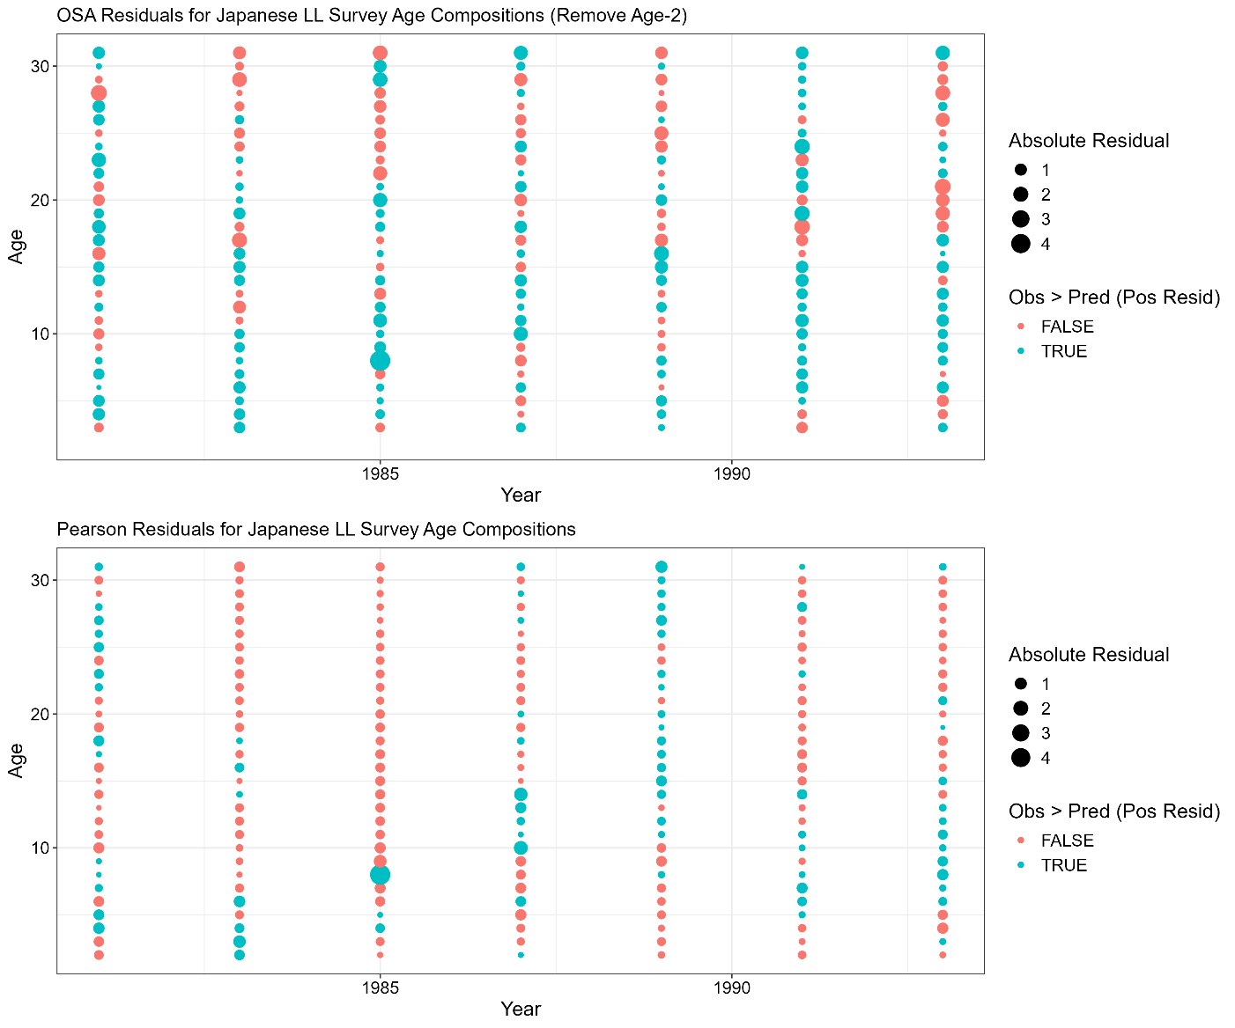

**Figure 3C.1.** Japanese cooperative longline survey age composition one step ahead (OSA; top row) and Pearson residuals (bottom row). Color denotes negative (red) or positive (blue) residuals. For OSA residuals the first age class was removed.

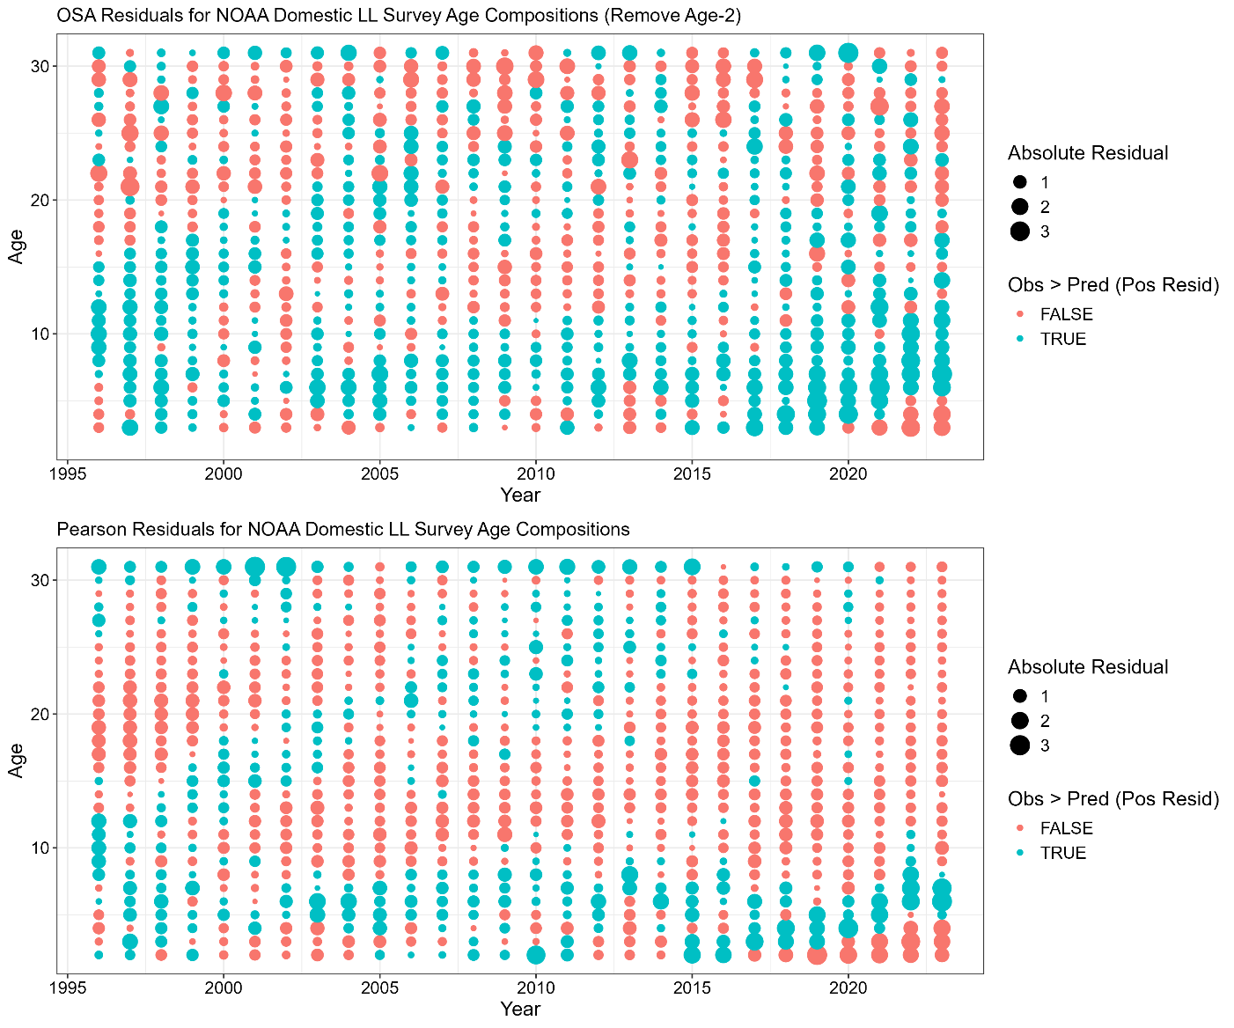

**Figure 3C.2.** NOAA domestic longline survey age composition one step ahead (OSA; top row) and Pearson residuals (bottom row). Color denotes negative (red) or positive (blue) residuals. For OSA residuals the first age class was removed.

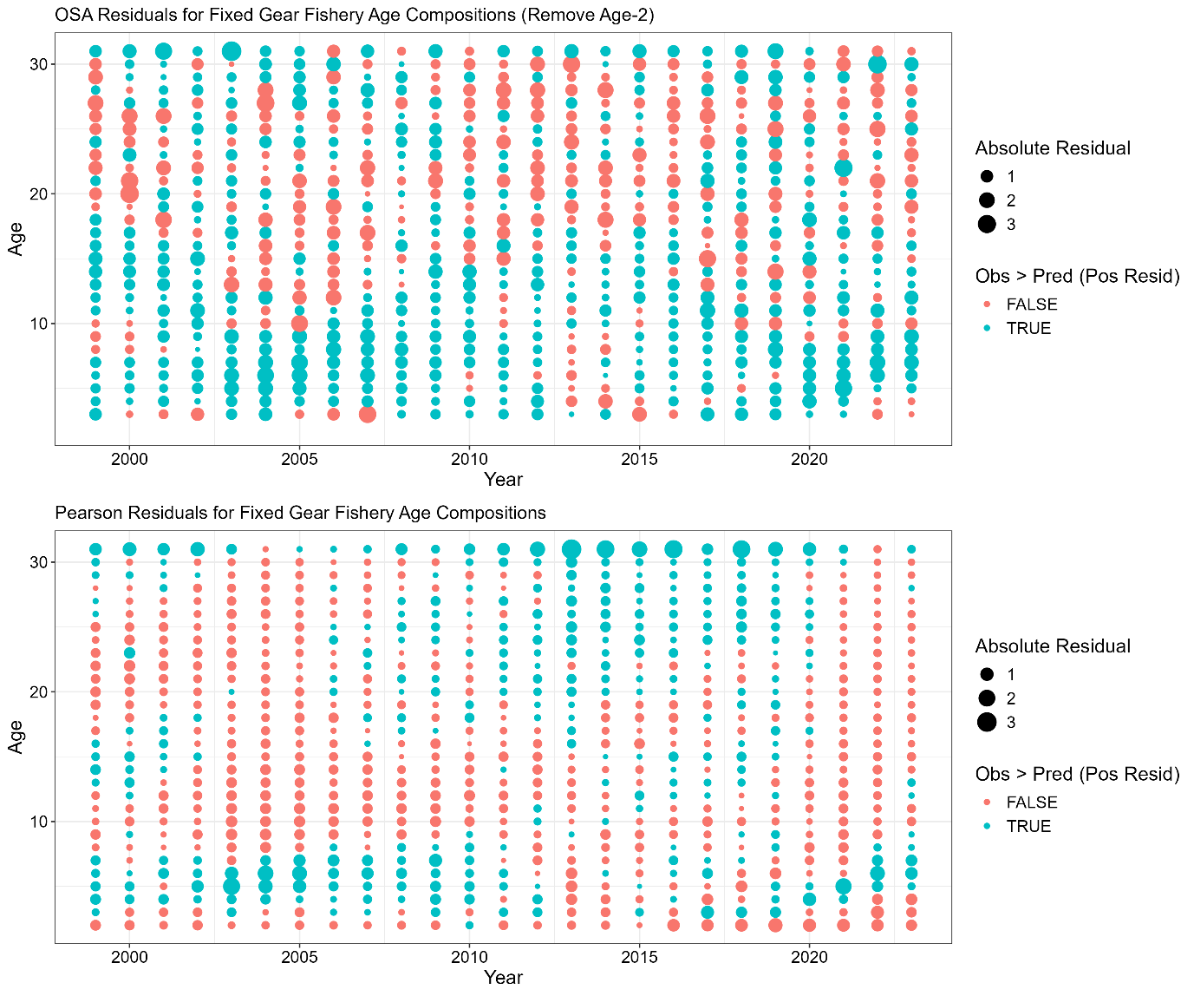

**Figure 3C.3.** Domestic fixed gear fishery age composition one step ahead (OSA; top row) and Pearson residuals (bottom row). Color denotes negative (red) or positive (blue) residuals. For OSA residuals the first age class was removed.

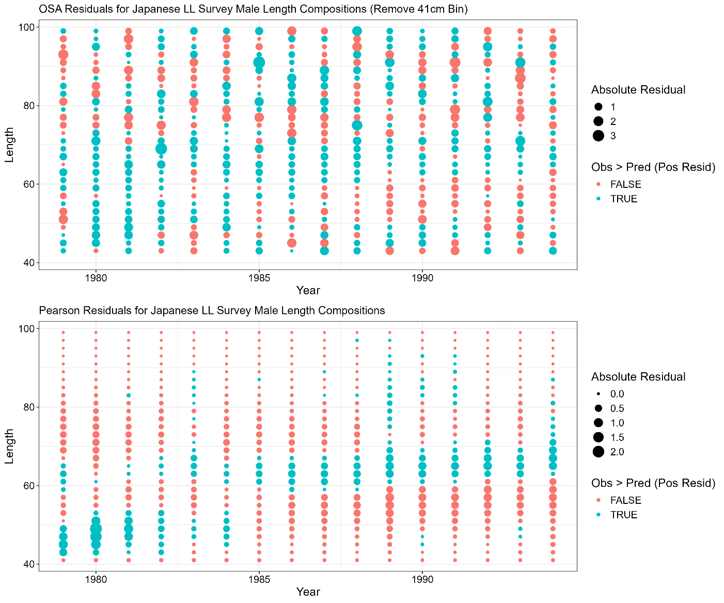

**Figure 3C.4.** Japanese cooperative longline survey male length composition one step ahead (OSA; top row) and Pearson residuals (bottom row). Color denotes negative (red) or positive (blue) residuals. For OSA residuals the first size class was removed.

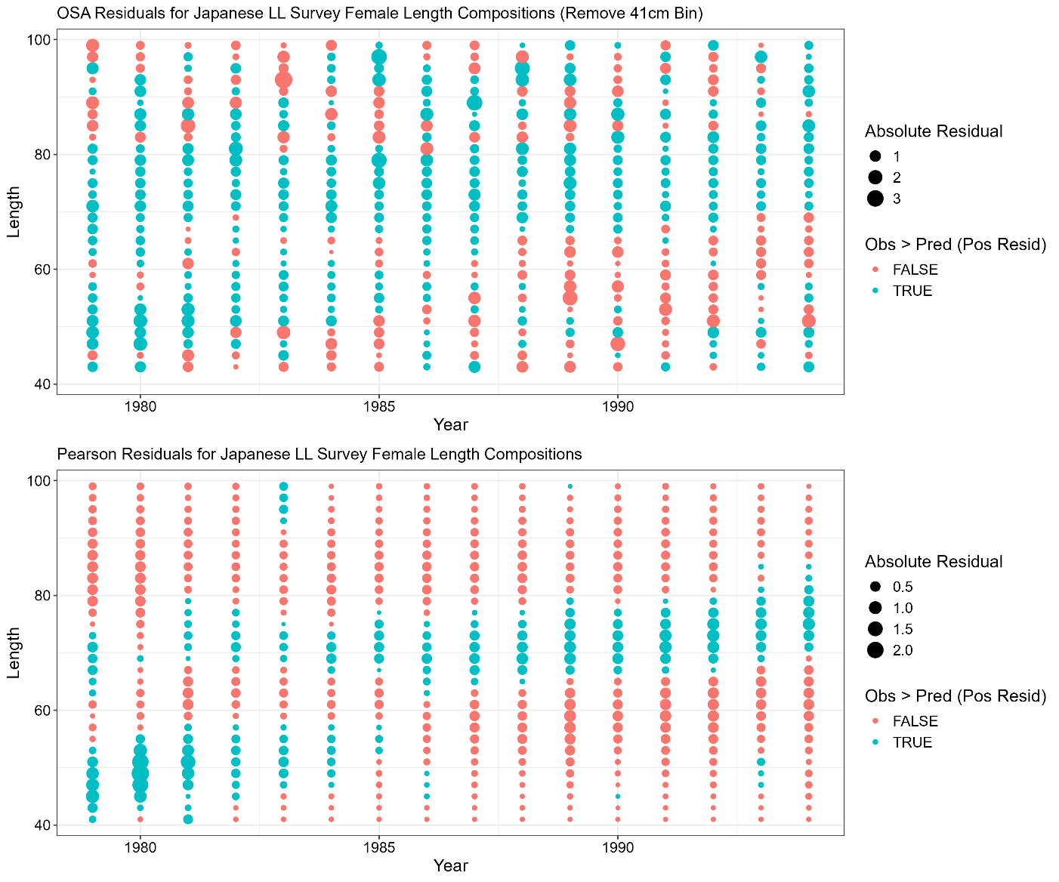

**Figure 3C.5.** Japanese cooperative longline survey female length composition one step ahead (OSA; top row) and Pearson residuals (bottom row). Color denotes negative (red) or positive (blue) residuals. For OSA residuals the first size class was removed.

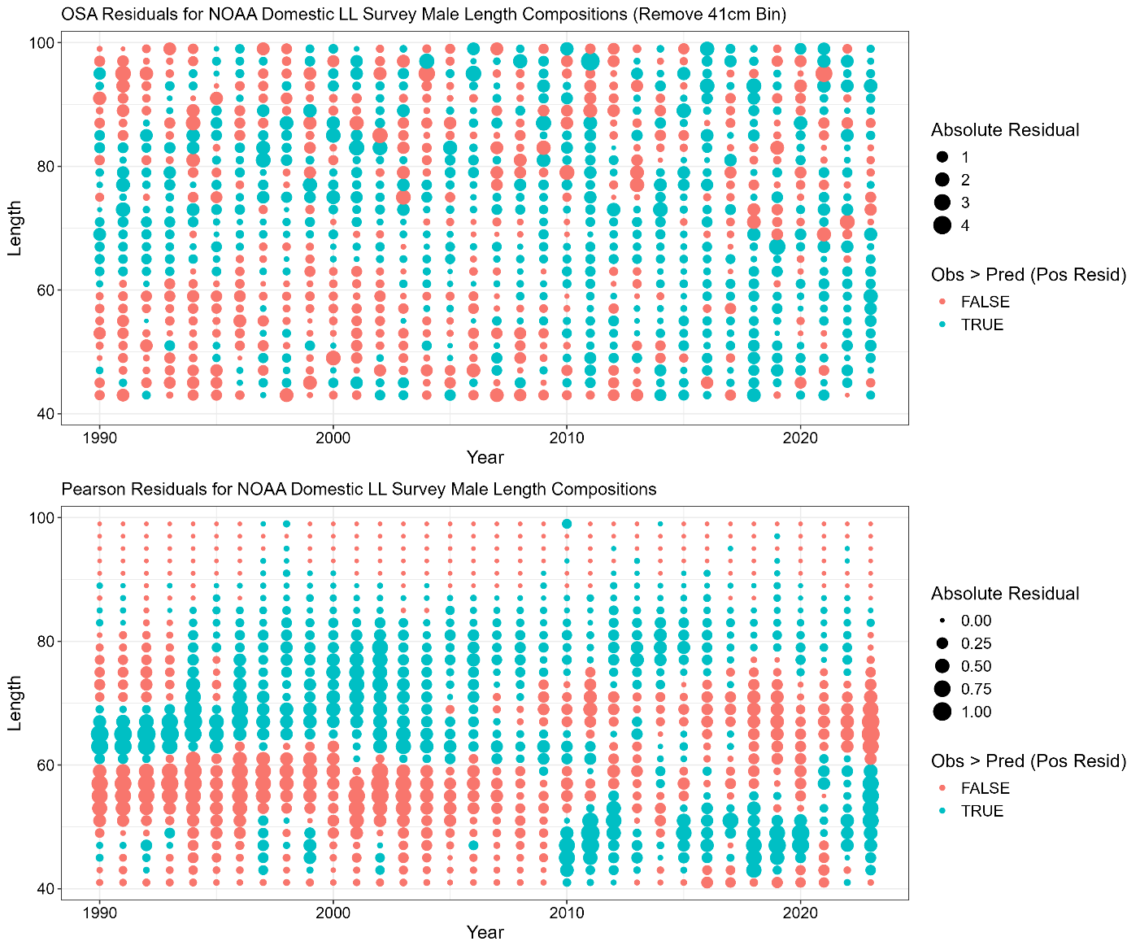

**Figure 3C.6.** NOAA domestic longline survey male length composition one step ahead (OSA; top row) and Pearson residuals (bottom row). Color denotes negative (red) or positive (blue) residuals. For OSA residuals the first size class was removed.

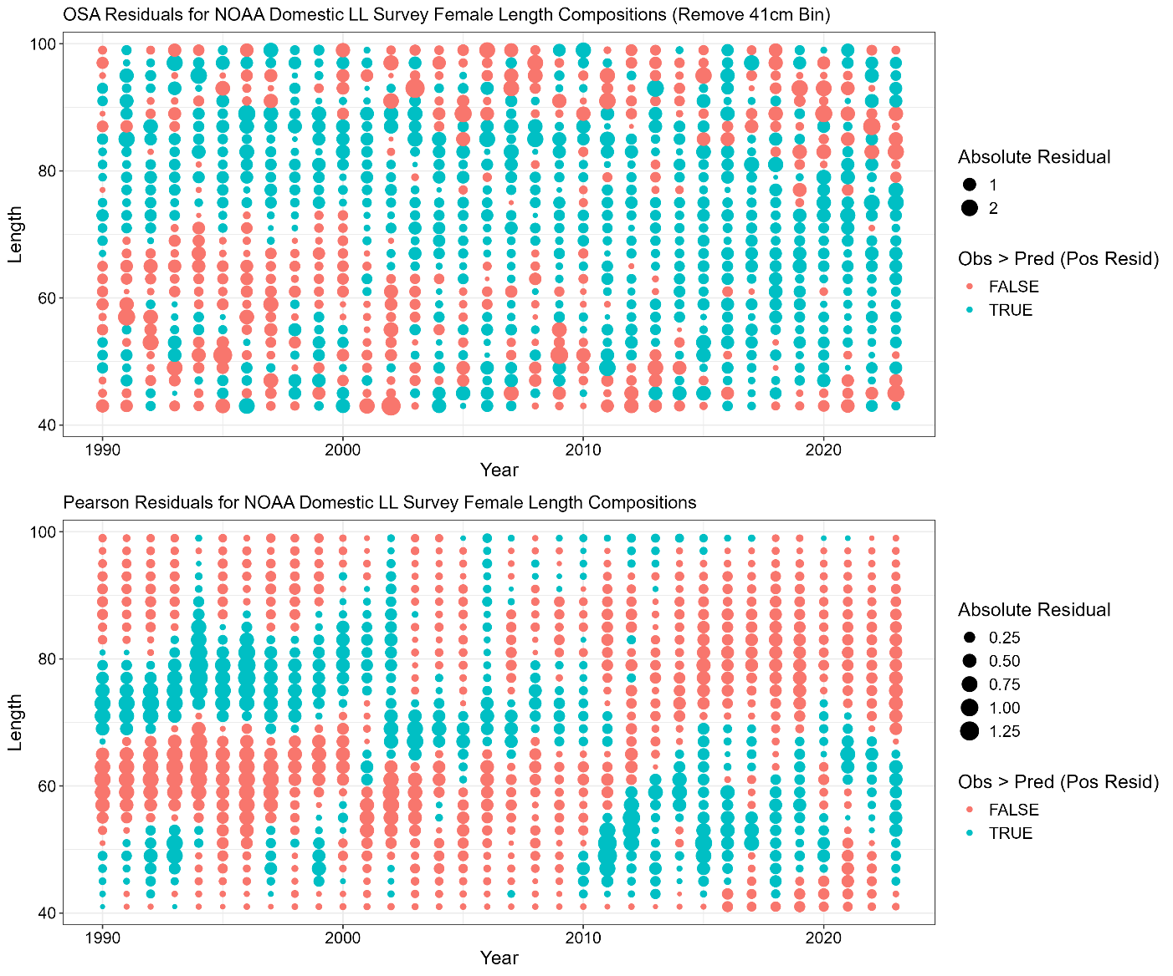

**Figure 3C.7.** NOAA domestic longline survey female length composition one step ahead (OSA; top row) and Pearson residuals (bottom row). Color denotes negative (red) or positive (blue) residuals. For OSA residuals the first size class was removed.

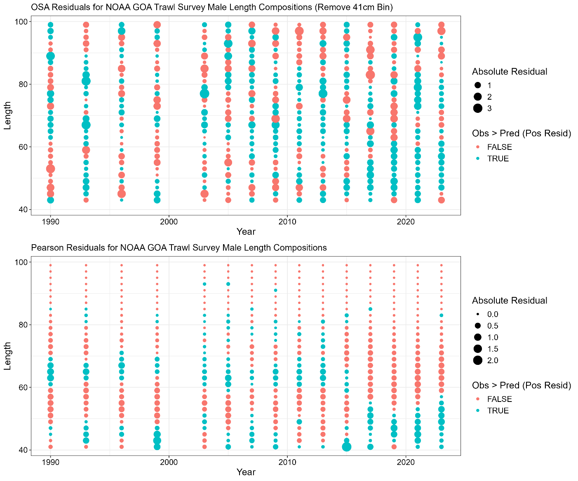

**Figure 3C.8.** NOAA Gulf of Alaska trawl survey male length composition one step ahead (OSA; top row) and Pearson residuals (bottom row). Color denotes negative (red) or positive (blue) residuals. For OSA residuals the first size class was removed.

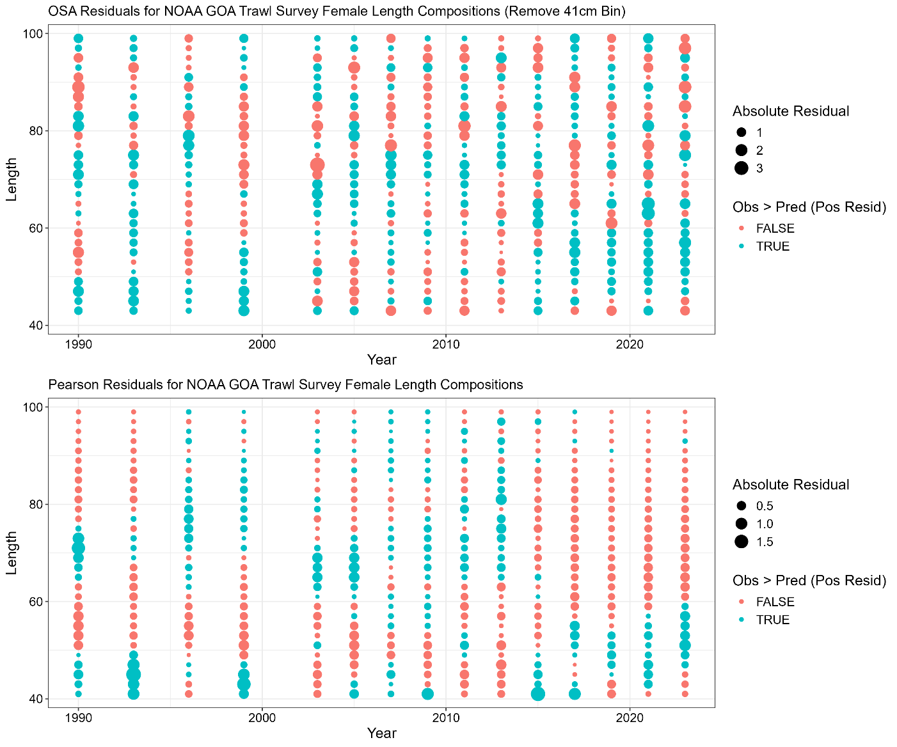

**Figure 3C.9.** NOAA Gulf of Alaska trawl survey female length composition one step ahead (OSA; top row) and Pearson residuals (bottom row). Color denotes negative (red) or positive (blue) residuals. For OSA residuals the first size class was removed.

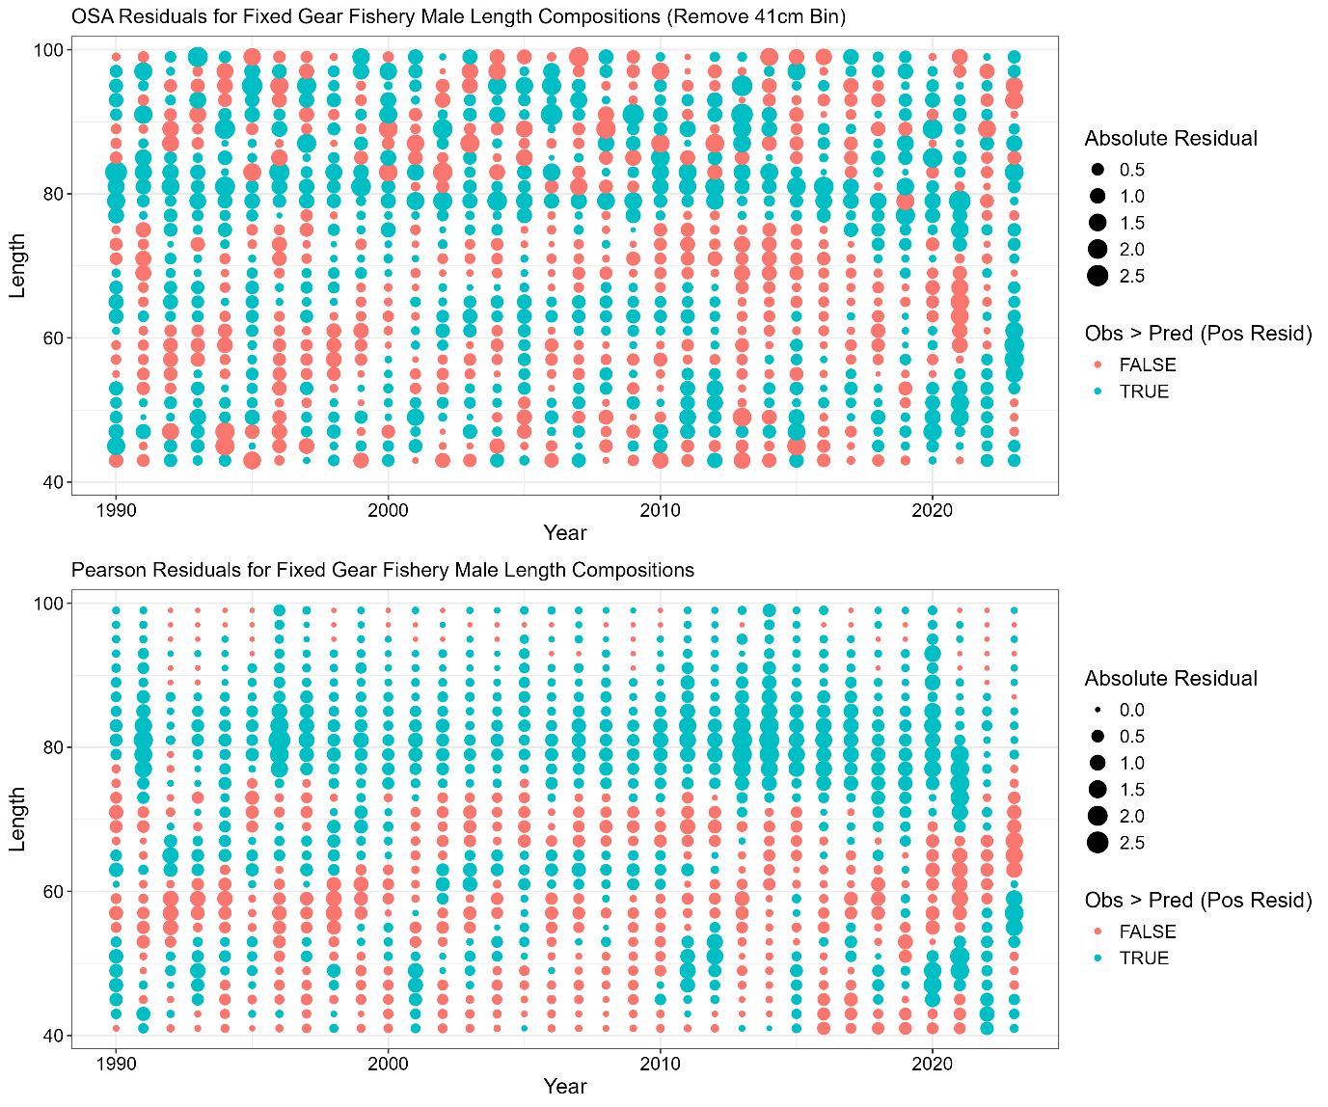

**Figure 3C.10.** Domestic fixed gear fishery male length composition one step ahead (OSA; top row) and Pearson residuals (bottom row). Color denotes negative (red) or positive (blue) residuals. For OSA residuals the first size class was removed.

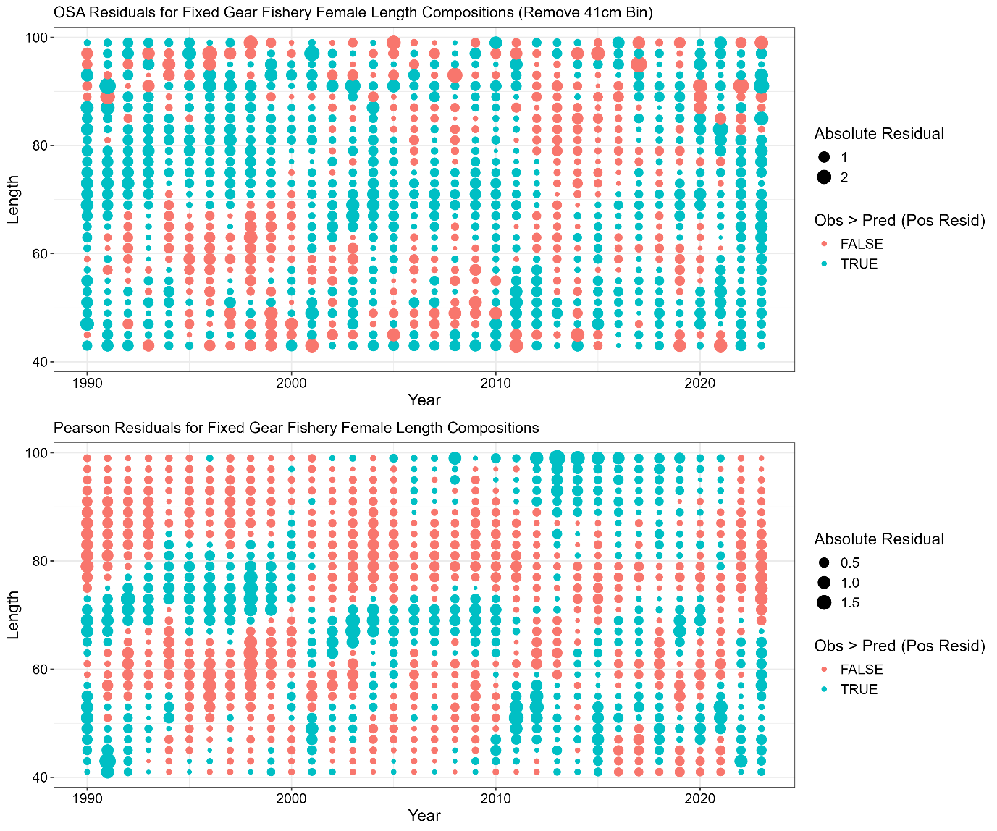

**Figure 3C.11.** Domestic fixed gear fishery female length composition one step ahead (OSA; top row) and Pearson residuals (bottom row). Color denotes negative (red) or positive (blue) residuals. For OSA residuals the first size class was removed.

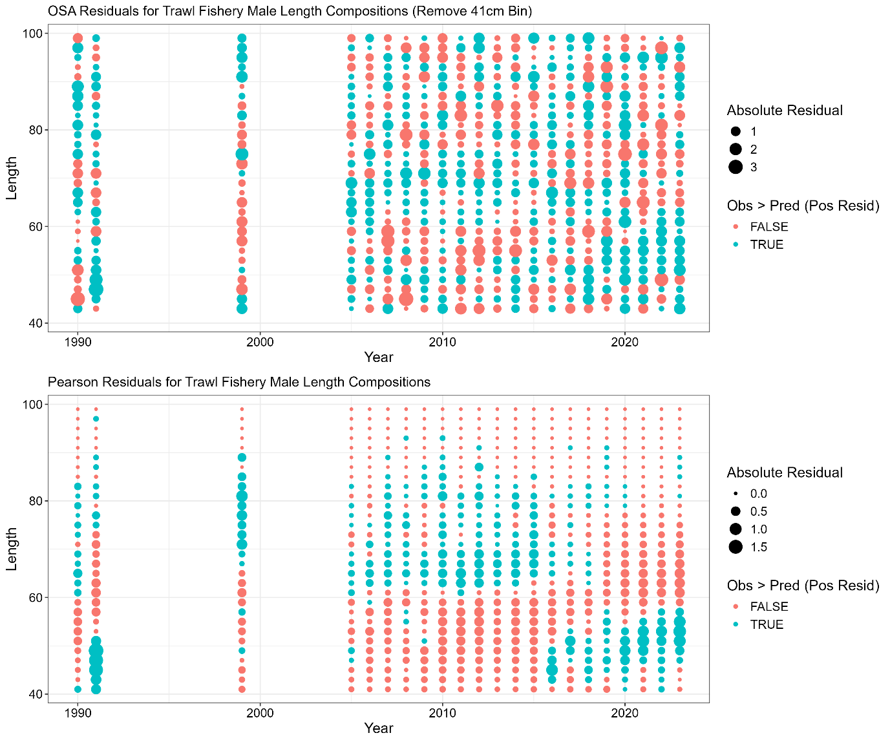

**Figure 3C.12.** Domestic trawl gear fishery male length composition one step ahead (OSA; top row) and Pearson residuals (bottom row). Color denotes negative (red) or positive (blue) residuals. For OSA residuals the first size class was removed.

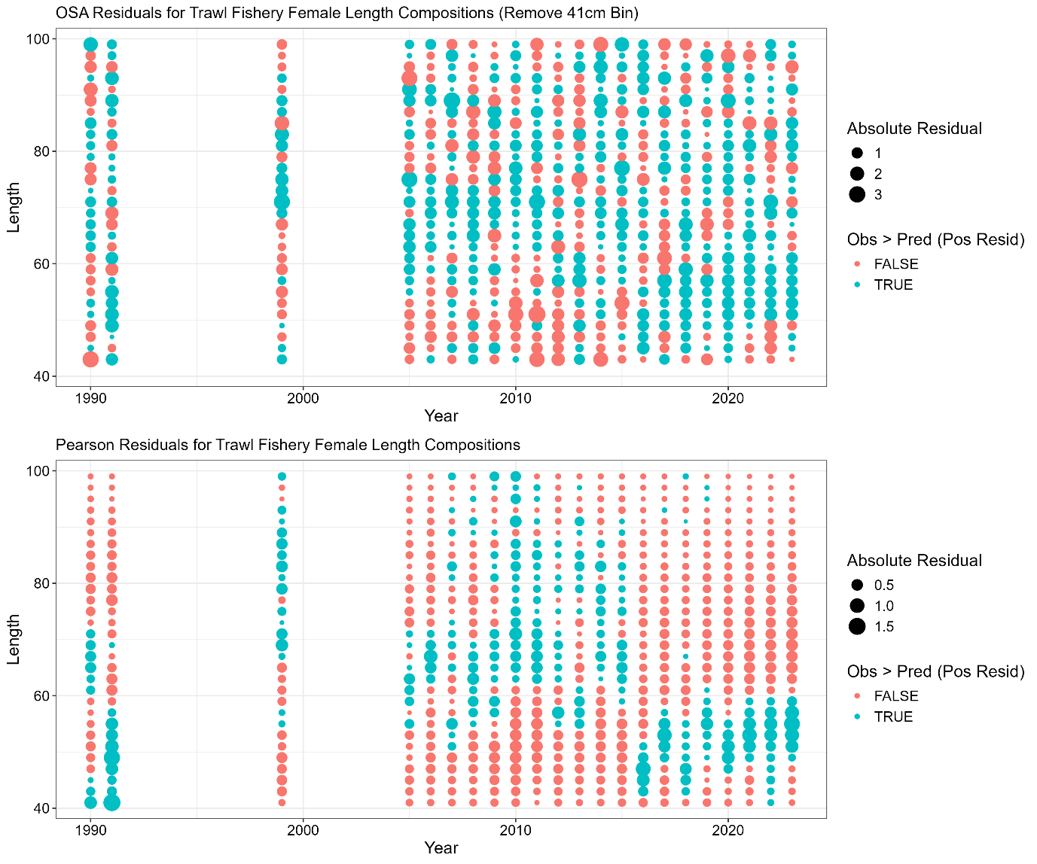

**Figure 3C.13.** Domestic trawl gear fishery female length composition one step ahead (OSA; top row) and Pearson residuals (bottom row). Color denotes negative (red) or positive (blue) residuals. For OSA residuals the first size class was removed.

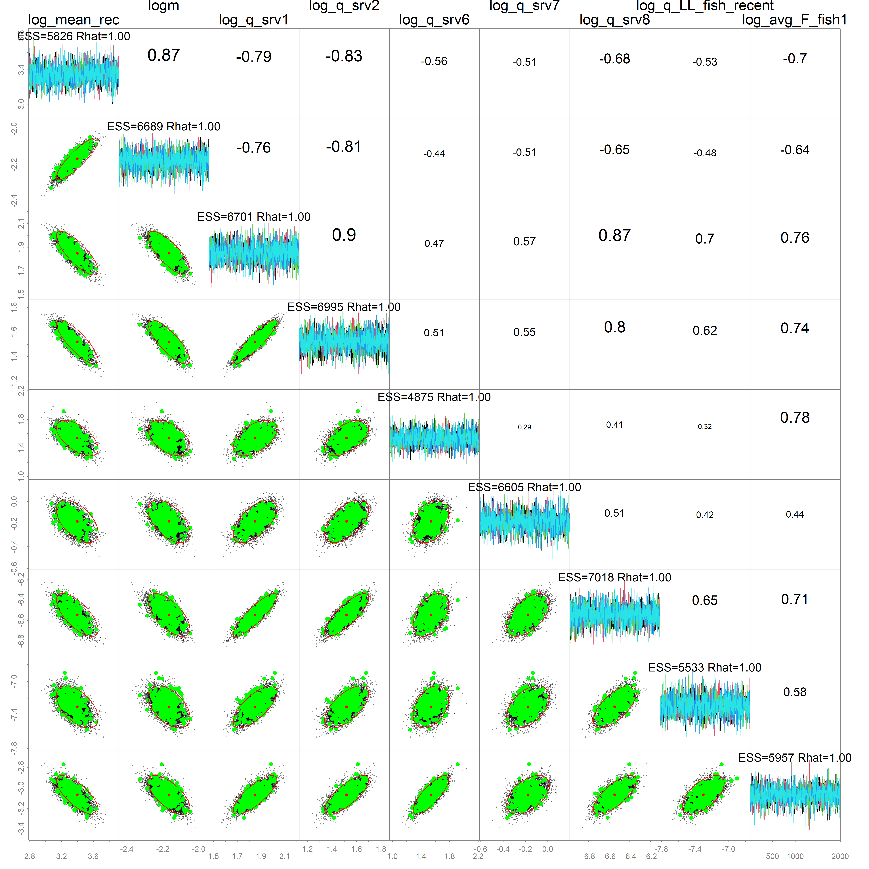

**Figure 3C.14.** MCMC pairwise correlation plots among key model parameters, where diagnostics are shown along the diagonal and parameter correlations are shown in the upper right quadrant.